3.1.3 Number of Workshops/ seminars conducted on Intellectual Property Rights (IPR) and Industry-Academia Innovative practices during the last five years.

1. Department of commerce has organized Faculty Development Programme on “HOW TO MAINTAIN QUALITY EDUCATION DURING COVID-19” as on 10 July 2020:

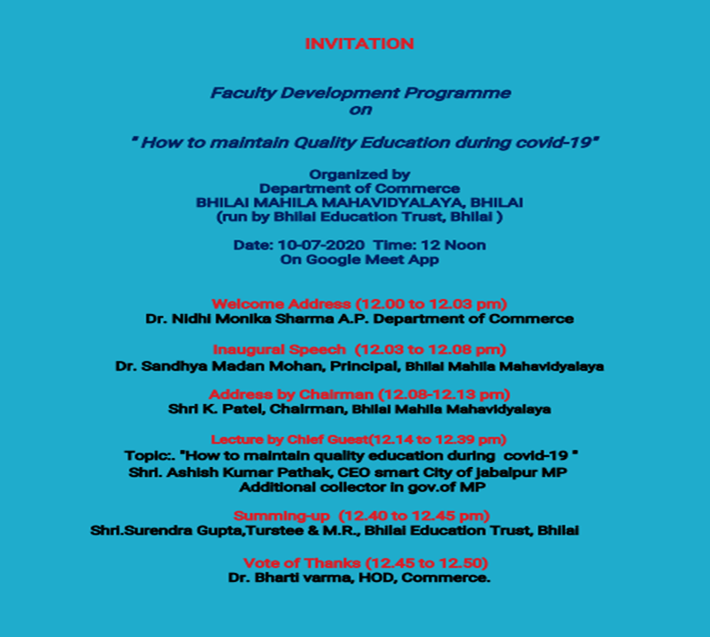
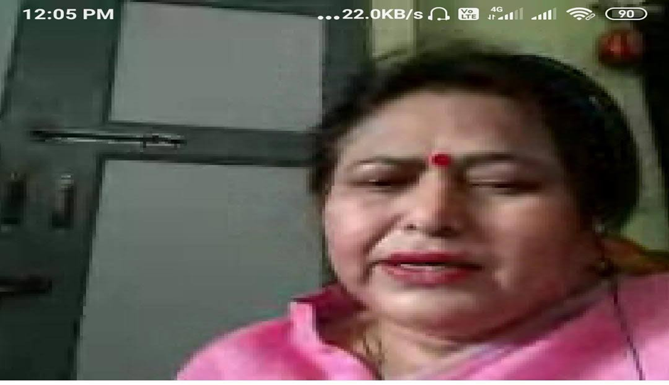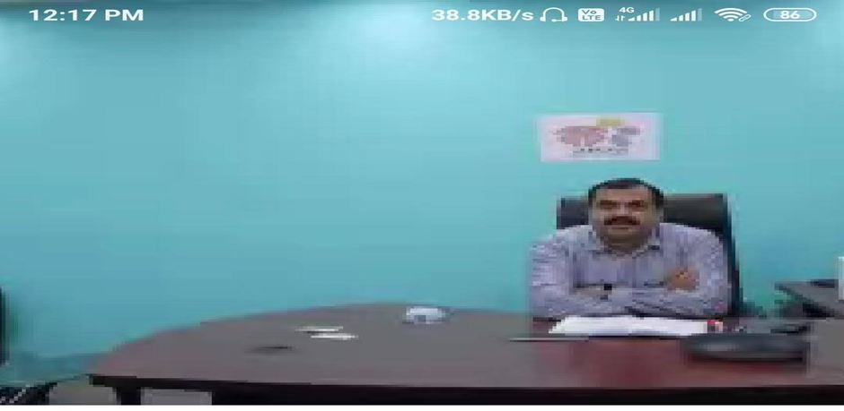

2.Department of commerce has organised FacultyDevelopment Programme on “Student Development Webinar on Small Teaching Strategic that give big result in COVID -19 Lockdown ” on 04th July, 2020
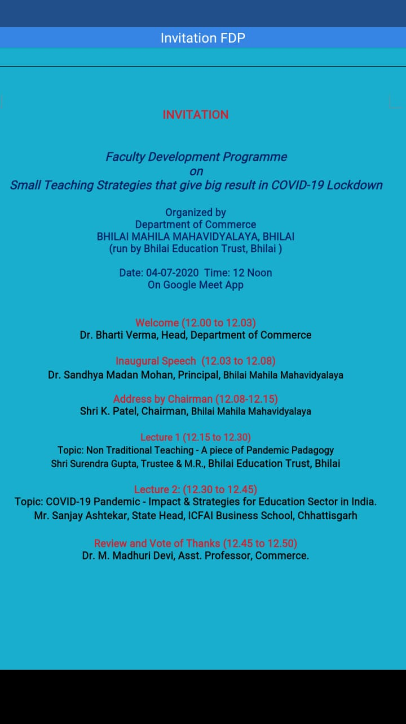
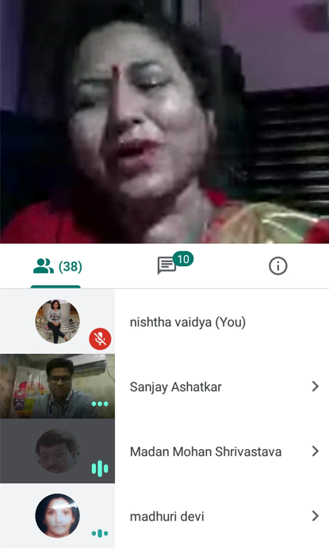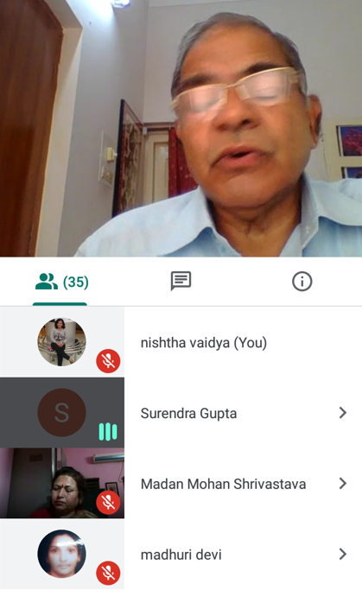

Report of the FDP
on
HOW TO MAINTAIN QUALITY EDUCATION DURING COVID-19”
(as on 10th July 2020)

Department of commerce has organised Faculty Development Programme on “HOW TO MAINTAIN QUALITY EDUCATION DURING COVID-19” as on 10th July 2020. Chief Guest and speaker of the occasion is Shri. Ashish kumar pathak , CEO smart city of Jabalpur MP Additional collector in Govt. of MP and he has given an excellence presentation on the necessity of maintaining Quality Education During Covid-19. Our honourable principal Dr. Sandhaya Madan Mohan has given inaugural speech and motivated our students. Dr. Nidhi Monika Sharma, AP department of commerce has welcomed the guests, Shri Surendra Gupta,Trustee,M.R. has summed up the programme and Shri K. Patel, chairman Bhilai Mahila Mahavidyalaya adressesed our students and Dr. Bharti Verma, HOD commerce has given vote of thanks and and other faculties members are also attended the program. Around 36 participants are present in the program.
Report of the FDP-2
FDP Faculty Development Programme
on
"Small Teaching Strategies that give big Result in COVID-19 Lockdown”
4th July 2020
Department of commerce has organised Faculty Development Programme on “"Small Teaching Strategies that give big Result in COVID-19 Lockdown” as on 4th July 2020. Chief Guest and speaker of the occasion is Mr. Sanjay Ashatekar, State Head, ICFAI, Chhattisgarh, Raipur. He has given an excellence presentation about the modern teaching techniques and various online platforms that are effective in COVID-19 Lockdown. Our honourable principal Dr. Sandhaya Madan Mohan has given inaugural speech and motivated our students. Shri Surendra Gupta,Trustee, M.R. has also given presentation on the importance of Non-traditional Teaching. Shri K. Patel, chairman Bhilai Mahila Mahavidyalaya adressesed our students and Dr. M. Madhuri Devi has given vote of thanks and all the faculty members have attended the program. Around 38 participants are there in the programme.

