3.3.3. Number of books and chapters in edited volumes/books published and papers published in national/ international conference proceedings per teacher during year 2021-22.

S.No | Author | Title | Publisher | ISBN/ISSN
1. | Dr. M. Madhuri Devi | Published one Chapter entitled” Women Empowerment through Self Help Groups” | Book entitled “ Women and Girls Development Issues and Challenges” Page-48-57  8th March,22 | ISBN No. 9788195547937 | 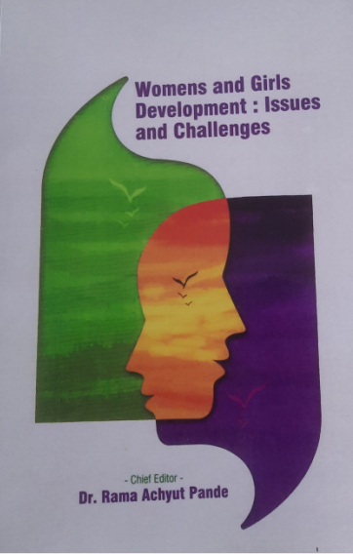
2. | Dr. M. Madhuri Devi | Impact of Pandemic COVID-19 Second Wave on the Personal Lives of the People living in Bhilai”  3 days | International Web Conference on Asian Biological Research Foundation(UP), India |  | 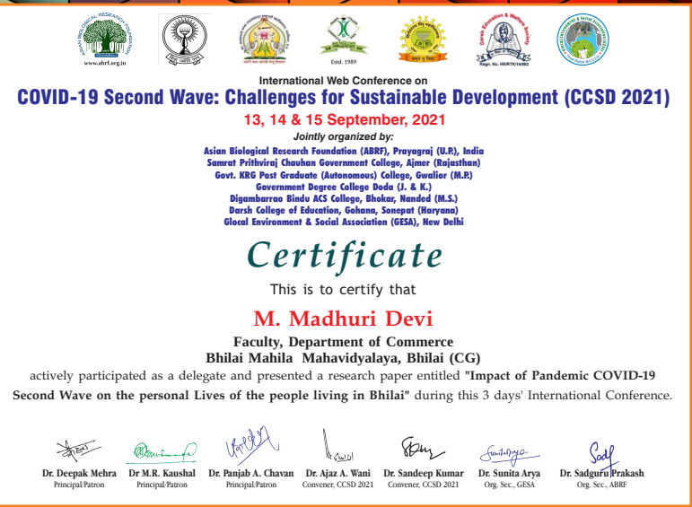
3. | Dr. Bhawana Pandey | Arsenic Pollution in Chhattisgarh and its Remediation | The Global Knowledge Foundation, USA, Inc. | ISSN 2769-5093 | 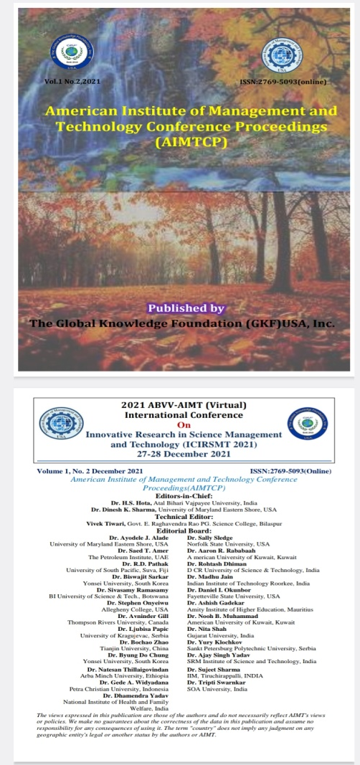
4. | Dr. Amarpreet Kaur Bhatia | Functionalized Nanomaterial (FNM)- Based Catalytic Materials for Energy Industry | Journal of Carbon Research by Wiley
5. | Dr. Shippi Dewangan | Removal Hydrophobic Contaminants from soil by Adsorption onto Carbon Material and Microbial Degradation | Journal of Carbon Research by Wiley

