5.1.4
Sl.no | Name of Guest speaker | Date | No of students participated | Topic
1 | Dr. Santosh Pandey,  AP, Botany,  Shahid Domeshwar Sahu Govt. college Jamgaon R. | 29.04.2022 | 28 | Importance and prepraton for UGC NET, SET, examination | 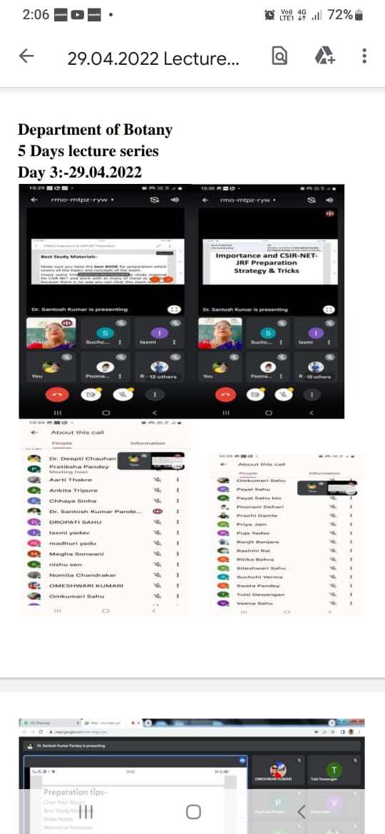 | 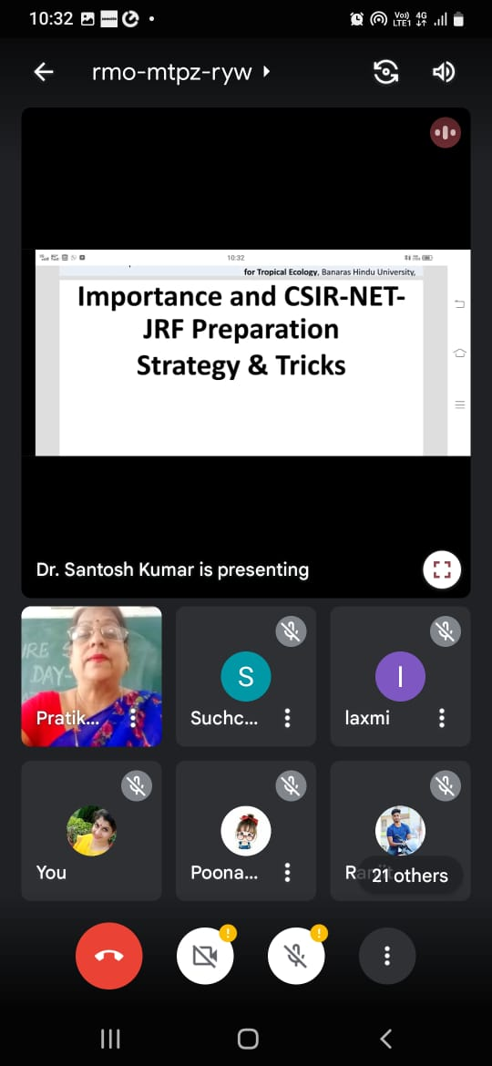
2 | Dr. Anita Mahishwer,  HOD, Botany  Govt. Digvijay college, Rajnandgaon | 09.03.2022 | 85 |  | 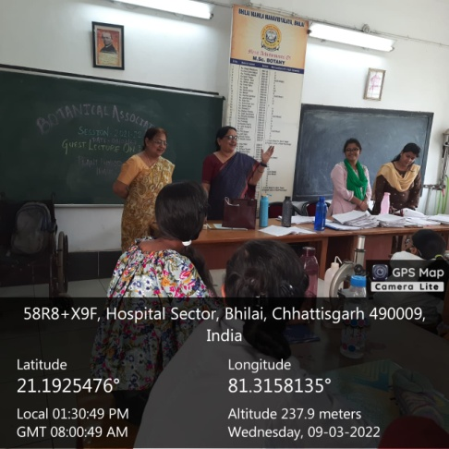
3 | Mr. Praveen Jain  Assistant Professor | 20.05.2022 | 22 | Career counseling and advance courses in Botany | 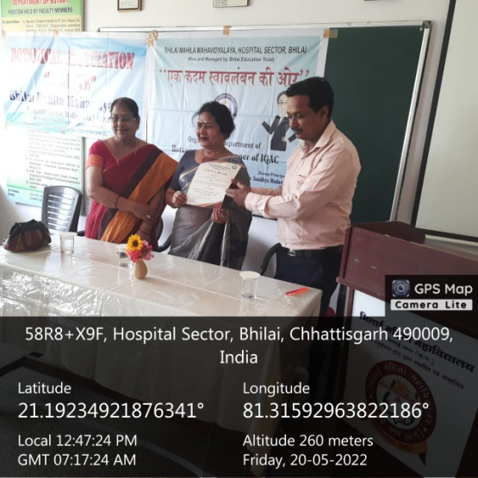 | 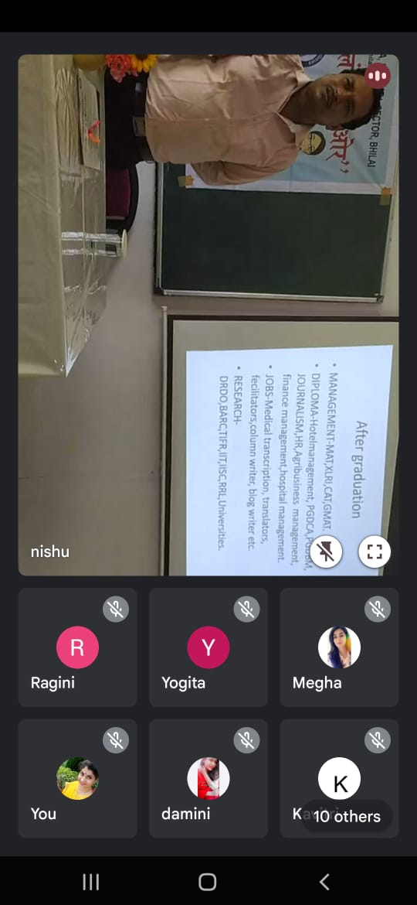
4. | B.Ed. | - 30/05/2022 to 04/06/2022 | 50 | Workshop on Career Guidance 2021-22  (Online & Offline Mode) | 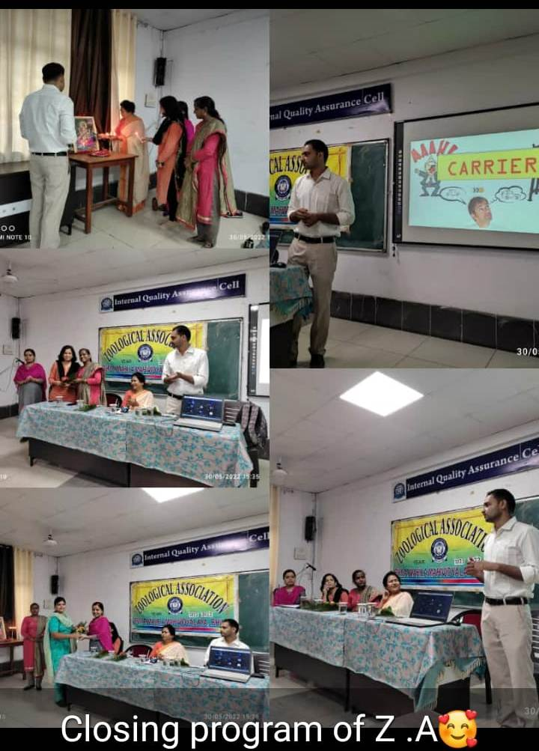 | 