**The Institution has a transparent mechanism for timely redressal of student grievances including sexual harassment and ragging cases**

**2020-21**

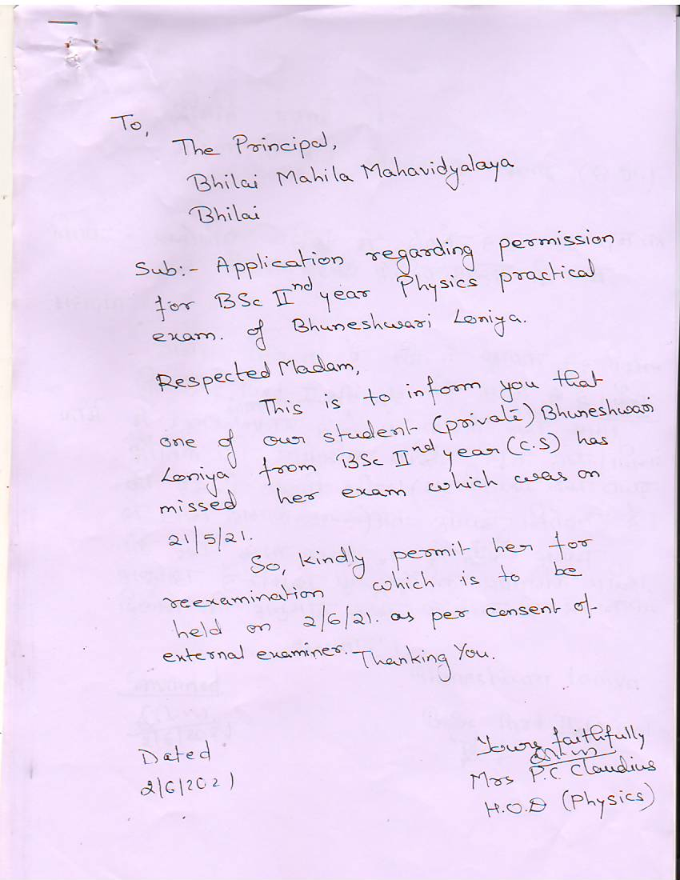

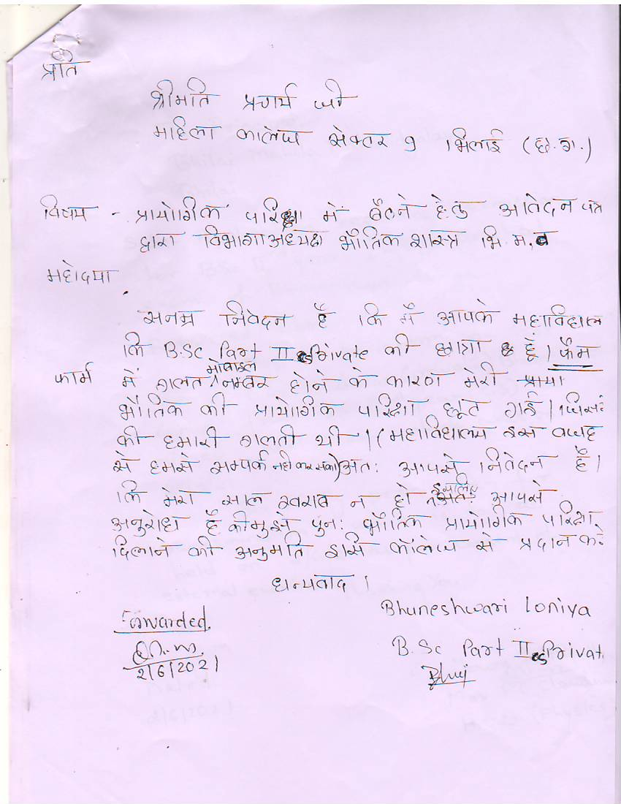

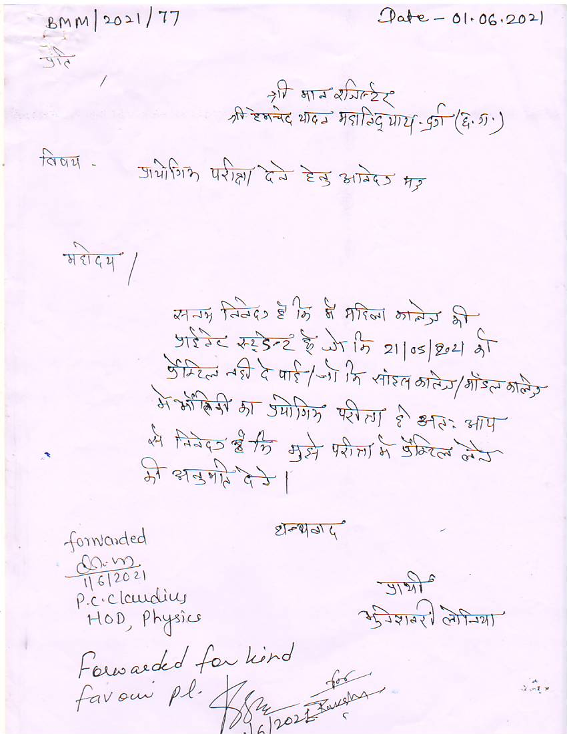

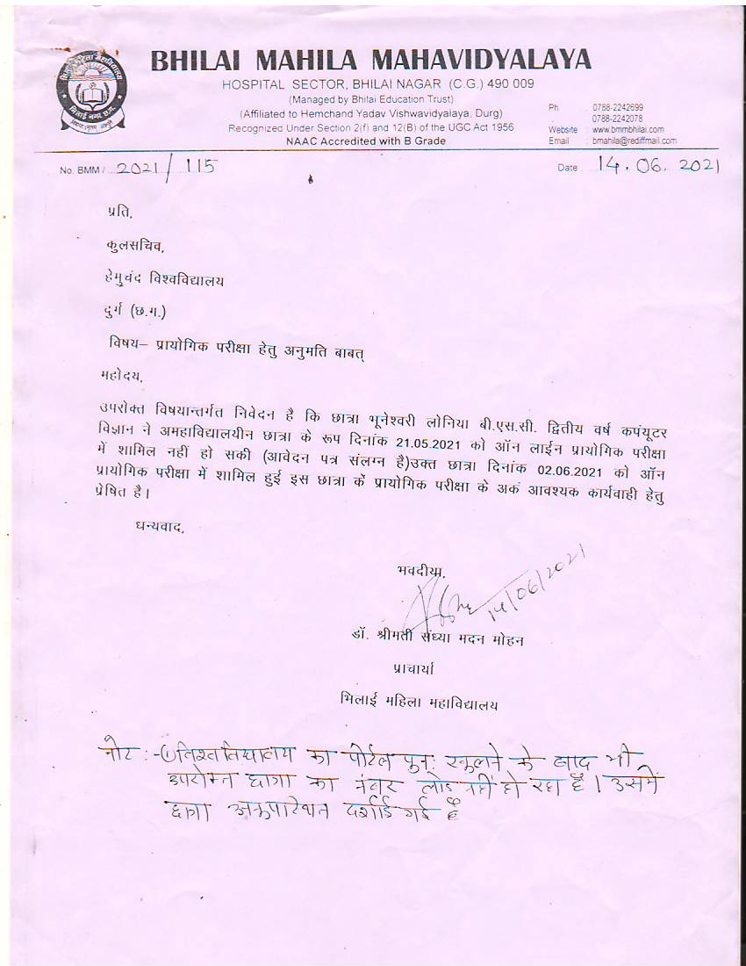

DIFFERENT COMMITEES (2015-16)

* **ANTIRAGGING COMMITEE**
* *Dr. R.A. YADAV*
* *Dr. N.M. Sharma*
* *All H.O.D’s*
* **WOMAN CELL**
* *Dr. S.M. Mohan*
* *Dr. M. Madhuri*
* *Mrs. H. Siddar*
* *Dr. P. Pandey*
* **GRIEVANCE REDRESSAL CELL**
* *Dr. S.M. Mohan*
* *Dr. S. Agrawal*
* *Dr. B. Verma*

