Criteria 5.1.5 Grievances 2021-22

S.No. | Name of Student | Class | Document
1. | Aparna Mohanti | B.com 1st year | 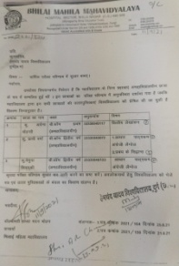  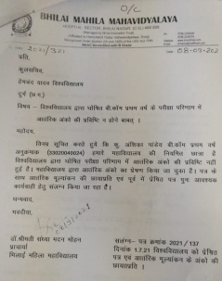
2. | Prachi Verma | B.com 2nd year
3. | Memuna Sidhiqui | B.com 2nd year
4. | Vimla Sahu | B.Sc. 2nd year | 