**Inter College Table Tennis Tournament Winner 2015-2016**

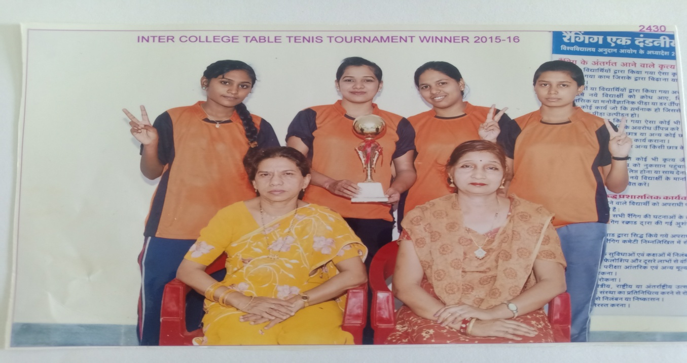

**Inter College Volley Ball Tournament Runner Up 2015-2016**

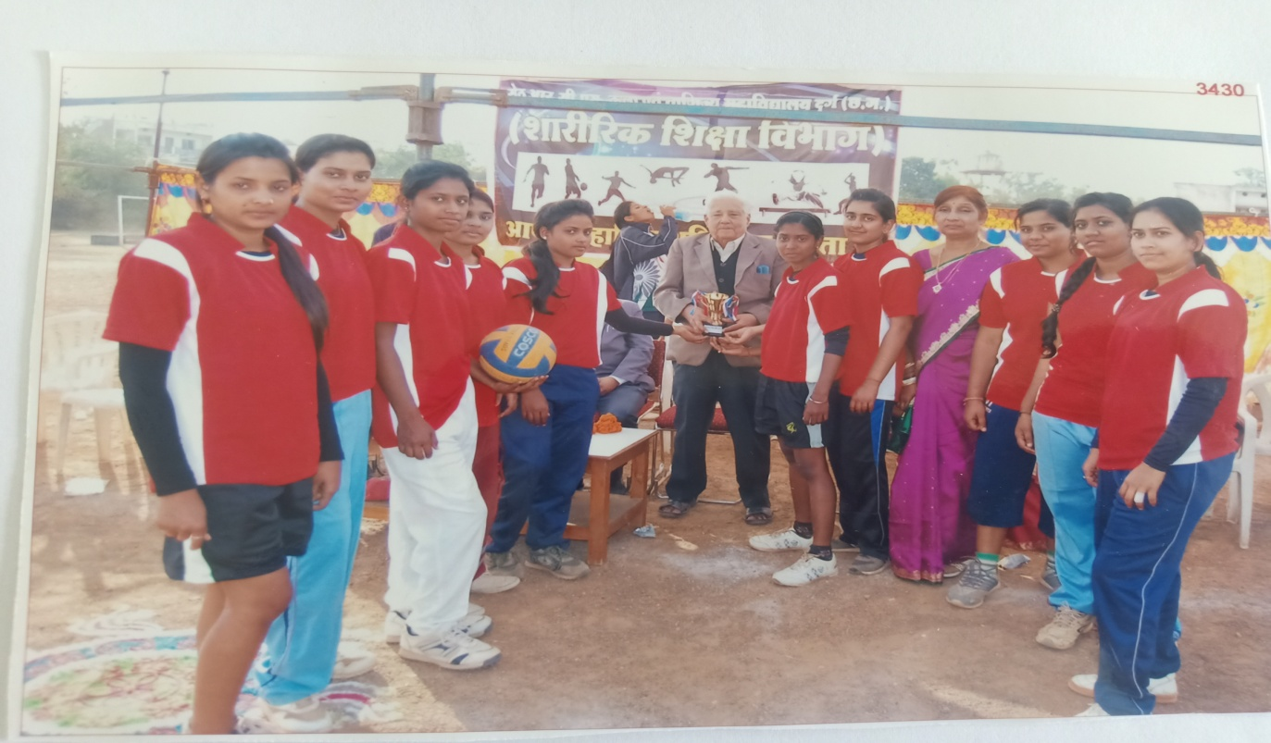

**Inter College Net Ball Tournament Winner 2016-2017**

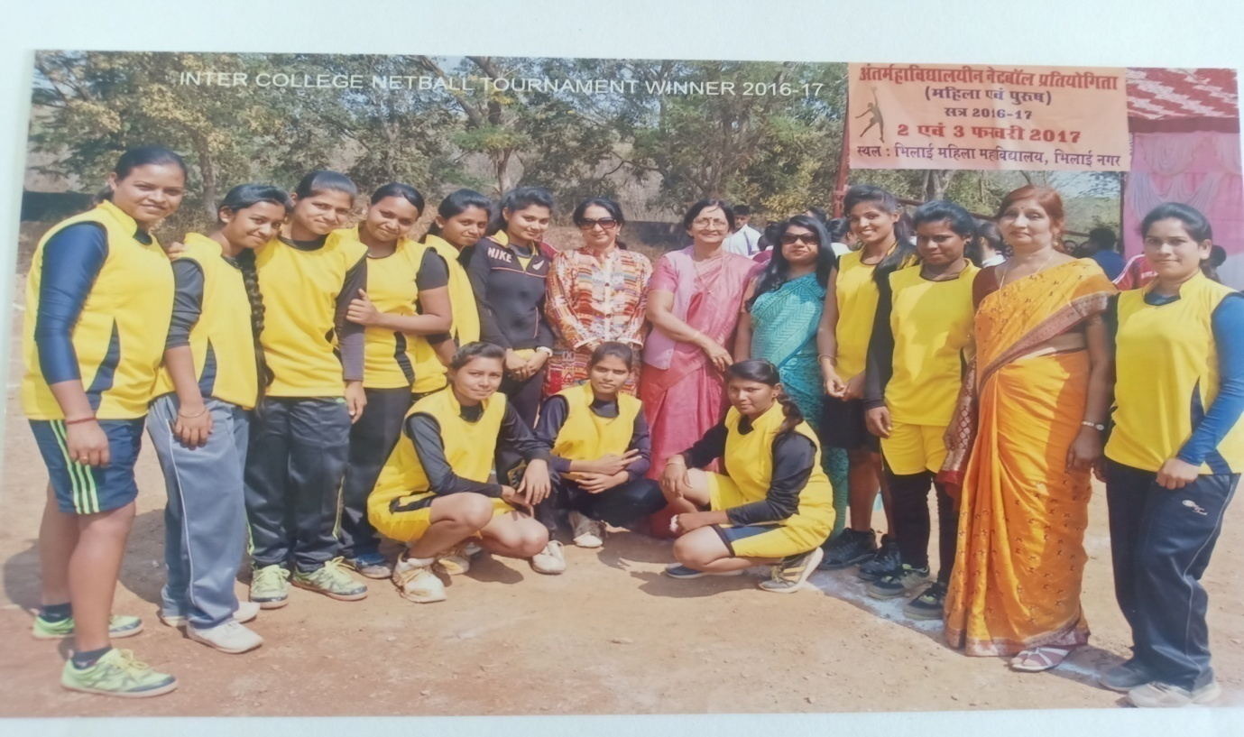

**Inter College Table Tennis Tournament Winner 2016-2017**

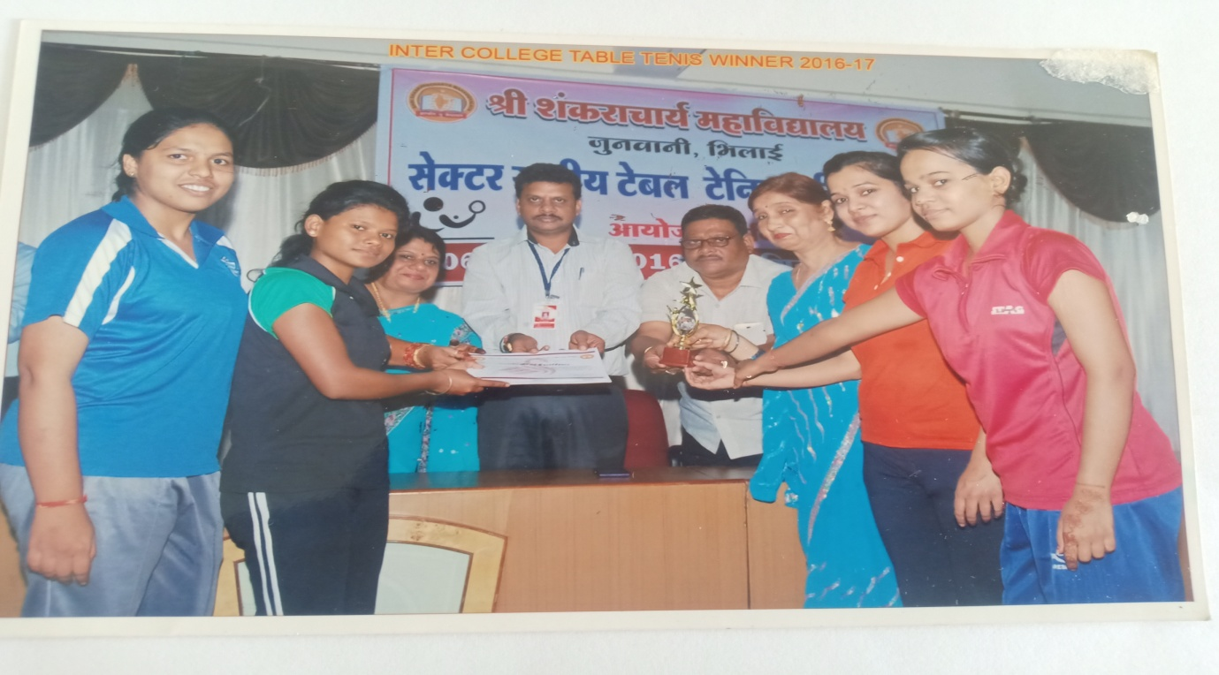

**Inter College Softball Tournament Winner 2017-2018**

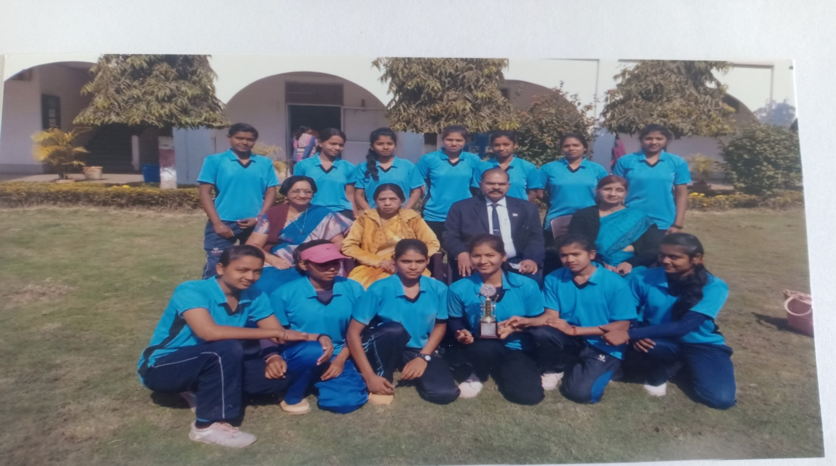

**Inter College Badminton Tournament Winner 2017-2018**

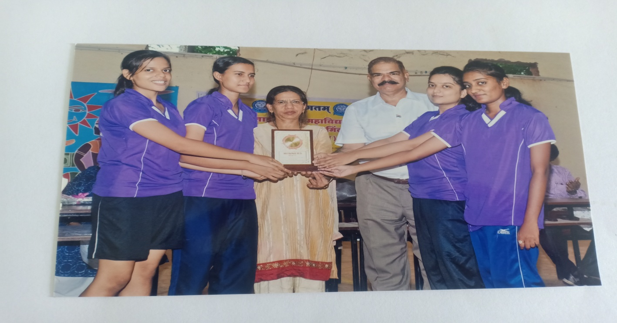

**Inter College Chess Tournament Winner 2018-2019**

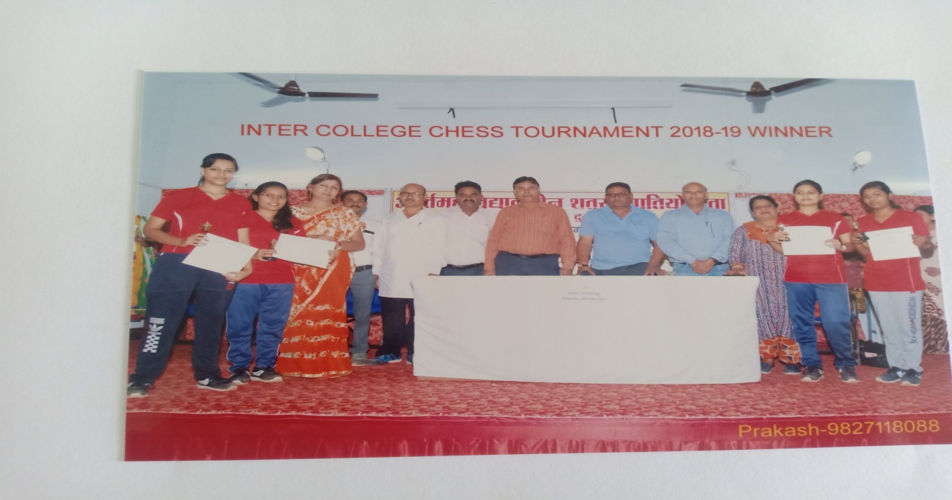

**Inter College Table Tennis Tournament Winner 2018-2019**

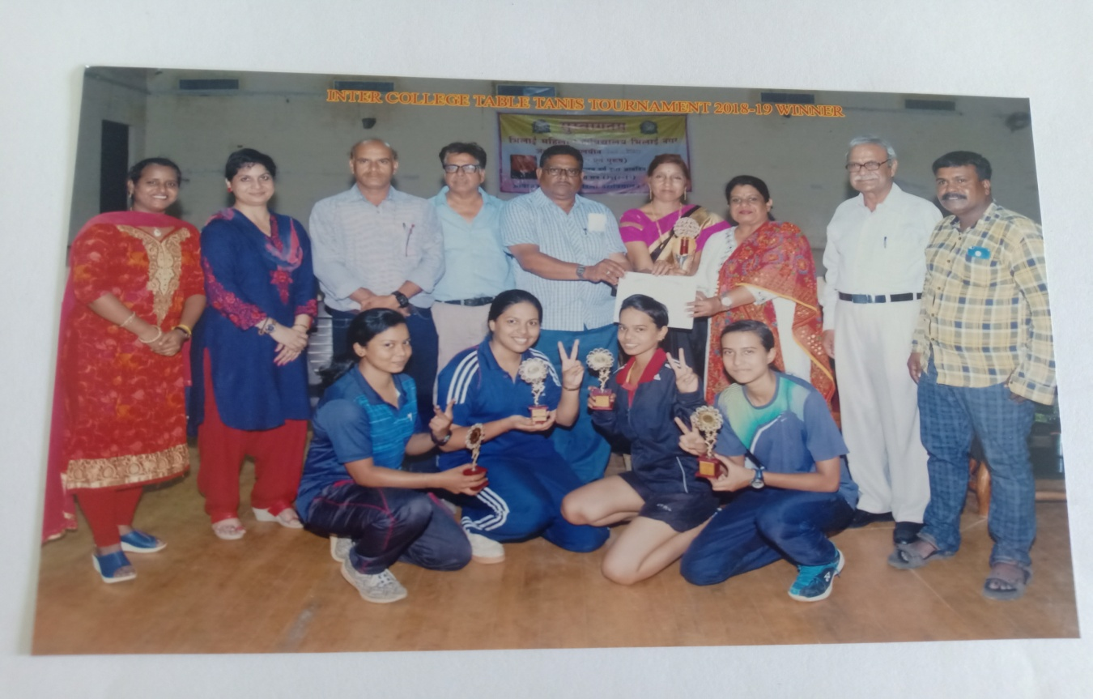

**Inter College Badminton Tournament Winner 2018-2019**

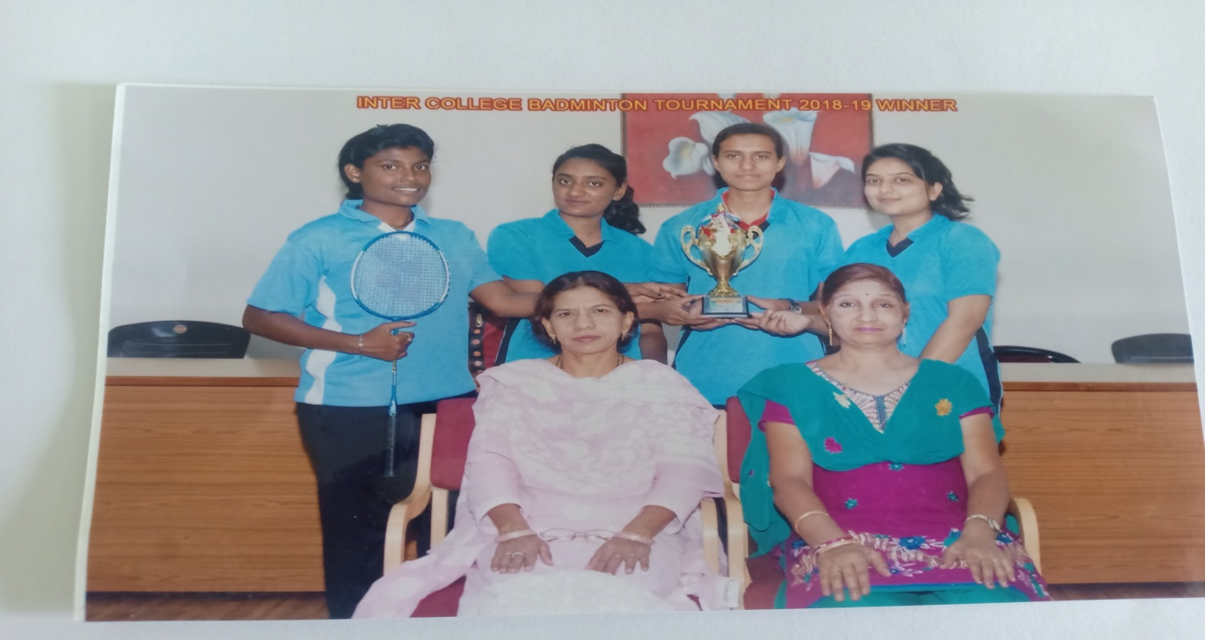

**Preeti Yadav M.Com 1st Semester Awarded with C.M. Trophy 2019-2020**

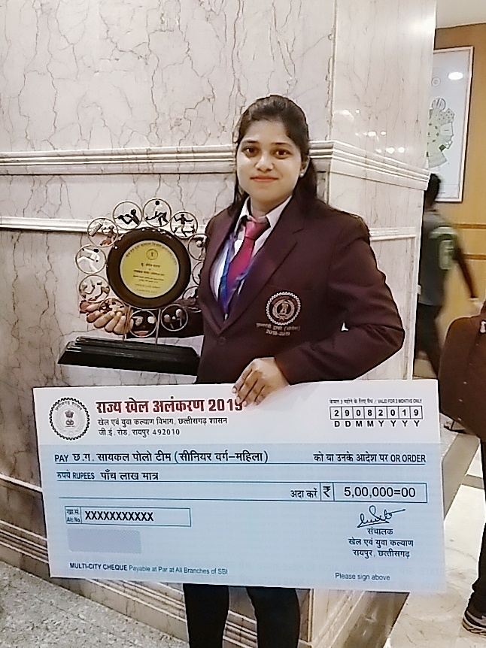

**Inter College Chess Tournament Winner 2019-2020**

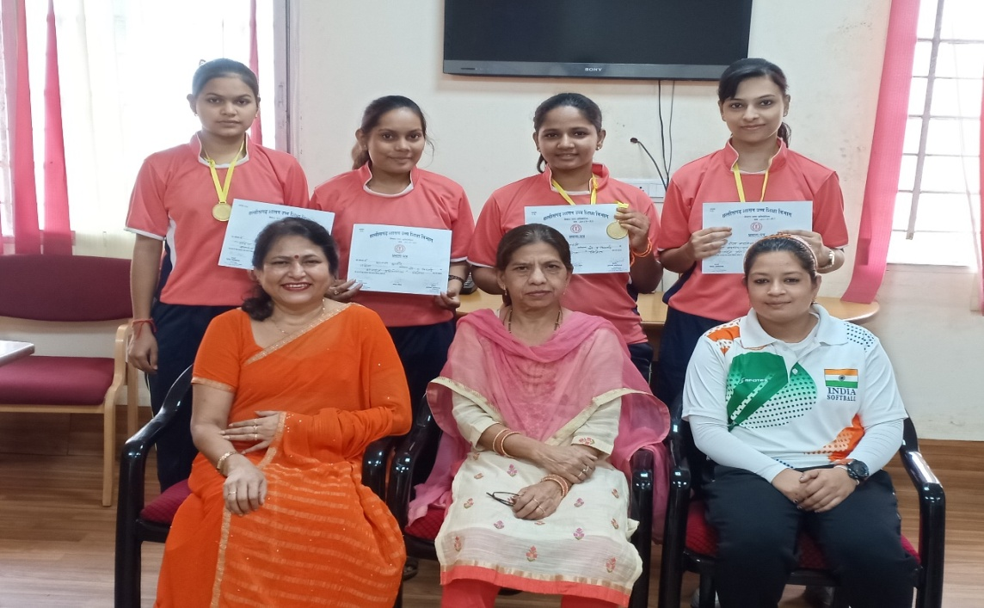

**Inter College Badminton Tournament Winner 2019-2020**

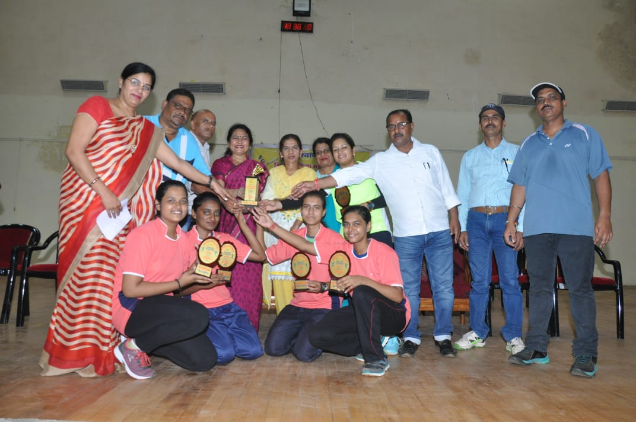

**Inter College Basketball Tournament Runner Up 2019-2020**

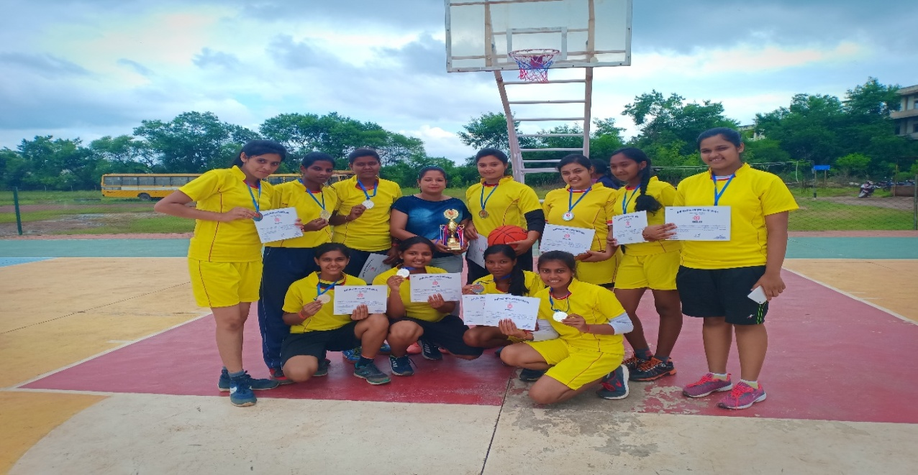

**Inter College SoftBall Tournament Runner Up 2019-2020**

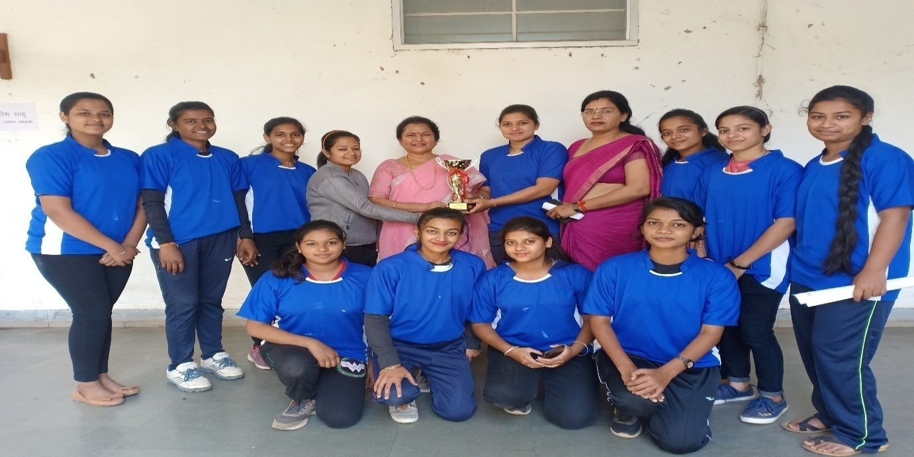

**Preeti Yadav of M.Com 3rd Semester and Archana Shome of M. Sc 1st Semester received Rs 12,000 and Rs 15,000 respectively as a Cash Award by Hemchand Yadav University, Durg 2019-2020**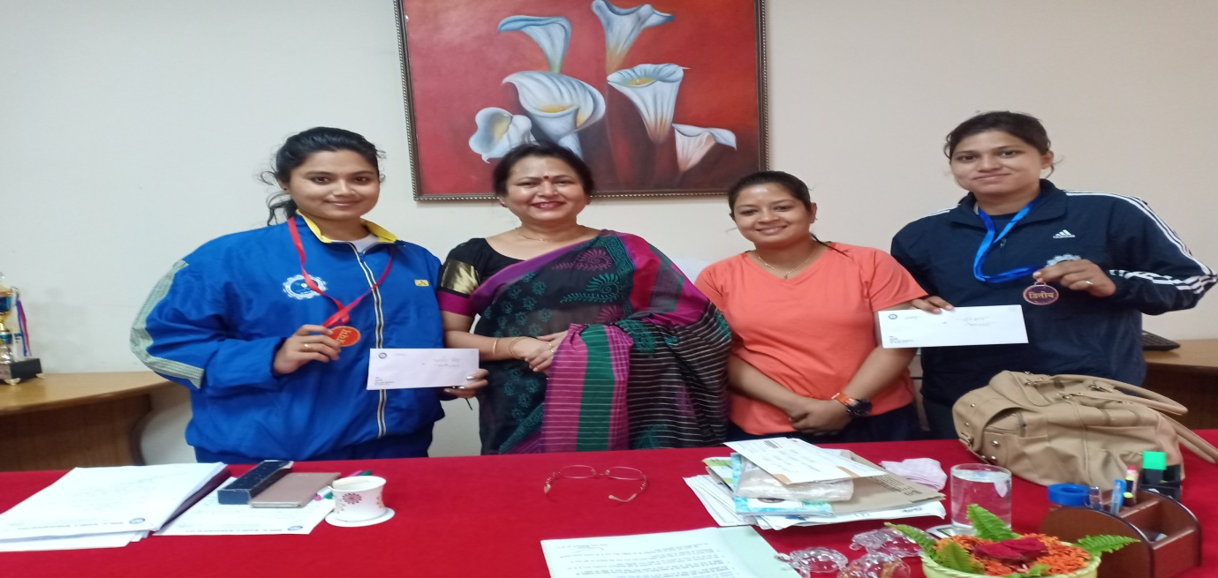

Hemchand Yadav University, Durg Women Badminton Team 2019-2020