Environmental Consciousness and Sustainability.
The Institution has facilities for alternate sources of energy and energy conservation measure.
  - Solar Energy

Electricity Generation from Grid connected Solar Power Plant of 50 KWp capacity

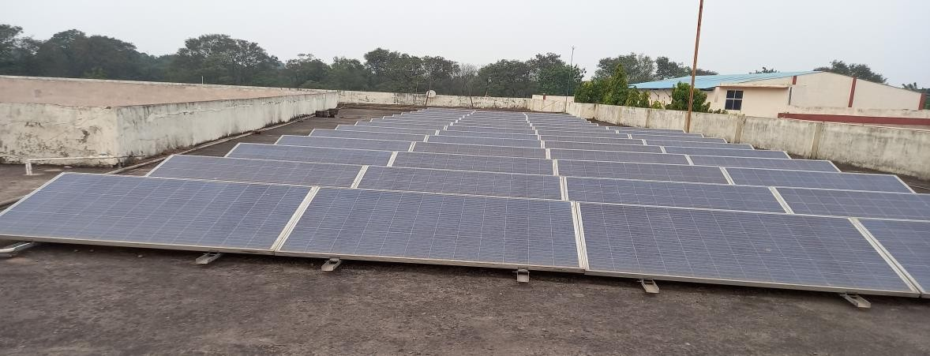
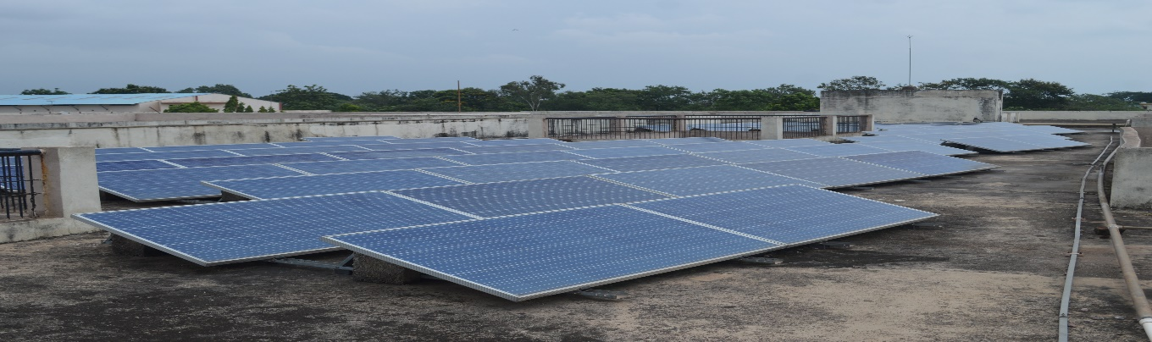

Electromech Devices Mfg. Co. Raipur has installed a Grid Connected Solar Power Plant of Tata Solar having capacity of 50 KWp and handed over to Bhilai Education Trust on 29th March, 2018.

Total Wattage of one Solar Panel | 0.31 Kwp
Total Numbers of Panel | 162
Total Wattage | 50 kwp

The seller can sell energy maximum up to 49%. The supply arrangement of Solar Power Plant is such that it will first meet in-house electricity consumption of college, then after it will supply surplus energy to grid, which will be recorded by Import/Export meter. The serial. number of Secure make import/export meter is X0480882. The shadow free area of college roof is 12,000 sq. meter.
The solar module efficiency will be about 90% after 10 year and about 80% after 25 years of installation. Module efficiency is 16.55%.

A View of Solar Power Plant

The technical details of electrical parameters of Solar panel is mentioned below :-

Type of Module | Multi | Make & Year | Tata Solar, 2018
Module Efficiency | 16.55% | Voltage & Nos. | 24 V, 162 Nos.
PCU Make& Rating | Delta, 50 KW | Tilt angle of module | 21.D
No. of series & parallel combinations |  | Series 18 x5, 18 x4 & parallel 9
AC output & Capacity |  | 230 V, three phase & 50 KWp

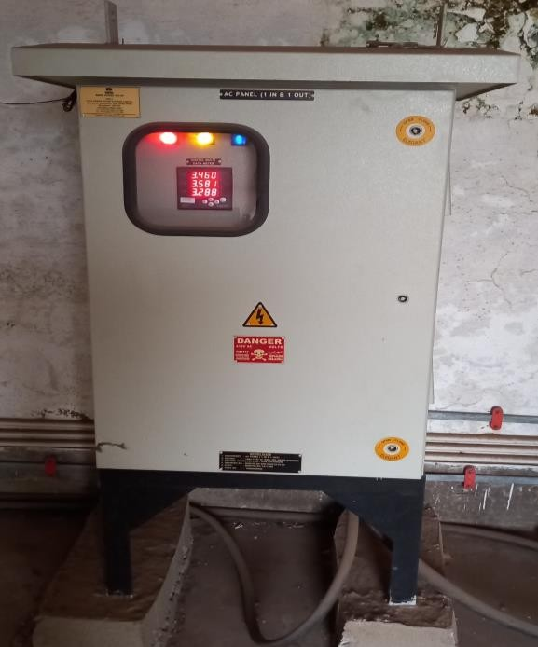

Considering the fact that the Bhilai Mahila Vidya;laya is a non-technical college, there is a significant energy conservation and environmental activity both by faculty and students. The environmental awareness initiatives are substantial. The installation of ongrid solar photo voltaic panels and five star rated equipments are noteworthy. This may lead to the prosperous future in context of Green Campus having energy conservation activities & use of renewable energy and thus sustainable environment and community development.

Solar Power Plant Generation

Month | Energy Yield in KWH
Jun-18 | 4856
Jul-18 | 3717
Aug-18 | 3773
Sep-18 | 5595
Oct-18 | 6899
Nov-18 | 5867
Dec-18 | 4921
Jan-19 | 5441
Feb-19 | 6338
Mar-19 | 7625
Total Generation | 55032
Total Average Generation per  month | 5503
Table 3 : Solar Power Plant Generation during first year of installation

Month | Energy Yield in KWH
Dec-20 | 4871
Jan-21 | 4018
Feb-21 | 4013
Mar-21 | 4973
Apr-21 | 4679
May-21 | 4866
Jun-21 | 4264
Jul-21 | 4023
Aug-21 | 5393
Sep-21 | 4696
Oct-21 | 6278
Total Generation in 11 month | 52074
Total Average Generation per month | 4,734
Table 4: Solar Power Plant Generation during first year of installation

Life Energy Total | 223.94 MWH | Run Time | 14965 Hours
Table 5 : Electricity generation & Run time hours since installation

  - Use of LED bulbs/power efficient equipment.
Electrical Connected Load :

Segment | Type | Wattage | Quantity | Total Load
Lighting | LED 2x2 | 32 | 28 | 896
 | FTL 40 | 40 | 572 | 22880
 | LED TL | 22 | 181 | 3982
 | LED 18 W | 18 | 12 | 216
 | LED 200 W | 200 | 8 | 1600
 | LED 12 W | 12 | 20 | 240
 | CFL 32 W | 32 | 1 | 32
 | LED 5 W | 5 | 2 | 10
 | Total |  |  | 29856
HVAC | Fan | 70 | 655 | 45850
 | AC 1.5 T | 1700 | 26 | 44200
 | Big Air Cooler | 600 | 8 | 4800
 | Air Cooler | 200 | 5 | 1000
 | Exhaust Medium | 200 | 11 | 2200
 | Exhaust Small | 70 | 18 | 1260
 | Total |  |  | 99310
Office | Computer | 70 | 68 | 4760
 | Printer/Scanner | 500 | 19 | 9500
 | Printer | 300 | 11 | 3300
 | Photocopy machine | 750 | 1 | 750
 | Total |  |  | 18310
Campus Lighting | LED 150 W | 150 | 2 | 300
 | LED 50 W | 50 | 11 | 550
 | LED 120 W | 120 | 7 | 840
 | LED 200 W | 200 | 3 | 600
 | CFL 85 W | 85 | 2 | 170
 | Total |  |  | 2460
Others | Water Cooler | 600 | 5 | 3000
 | Submersible Pump | 750 | 1 | 750
 | Pump | 750 | 3 | 2250
 | Heater | 1000 | 1 | 1000
 | Induction heater | 2000 | 3 | 6000
 | Refrigerator Big | 900 | 1 | 900
 | Refrigerator Medium | 700 | 3 | 2100
 | Refrigerator small | 500 | 6 | 3000
 | Geyser | 2000 | 5 | 10000
 | Miscellaneous |  |  | 11000
 | Total |  |  | 40000
Total Connected Load in watt |  |  |  | 189936
Say |  |  |  | 190 KW
Table 8: Connected Load of Bhilai Mahila Mahavidyalaya, Bhilai
The total connected load of St. Thomas, Bhilai Campus is about 121 KW. The maximum share of connected load is in HVAC segment, which is 45% and alone air conditioner has about 13% load share among all the electrical equipment.

Equipment | Connected Load in Watt
Lighting | 29856
HVAC | 99310
Office | 18310
Campus Lighting | 2460
Others | 40000
Total | 189936
Table 9 : Segment wise Connected Load of of Bhilai Mahila Mahavidyalaya, Bhilai

Graphical representation of Connected Load
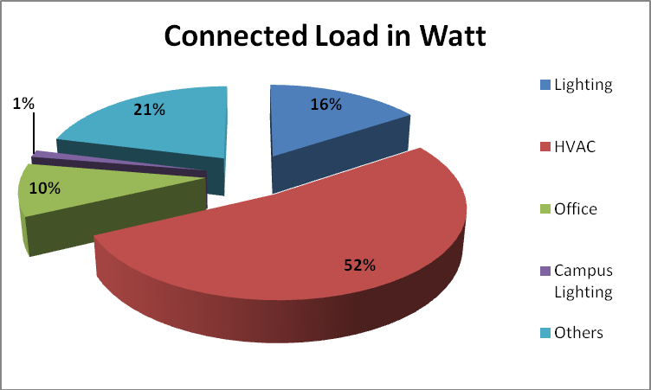
Figure 1 : Graphical representation of connected Load

As per requirement, we have calculated installed load of LED fittings and Conventional light fittings.
Types of Light Fittings | Load in Watt
LED Light Fittings | 9234
Conventional Light Fittings | 23082
Table 10 : Connected Load of LED light fittings & Conventional fittings at of Bhilai Mahila Mahavidyalaya, Bhilai

Percentage of Lighting Power requirement met through LED lights

LED Lighting Load in Watt | 9234
Total Lighting Load in watt | 32316
Percentage of Lighting Power requirement met through LED lights | 28.57
Table 11: Percentage of Lighting Power requirement met through LED lights
Thus, total Percentage of Lighting Power requirement met through LED lights is about 29 %.

Graphical representation of Percentage of Lighting Power requirement met through LED lights
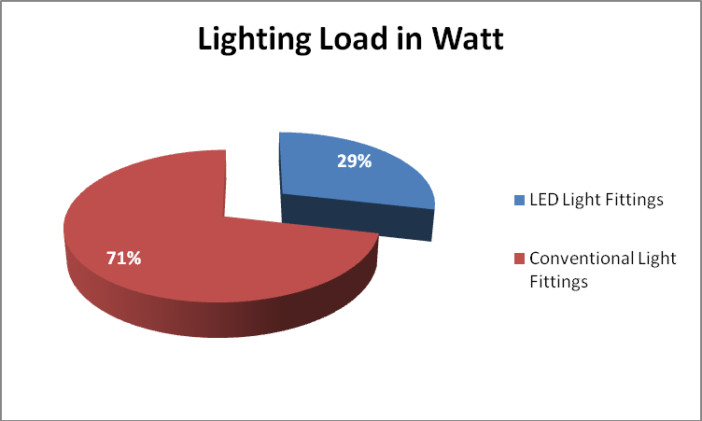
Figure 2 : Graphical representation of Percentage of Lighting Power requirement met through LED lights

Electricity Bill Analysis
We have analyzed the electricity bills of last six years i.e. 2015-16,2016-17,2017-18,2018-19,2019-20 & 2020-21

1. 2015-16

Month | Unit Consumption
Apr-15 | 5000
May-15 | 25577
Jun-15 | 5000
Jul-15 | 15466
Aug-15 | 5000
Sep-15 | 23745
Oct-15 | 5000
Nov-15 | 19300
Dec-15 | 5000
Jan-16 | 13280
Feb-16 | 5000
Mar-16 | 18775
Total | 146143
Table 12 : Electricity Consumption for the year 2015-16

2. 2016-17
Month | Unit Consumption
Apr-16 | 5000
May-16 | 23089
Jun-16 | 5000
Jul-16 | 18182
Aug-16 | 5000
Sep-16 | 28377
Oct-16 | 5000
Nov-16 | 22327
Dec-16 | 5000
Jan-17 | 18214
Feb-17 | 5000
Mar-17 | 15061
Total | 155250
Table 13 : Electricity Consumption for the year 2016-17

3. 2017-18
Month | Unit Consumption
Apr-17 | 5000
May-17 | 29881
Jun-17 | 5000
Jul-17 | 15161
Aug-17 | 5000
Sep-17 | 26387
Oct-17 | 5000
Nov-17 | 20528
Dec-17 | 5000
Jan-18 | 5000
Feb-18 | 5000
Mar-18 | 5000
Total | 131957
Table 14 : Electricity Consumption for the year 2017-18

4. 2018-19
Month | Unit Consumption
Apr-18 | 5000
May-18 | 5000
Jun-18 | 5000
Jul-18 | 5000
Aug-18 | 5000
Sep-18 | 89084
Oct-18 | 14400

Nov-18 | 4600
Dec-18 | 6440
Jan-19 | 5400
Feb-19 | 7640
Mar-19 | 5000
Total | 157564
Table 15 : Electricity Consumption for the year 2018-19

5. 2019-20
Month | Unit Consumption
Apr-19 | 16040
May-19 | 5000
Jun-19 | 5000
Jul-19 | 5000
Aug-19 | 5000
Sep-19 | 42640
Oct-19 | 13320
Nov-19 | 7680
Dec-19 | 4200
Jan-20 | 5000
Feb-20 | 22680
Mar-20 | 5000
Total | 136560
Table 16 : Electricity Consumption for the year 2019-20

6. 2020-21

Month | Unit Consumption
Apr-20 | 5000
May-20 | 5000
Jun-20 | 13120
Jul-20 | 6040
Aug-20 | 5000
Sep-20 | 4800
Oct-20 | 6080
Nov-20 | 2960
Dec-20 | 3320
Jan-21 | 3360
Feb-21 | 3480
Mar-21 | 2800
Total | 60960
Table 17 : Electricity Consumption for the year 2020-21

The yearly electricity consumption of last six years is summarized below :-

Sl. No. | Year | Unit Consumption
1 | 2015-16 | 146143
2 | 2016-17 | 155250
3 | 2017-18 | 131957
4 | 2018-19 | 157564
5 | 2019-20 | 136560
6 | 2020-21 | 60960
Table 18 : Summary of Electricity Consumption for last six years

Graphical representation of Unit consumption of last six years

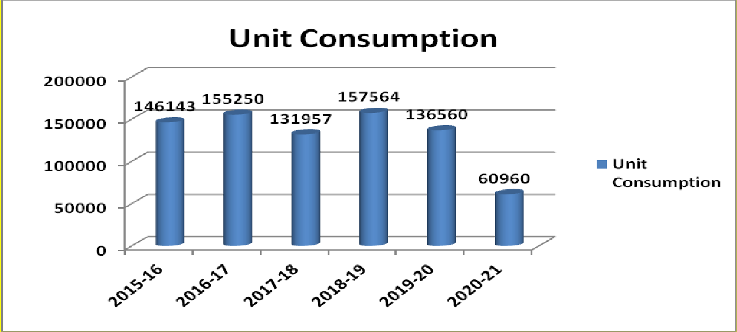
Figure 3: Graphical representation of Unit consumption of last six years.

Annual Electricity Consumption
On the basis of operational hours, we have calculated annual unit consumption:-

Segment | Type | Wattage |  | Quantity |  | No. of Hours | Nos. of Days | Diversity Factor | Total Annual Unit  Consumption
Lighting | LED 2x2 | 32 |  | 28 |  | 6 | 220 | 0.8 | 946
 | FTL 40 | 40 |  | 572 |  | 6 | 220 | 0.8 | 24161
 | LED TL | 22 |  | 181 |  | 6 | 220 | 0.5 | 2628
 | LED 18 W | 18 |  | 12 |  | 6 | 220 | 1 | 285
 | LED 200 W | 200 |  | 8 |  | 6 | 30 | 0.8 | 230
 | LED 12 W | 12 |  | 20 |  | 6 | 220 | 1 | 316
 | CFL 32 W | 32 |  | 1 |  | 6 | 220 | 1 | 42
 | LED 5 W | 5 |  | 2 |  | 6 | 220 | 1 | 13
 | Total |  |  |  |  |  |  |  | 28621
HVAC | Fan |  | 70 |  | 655 | 6 | 220 | 0.7 | 42365
 | AC 1.5 T |  | 1700 |  | 26 | 6 | 100 | 0.8 | 21216

 | Big Air Cooler | 600 | 8 | 6 |  | 20 |  | 0.8 |  | 461
 | Air Cooler | 200 | 5 | 6 |  | 180 |  | 0.5 |  | 540
 | Exhaust  Medium | 200 | 11 | 6 |  | 180 |  | 0.5 |  | 1188
 | Exhaust Small | 70 | 18 | 6 |  | 180 |  | 0.5 |  | 680
 | Total |  |  |  |  |  |  |  |  | 66450
Office | Computer | 70 | 68 | 6 |  | 270 |  | 0.6 |  | 4627
 | Printer/Scanner | 500 | 19 | 1 |  | 270 |  | 0.4 |  | 1026
 | Printer | 300 | 11 | 1 |  | 270 |  | 0.4 |  | 356
 | Photocopy  machine | 750 | 1 | 6 |  | 270 |  | 0.7 |  | 851
 | Total |  |  |  |  |  |  |  |  | 6860
Campus Lighting | LED 150 W | 150 | 2 | 11 |  | 365 |  | 1 |  | 1205
 | LED 50 W | 50 | 11 | 11 |  | 365 |  | 1 |  | 208
 | LED 120 W | 120 | 7 | 11 |  | 365 |  | 1 |  | 3373
 | LED 200 W | 200 | 3 | 11 |  | 365 |  | 1 |  | 2409
 | CFL 85 W | 85 | 2 | 11 |  | 365 |  | 1 |  | 683
 | Total |  |  |  |  |  |  |  |  | 7878
Water Supply | Submersible  Pump | 750 | 1 | 5 |  | 365 |  | 0.8 |  | 1095
 | Pump | 750 | 3 | 5 |  | 365 |  | 1 |  | 4106
 |  |  |  |  |  |  |  |  |  | 5201
Others | Water Cooler | 575 | 5 | 8 |  | 365 |  | 0.8 |  | 6716
 | Heater | 1000 | 1 | 1 |  | 180 |  | 1 |  | 180
 | Induction heater | 2000 | 3 | 1 |  | 270 |  | 0.8 |  | 1296
 | Refrigerator Big |  |  |  |  |  |  |  |  | 500
 | Refrigerator Medium |  |  |  |  |  |  |  |  | 400
 | Refrigerator small |  |  |  |  |  |  |  |  | 300
 | Geyser | 2000 | 5 |  | 3 |  | 90 |  | 1 | 2700
 | Miscellaneous |  |  |  |  |  |  |  |  | 5000
 | Total |  |  |  |  |  |  |  |  | 17092
 | Grand Total |  |  |  |  |  |  |  |  | 1,32,102
Table 19 : Annual Electricity Consumption

Segment wise Unit Consumption

Lighting | 28621
HVAC | 66450
Office | 6860
Campus Lighting | 7878
Water Supply | 5201
Others | 17092
Table 20 : Segment wise Unit Consumption

Graphical Representation of Unit Consumption

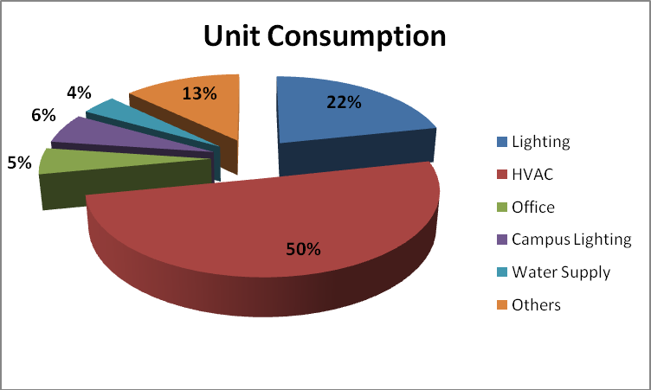
Figure 4 : Graphical Representation of Unit Consumption

Thus, we may say that the maximum share of electricity consumption is in HVAC

