7.1.8 – Inclusion and Situatedness-

Describe the Institutional efforts/initiatives in providing an inclusive environment i.e, tolerance and harmony towards cultural, regional, linguistic, communal socioeconomic and other diversities (within 500 words)

Bhilai Mahila Mahavidyalaya, gives admission to the students belonging to various sections and culture of the society. Various scholarships including those to minorities are granted to students and festivals of all religious are celebrated with equal fervor and fanfare. The Social Responsibility Cell takes care of organizing these functions. Values for respecting people from all strata of society are also inculcated. Students of senior classes are encouraged to go and teach the students of underprivileged schools.
The N.S.S. students visit different villages to educate the underprivileged women and children on various issues.
The Book-Bank of the college library provides books to underprivileged students. Various competitions are conducted in the form of debates, reciting poetry and delivering speeches to create tolerance and harmony towards culture, regionalism and communal socioeconomic diversities.

S.NO. | YEAR | ACTIVITY (ACADEMIC) | DATE | PARTICIPANTS
1 | 2015-16 | HINDI DIVAS- KAVYA-PATH, NIBANDH, BHASHAN COMP. | 14-09-2016 | . 25
2 | 2015-16 | YUVA UTSAV:- PARICHARCHA, VAAD-VIVAAD, TATKALIK BHASHAN. | 2015-16 | . 22
3 | 2015-16 | SCIENCE DAY:- NIBANDH & POSTER PRATIYOGITA. | 27-02-2016 | . 30
4 | 2016-17 | HINDI DIVAS- KAVYA-PATH, BHASHAN, PARICHARCHA, VAAD-VIAAD | 14-09-2016 | . 28
5 | 2016-17 | SCIENCE DAY:- MAKE IN INDIA | 27-02-2016 | . 35
6 | 2017-18 | HINDI DIVAS:- NARA LEKHAN, KAVYA-PATH, NIBHANDH PRATIYOGITA,PRASHNOTTARI, | 21-02-2018 | . 32
7 | 2018-19 | HINDI DIVAS- KAVYA-PATH, NIBANDH, SHUDH LEKH. | 20-09-2018 | . 28
8 | 2018-19 | YUVA UTSAV:- VAAD-VIVAAD, BHASHAN. | 20-09-2018 | . 15
9 | 2018-19 | VISHVA MATRIBHASHA DIVAS:- NIBHANDH, GEET SPARDHA. | 23-02-2019 | . 35
10 | 2019-20 | HINDI DIVAS- TATKALIK BHASHAN, PRASHNOTTARI, NIBANDH. | 14-09-2019 | . 50
11 | 2019-20 | VISHVA MATRIBHASHA DIVAS:- EKAL GAAN SPARDHA, SAMUH GAAN SPARDHA, KAVYA LEKHAN | 22-02-2020 | . 35
S.NO. | YEAR | ACTIVITY (NON-ACADEMIC) | DATE | PARTICIPANTS
1 | 2015-16 | MATDATA JAGRUKTA KARYAKRAM:- VAAD-VIVAAD, RANGOLI, PARICHARCHA | 2015-16 | . 27
2 | 2015-16 | YUVA DRISTI KARYASHALA | 18-04-2016 | . 50
3 | 2016-17 | MATDATA JAGRUKTA KARYAKRAM:- PARICHARCHA, VAAD-VIVAAD, NARA LEKHAN, NIBANDH LEKHAN | 11-03-2016 | . 45

SI.NO | Year | Title of the Activity & Agency | Duration (From-To) | Participants
 | 21/06/2017 | Jati Viheen Samaj Nirman Hetu by the members of EK Manav Samaj through IQAC of the College | 21/06/2017 | 60
 | 12/07/2016 | Stress Management Programme by Followers of Sehaj Yog group from Delhi & Bhilai | 12/07/2016 | 70
 | 04/11/2016 | Lecture by two members of Arya Samaj from Firozabad on the Fading values, Morals and Conduct of the Youth | 04/11/2016 | 80
 | 04/08/2015 | An Essay Competition titled ‘The Missile Man’s Vision 2020’ in the memory of Late President Abdul Kalam | 04/08/2015 | 10
 | 2019-20 | Mind Power & Meditation by Vikas Tiwari from ‘Rebirth’ conducted by IQAC | 13-15 Nov | 200
 | 2019-20 | IQAC meeting of internal and guest member | 16/11/2019 | 11
 |  | Impact of Pandemic Covid-19 on ‘Women Worldwide’ conducted by IQAC | 1/06/2020 | 140
 | 2018-19 | BOOT Camp at BIT Durg | 9/08/2018 | 50
 |  | Stress Management Program ‘Mind Matters’by Isha Sharma of Art of Living conducted by IQAC | 24/01/2018 | 100
 |  | Services were extended by Mr.Arpan Agrawal through his Income Tax Pan Service centre on behalf of UTT infrastructure to prepare PAN CARDS of the students through college premises at reduced rates. | 13/12/2016 | 200
 |  | ‘ Naari Samman Mera Abhiman’ Signature campaign by Jansunwai Foundation for any kind of support to girls whenever in crisis or problem. | 03/11/2016 | 250
 | 2015-16 | An extempore speech competition organised by the Vigilance Deptt of Bhilai Steel Plant to observe the Vigilance week on the subject ‘Preventive Vigilance is a tool of Good Governance’ | 30/10/2015 | 55
 |  | A debate competition was conducted by Power Grid Corporation of India by the Physics Deptt of C.V.Raman Hall of Pt R.S.U Raipur entitled ‘Ethical Values in the present society is capable to crush Corruption’. | 27/10/2015 | 02
 | 2019-20 | Swachhata Hei Sewa Hai cleanliness Drive organised by the college under the banner of IQAC on the guidelines of HYU Durg & MHRD Govt of India. | 11/09/2019 to 02/10/2019 | 180

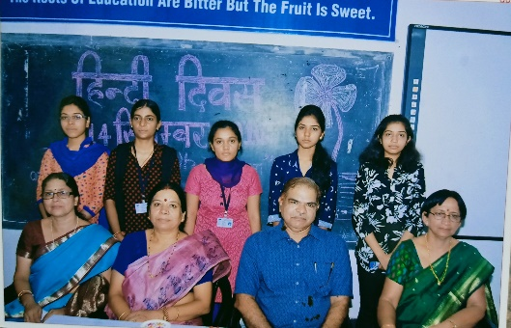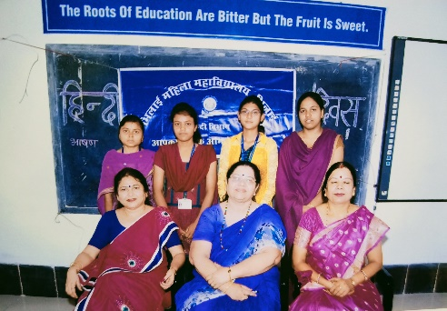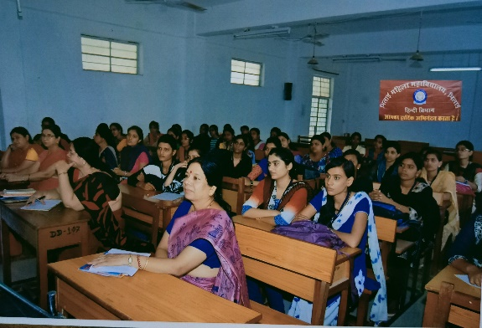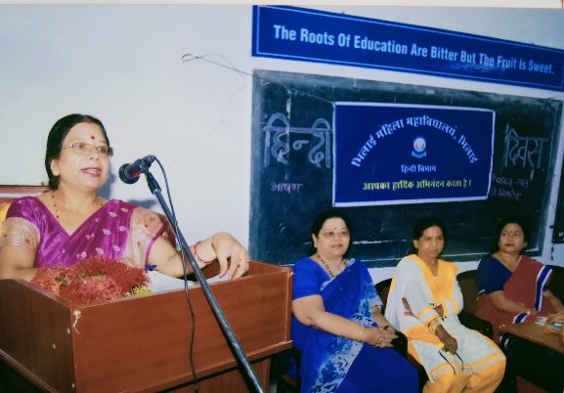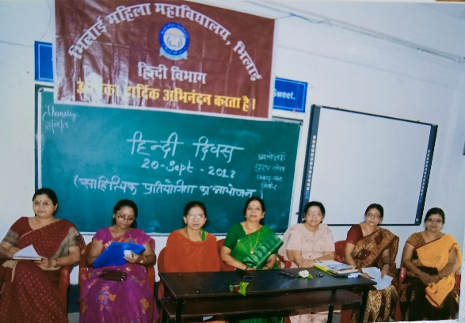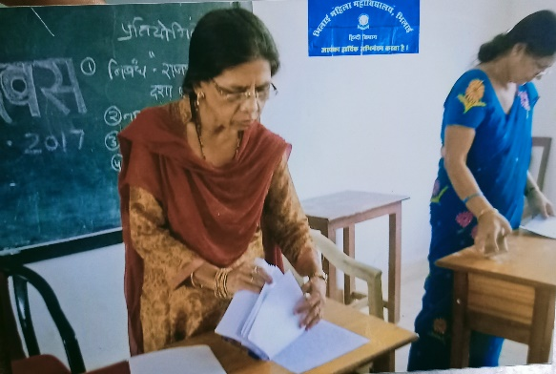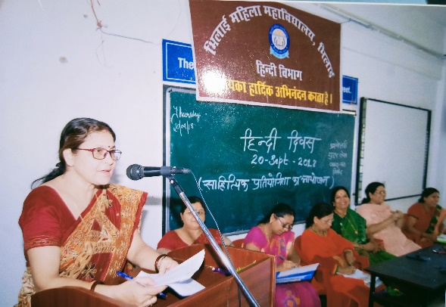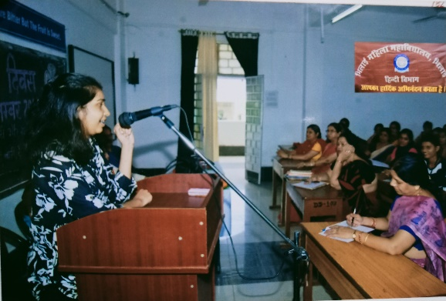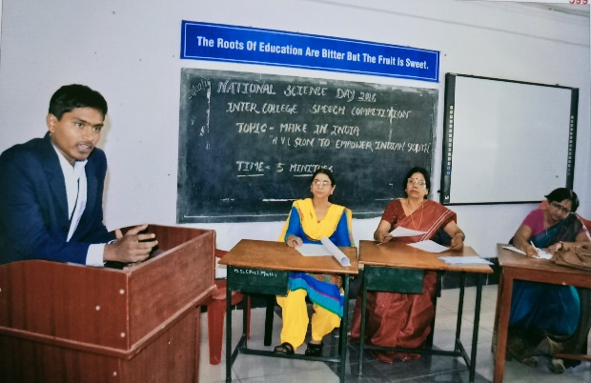
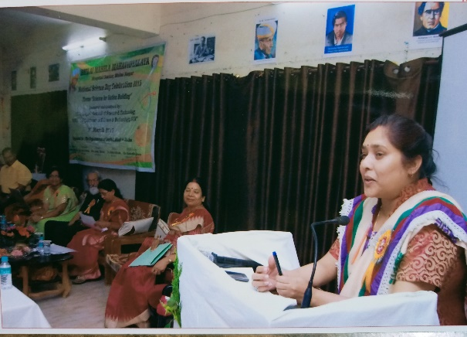
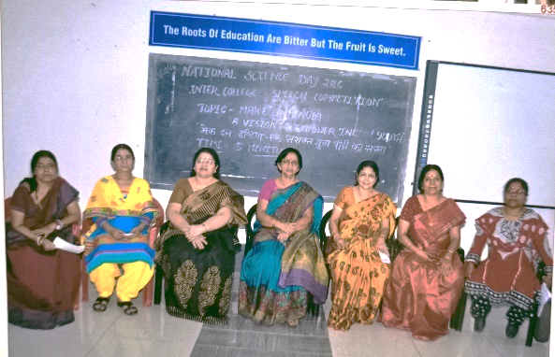
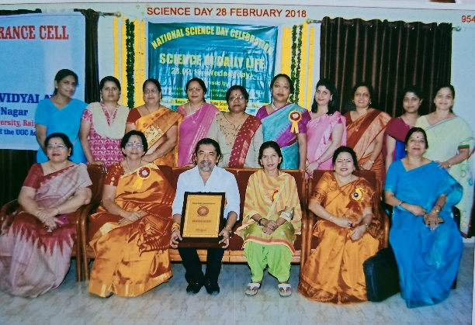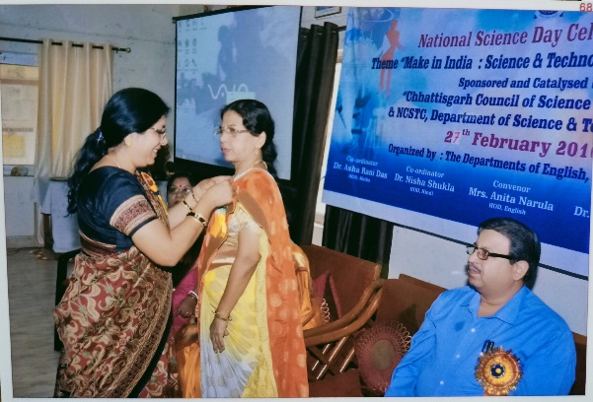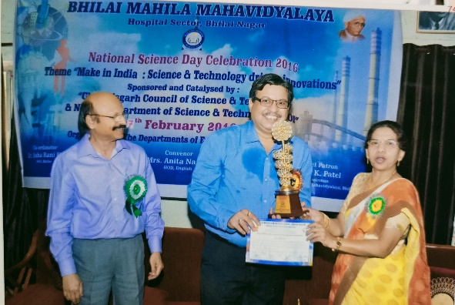
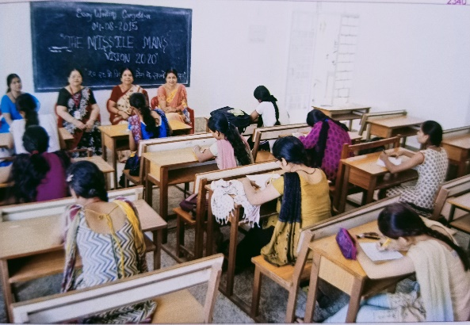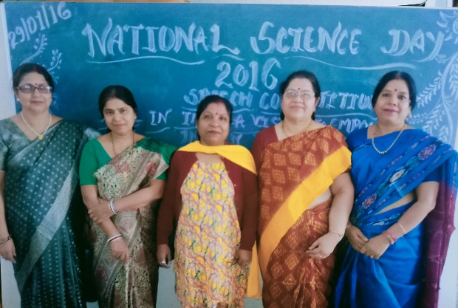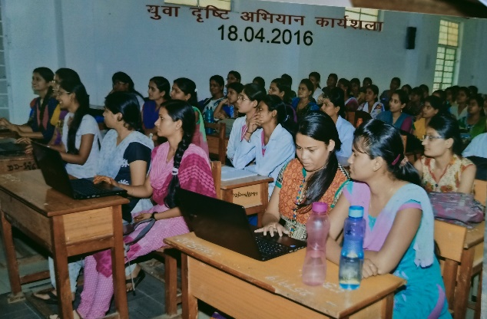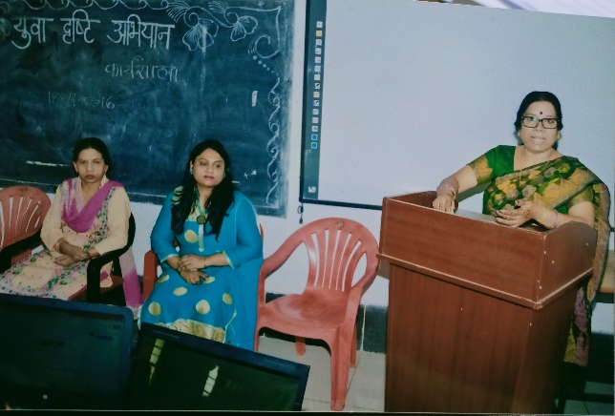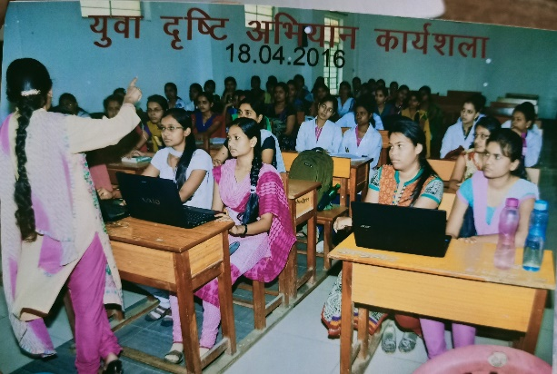
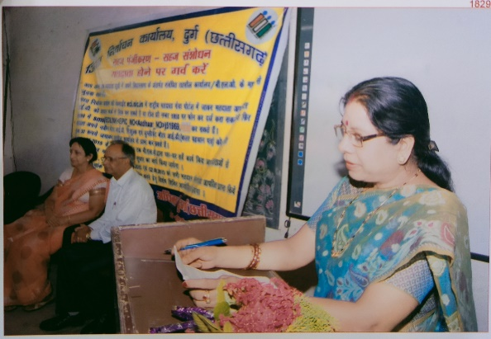
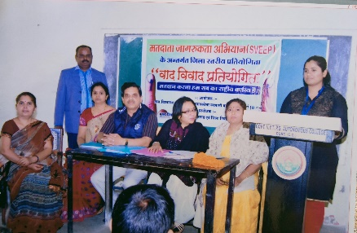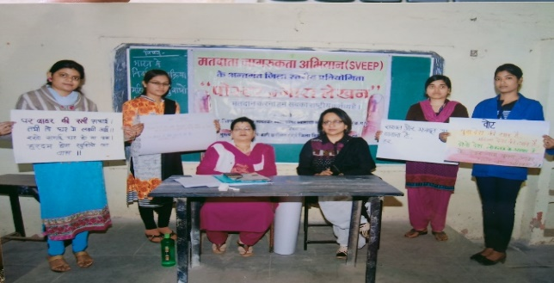
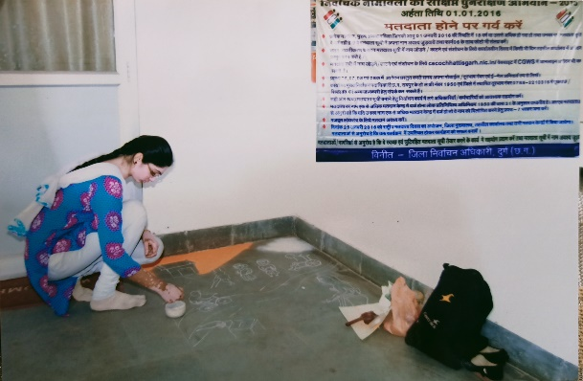
HINDI DIWAS
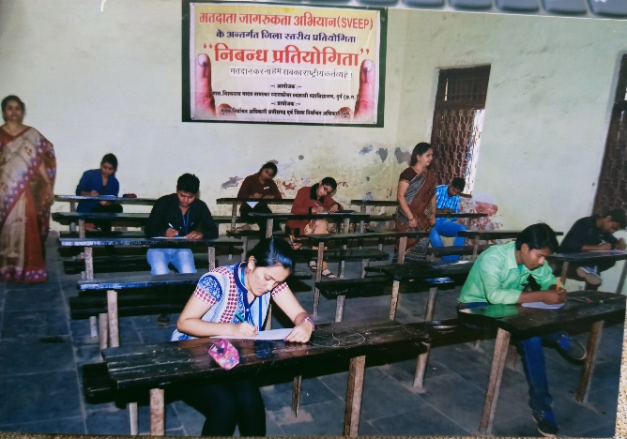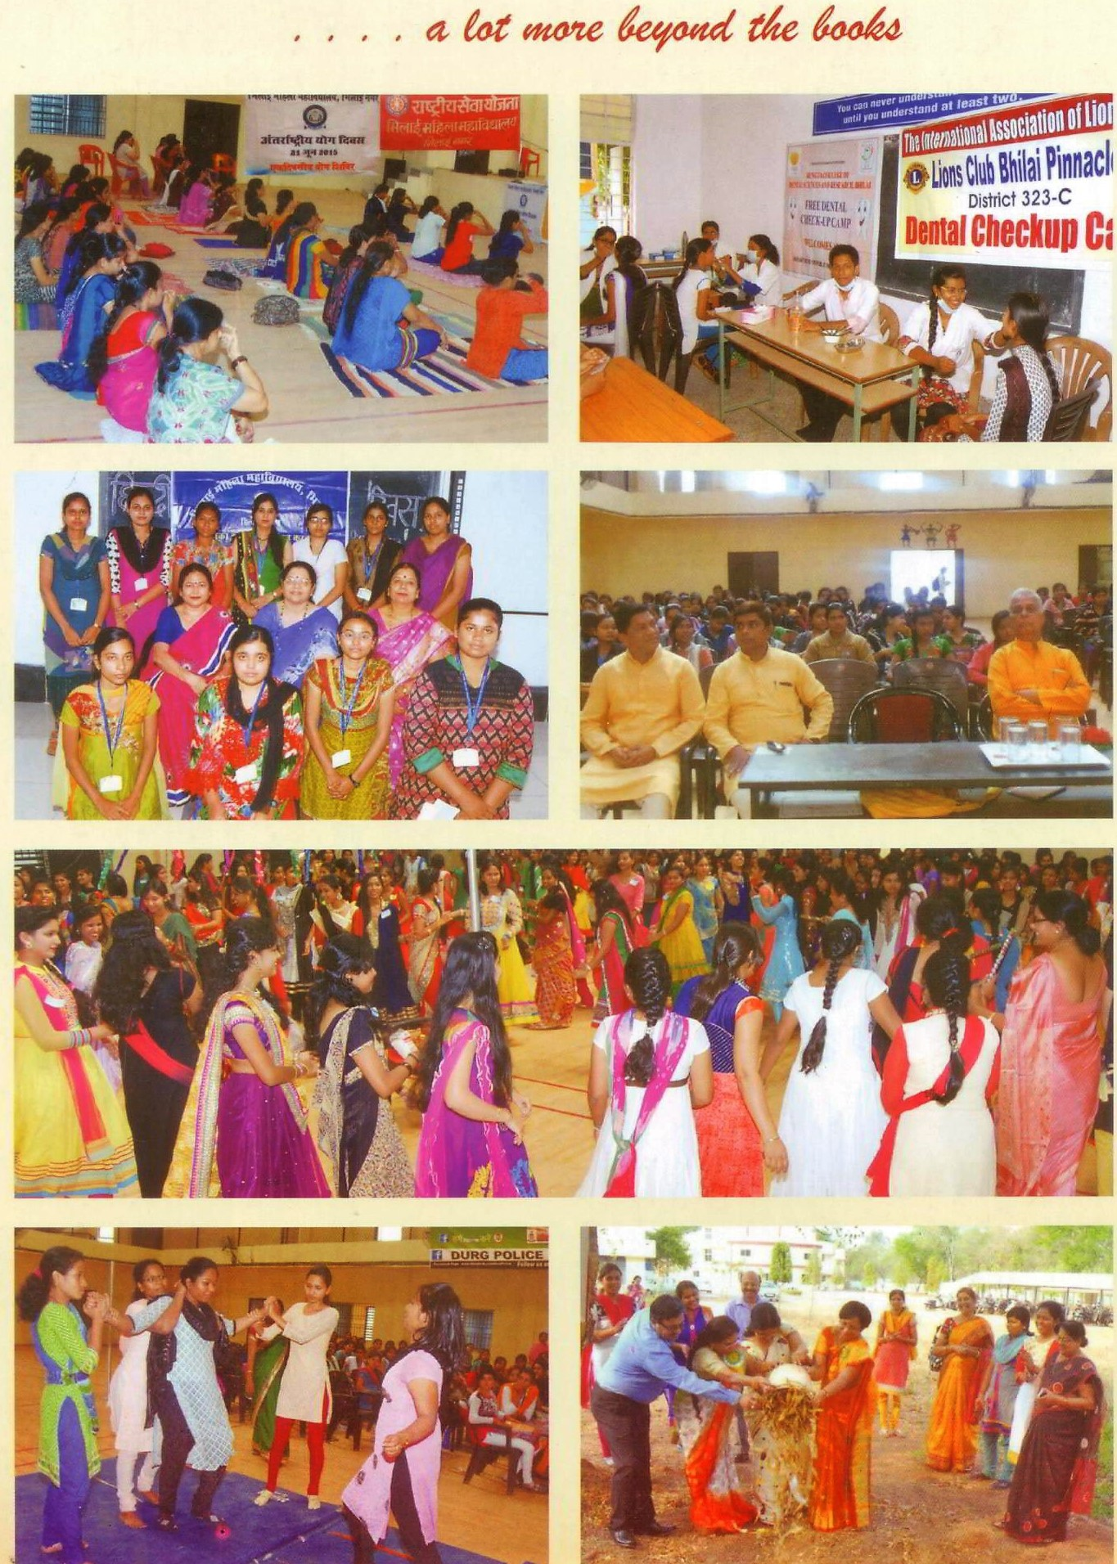

YUVA UTSAVA 2016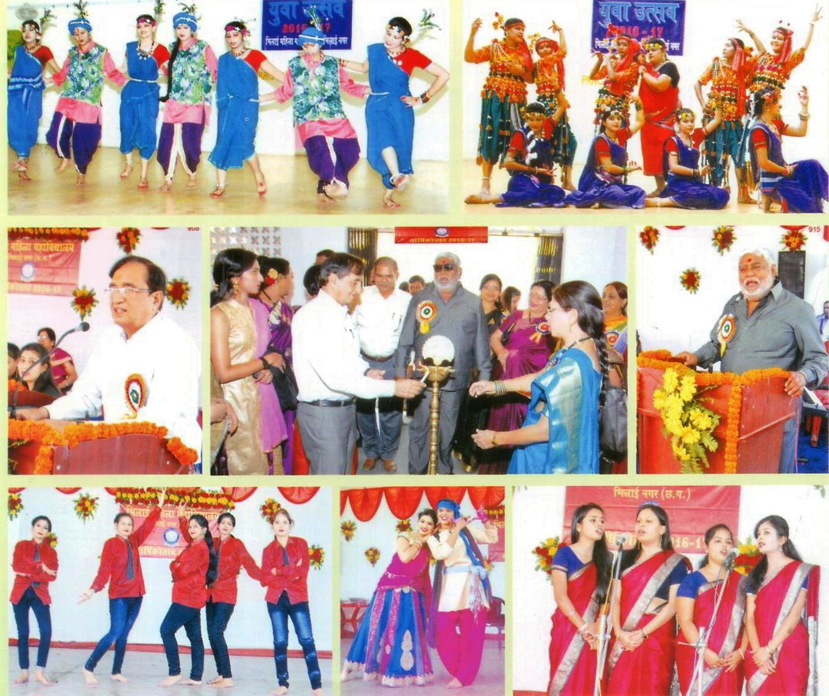

ANNUAL FUNCTION 2016
ANNUAL FUNCTION 2015
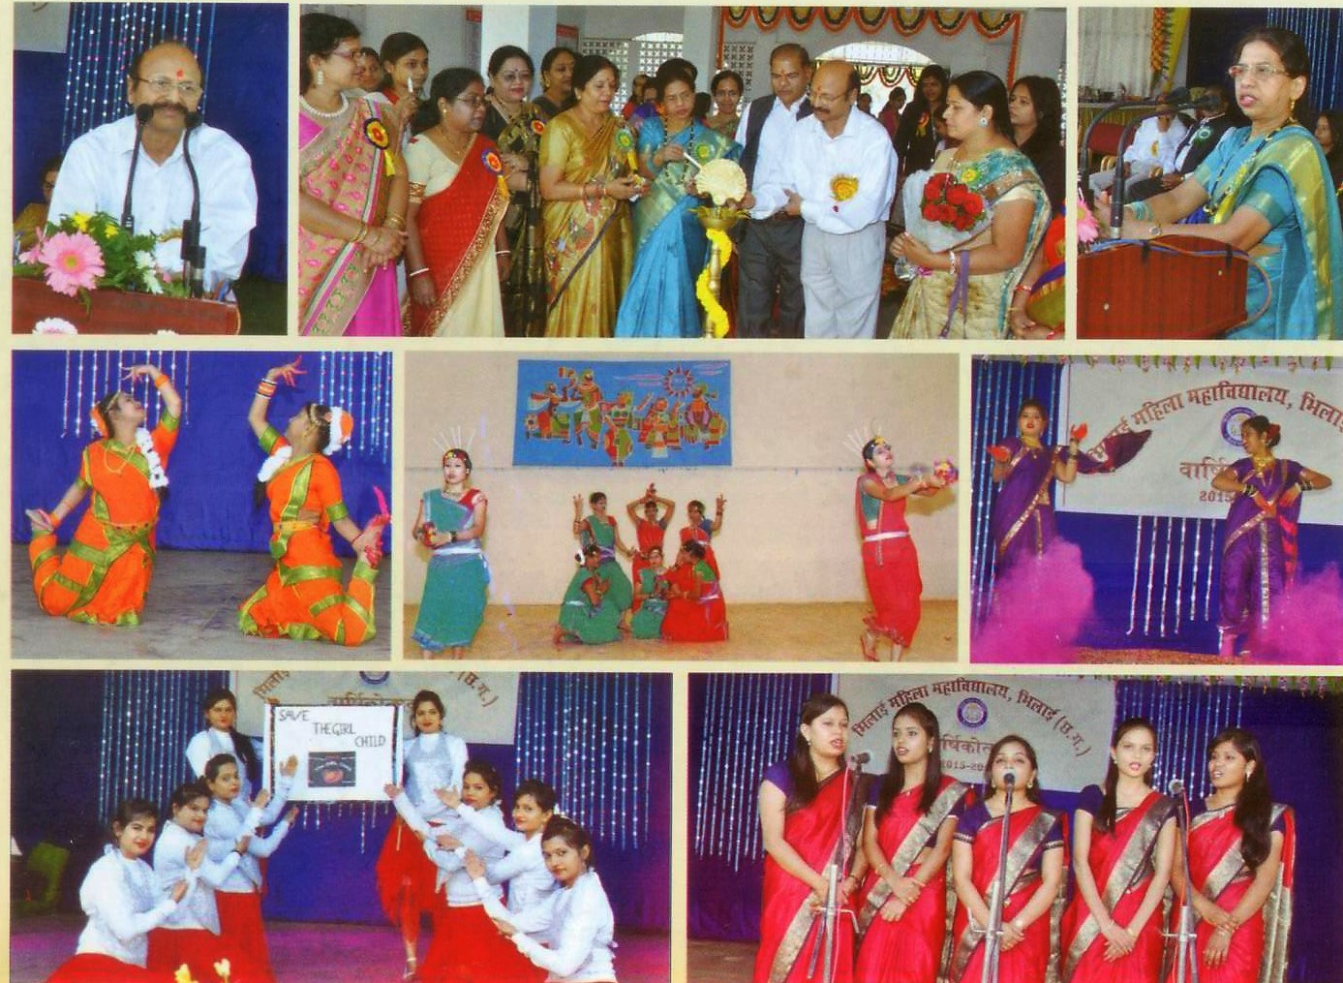
YUVA UTSAVA 2015
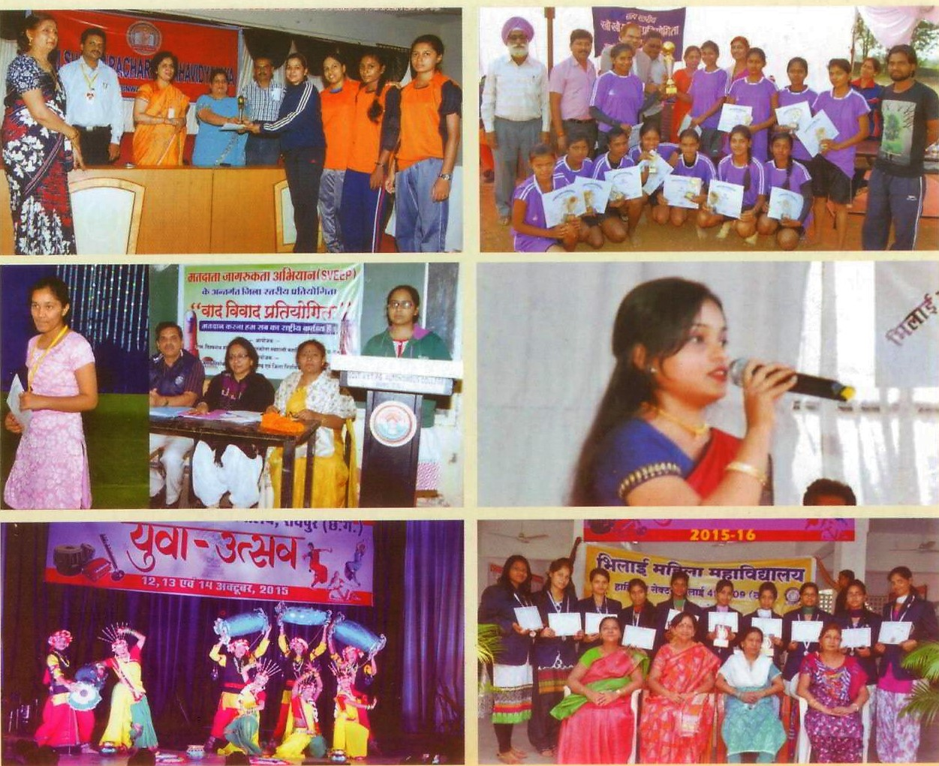

ANNUAL FUNCTION 2018-2019
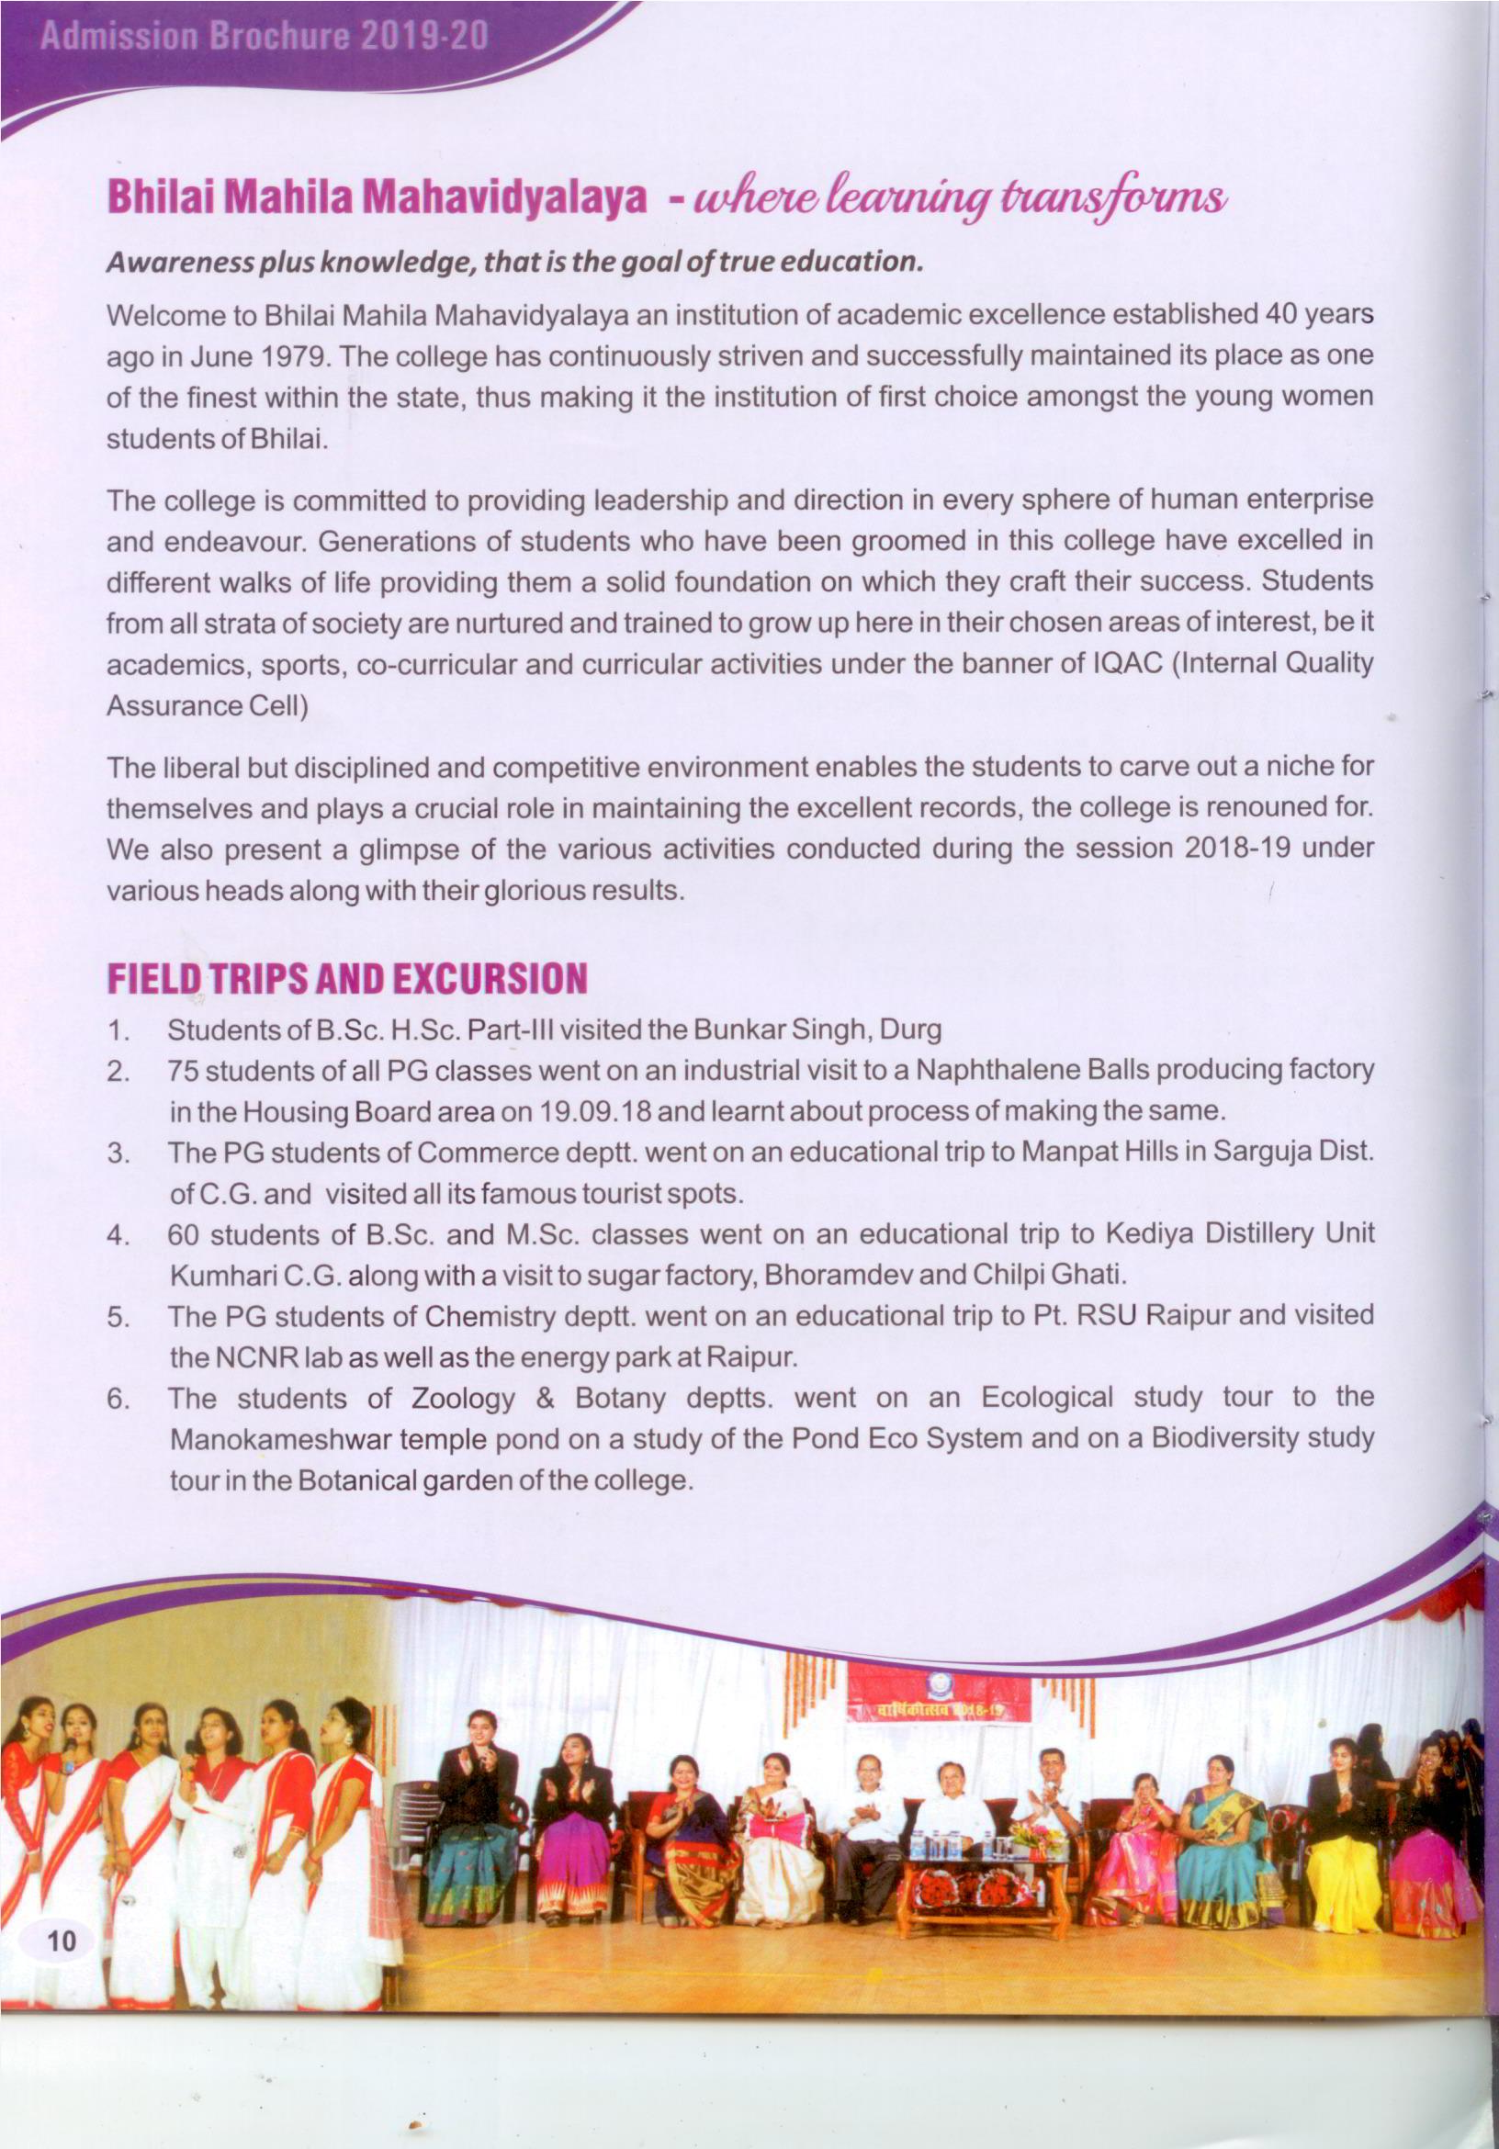
REGIONALISM
Bhilai Mahila Mahavidyalaya, gives admission to the students belonging to various sections and culture of the society. Various religious festivals are celebrated with equal fervor and fanfare. The Social Responsibility Cell takes care of organizing these functions. Values for respecting people from all strata of society are also inculcated. Students of senior classes are encouraged to go and teach the students of underprivileged schools.
The N.S.S. students visit different villages to educate the underprivileged women and children on various issues.
The Book-Bank of the college library provides books to underprivileged students. Various competitions are conducted in the form of debates, reciting poetry and delivering speeches to create tolerance and harmony towards culture, regionalism and communal socioeconomic diversities.

GARBA TO MARK NAVARATRI CELEBRATIONS
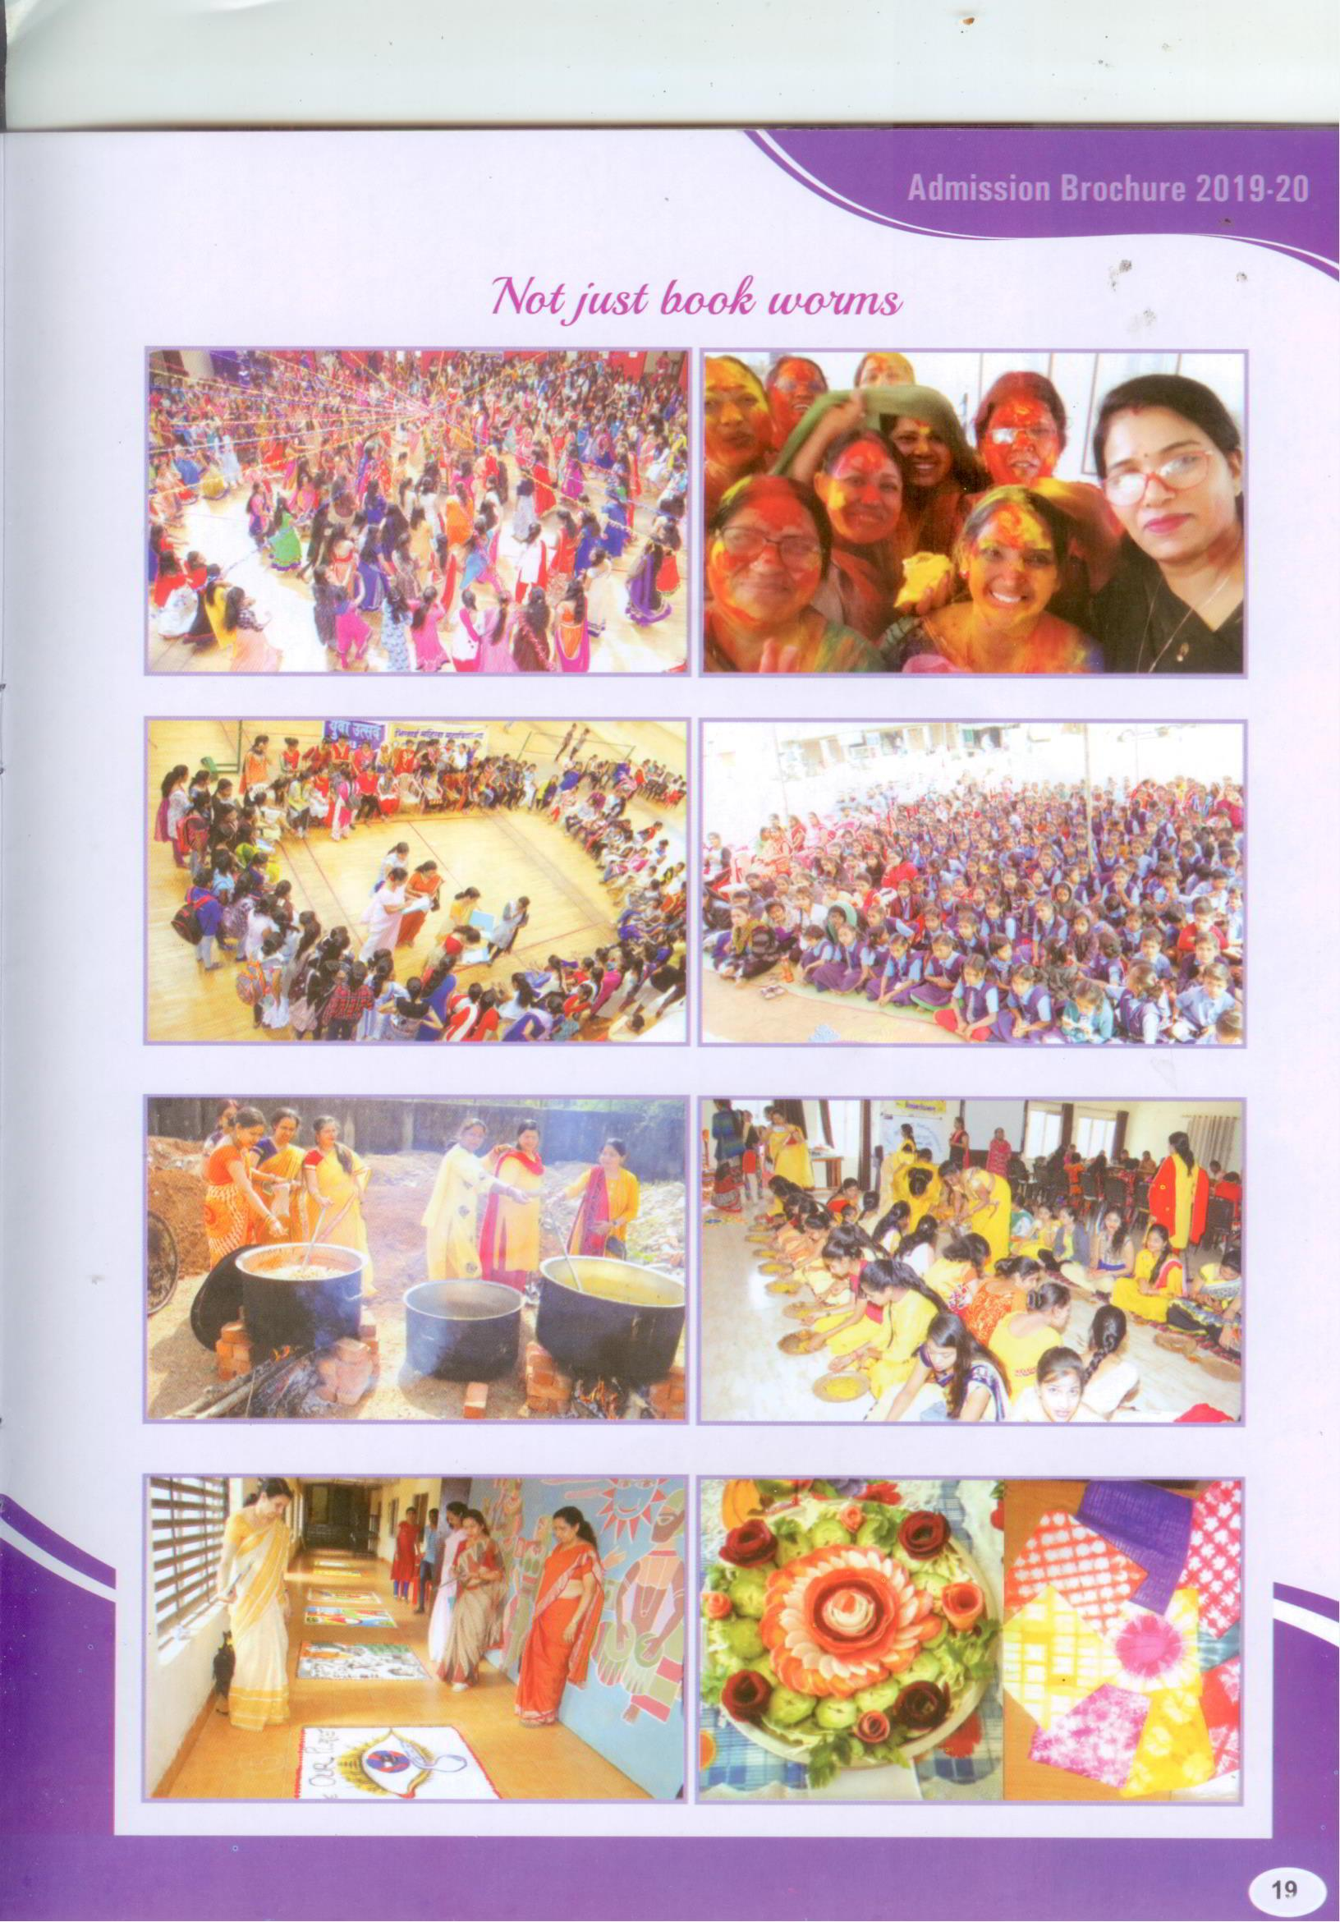
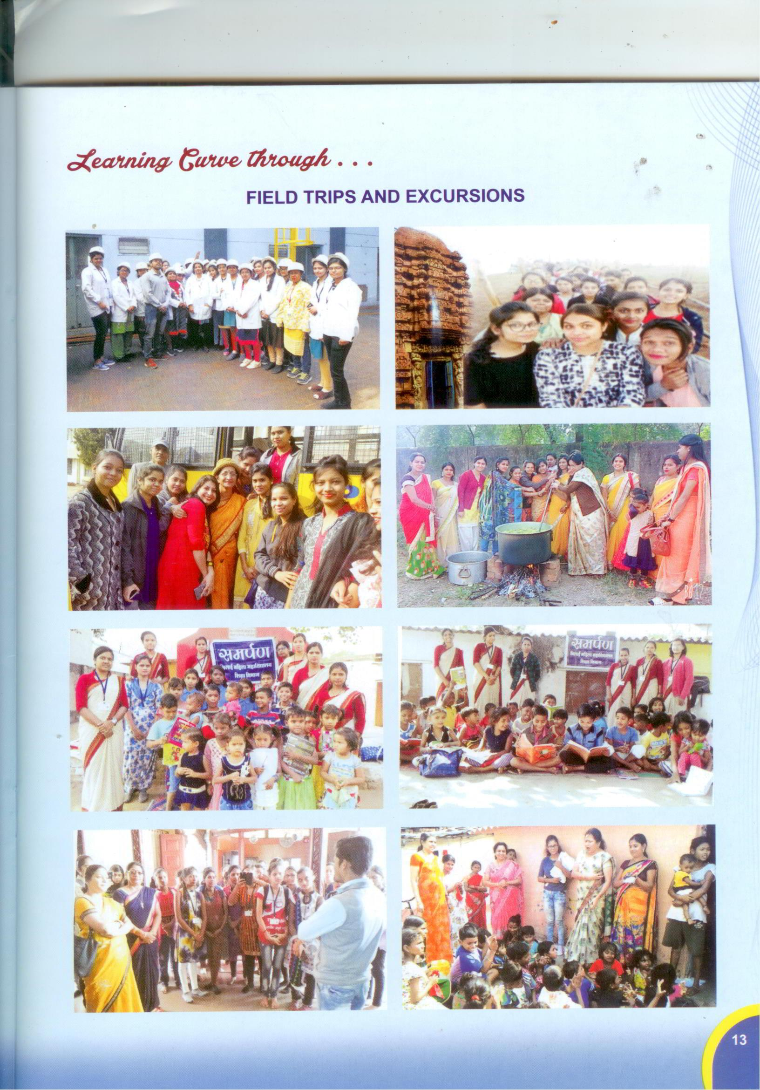 SARASWATI POOJA 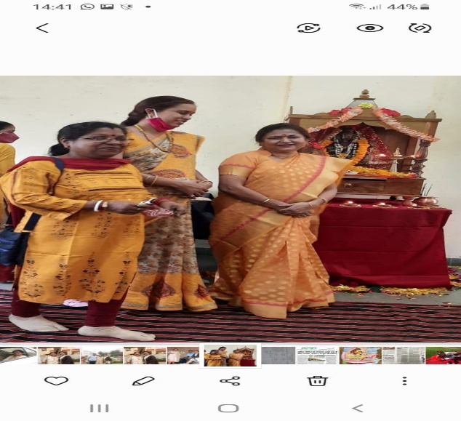
DIWALI CELEBRATIONS
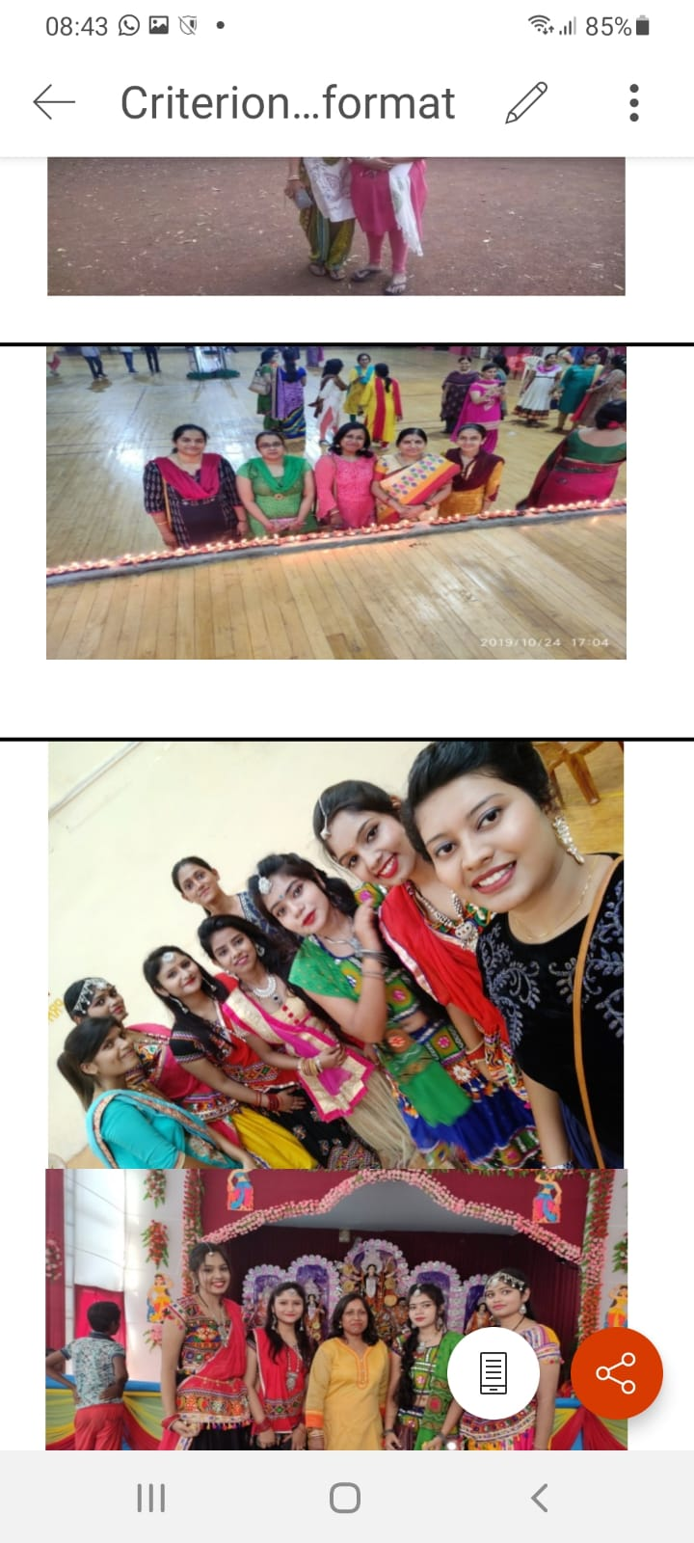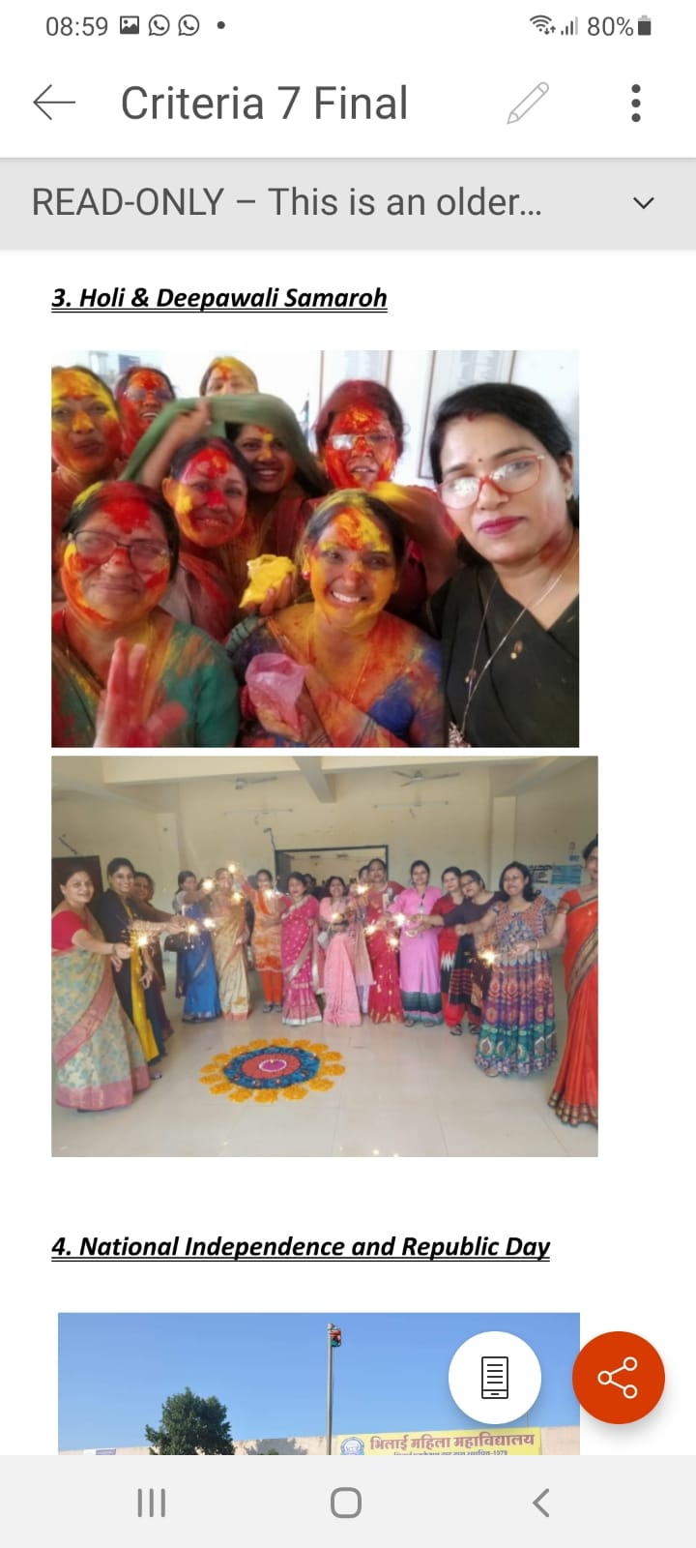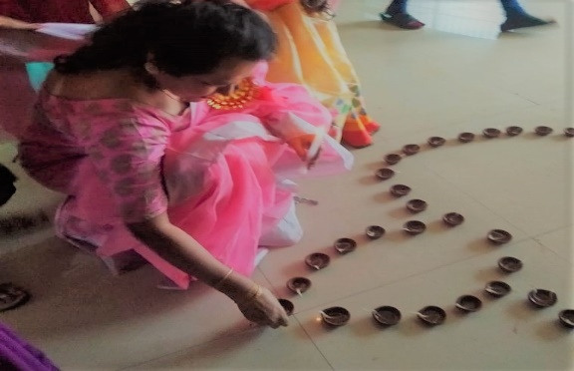
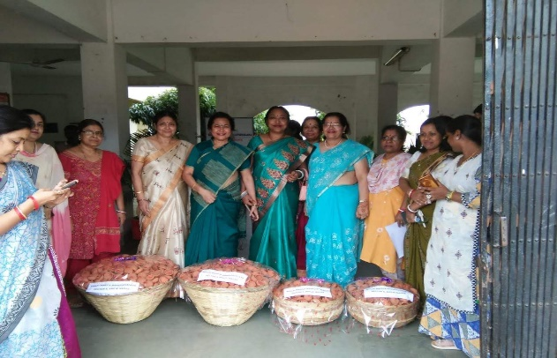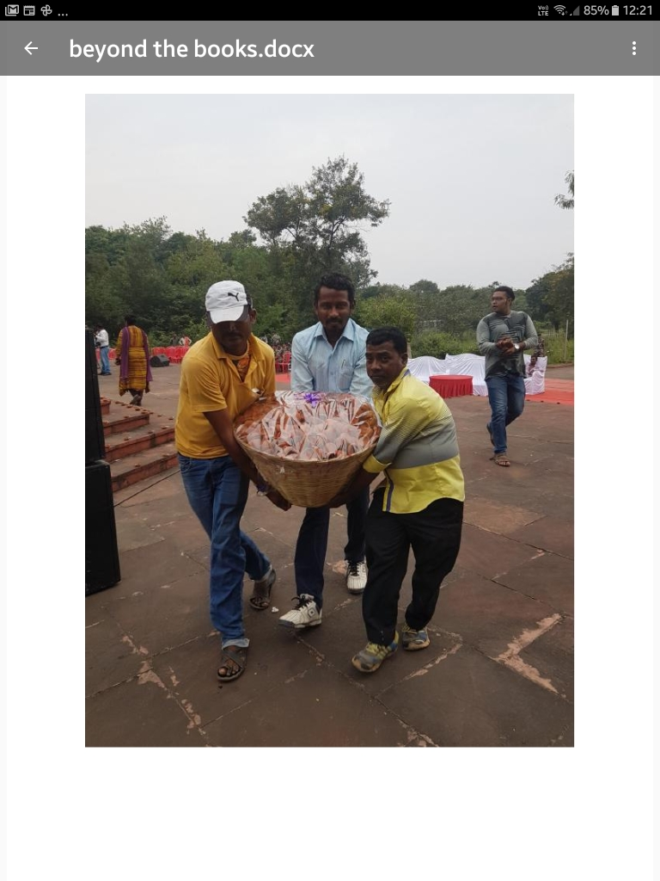
EK DIYA DESH KE NAAM

NEW YEAR CELEBRATION AND RELEASE OF NEW YEAR CALENDAR
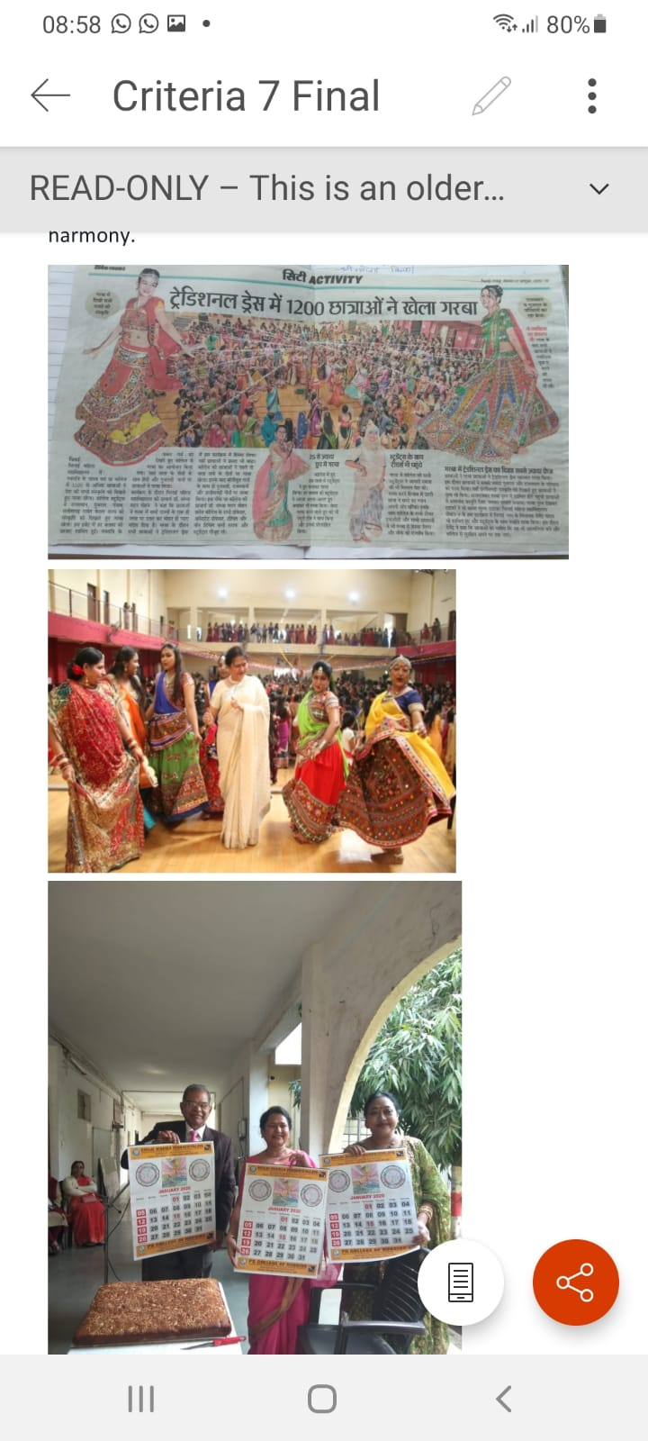
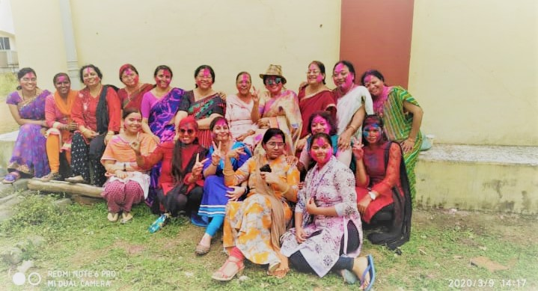
HOLI CELEBRATIONS

TEACHER’S DAY CELEBRATION
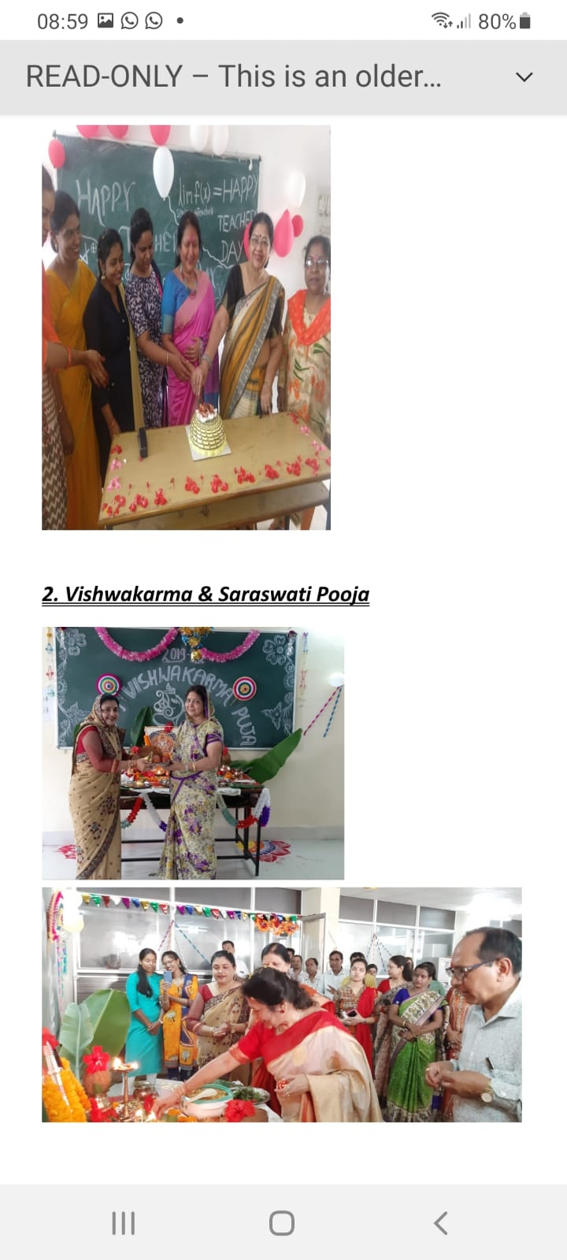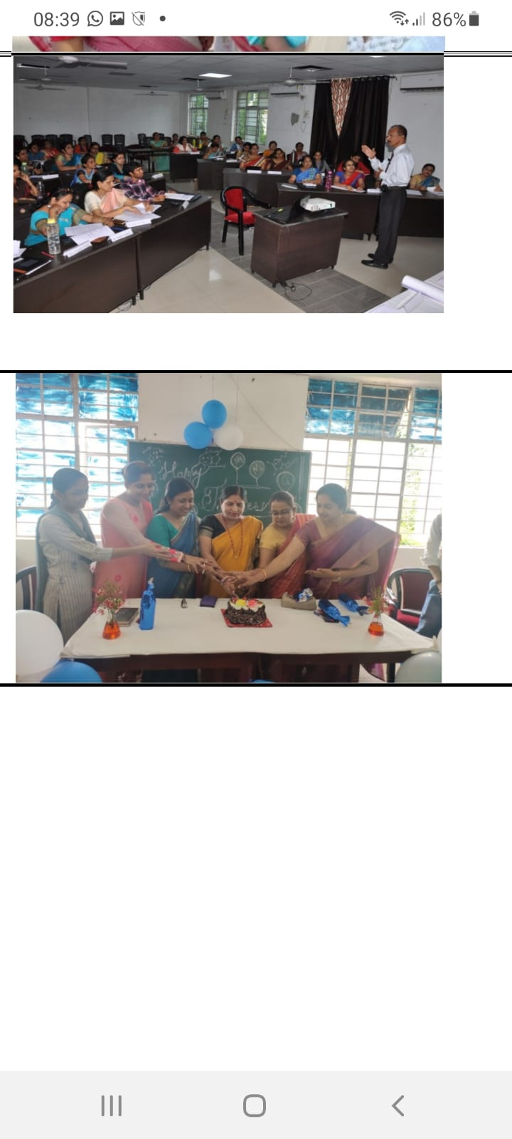
VISHWAKARMA JAYANTI
LECTURE ON VALUES AND MORALITY BY A GROUP FROM HARIDWAR
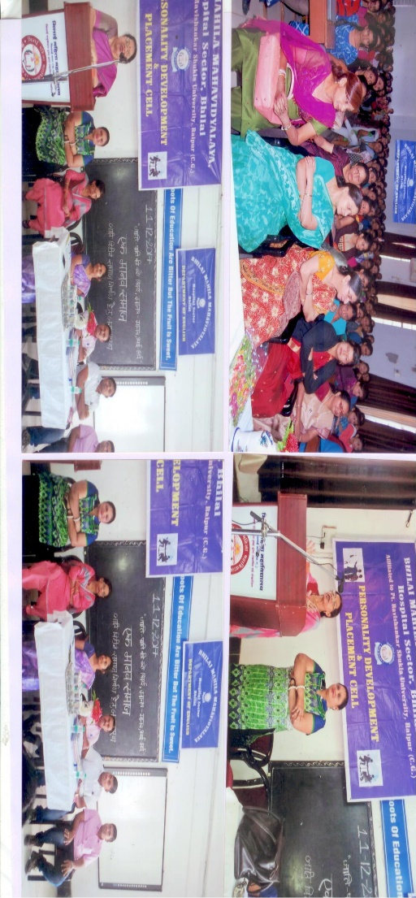
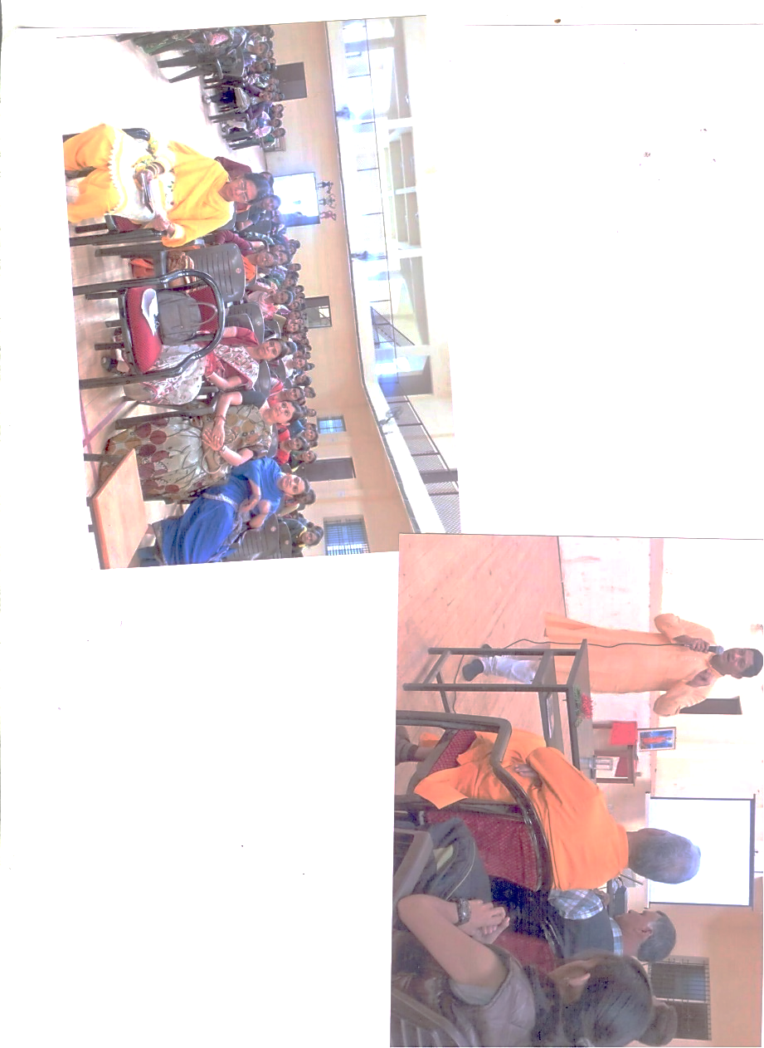

ART OF LIVING
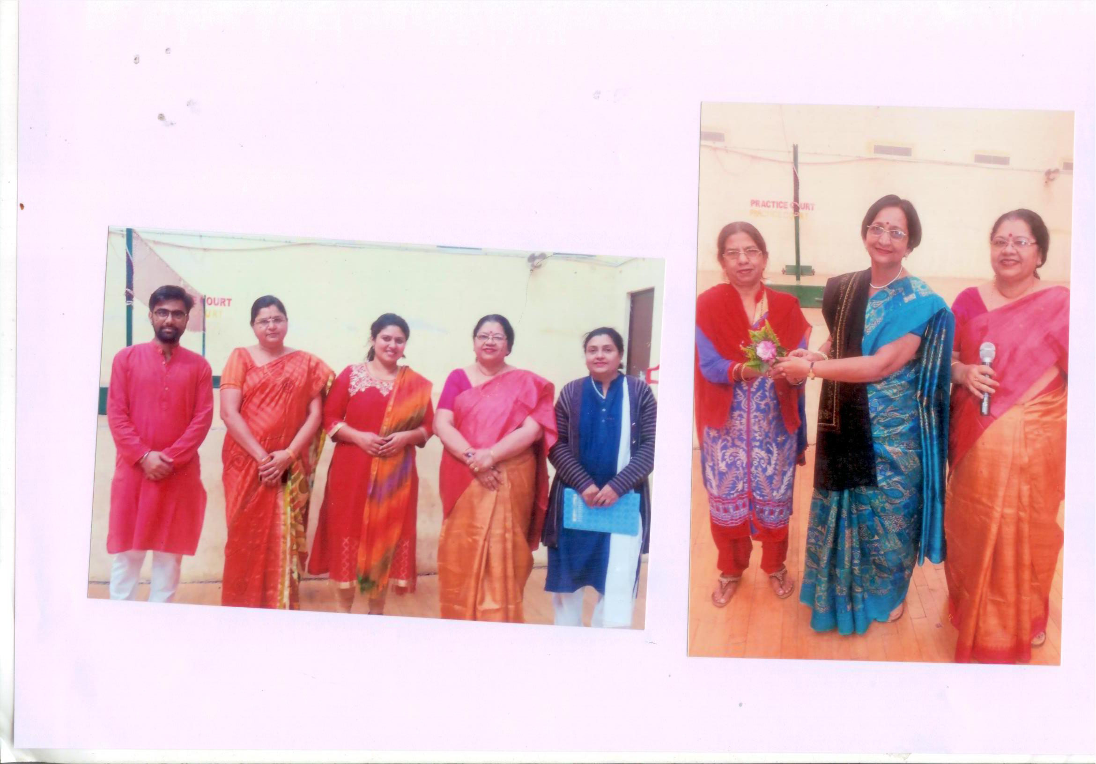

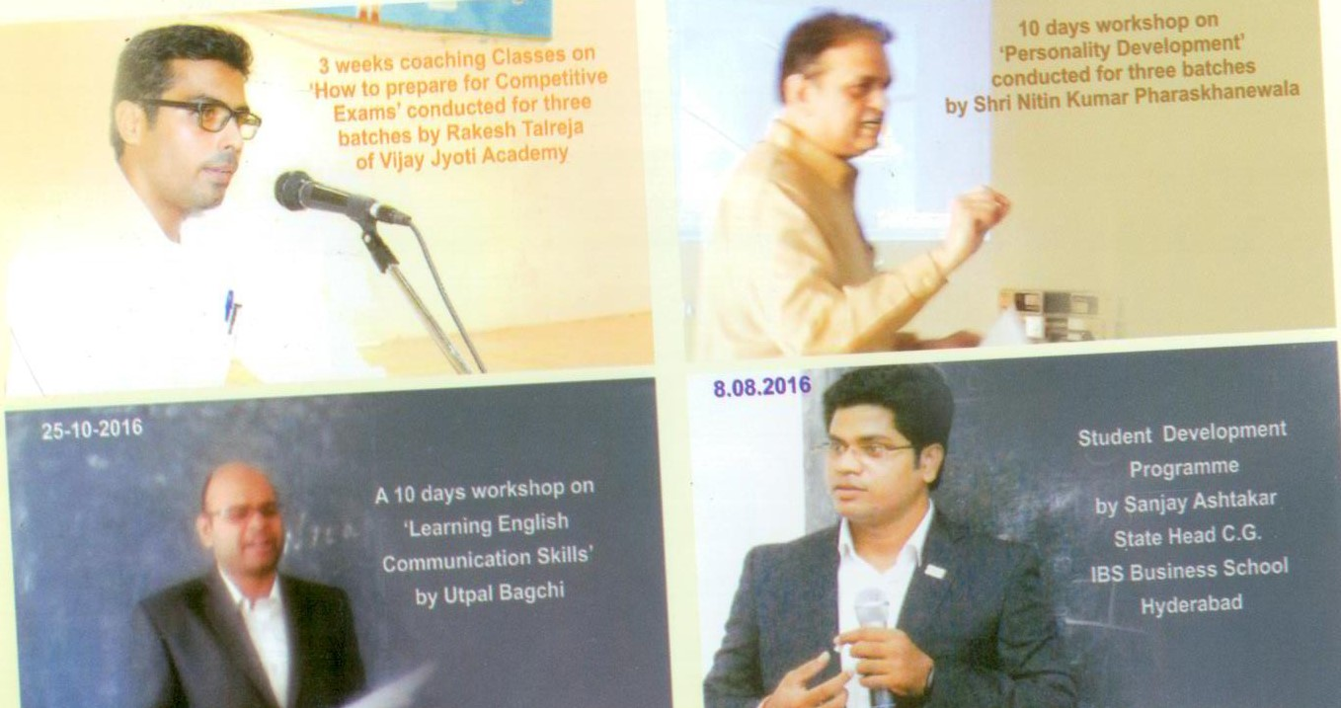
GUEST LECTURES 2016-17

