7.1.9 – Sensitization of students –
Sensitization of students and employees of the Institution to the constitutional obligations: values, rights, duties and responsibilities of citizens.

Describe the various activities in the Institution for inculcating values for being responsible citizens as reflected in the Constitution of India (within 500 words).

The staff and students are sensitized to constitutional awareness and aquainted to their Fundamentals Rights and duties as well as their responsibility as voters and with the new methodology and means of voting like E.V.M. machine etc. The NSS creates a sense of patriotic commitment for National development. Students also participate in the various programmes organized by SVEEP besides participating in rallies and camps.
The NSS students are also engaged in community service programmes and under the Fundamental rights to education they teach the under privileged students. Lectures and competitions are organized to celebrate Constitutional Day both at college and inter college levels.
The Vigilance Awareness week is also observed from time to time.
In order to promote the Swachha Bharat Abiyaan a 15 days long programme was organized in Sep. – Oct. 2019 through various activities and competitions.
The program also initiated antiplastic & antipolythene campaign and promoted the use of cloths bags through various activities. International yoga day is organized every year on 21st June.
Programmes are conducted by the EK BHARAT SHRESHT BHARAT team.
Lectures are conducted to promote religious harmony and festivals of various religious are celebrated annually.

2017-18 | Sweep Program |  |  | IQAC
2015-16 | Sweep Program At Bhilai Mahila Mahavidyalaya | 01-09-2016 | 6 | IQAC
2015-16 | District Level Inter-College Competition At Science College,Durg | 19/01/2016 | 1 | IQAC
2019-2020 | Celebration of 70th Anniversary of Indian Constitution to acquaint the present generation about Indian Constitution; Rights and Duties of Indian citizens. | 26/11/2019 to 16/01/2020 13/03/2020 14/04/2020. | 150 | IQAC
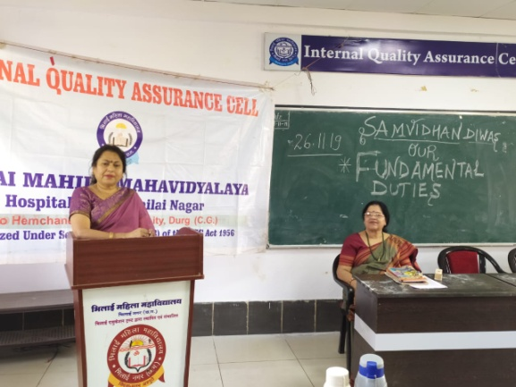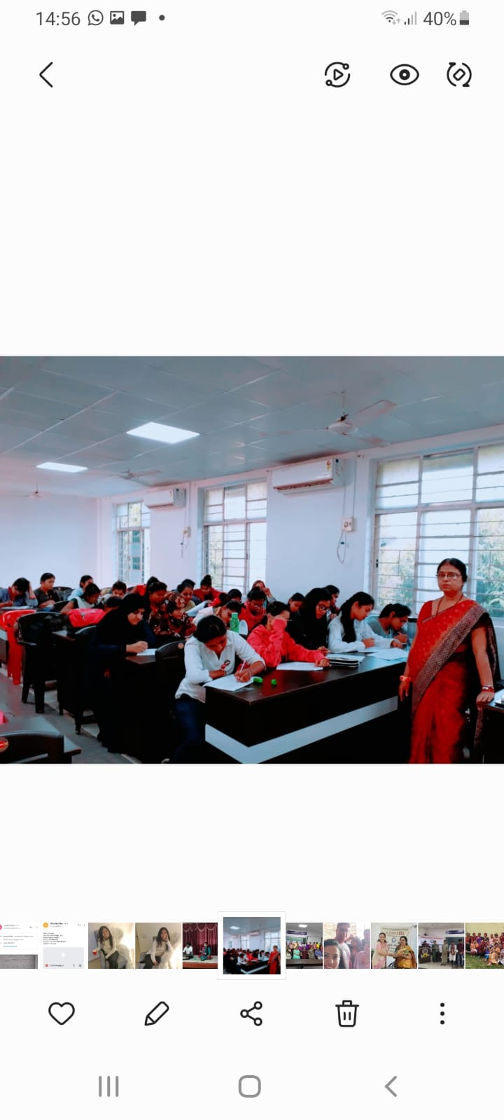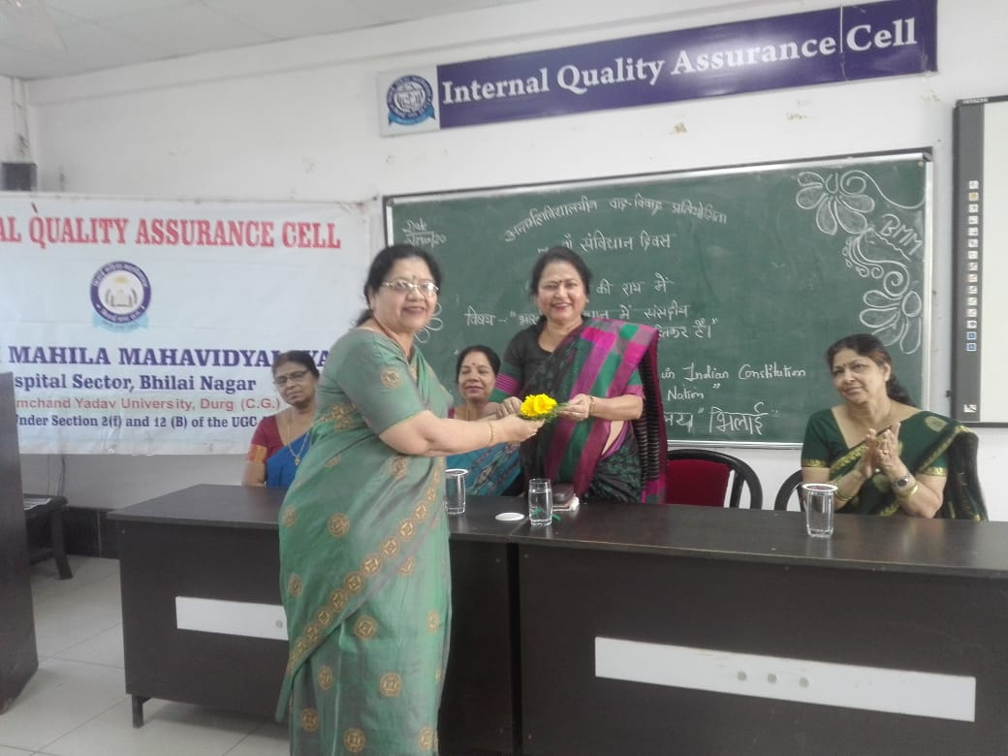
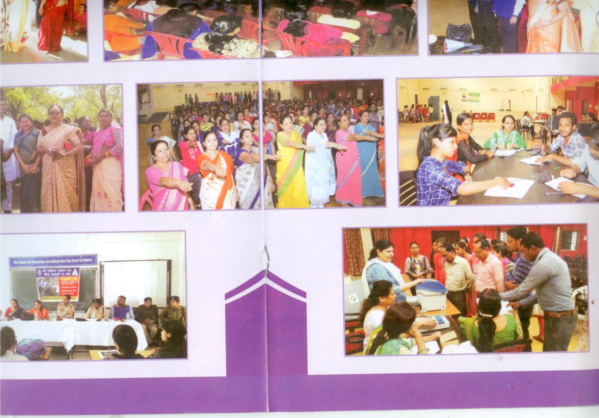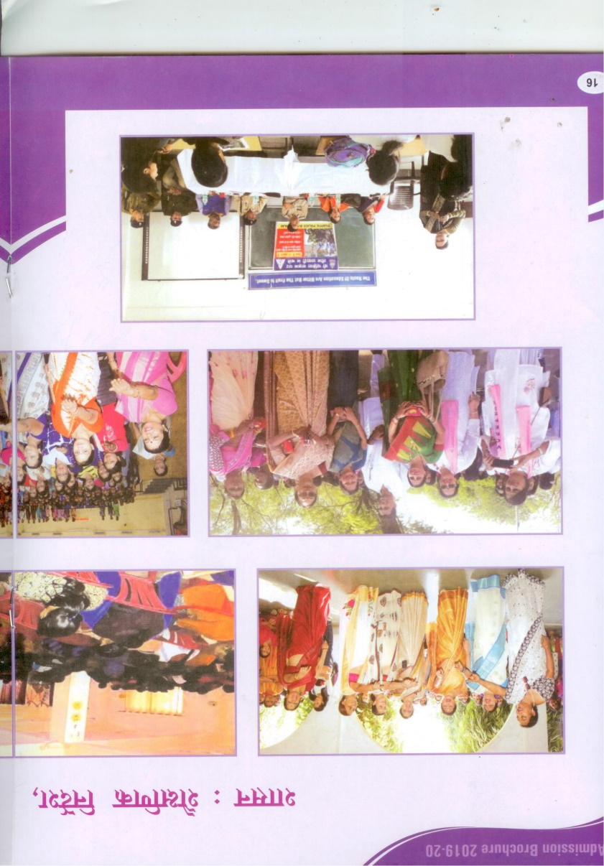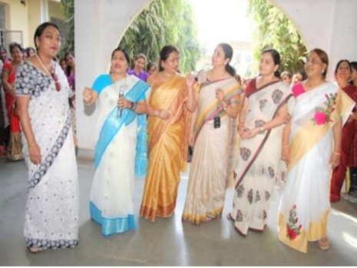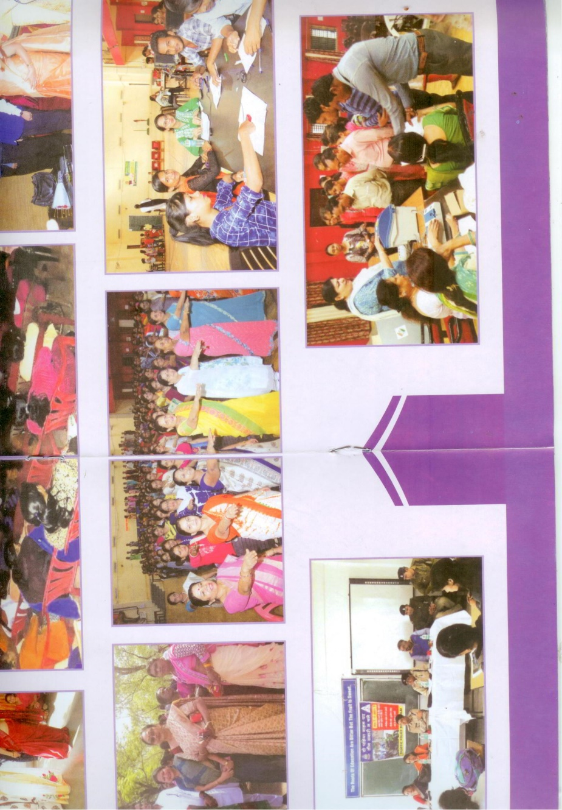

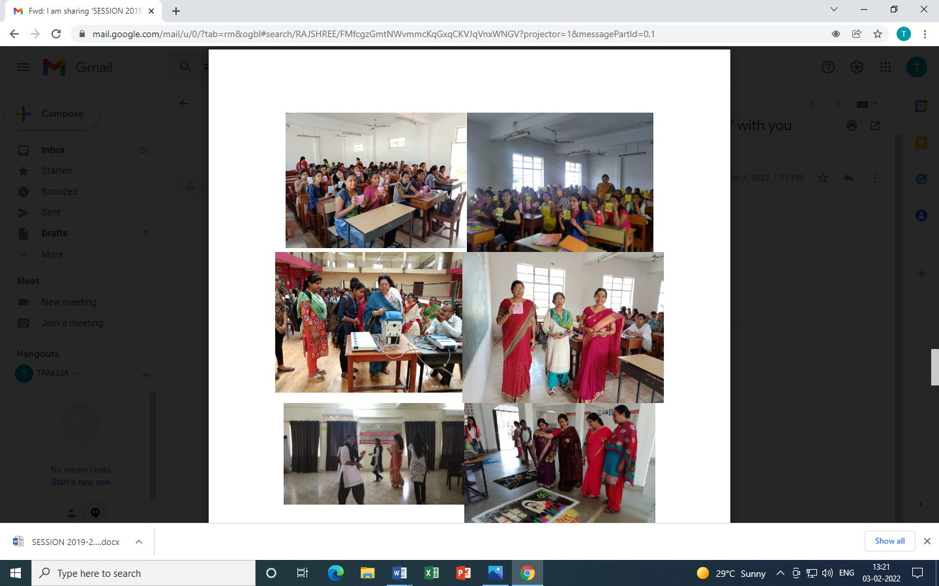

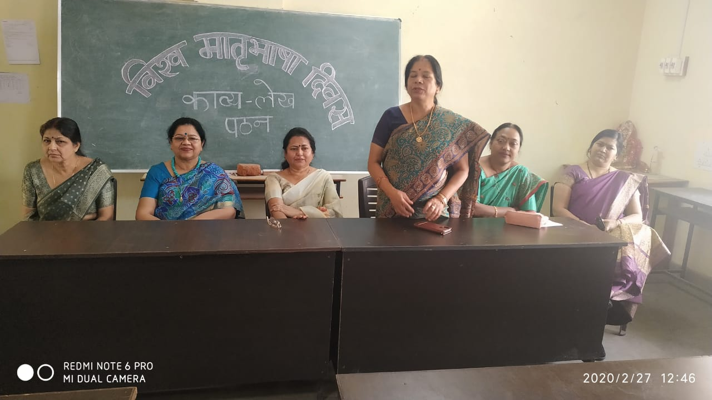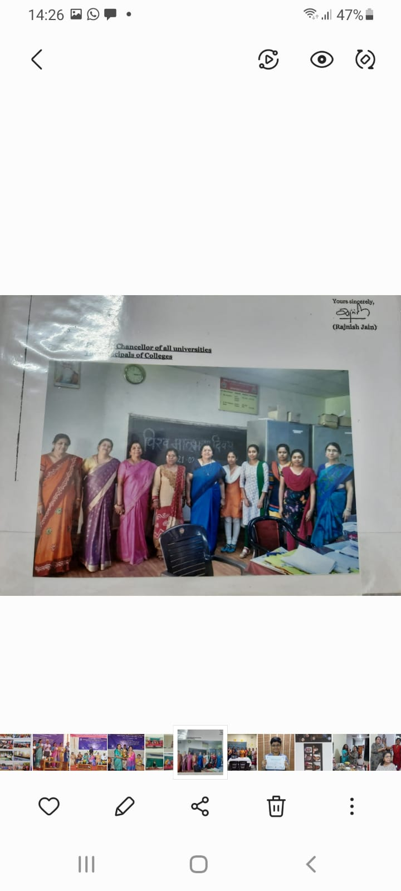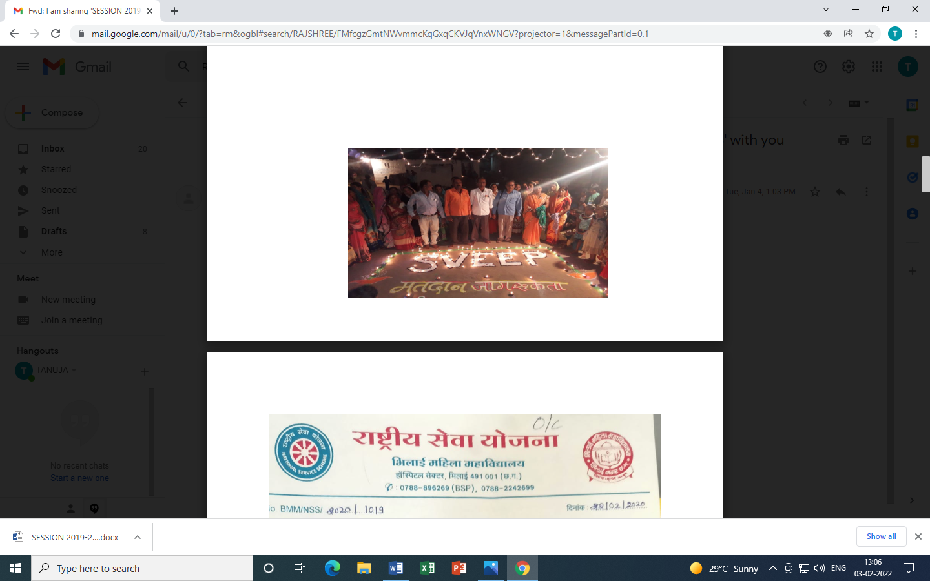

COMMUNITY SERVICE PROGRAMMES BY NSS STUDENTS

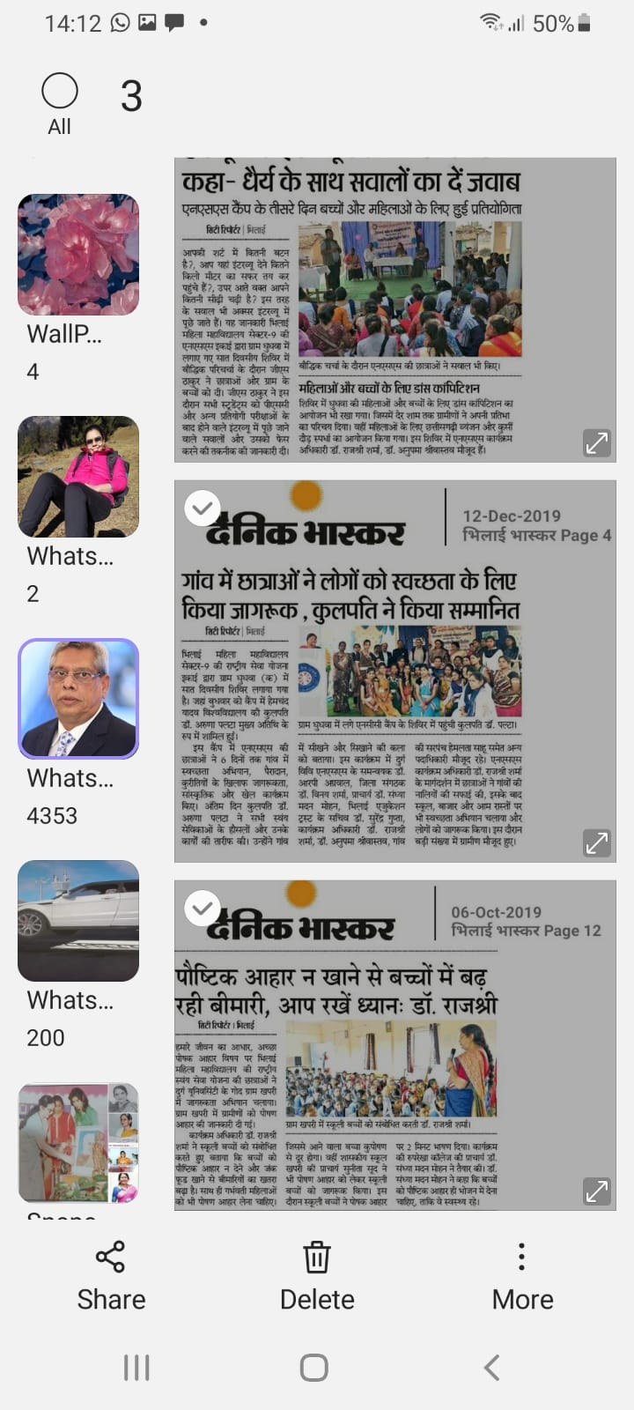
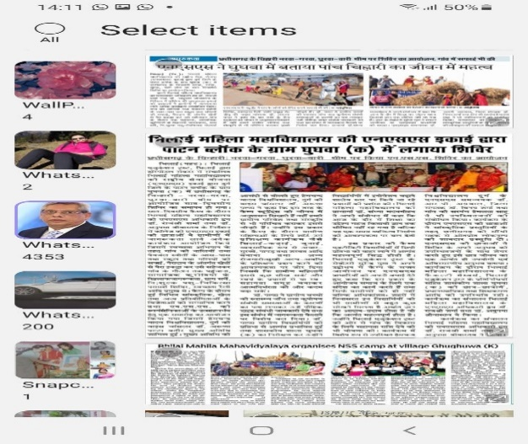
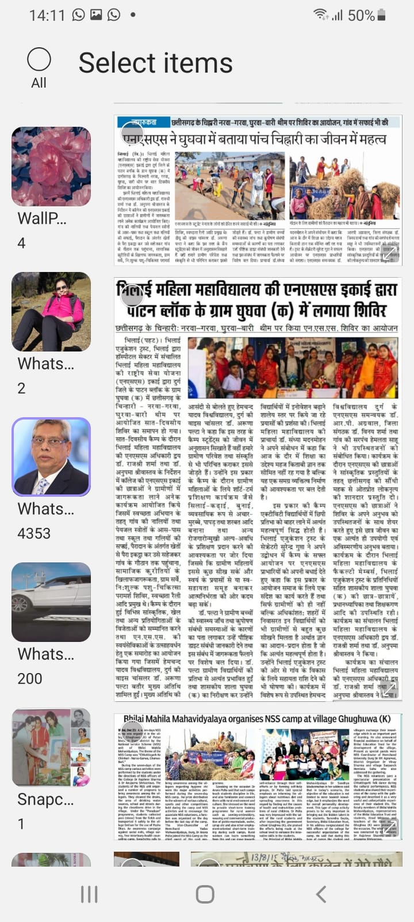
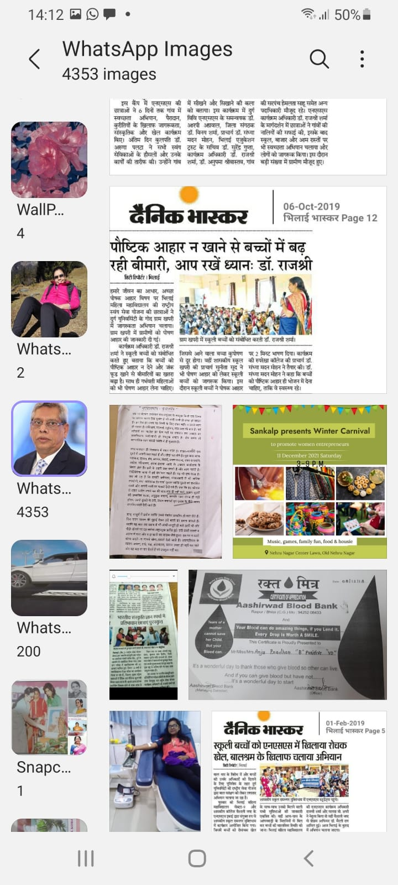

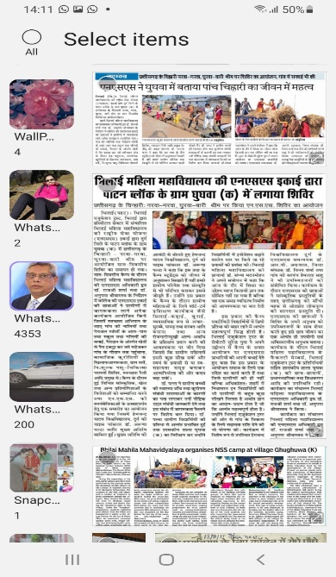
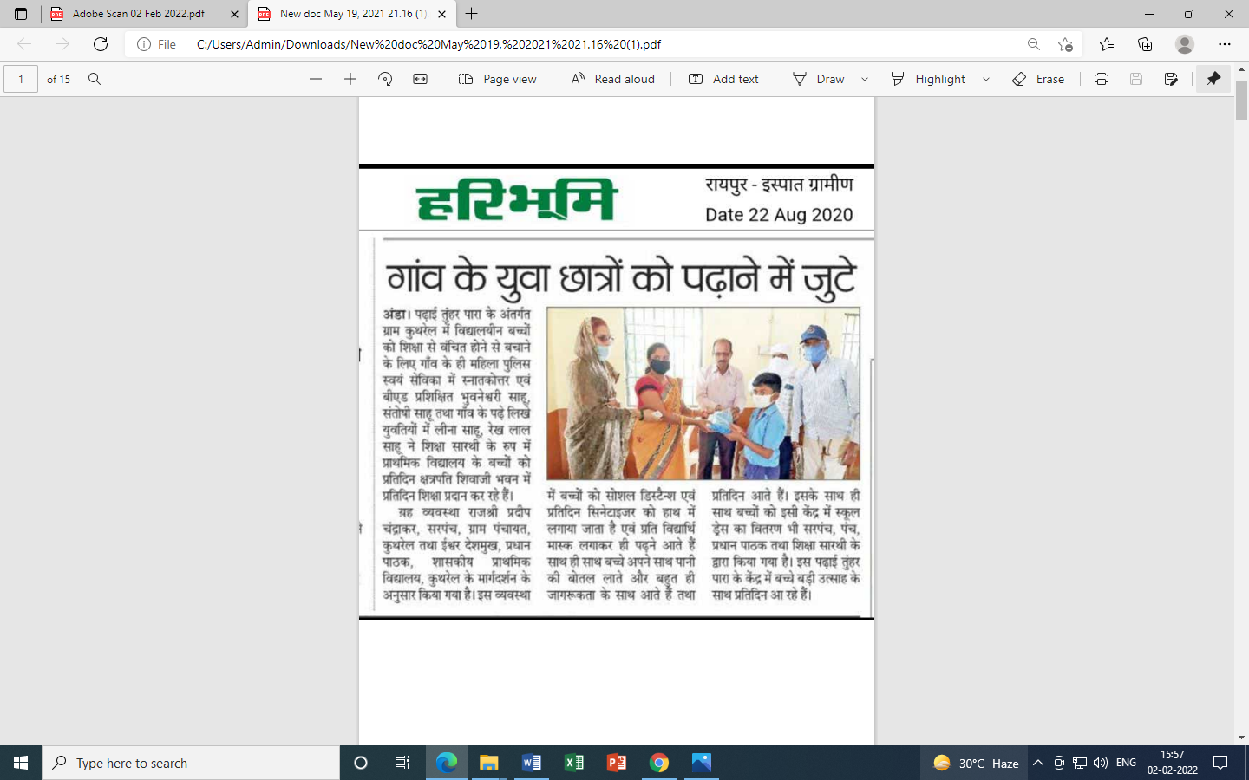
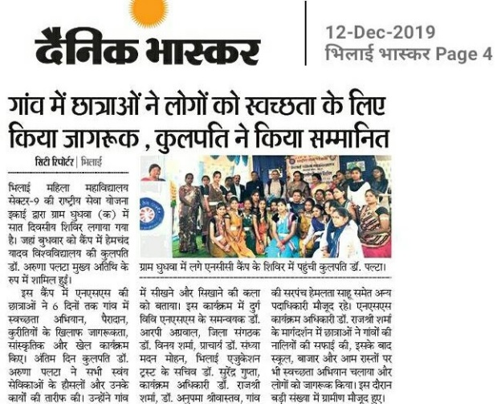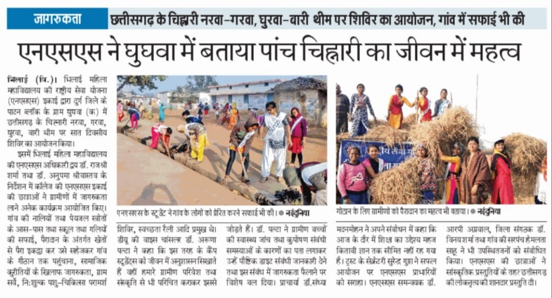

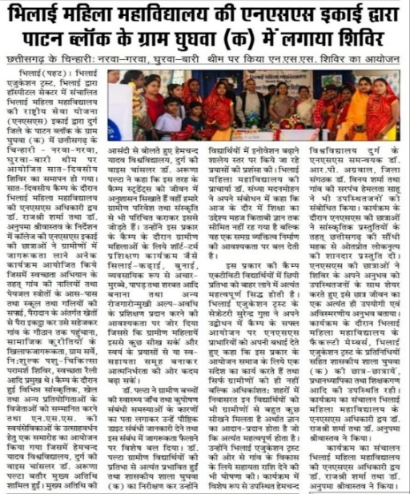

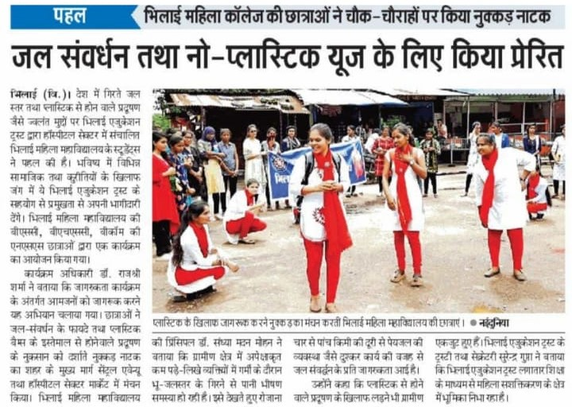

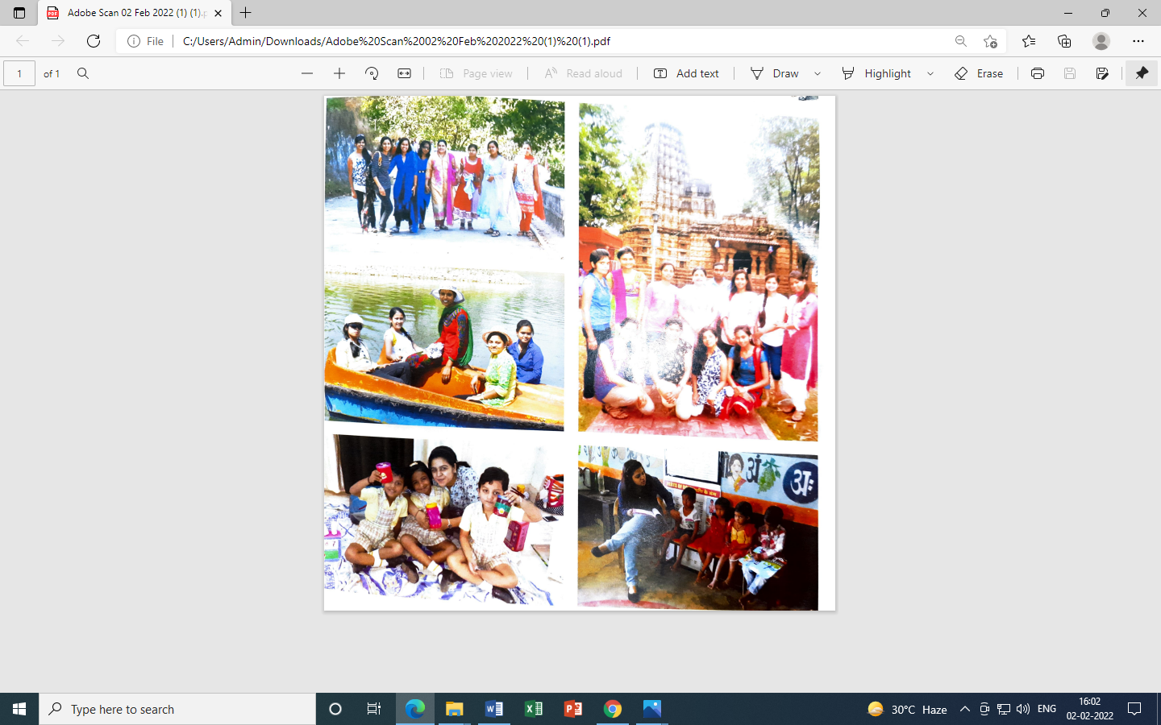

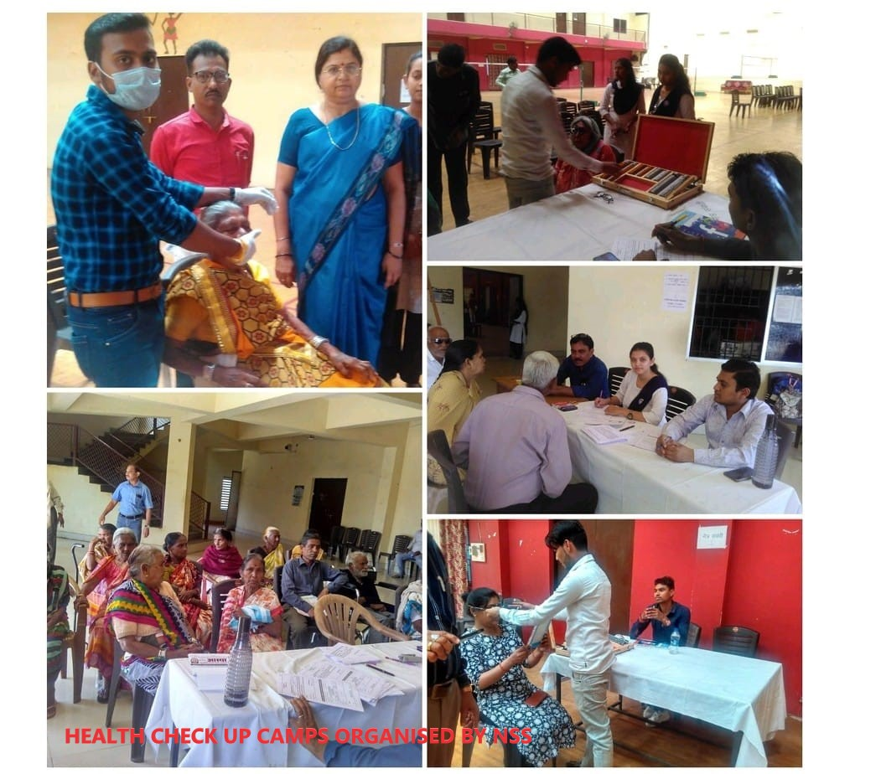

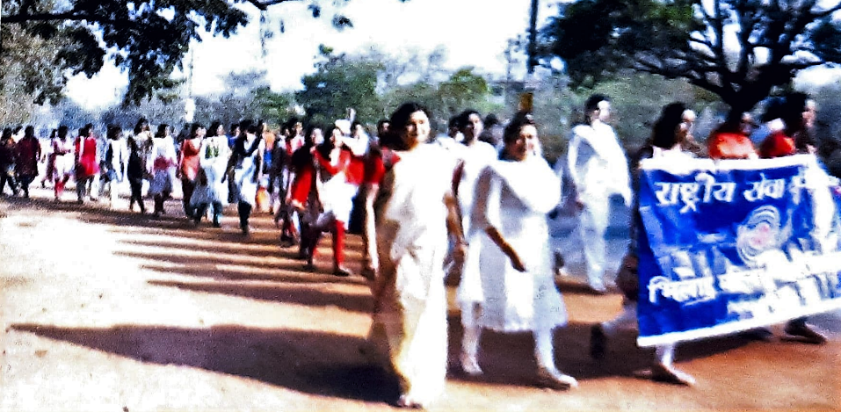
PRIME MINISTER’S MESSAGE
