**Best Practice** (01)

The Best Practices of Criteria - VII in the overall Assessment and Accreditation of a college carries 100 points. Best Practices add value to human life and support the main cause of an institution. They help in the development of an institution and are a source and means to perform social responsibility.

* 1. Best Practice #1 – **Making Women Self Reliant Through Education.**
* 2. **Objectives of the Practice**
* As our Vision goes, we are an institute that strives to prepare Women of tomorrow through an Education System that is Holistic and Transformative. As an institute, we don’t believe in limiting this philosophy to only our students but also extending it to women across all strata of the society. We believe in imparting education that not only makes women academically well informed but also makes them socially aware and conscious. Basic Education, makes women more self-reliant and capable to make their own decisions without depending on someone else. As Mahatma Gandhi rightly said, *“when you educate a man, you educate an individual but when you educate a woman you educate the nation”* and we echo that sentiment completely.
* 3. **The Context**
* Women in Grade- 3 and housekeeping roles, no matter how hard working they are, often fall pray to misinformation, cheating and false news. Lack of basic education makes them depend on others to help them and often make them fall pray to people misguiding them and taking advantage. Basic reading and writing skills, enable women become more independent. With the knowledge of commonly used words and signs, they become more aware and learned to comprehend information in public places, hospitals, offices, post offices, ration shops etc. An educated woman knows the difference between right and wrong without relying on someone else to help her. An educated woman understands the importance of learning and makes sure her children value the same. Once a woman acquires basic education, it opens a world of opportunities for her. She can use her basic knowledge to learn further and take up more lucrative jobs and improve her and her family’s standard of living in the long-run.
* 4. **The Practice**
* Describe the practice and its uniqueness in the context of India higher education. What were the constraints / limitations, if any, faced (in about 400 words)?
* In the year 2020, as a part of the college ‘Best Practices’ the BEd department of Bhilai Mahila Mahavidhyalay under the able guidance of the Principal and HOD, on the auspicious occasion of Basant Panchmi and Saraswati Pooja flagged-off the literary initiative ‘Gyaanoday’.
* Six women from our housekeeping staff were taught basics of Hindi and English language. They were a taught simple sentence construction and word formation. The housekeeping staff used to take half an hour out everyday from one hour long lunch break to attend these classes.
* The classroom sessions were kept conversational and doubt clarification was encouraged through discussions and debates. Housekeeping Staff were taught using the traditional chalk & Board method and also modern teaching tools like Power Point. Not only that, the students from the BEd course also joined hands with their teachers by extending their contribution in this activity.
* This was a unique effort not only at a social level but also rooted in the purpose of education at its core and thus making it a Best Practice.
* 5. **Evidence of Success**
* Provide evidence of success such as performance against targets and benchmarks, review/results. What do these results indicate? Describe in about200 words.
* Six employees from our Housekeeping Staff were a part of this initiative that started on 31st January, 2020 and went on till 20th March, 2020. Each student was provided stationary as a part of the learning process. Besides the regular teaching and learning process, Housekeep Staff students were also given Class Tests to evaluate their performance and recognised suitably.
* 6. **Problems Encountered and Resources Required**
* Please identify the problems encountered and resources required to implement the practice (in about 150 words).
* The initiative was meant to continue longer but had to come to an untimely close due to the unexpected nationwide lockdown on 20th March, 2020. As the situation with the global Pandemic has still not normalized, once the situation improves, we would like to reactivate the program, cover all the planned topics and bring it to its desired close.
* There was some mental blocks in the housekeeping staffs’ mind to be a part of an activity like this. They were apprehensive to take up education so late in life. There was hesitation to open-up and interact freely with an open mind with the teaching staff but warmed up and developed a comfort level after a few ice-breaking sessions of interpersonal chat and counseling.

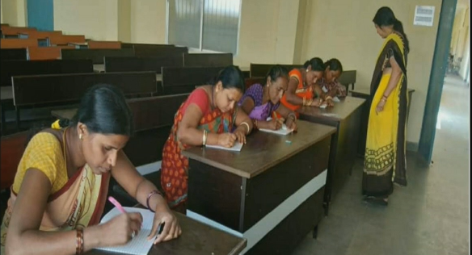 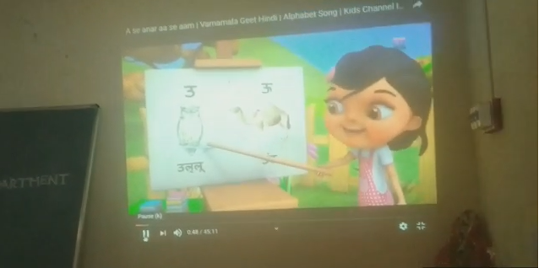 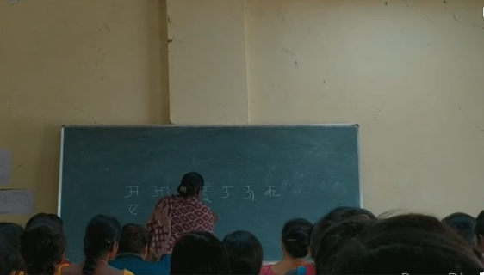 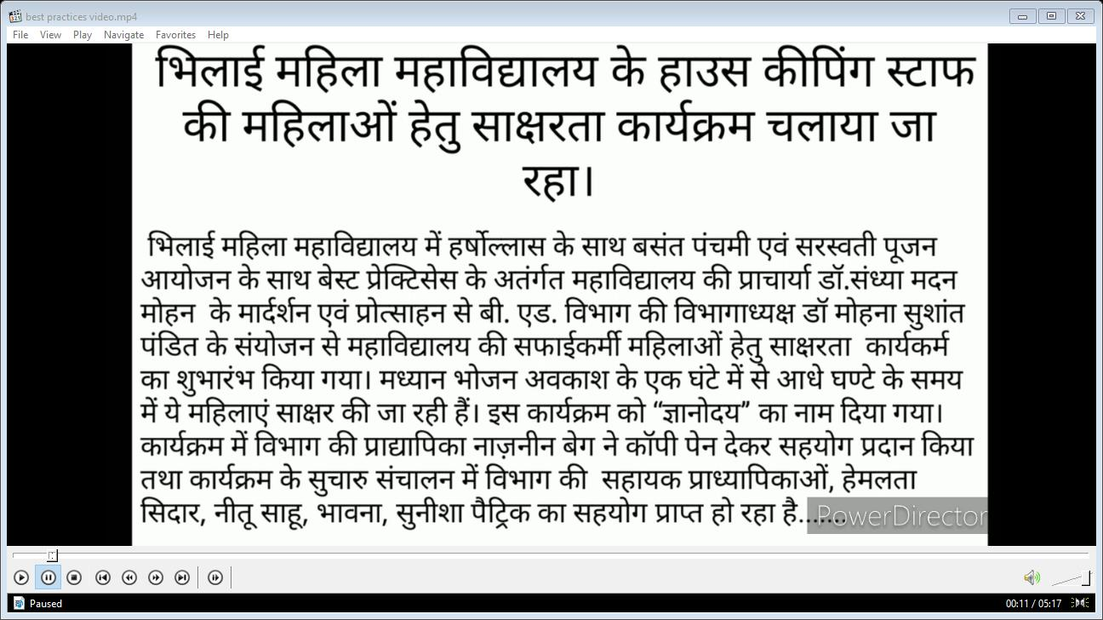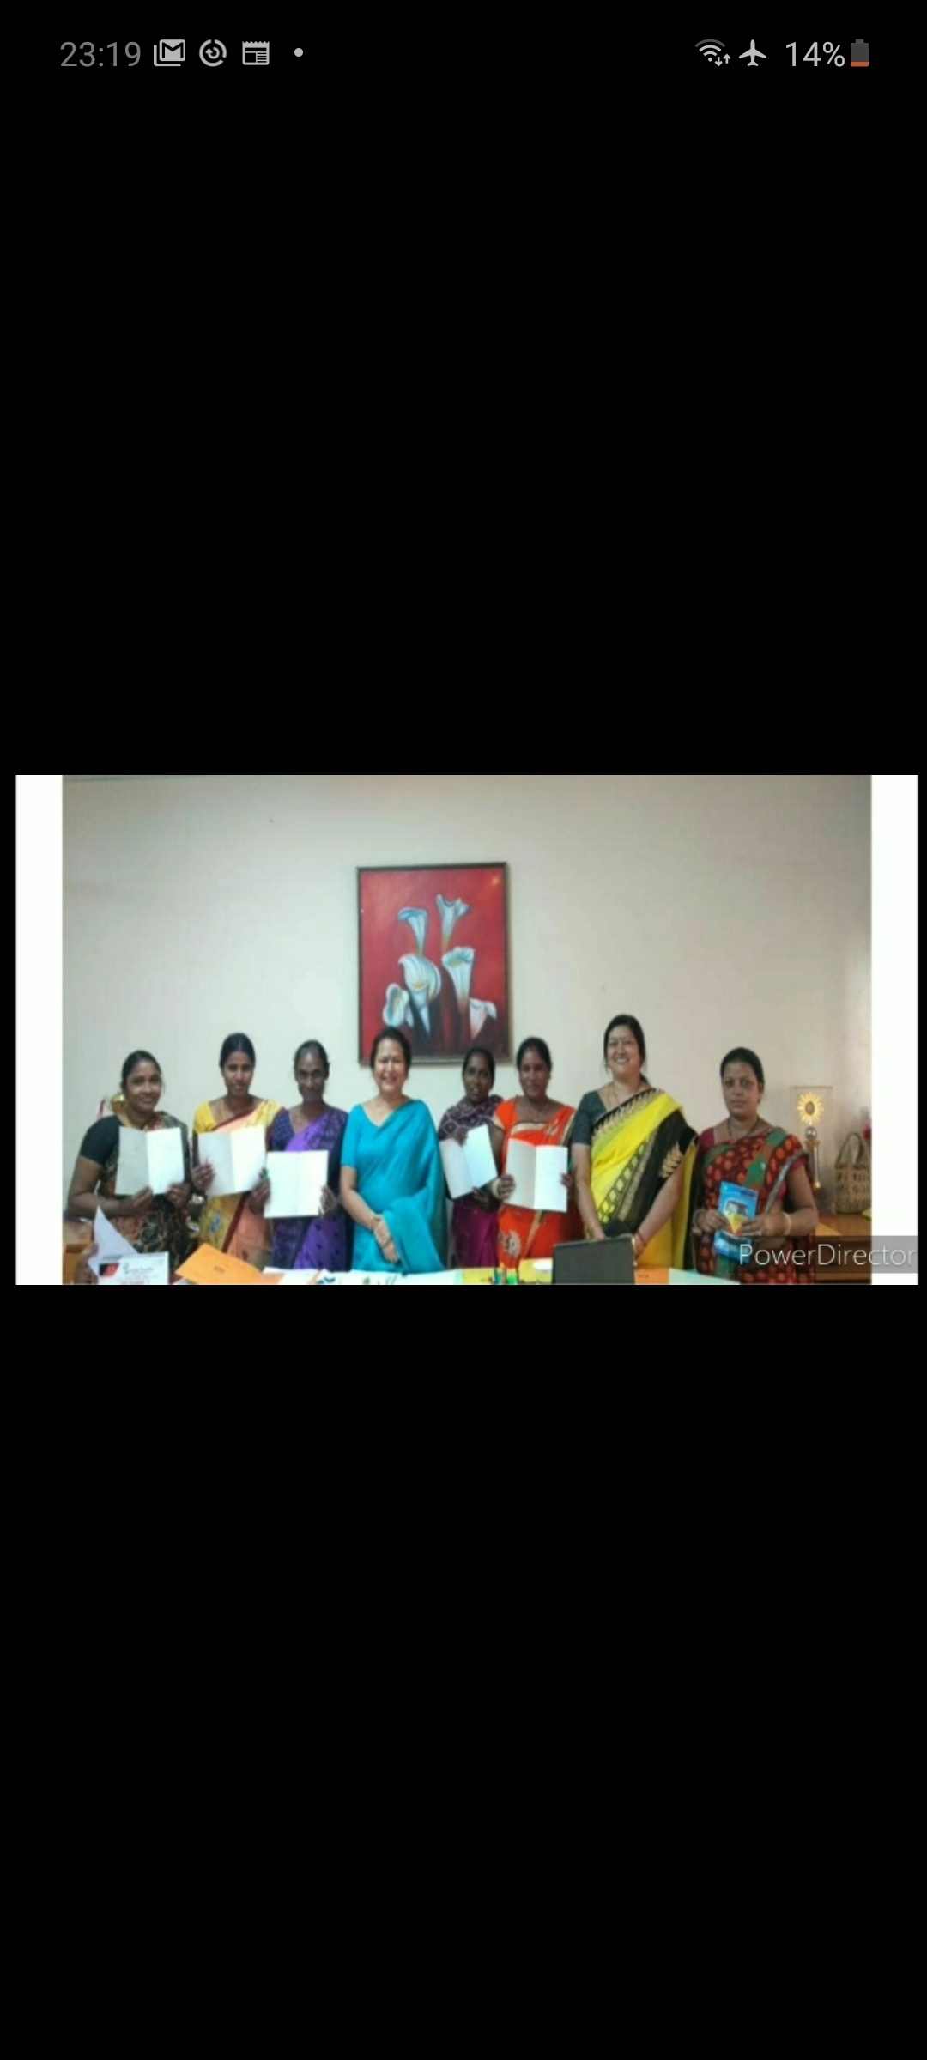 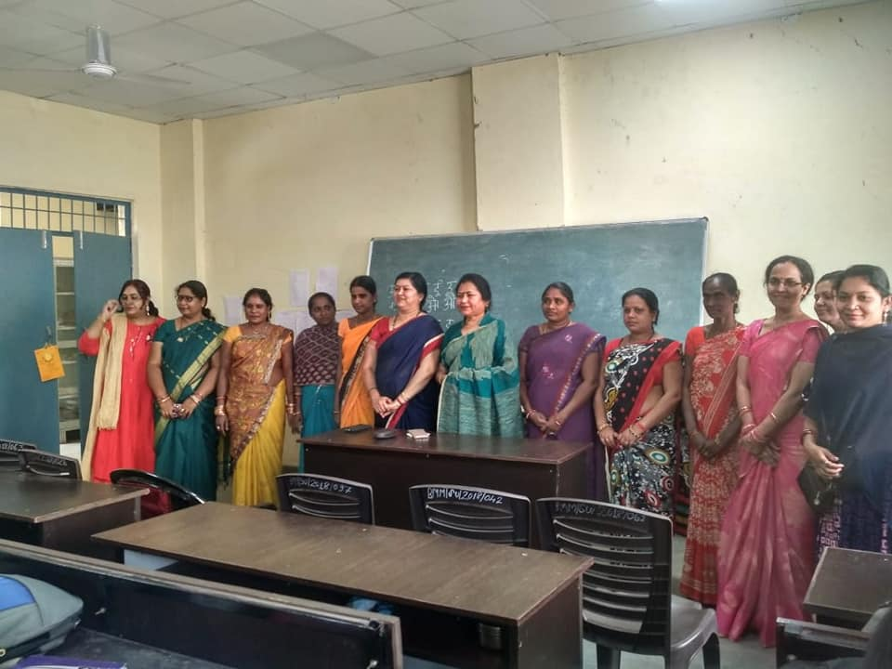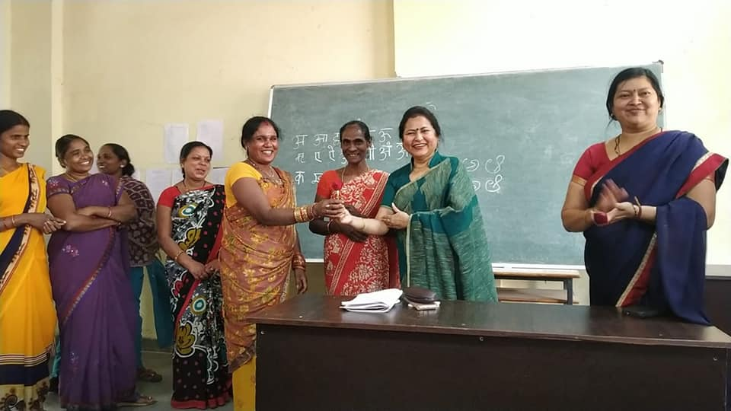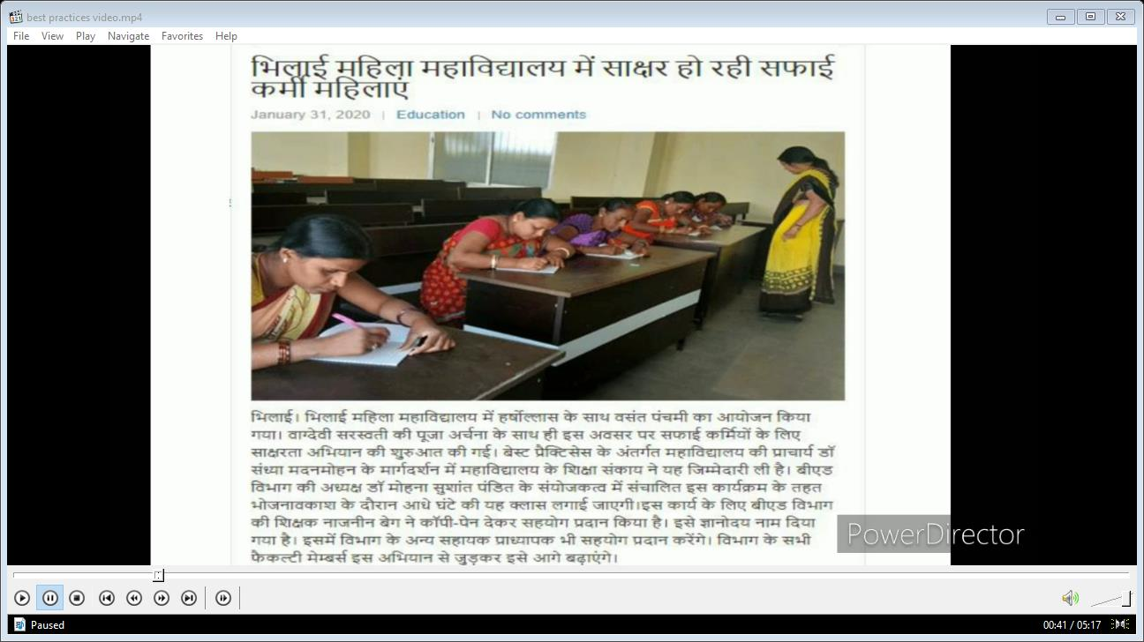 

* **Best Practice #2 – Service Before Self.**
* 2. **Objectives of the Practice**
* Inspired from our Vision, this Best Practice is also an example of preparing Women of tomorrow through an Education System that is Holistic and Transformative. As an institute, we don’t believe in limiting this education to the four walls of the classroom but make it experiential and practically relevant. We believe that real education not only makes girls academically aware but also something that can be used for the larger good of the society. So that when any need or calamity arises, our students are prepared to give the best they can with their knowledge and skill-set for the benefit of others.
* 3. **The Context**
* In 2020, when the world was grappling with the fear and wrath of the global Pandemic, Covid – 19 and was under lockdown, our students while attending online classes from home also extended their services to help those in need. As per Govt. of India guidelines and safety, wearing masks was made mandatory. However, not all the people were fortunate to have the resources to afford the same. As a gesture to lend support and help those in need our students from the Home Science and BEd department took the initiative to stitch cloth masks at home and distribute them for free in areas near their homes.
* 4. **The Practice**
* Students from our BHSc and BEd department under guidance of the Principal and faculty took the initiative of stitching several hundreds of cloth masks and distribute them for free. The activity was aimed to drive awareness and educate the common people about the importance of masks in their personal protection and fighting the spread of this deadly disease. The masks were made of washable muslin cloth, making it hygienic and easy to reuse.
* Not only our students but their families also participated actively in lending their support and help.
* The masks were stitched at home and distributed to shopkeepers, hawkers, street vendors, front line workers and residents near their houses. The students made sure that all social distancing protocols were maintained during the distribution of the masks.
* The students not only extended their support and hardwork through their skill but also displayed tremendous humility by not taking any financial assistance from anyone for this noble gesture.
* 5. **Evidence of Success**
* Three students from the institute, namely – Monika Joshi & Neetu Sahu from BEd and Aparna Shrivastava, Shikha Singh and Pooja Vaishnav from MHsc Clothing & Textile were the active participants of the activity. While Aparna Shrivastava donated 50 masks, Shiksha Singh donated 1200 masks and Poja Vaishnav donated – 60 masks. As the activity gained momentum and more people got to know about this initiative, Aparna Shrivastava received an order from a Hyderabad based Boutique for 100 masks and Pooja received an order several masks from her local shop keepers.
* Students from other departments also extended their support and participation though the online medium towards the initiative.
* All the students received great appreciation and encouragement both a college and local level.
* 6. **Problems Encountered and Resources Required**
* Please identify the problems encountered and resources required to implement the practice (in about 150 words).
* As it was the time of a global pandemic, local movement was risky and restricted. Since shops were closed due to lockdown, procuring raw material for making the masks was a challenge. However, our students with their skill, knowledge and expertise in the field, found most innovative resources and raw materials that were readily available that time at home.
* There was also great apprehension amongst people to wear masks and it took a lot of education and convincing for them to understand their benefits.
* The students also had their personal safety at stake while distributing the masks, as a large part of the population was not aware of the social distancing norms and practices.

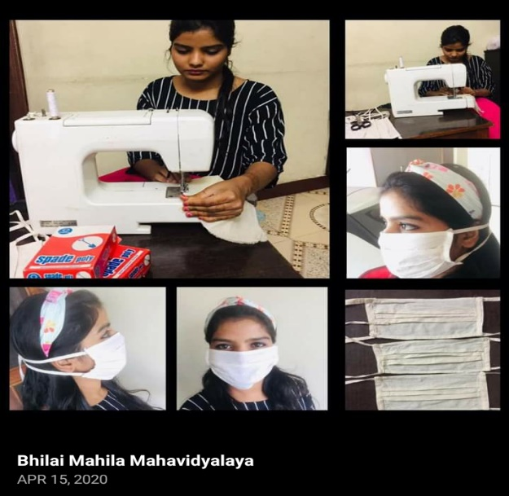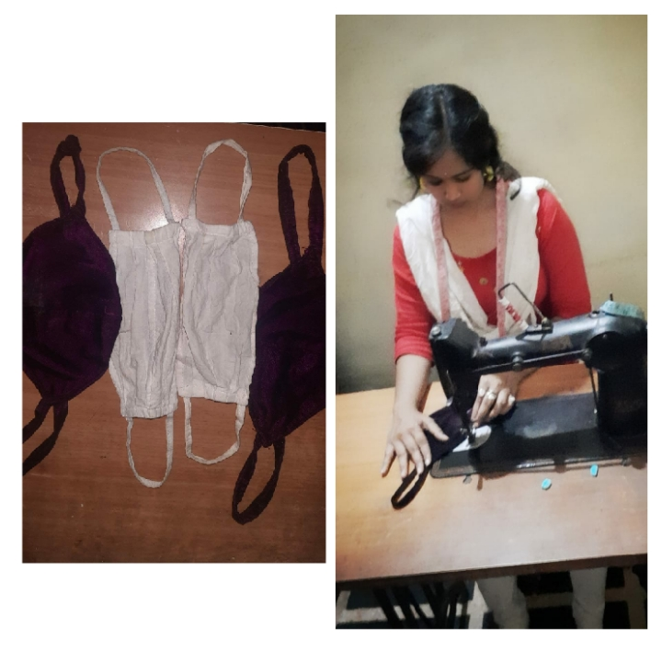

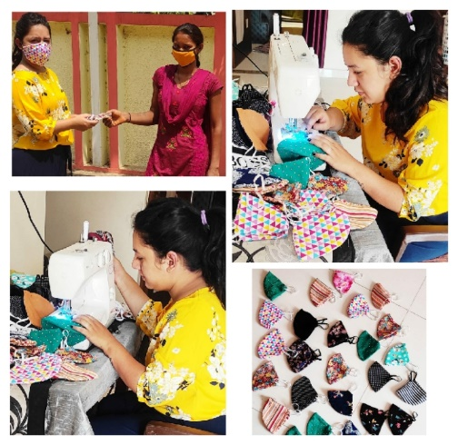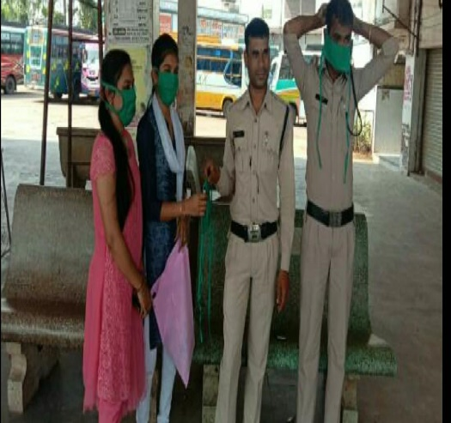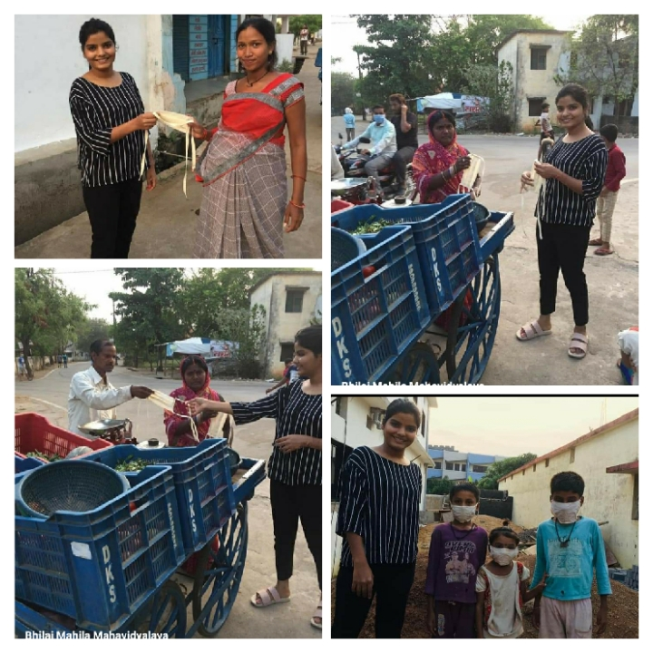

Home Science Staff training the attendants to stitch masks.

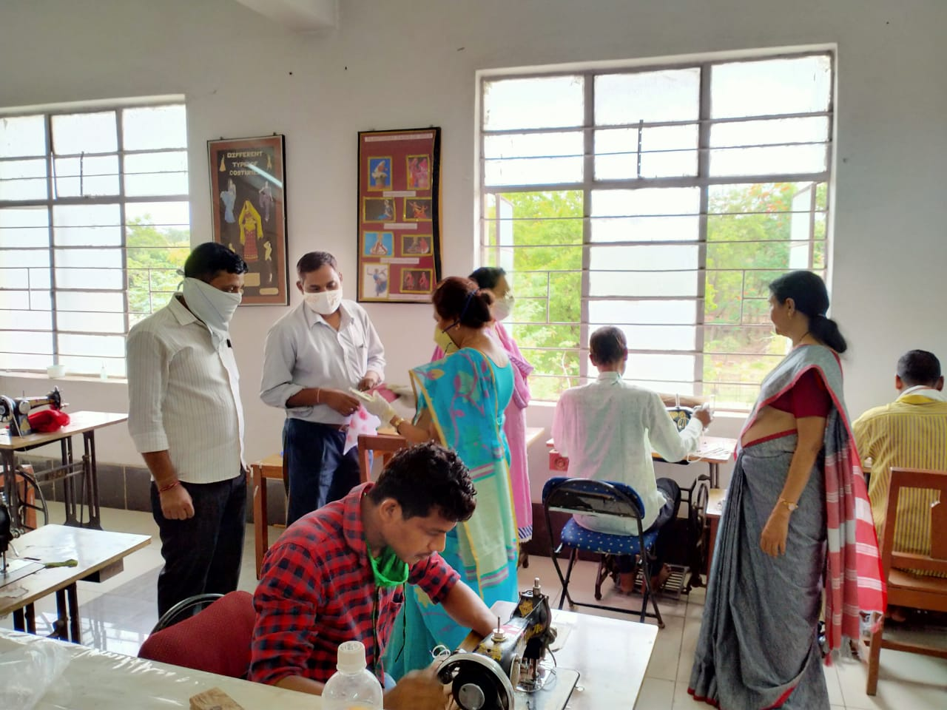 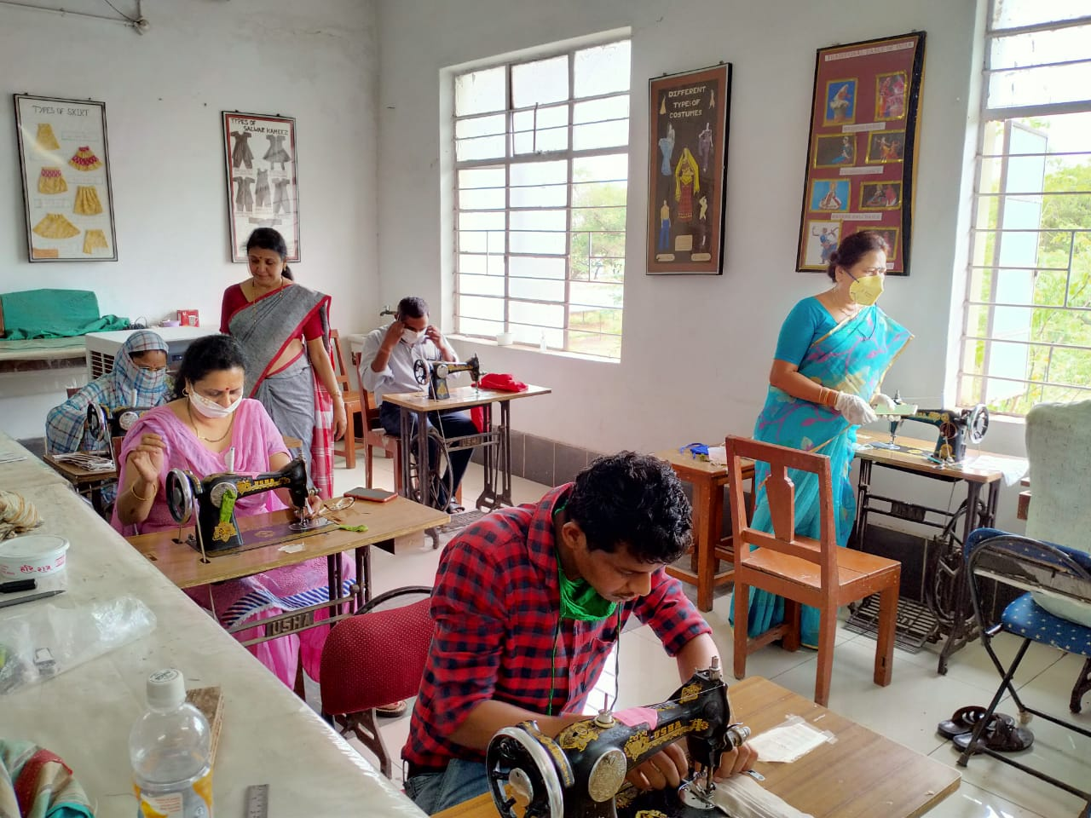

NSS students educating the masses regarding the risks of covid-19 and methods to prevented by staying at home and using masks.