7.1.3 Institutional Distinctiveness
Every institution has to strive hard to achieve excellence in various fields. From the date of its inception the college has achieved excellence and distinctiveness in the efforts of its teachers in their teaching quality leading to excellent results.
“Sa Vidya Ya Vimuktye” this guiding philosophy “Knowledge is that which liberates” is taken from the Vishnu Puran and gives us the genuine meaning of education. We believe that the aim of education is to “know thy self “and in this Self-Discovery emancipates our minds from ignorance and experience the infinite comparison, wisdom and intelligence within. The present education system is globally a system rooted, in competition, fear and challenges.
The biggest challenge before education is to design a curriculum which has a global perspective. It should not only stimulate the young minds with theoretical knowledge but also bridge the gap of its practical usage thus helping them to understand its value in their professional life as well as their organization of employment at a future date benefitting the society as a whole.
The Distinctiveness: The question before us is to see how the future of our students can be shaped in the class rooms. This is justified in our institution by giving proper guidance to the students by their teachers who themselves are well versed in their field of specialization and at the same time seekers of current knowledge and keen learners to keep themselves & the students abreast with the current trends. They try to enhance their knowledge through Orientation and Refresher courses from time to time by attending International & National Seminars and Workshops where they present papers on topics concerned to their subjects and get their papers published in journals of national & international recognition and completing their doctorate. Many of the doctorate teachers are also appointed as research guide for students placed under them wishing to attend their P.HD

Yet another innovative step taken in this context by our Principal was to initiate special classes conducted by the alumni of the college in their respective fields of specialization. Departments of Physics, Chemistry, Zoology, Botany & Maths invited five to seven of their alumni to deliver lectures to the PG and Part – III UG students for seven days on their topics of specialization. The subject teachers also requested the alumni to take up those topics which were recently included in the syllabus and they were also not very well versed with these as the books on these topics were readily available .The students enjoyed these classes and availed the most from their seniors. They were more at ease in discussing their problems and clarifying their doubts with them. They felt free to learn from them as to what led to their achievements and attain these heights of success, knowledge and experience. They also learnt the nuances of appearing in and qualifying the NET/SET exams, various competitive exams and applying for their doctorate degree.

The alumni were to glade and welling to be back to their ammeter and see it progressing and flourishing over the years. They Delivered these lecture without charging any honorarium which save the institution of financial burden. The head and staff of the departments invited those alumni who had proved themselves in their field of specialization and were labelled as achievers so that they could set an example before their juniors.

ALUMNI GUEST LECTURE SERIES MATHEMATICS

 | Department | Date of lecture | Topic | Name of the Alumni | No of Student | Remark
 | Mathematics | 05-02-2020 | Importance of Mathematics in Computer Science | Dr. Mrs. Jyoti Pillai, Professor, Department of IT, BIT Durg, Chhattisgarh | 40
 | Mathematics | 06-02-2020 | Graph and its Application | Ms. Pratibha Sahu, Aspirant | 40
 | Mathematics | 06-02-2020 | Graph Coloring | Ms. Roja, Aspirant | 40
 | Mathematics | 07-02-2020 | Limit Superior and Limit Inferior | Ms. Jyoti Dewangan, Aspirant | 40
 | Mathematics | 08-02-2020 | Basic Celestial Mechanics | Dr. Mrs. Anandita Chakraborty, Assistant Professor, Department of Mathematics, BIT, Durg, Chhattisgarh | 40
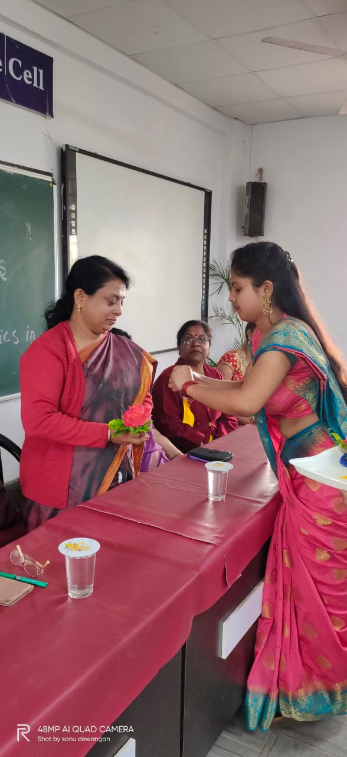
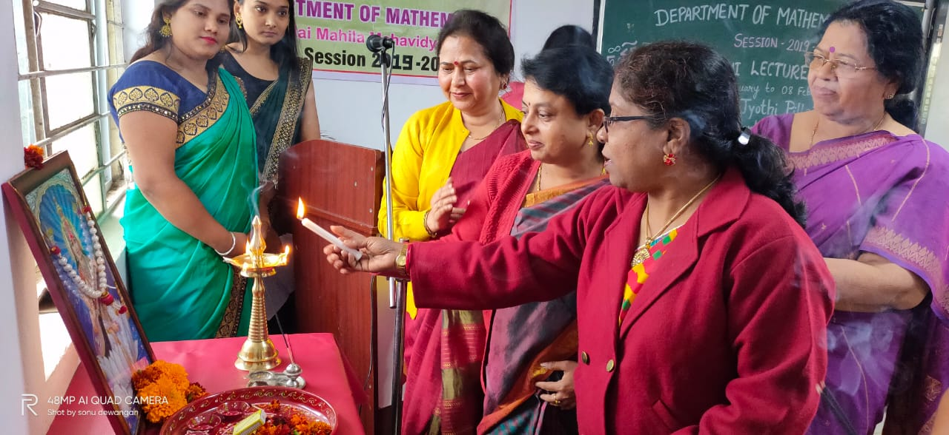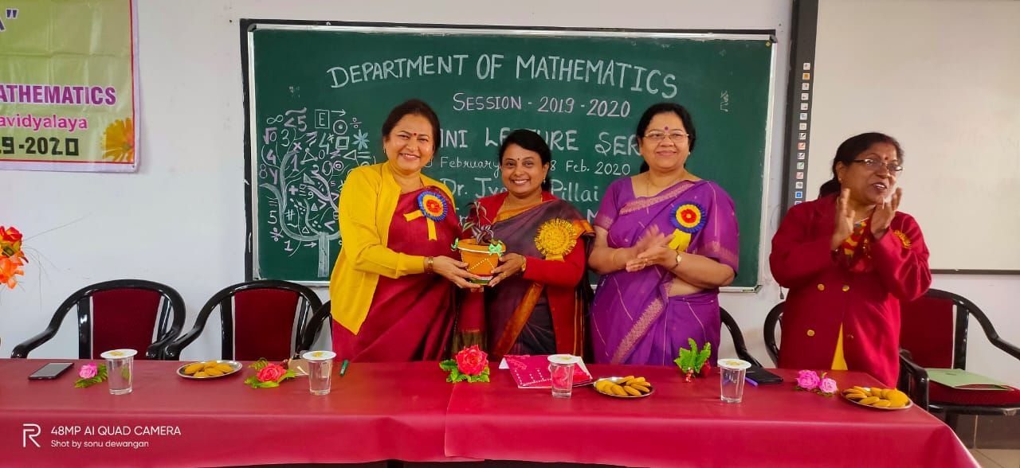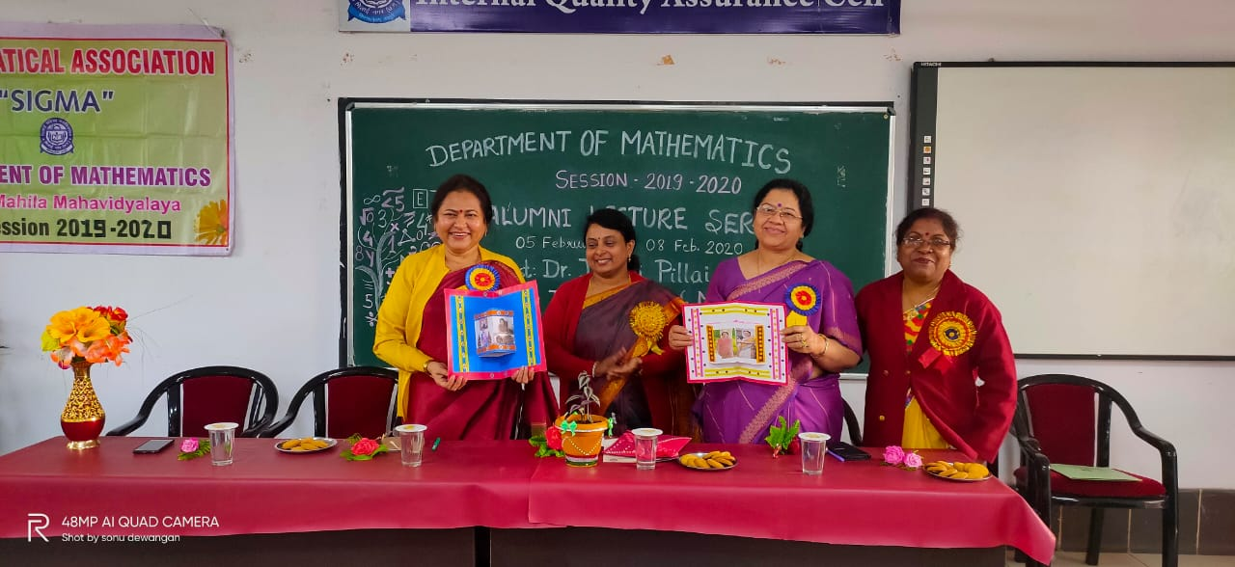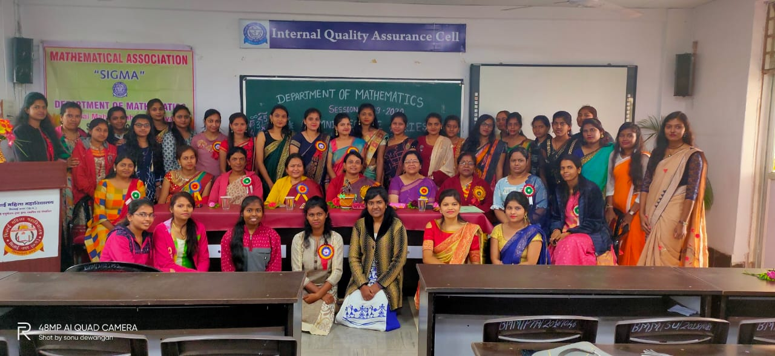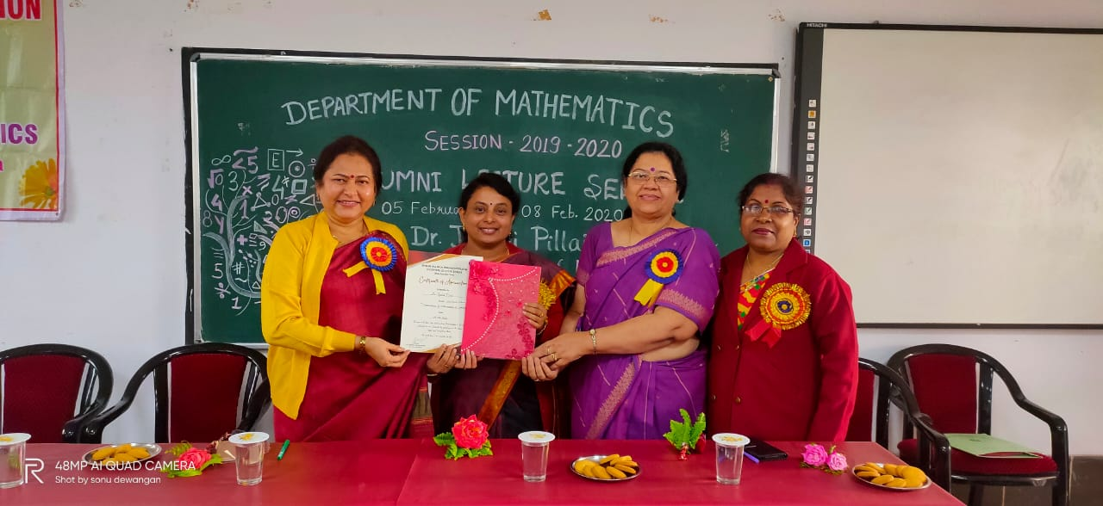

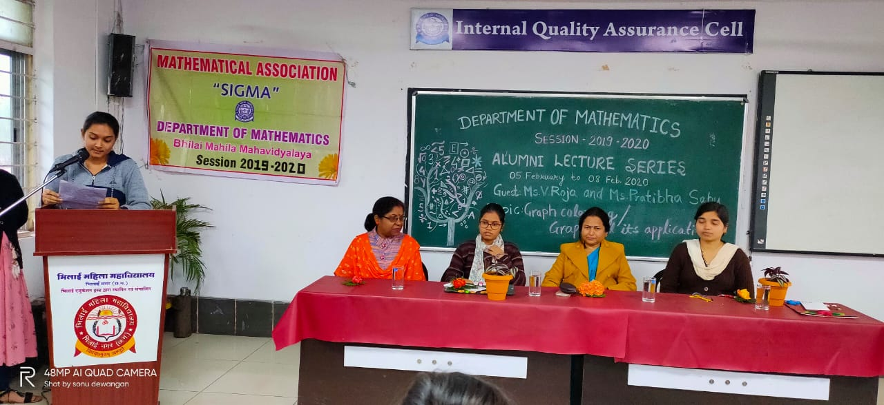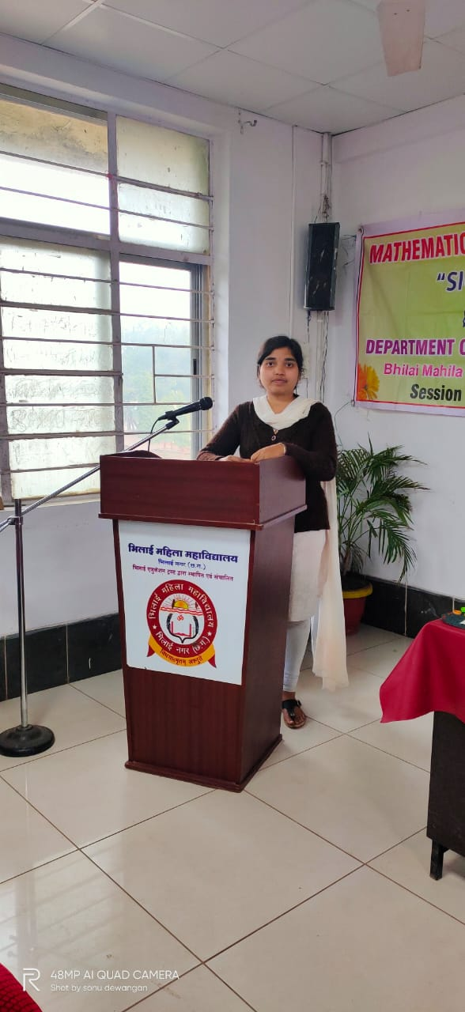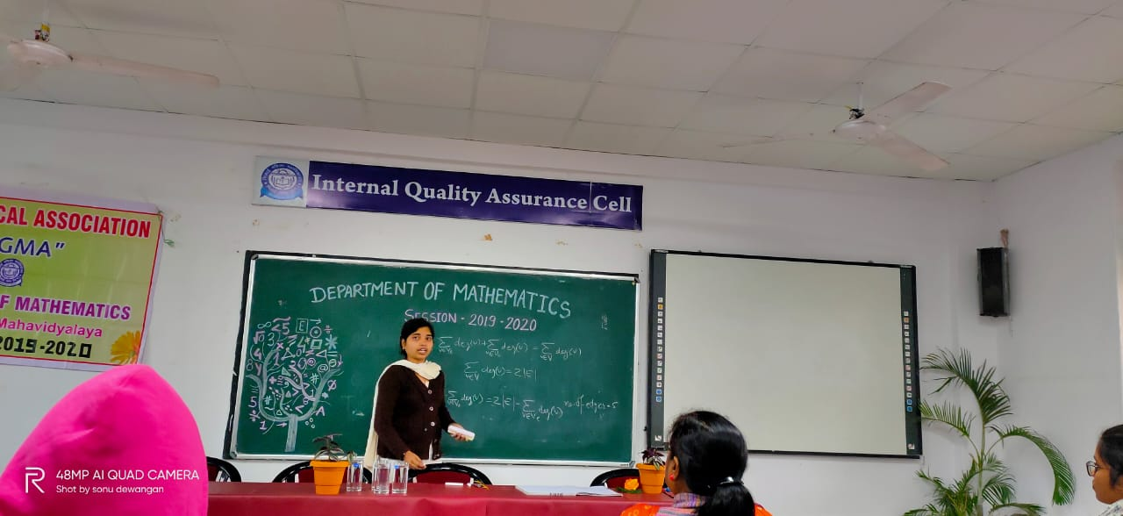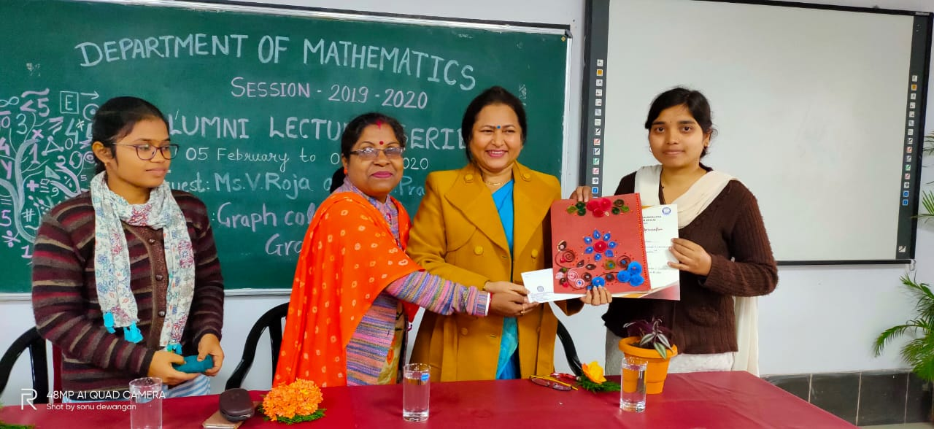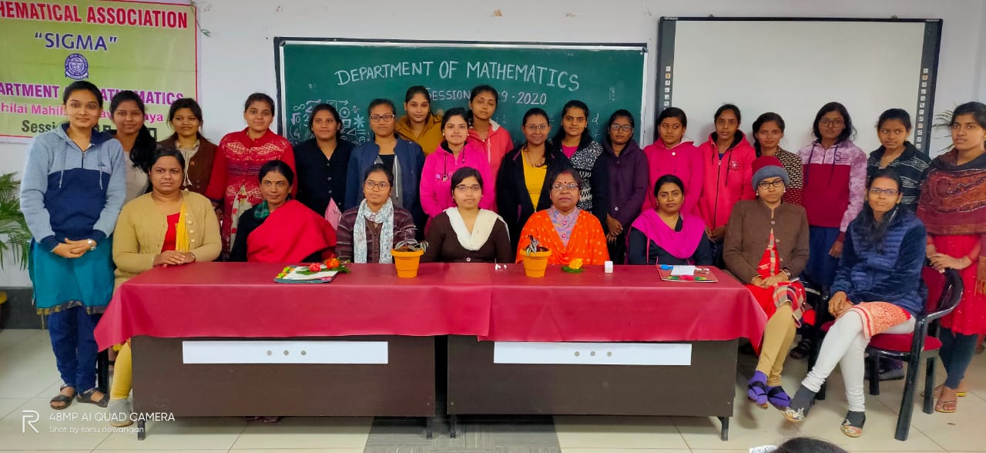

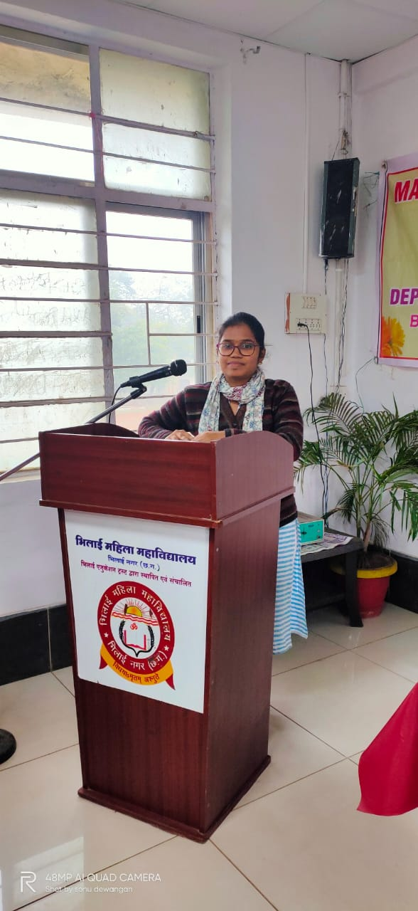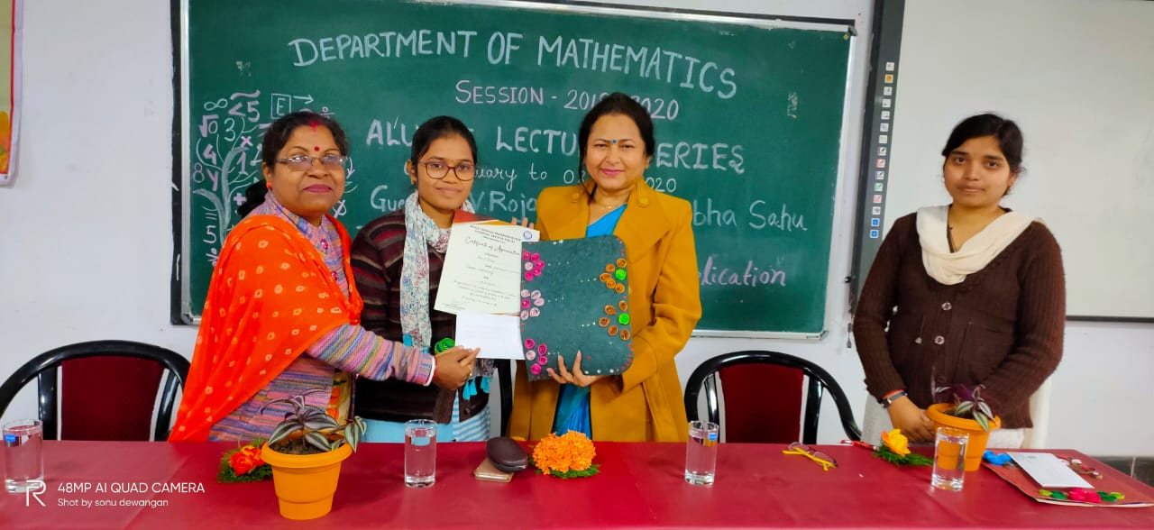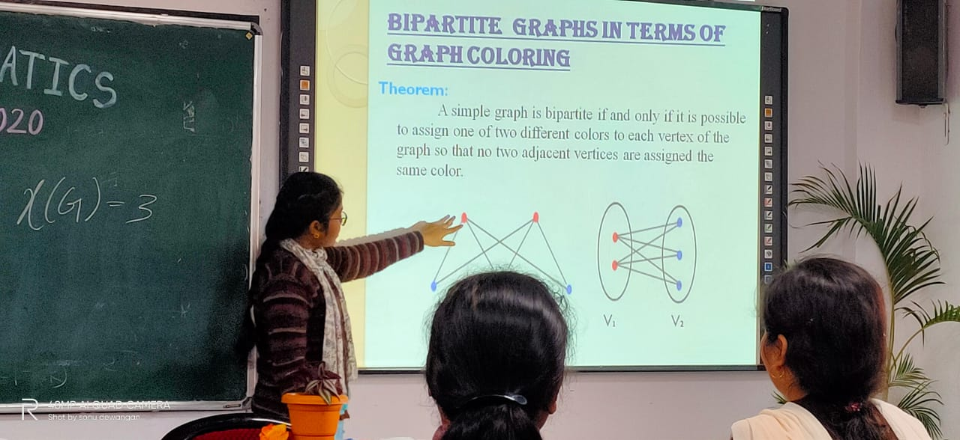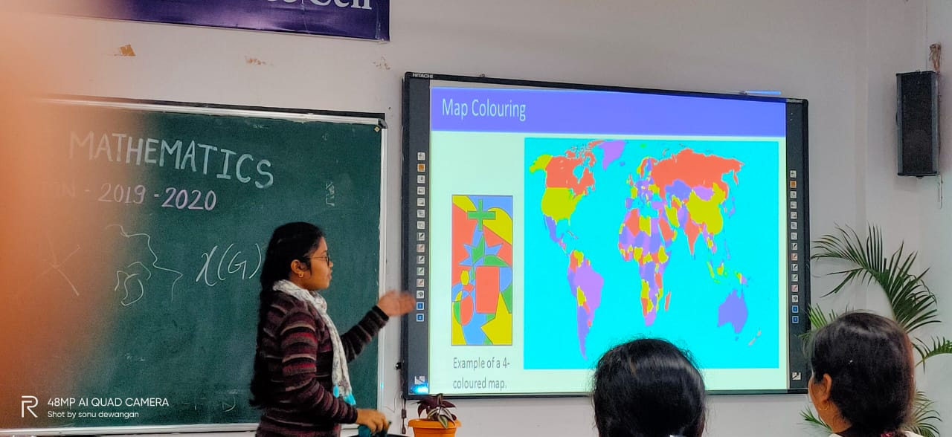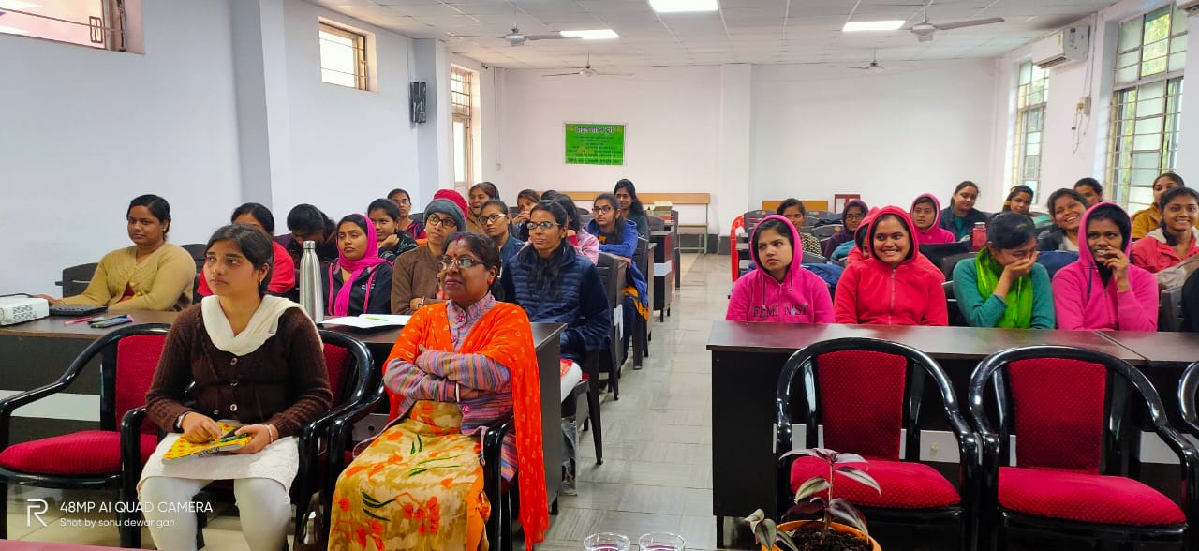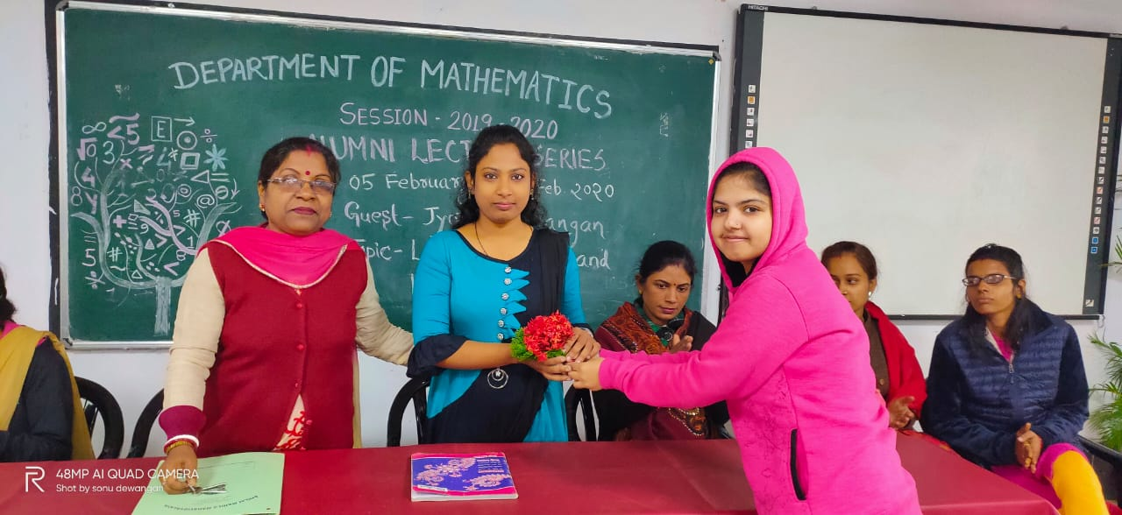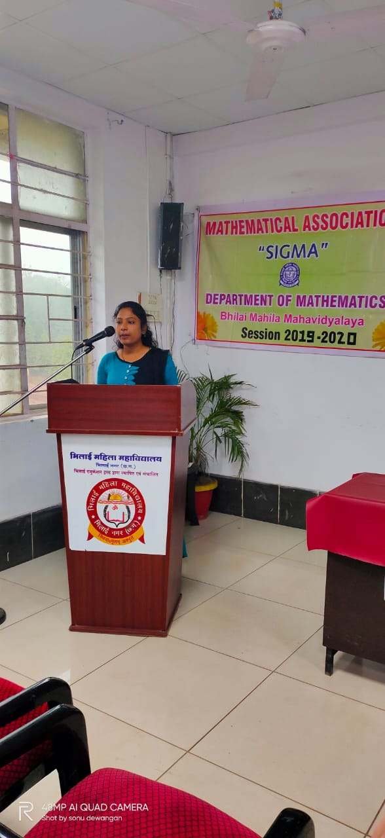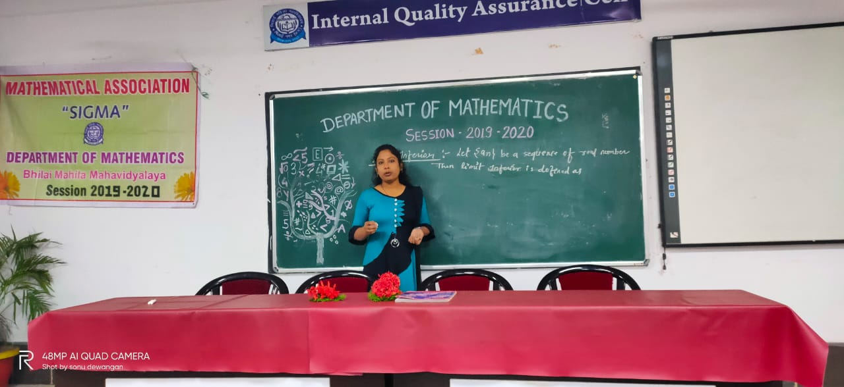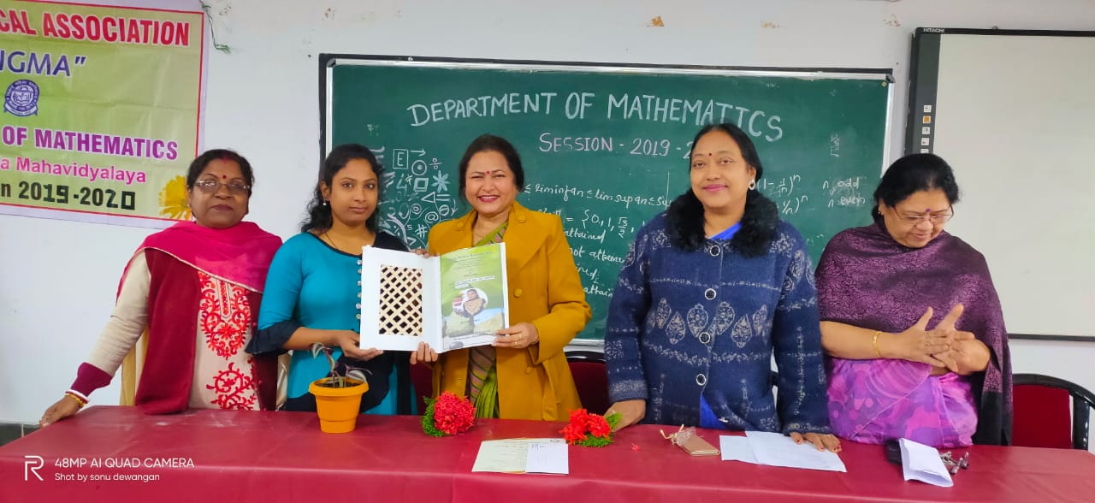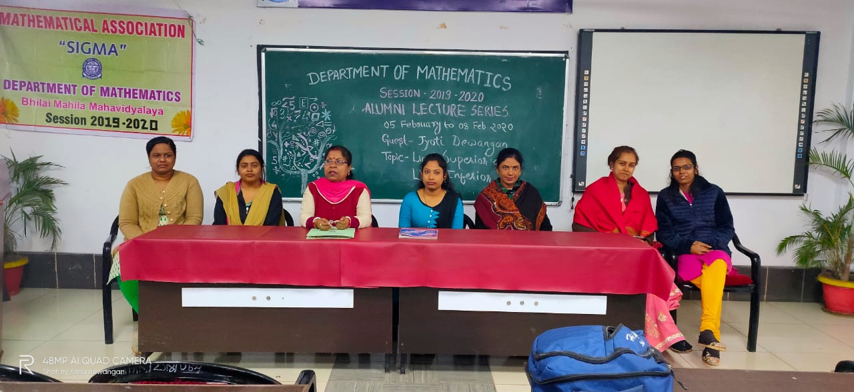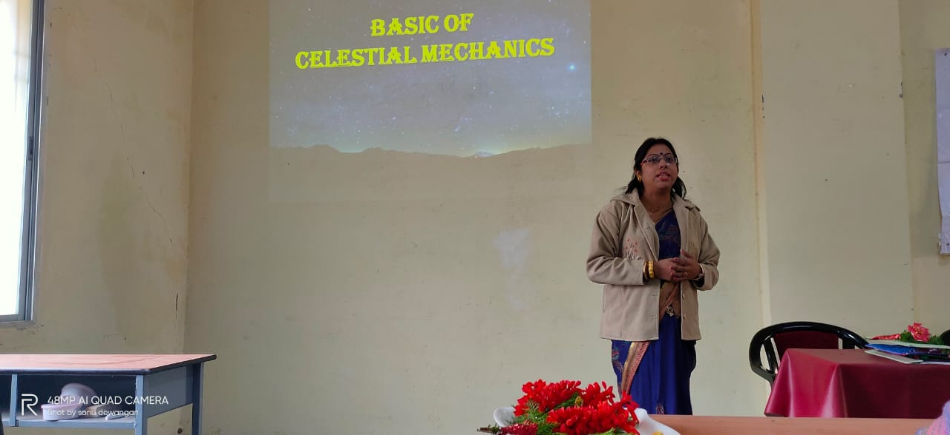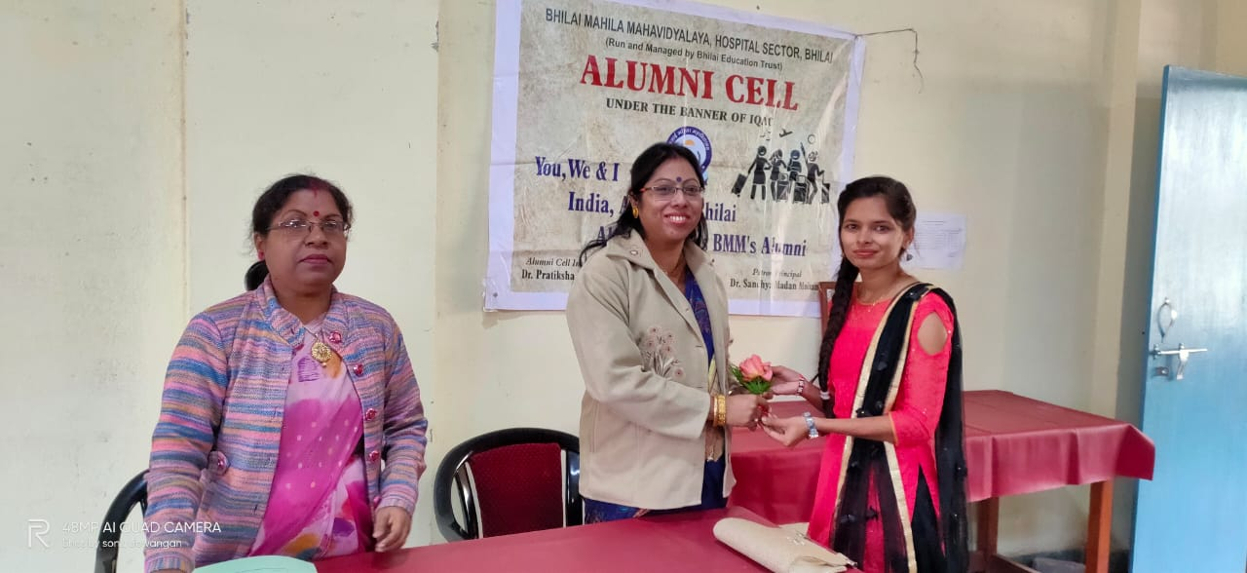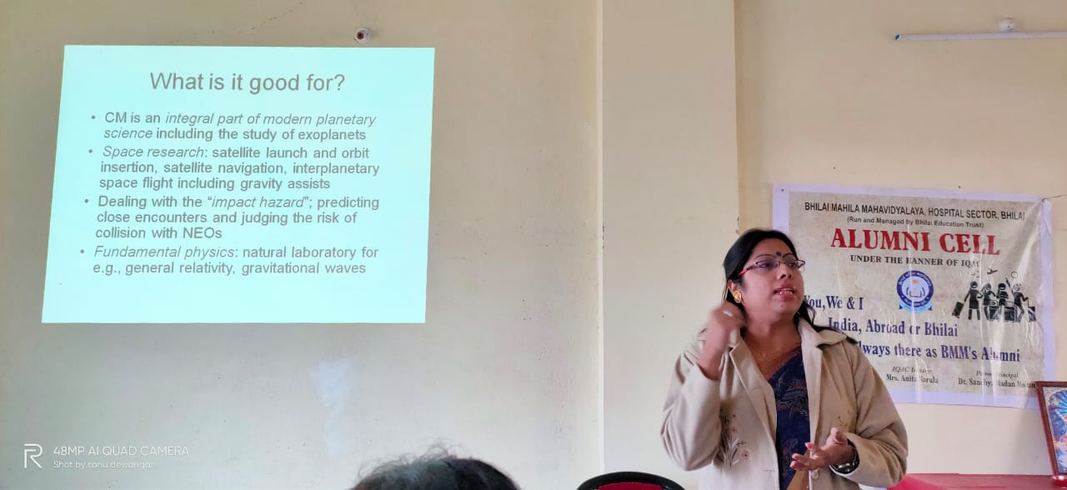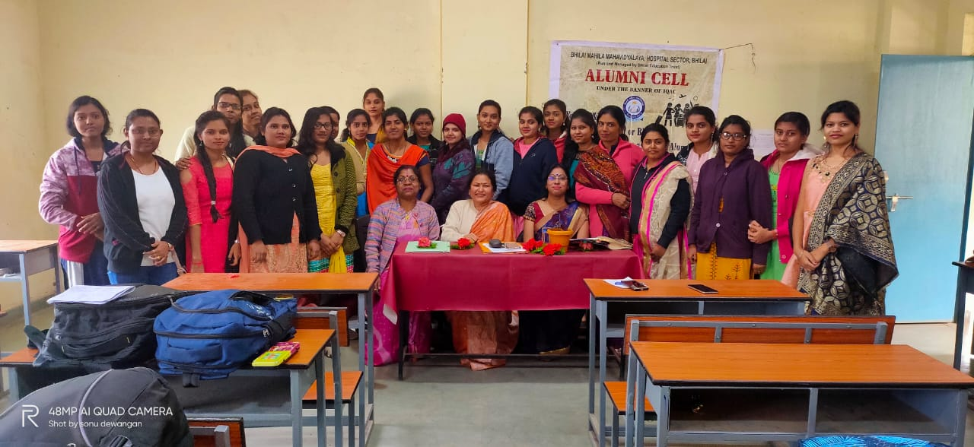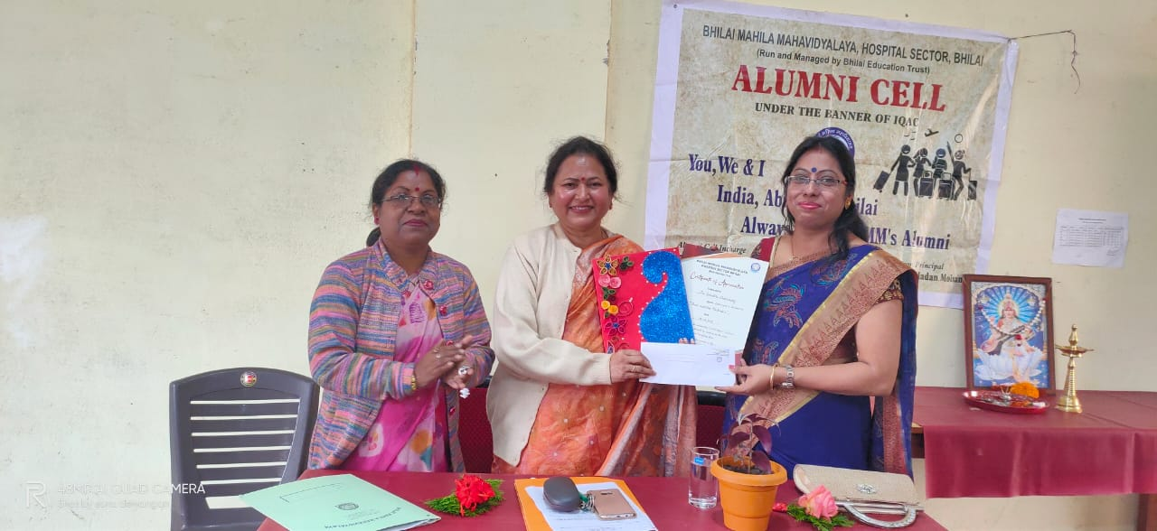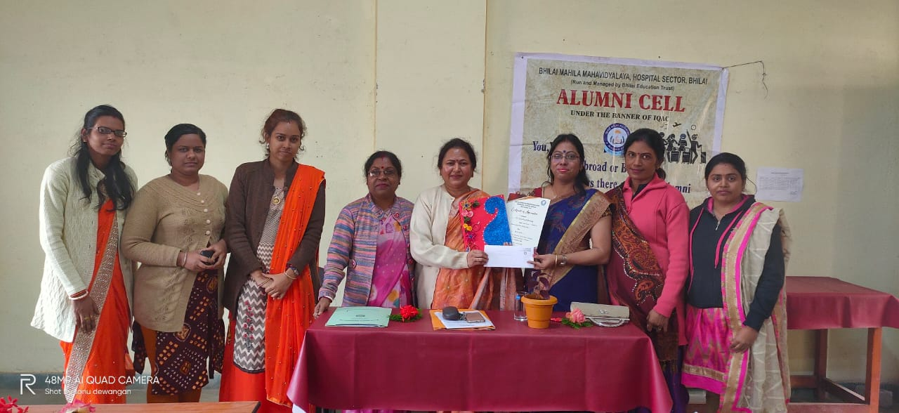
Alumni guest lecture series Botany
S | Department | Date of lecture | Topic | Name of the Alumni | No of student | Remark
 | Botany | 6-1-2020 | Transcription and translation in prokaryotes and eukaryotes | Mrs. Anuradha Sahu, Govt. Higher Secondary School, Hardi , Rajnandgaon, Chhattisgarh | 34
 | Botany | 6-1-2020 | Epidimology | Ms. Varsha Yadav, Headof the department, Botany, Shri Shankracharya,Mahavidyalaya, Junvani, Bhilai, Chhattisgarh | 36
 | Botany | 7-1-2020 | Microsporogenesis | Mrs. Rizwana Khatoon, Assistant Professor of department of Botany, Rungta college of Science and Technology, Ganjapara, Durg, Chhattisgarh | 35
 | Botany | 7-1-2020 | Sensory Photobiology in Plants | Ms. Bhabita Mandavi, Aspirant | 32
 | Botany | 8-1-2020 | Protein targeting and Protein sorting in organelles | Ms. Tarini Sahu, Lecturer of Department of Botany, St. Thomas College, Ruabandha, Bhilai, Chhattisgarh | 30
 | Botany | 8-1-2020 | Conservation in Biodiversity | Ms. Heena Verma, Aspirant | 38
 | Botany | 10-1-2020 | Singal transduction | Mrs. Kanxilata, Mata Karma PG, College, Gunderdehi Durg, Chhattisgarh | 33
 | Botany | 11-1-2020 | Secondary metabolites :Natural products | Dr. Niharika Dewangan, HOD, Botany, Swami Shree Swroopanand Saraswati Mahavidyalaya, Bhilai, Chhattisgarh | 37

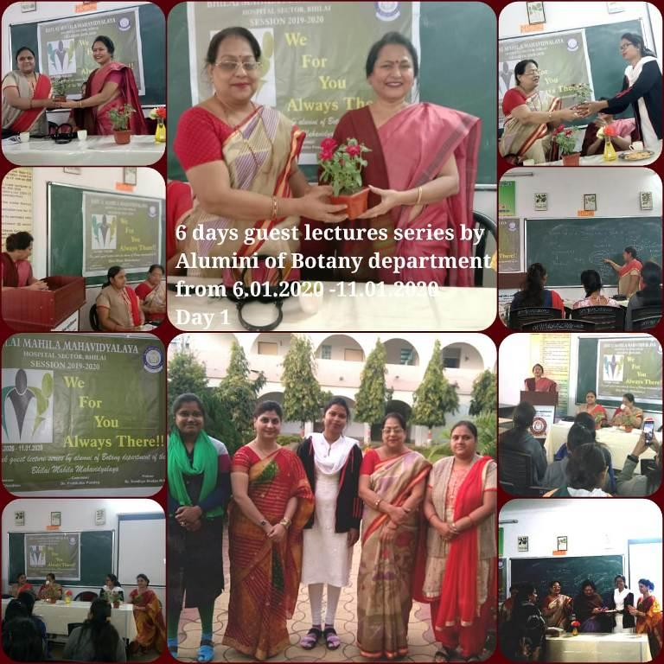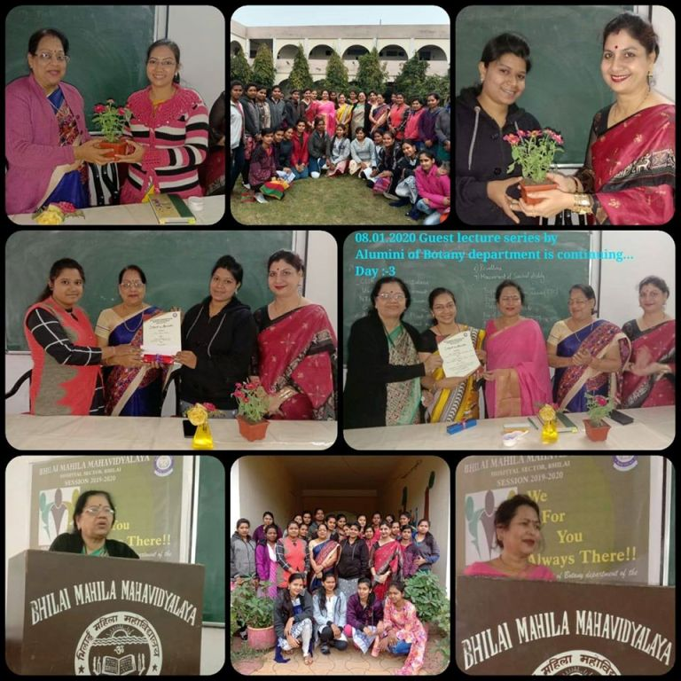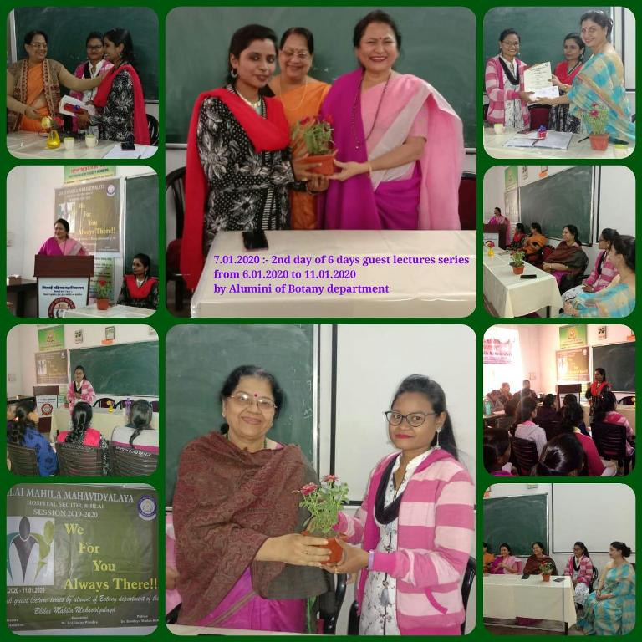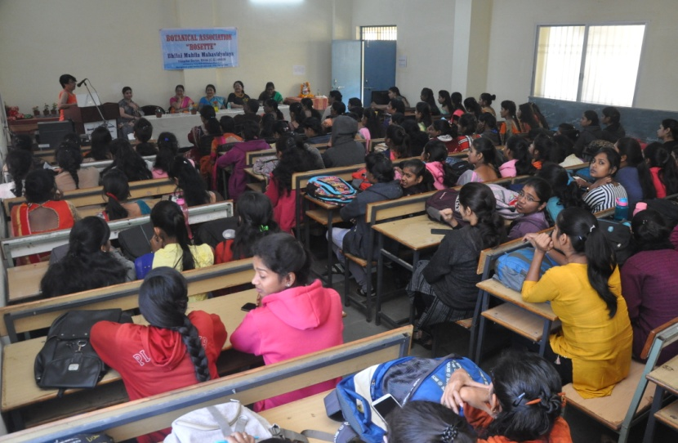

Alumni guest lecture series conducted by Department of Chemistry
S.N | Department | Date of Delivered Lecture | Topic of the Lecture | Name of the Alumni and their details | No of Students attended | Remarks
1. | Chemistry | 13.01.2020 | Quantum operators and Approximate methods. | Dr.Toshikee Yadav Centre of Basic Sciences, Pt.Ravishankar ShuklaUniversity, Raipur, Chhattisgarh. | 38
2. | Chemistry | 14.01.2020 | Photoelectron Spectroscopy | Ku. Ravina Rajput Guest Lecture, Govt. College, Rajnandgaon.  Chhattisgarh. | 39
3. | Chemistry | 15.01.2020 | Ion Exchange Chrometography | Ku. Sushmita Tandi Lecturer, Jamul.  Chhattisgarh. | 33
4. | Chemistry | 16.01.2020 | Heterolytic Compounds | Ku. Sushma Yadav Research Scholar, Govt. V.Y.T.PG Autonomous College, Durg. Chhattisgarh. | 37
5. | Chemistry | 17.01.2020 | Electronic Spectroscopy | Dr. Aruna Sao,  Asst.Professor,  Govt. College, Arjunda,  Chhattisgarh. | 38
6. | Chemistry | 18.01.2020 | Research Methodology | Ku. Pratibha Kurup  Asst.Professor,  Chhatrapati Shivaji Institute of Technology, Durg  Chhattisgarh. | 36

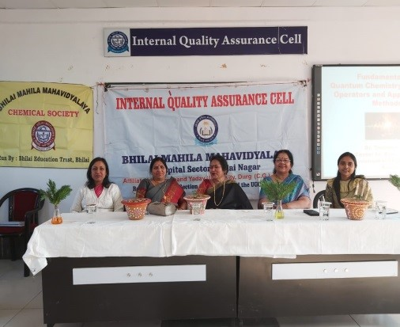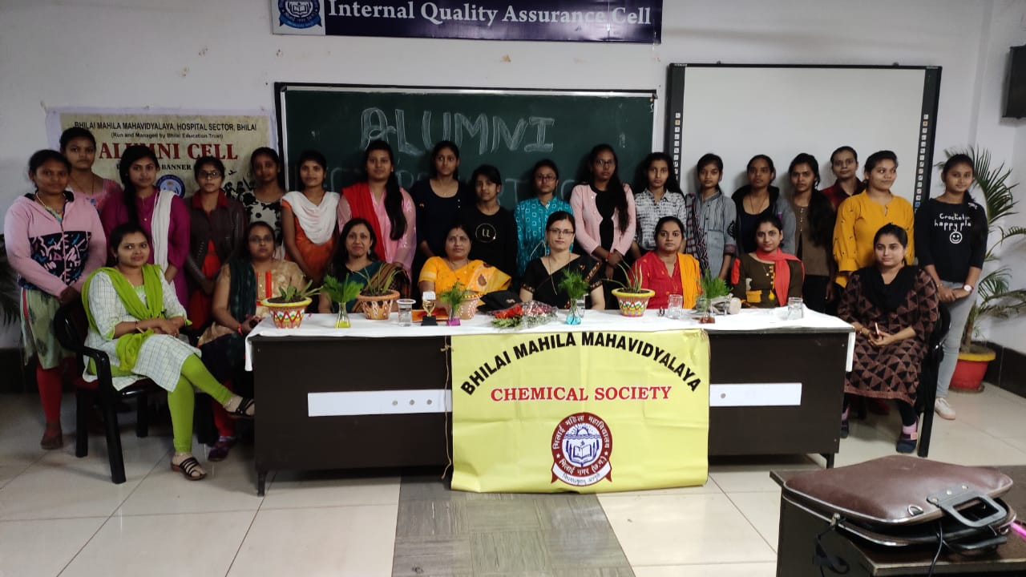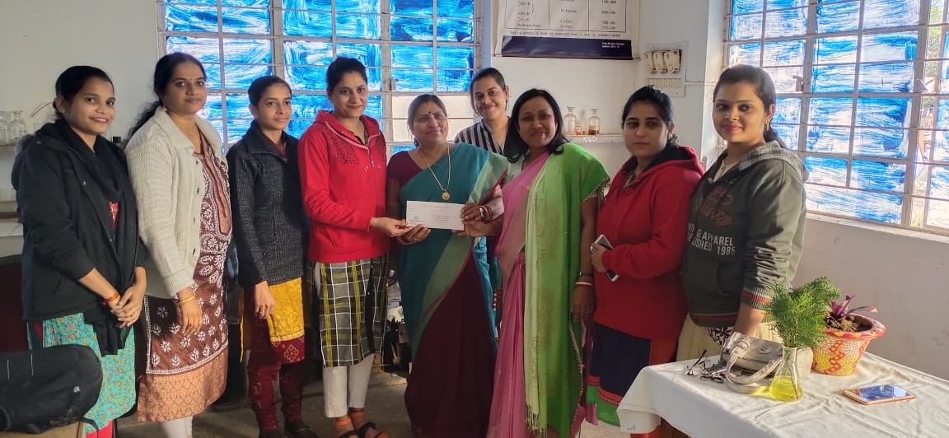
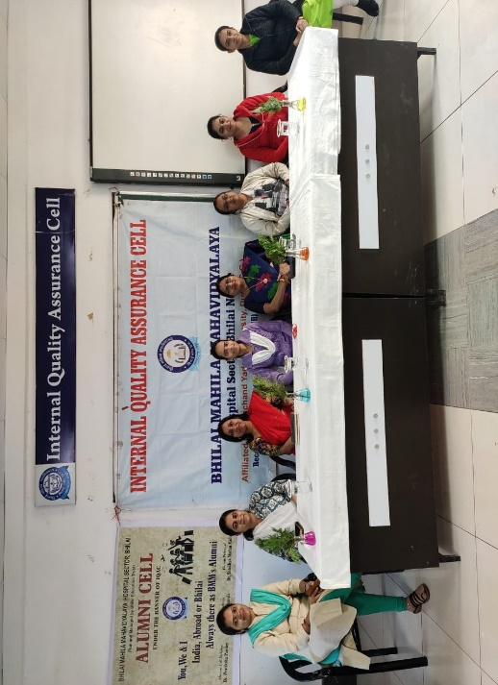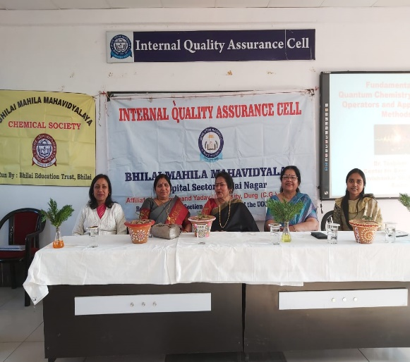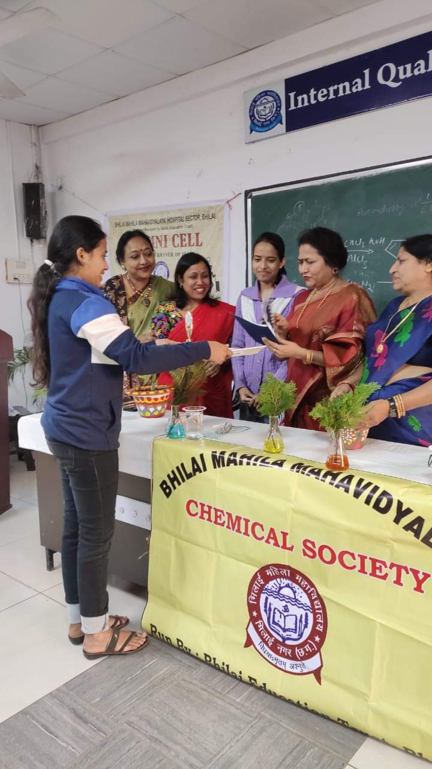

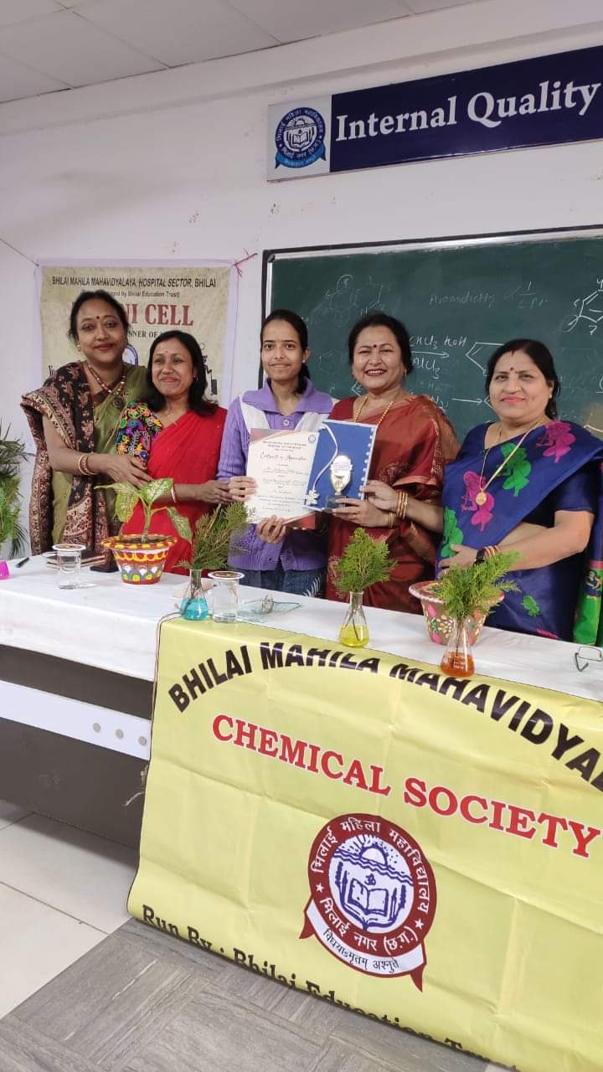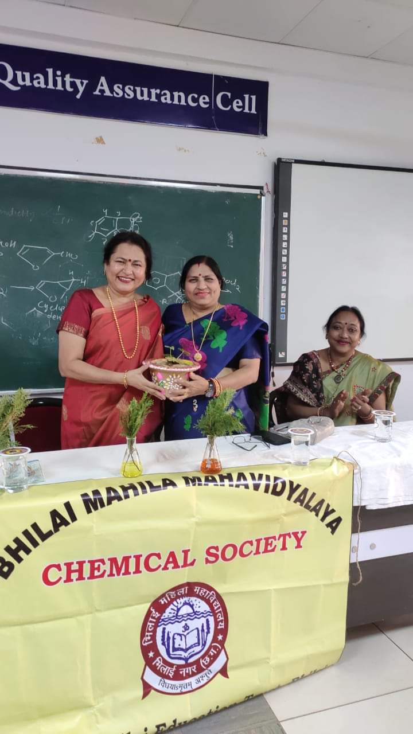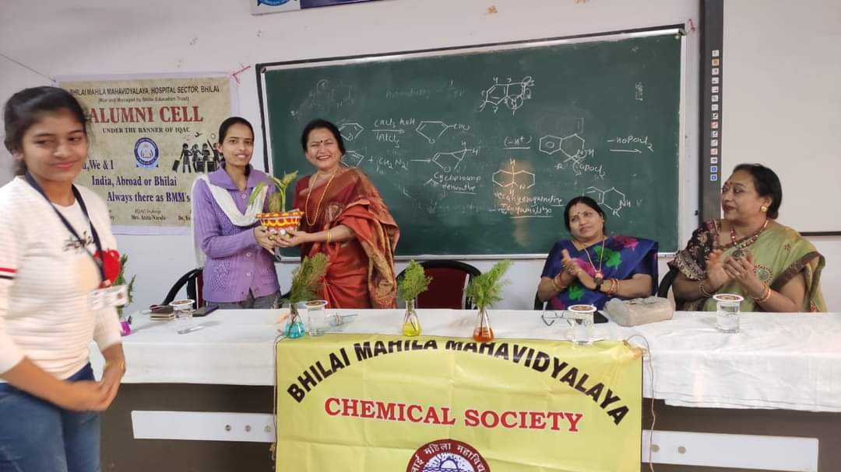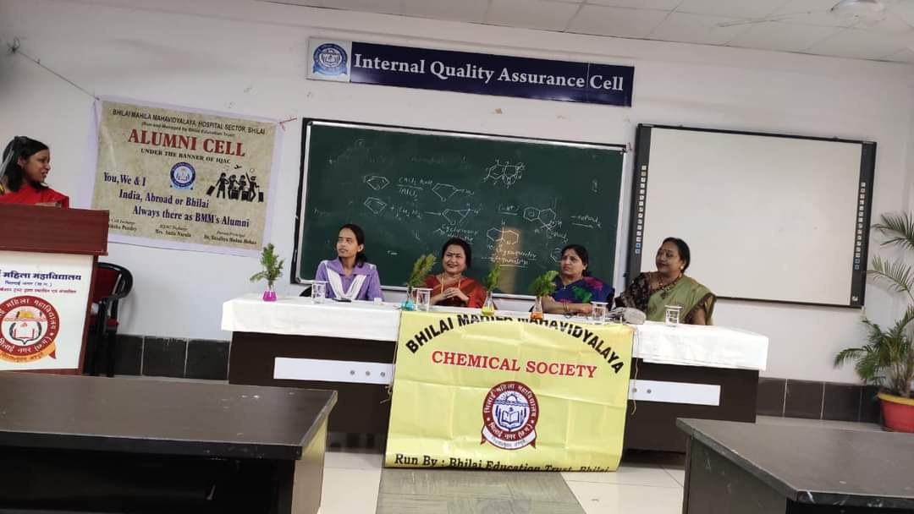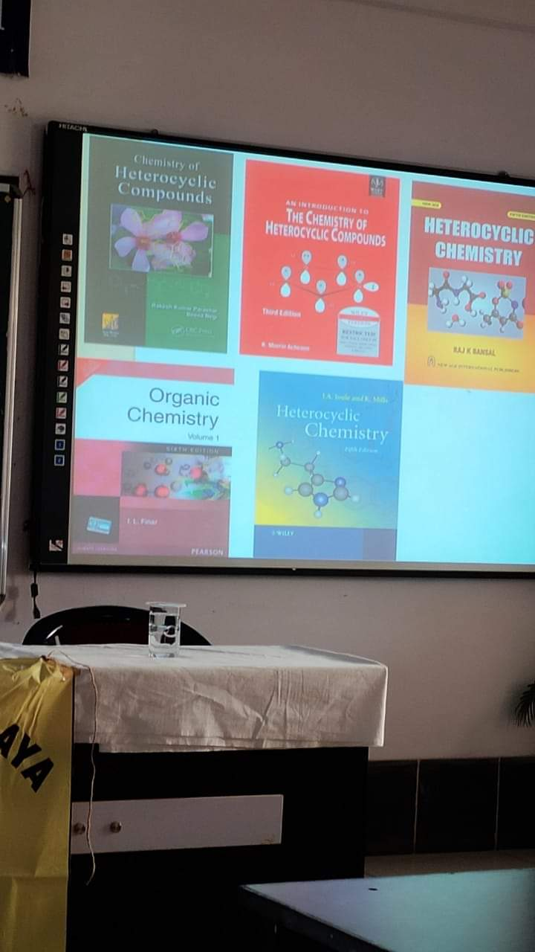

ALUMNI LECTURE SERIES(Physics)
S.NO. | NAME OF DEPARTMENT | DATE OF CLASS | TOPIC | NAME OF ALUMNI | NO.OF STUDENTS WHO ATTENDED THE CLASS | REMARKS (if any)
1 | Physics | 13/1/20 | Statistical Mechanics | Ms Khushboo Sharma | 20
2 | Physics | 14/1/20 | Superposition of two Simple Harmonic motion of the same Frequency | Mrs Tulika Harshit | 94
3 | Physics | 16/1/20 | Optical fibre | Dr. Mimi A. Pateria | 20
4 | Physics | 17/1/20 | Polarisation of Light | Mrs. Siteshwari Chandrakar | 107
5 | Physics | 18/1/20 | Silicon Controlled Rectifier | Dr Sanjay Parganiha | 20

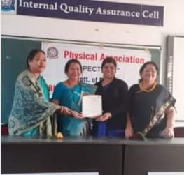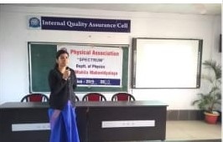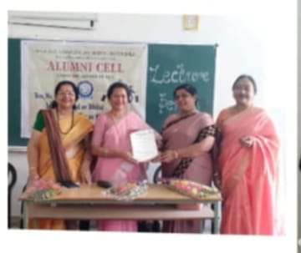

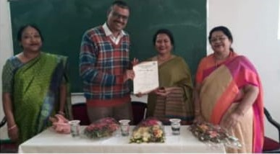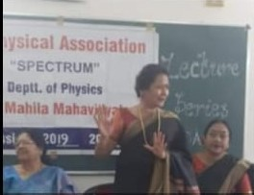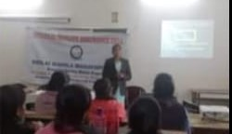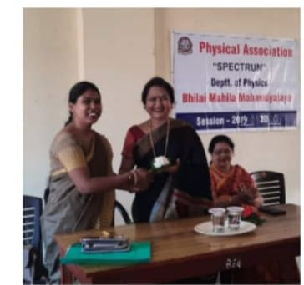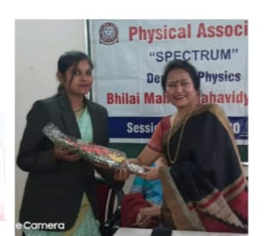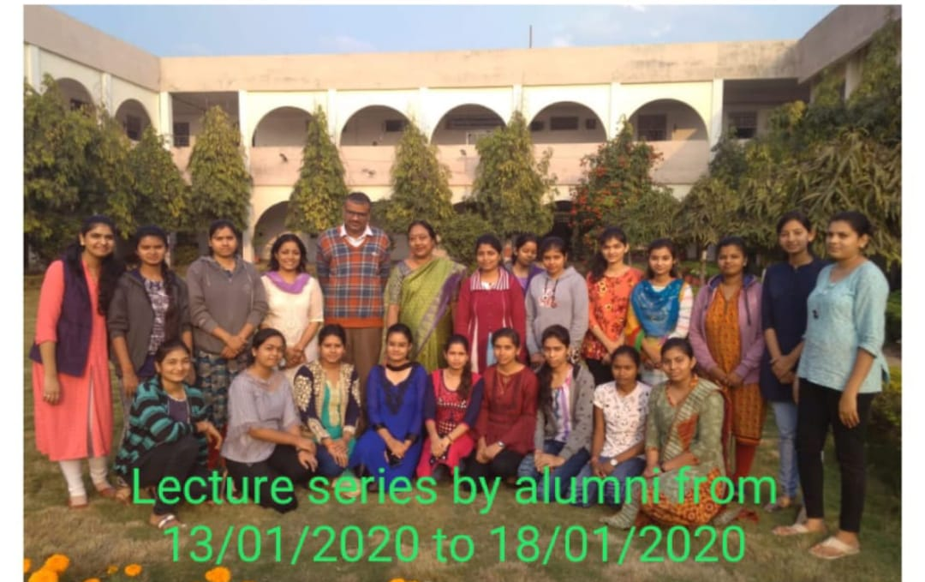
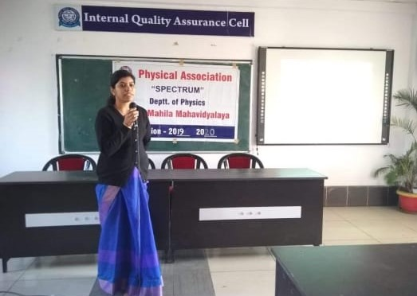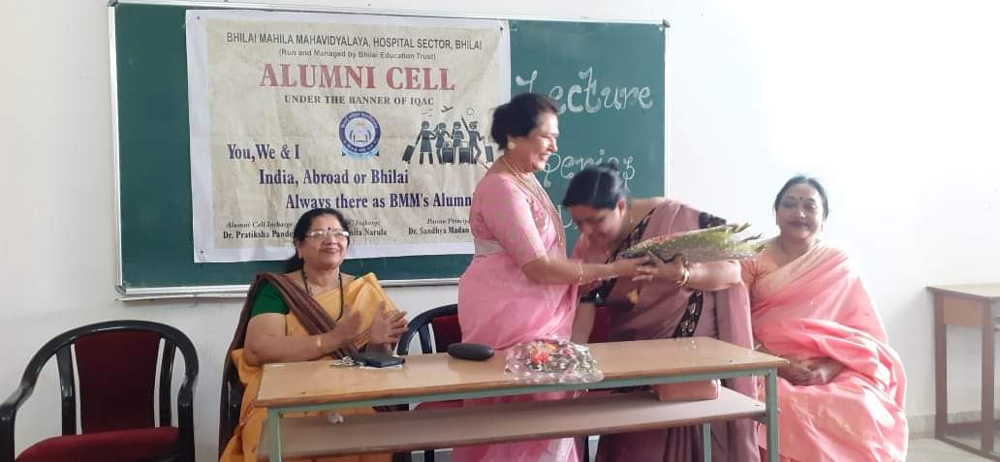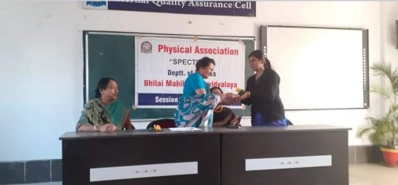
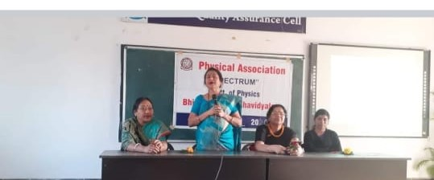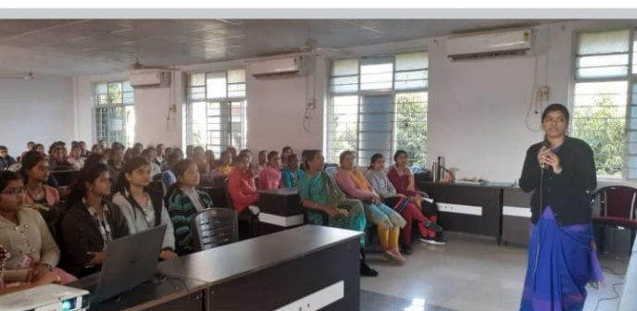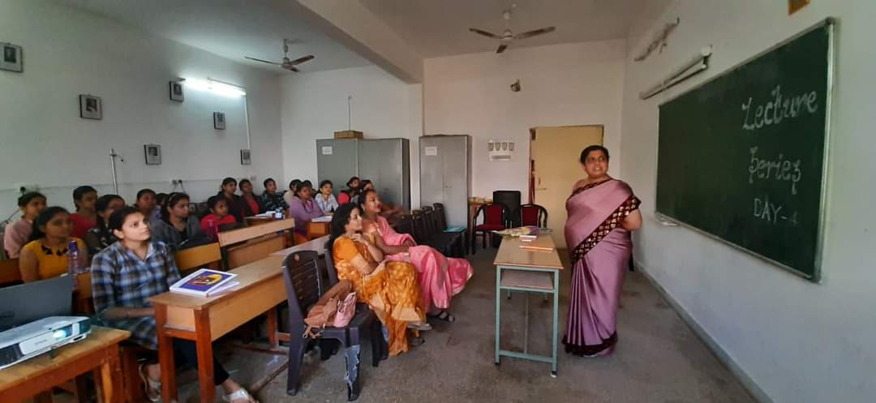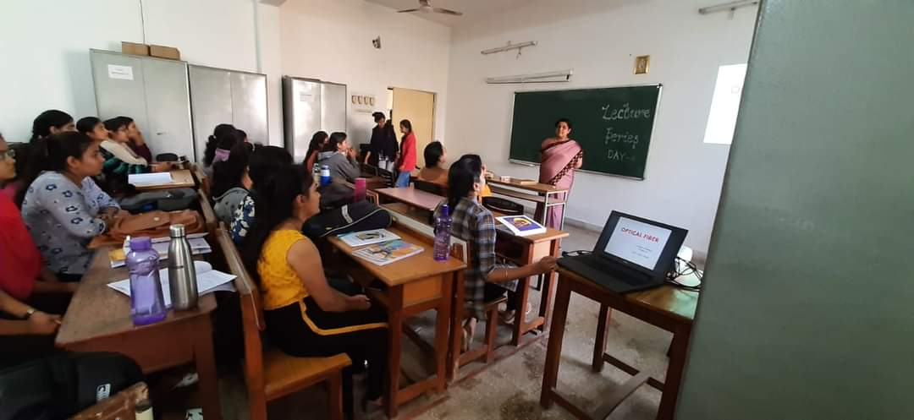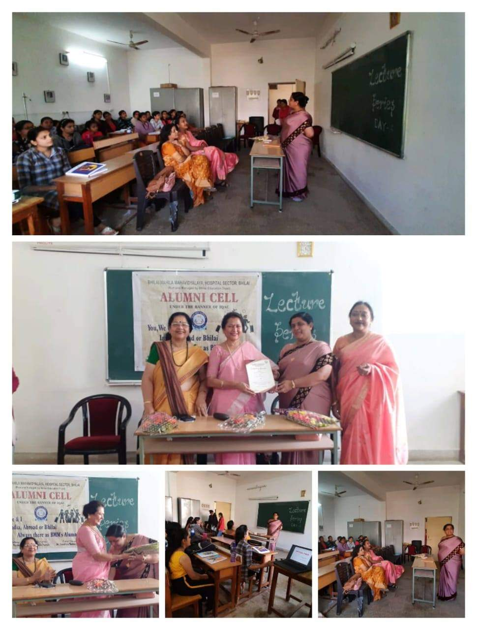

DEPARTMENT OF ZOOLOGY
S.No. | Name Of Department | Date Of Class | Topic | Name Of The Alumni | No Of Students Who Attended The Class
1 | ZOOLOGY | 27/02/2020 | Nerve and Neural Transmission | Dr. Nisreen Husain | 36
2 | ZOOLOGY | 28/02/2020 | Function of Mitochondria | Miss Sarita Verma | 35
3 | ZOOLOGY | 29/02/2020 | Membrane Receptor And CSIR NET Preparation guideline | Miss Pooja Tiwari | 22
4 | ZOOLOGY | 02/03/2020 | Poster Designing | Miss Neha Tiwari | 37
5 | ZOOLOGY | 03/03/2020 | Heterochromatin and DNA Methylation | Dr. Hema Kulkarni | 38
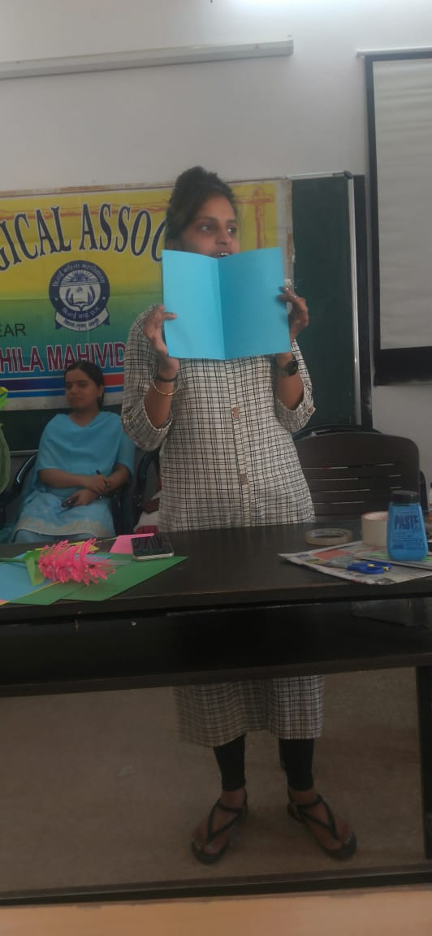
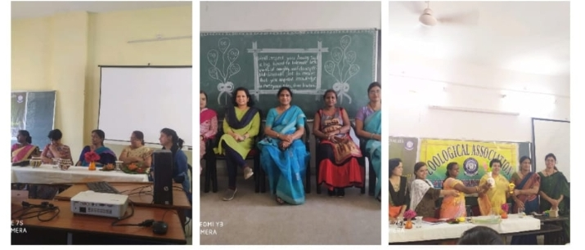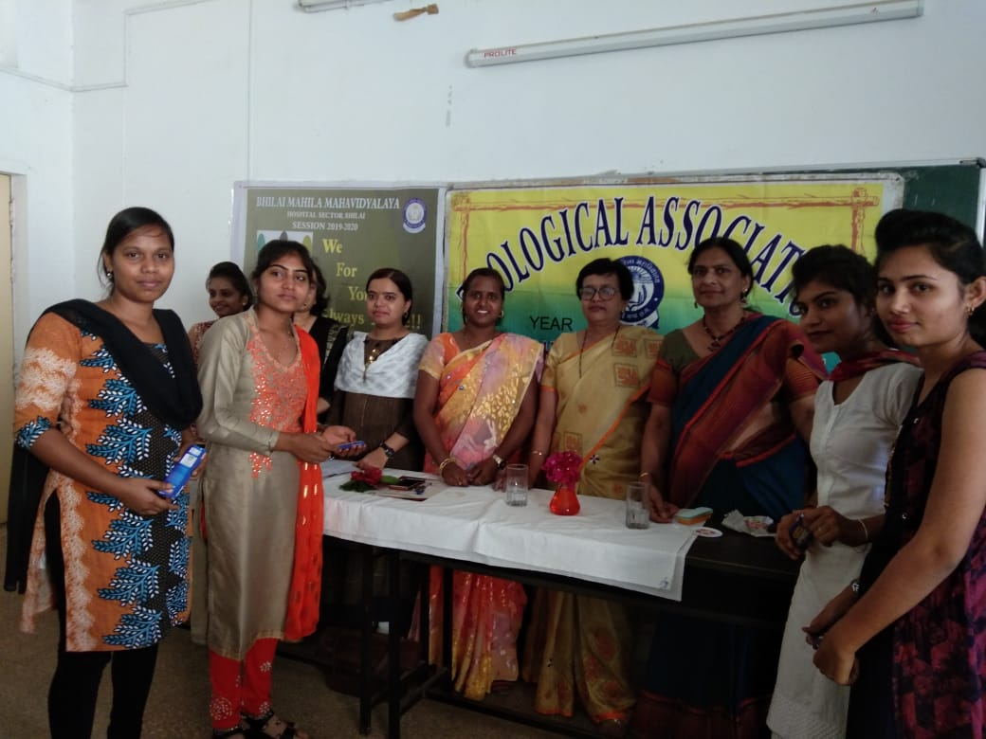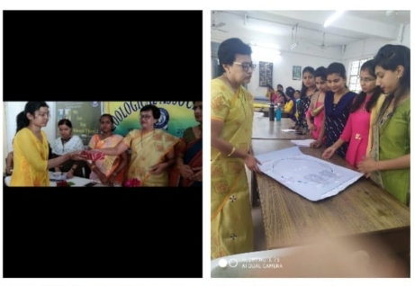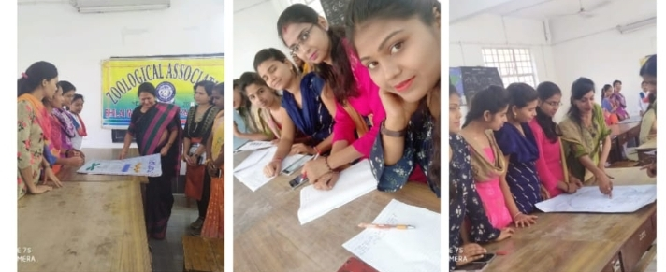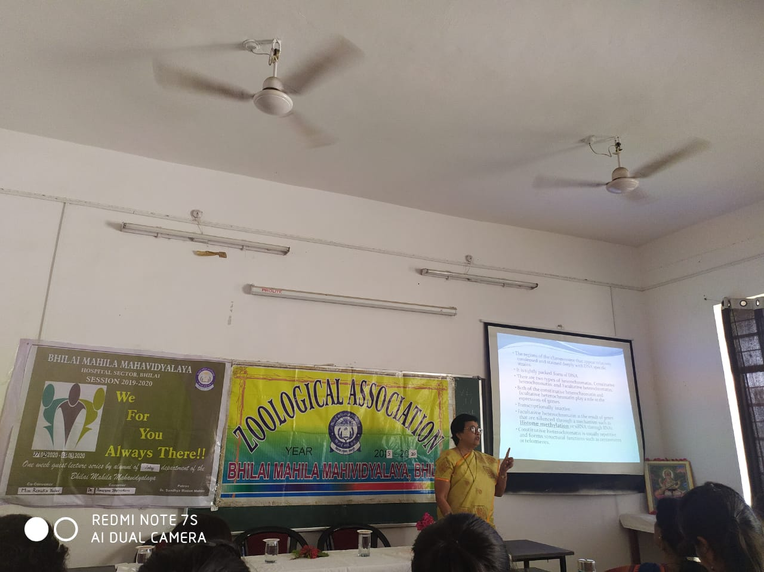
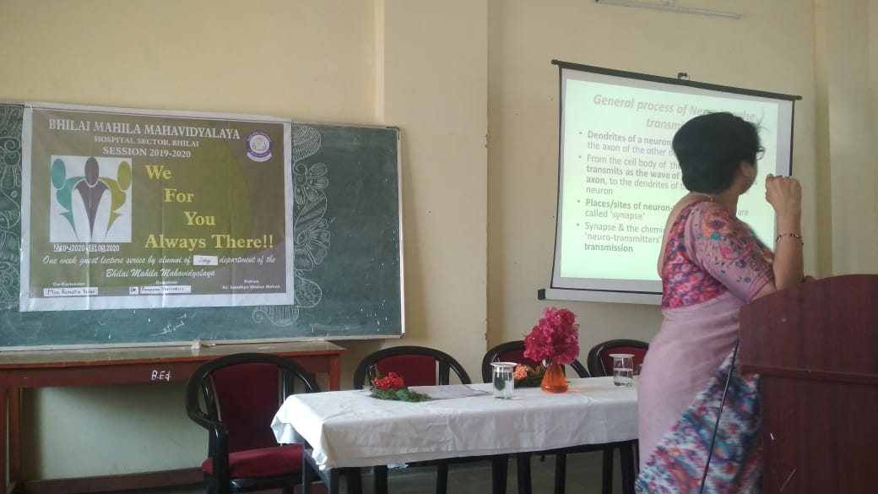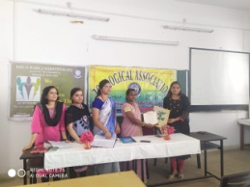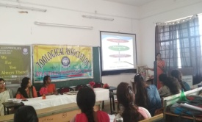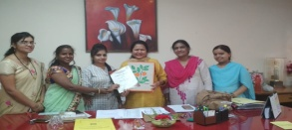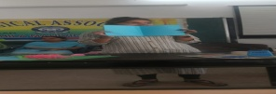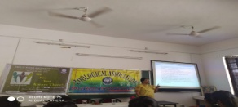

Brilliant results over the years with the hard-work and dedication put in by the Teaching Staff
Institute distinctiveness (3)
University Gold Medallists and Merit list holder year wise.
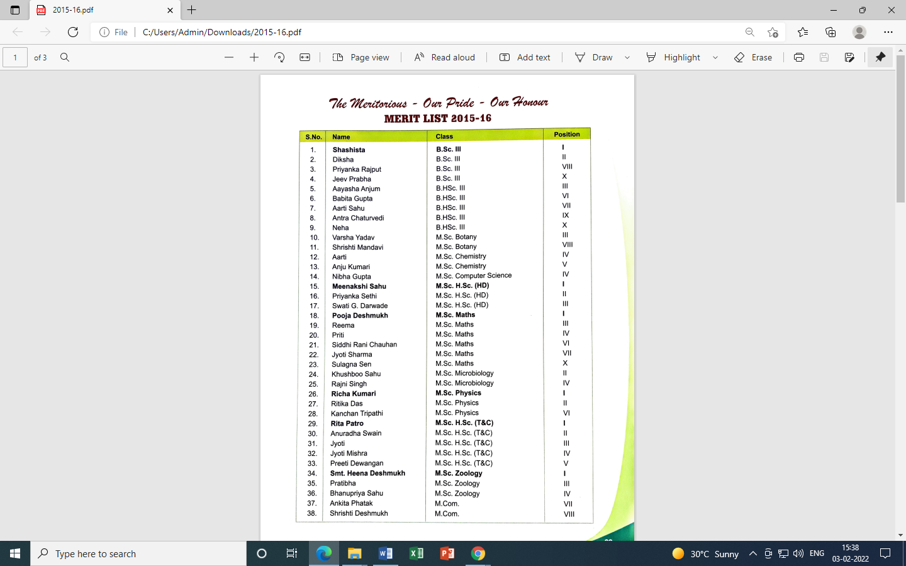

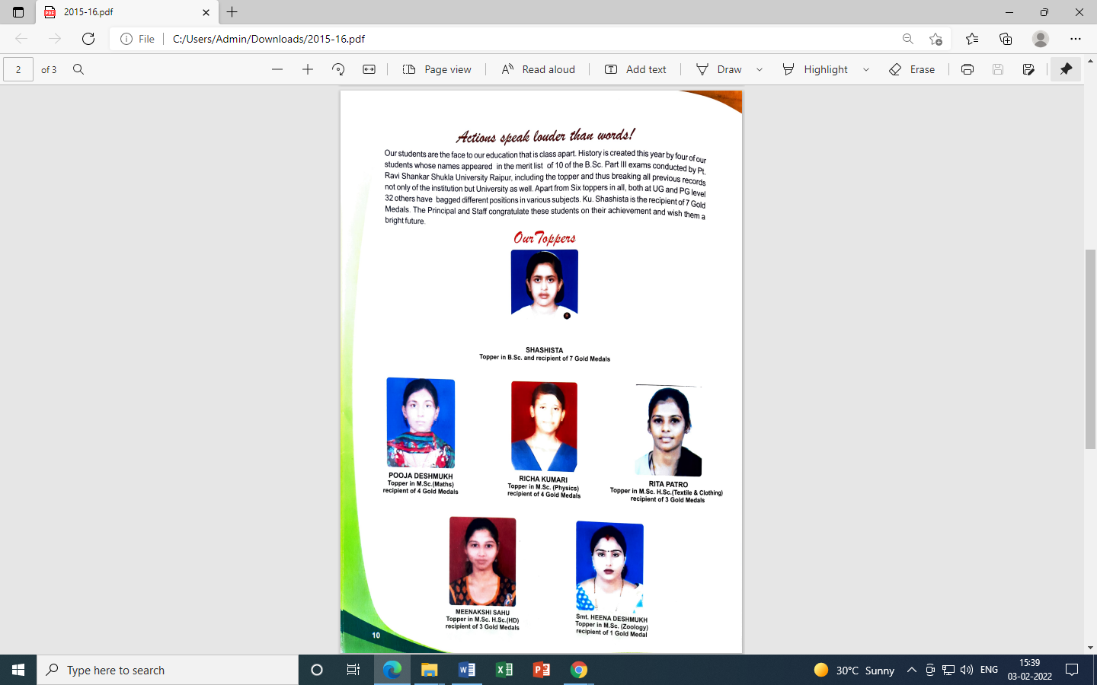

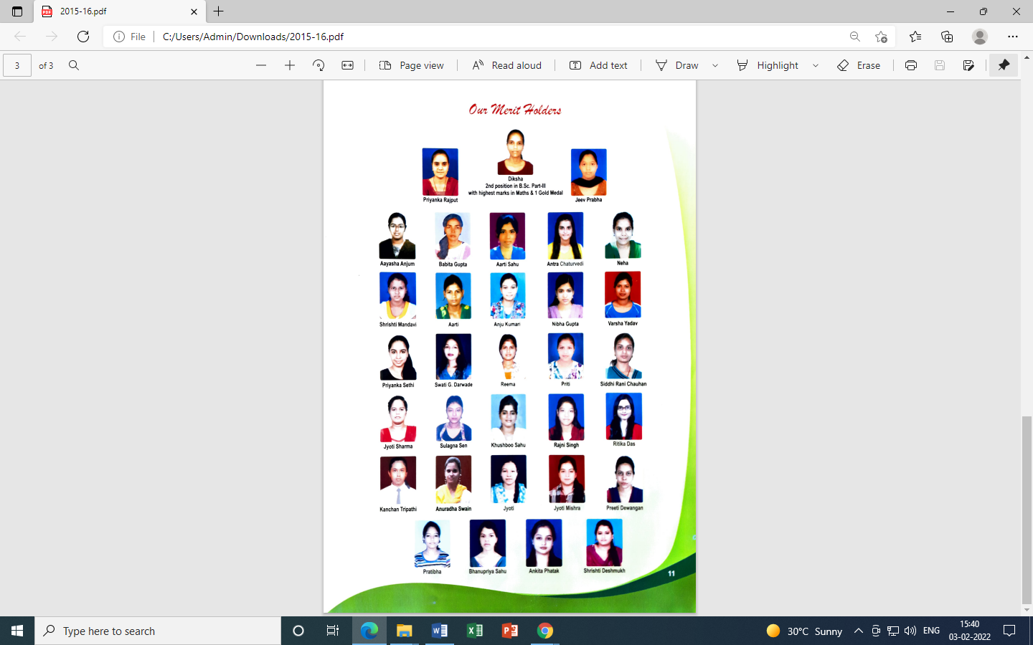
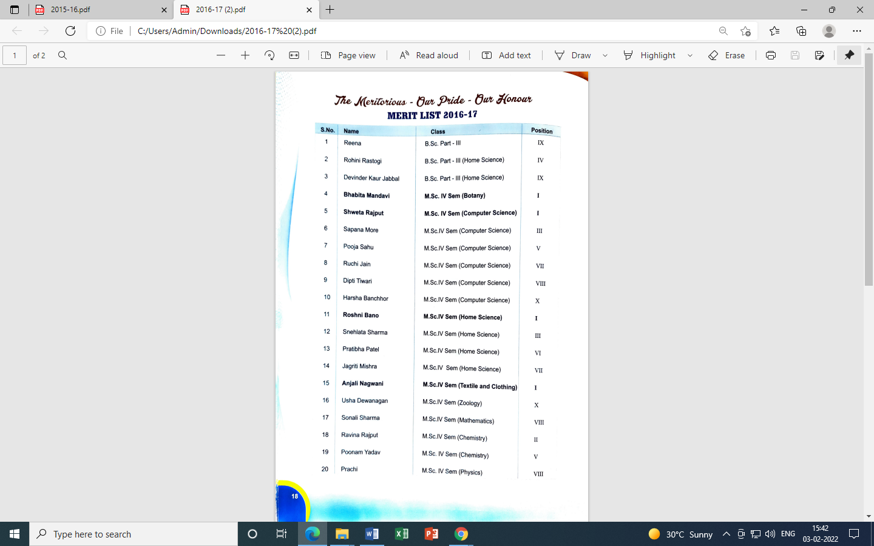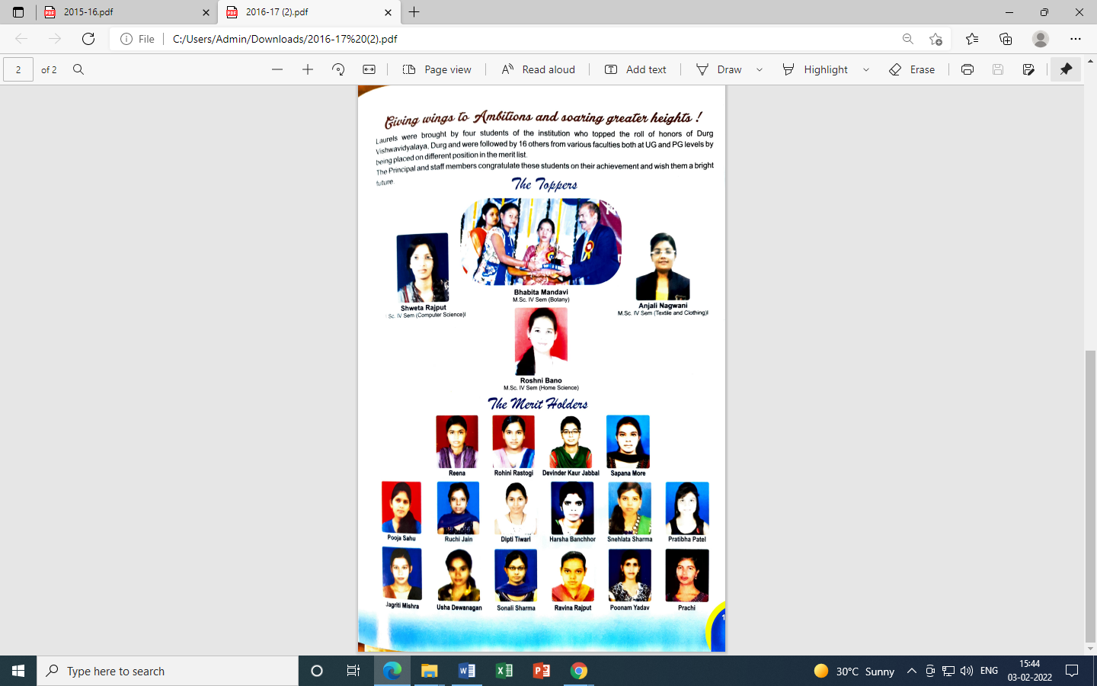

2018-19
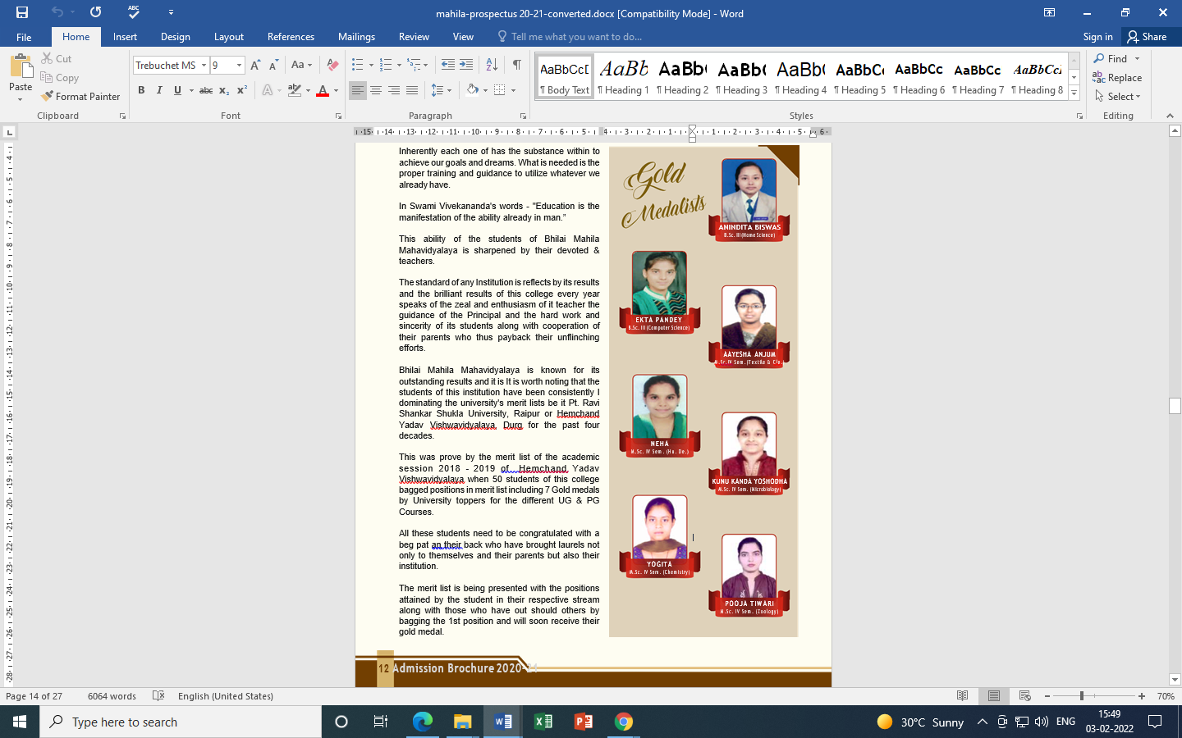

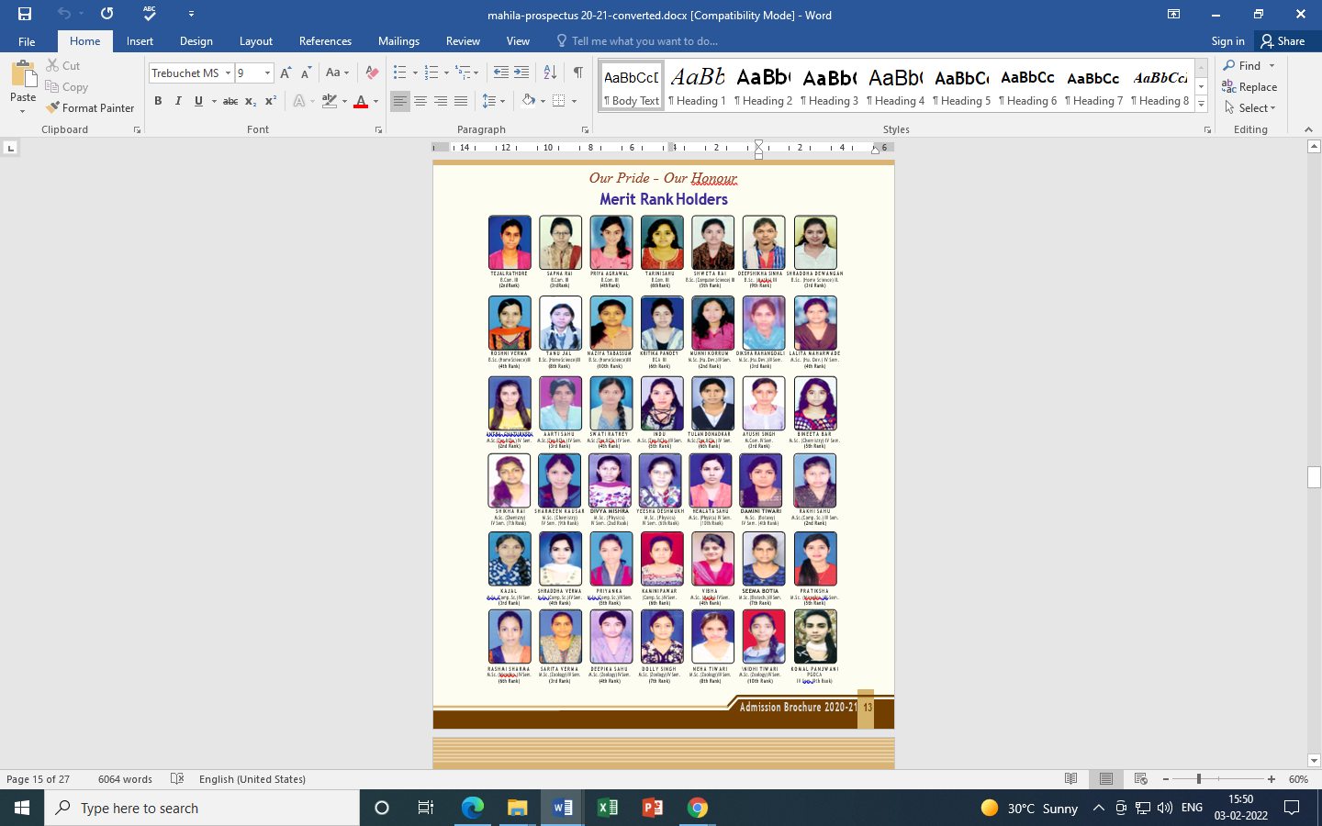

2019-2020

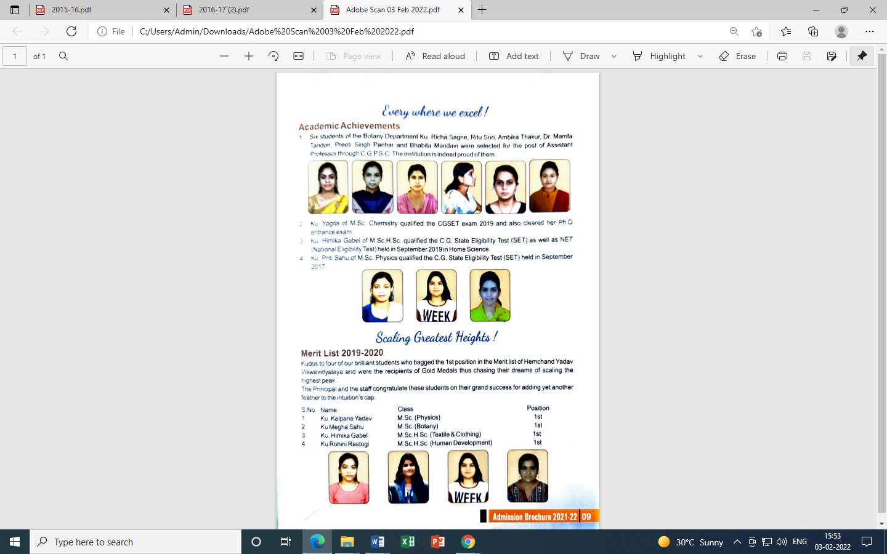
Concluding Remarks –
We are hereby submitting the SSR prepared by us for the 2nd cycle of NAAC peer team visit. The college has always aimed to stress on the education and all round development of students coming from different strata & society.
The students are trained to face all olds in life and come out with more confidence in their guest for excellence.

