3.2.2. Number of Workshops/ seminars conducted on Intellectual Property Rights (IPR) and Industry-Academia Innovative practices during the last year

3.2.2.1. Total number of workshops/ seminars conducted on Intellectual Property Rights (IPR) and Industry- Academia Innovative practices year wise during last year.

SN | Name of the workshop/ seminar | Department | Number of Participants | Date From – To
 | One day Workshop on  PCR and SDS PAGE | Biotechnology and Microbiology | 73 | 16 th Feb 2023
 | 30 days Value Added Courses on Mushroom Cultivation , Spawn Production and its Post Harvest Management | Biotechnology and Microbiology | 120 | 20th Sep to 20th Oct 2023
 | National Seminar on Financial Awareness for women | Commerce | 280 | 3rd to 4th May 2023
 | Faculty Development Programme on Investment Planning | Commerce | 131 | 6th May 2023
 | Seminar on "Start-up India Policy” (under Youth-20 Summit) -Inspiration to the youth | Commerce | 182 | 23rd February 2023

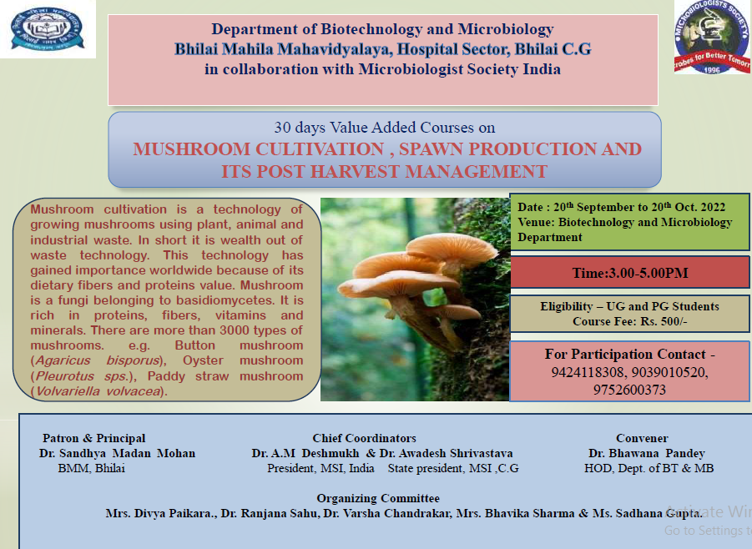

LIST OF PARTICIPANTS IN 30 DAYS VALUE ADDED COURSE

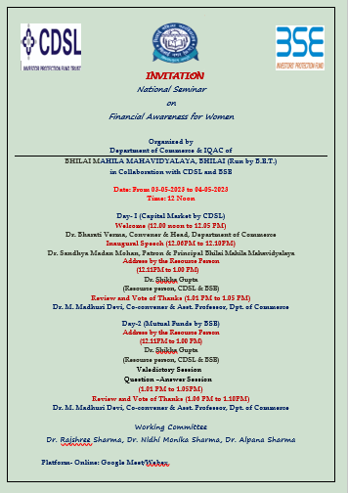

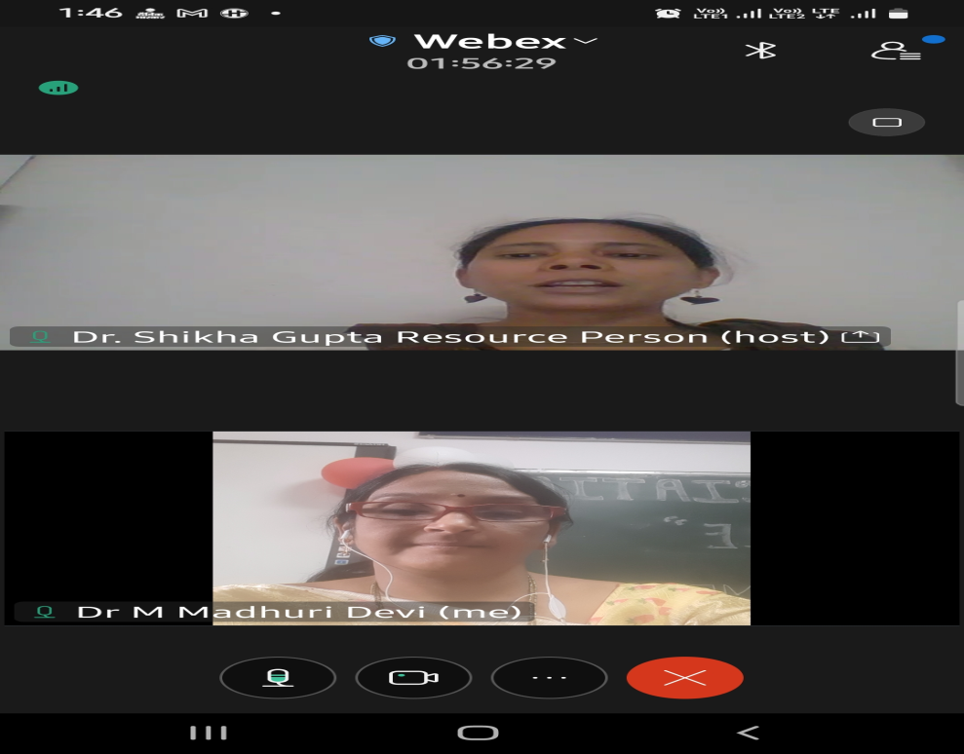

Faculty Development Programme on Investment Planning:
6th May 2023: 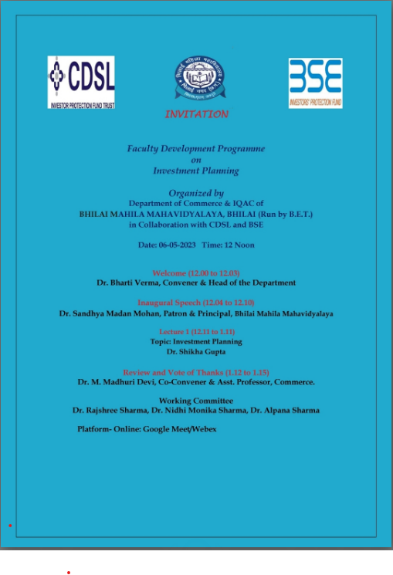

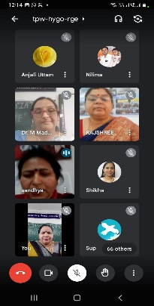

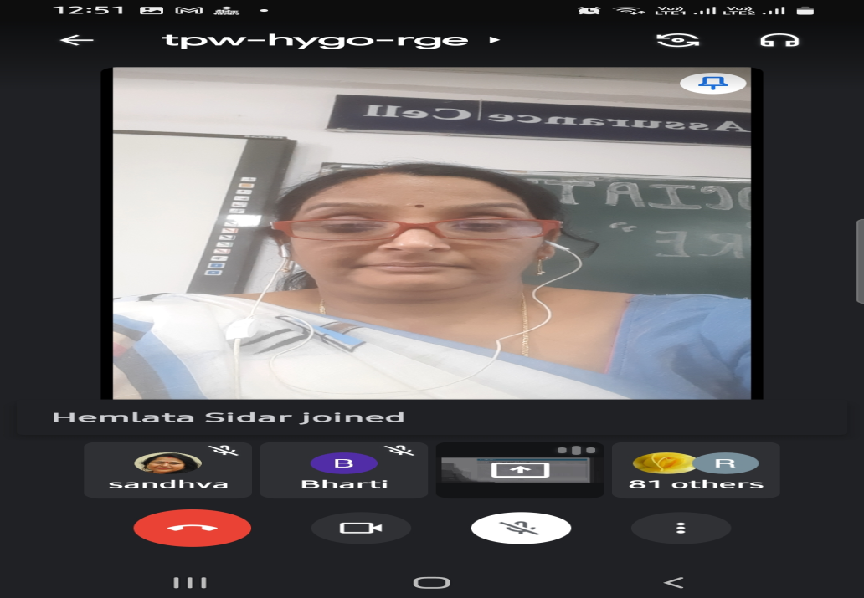

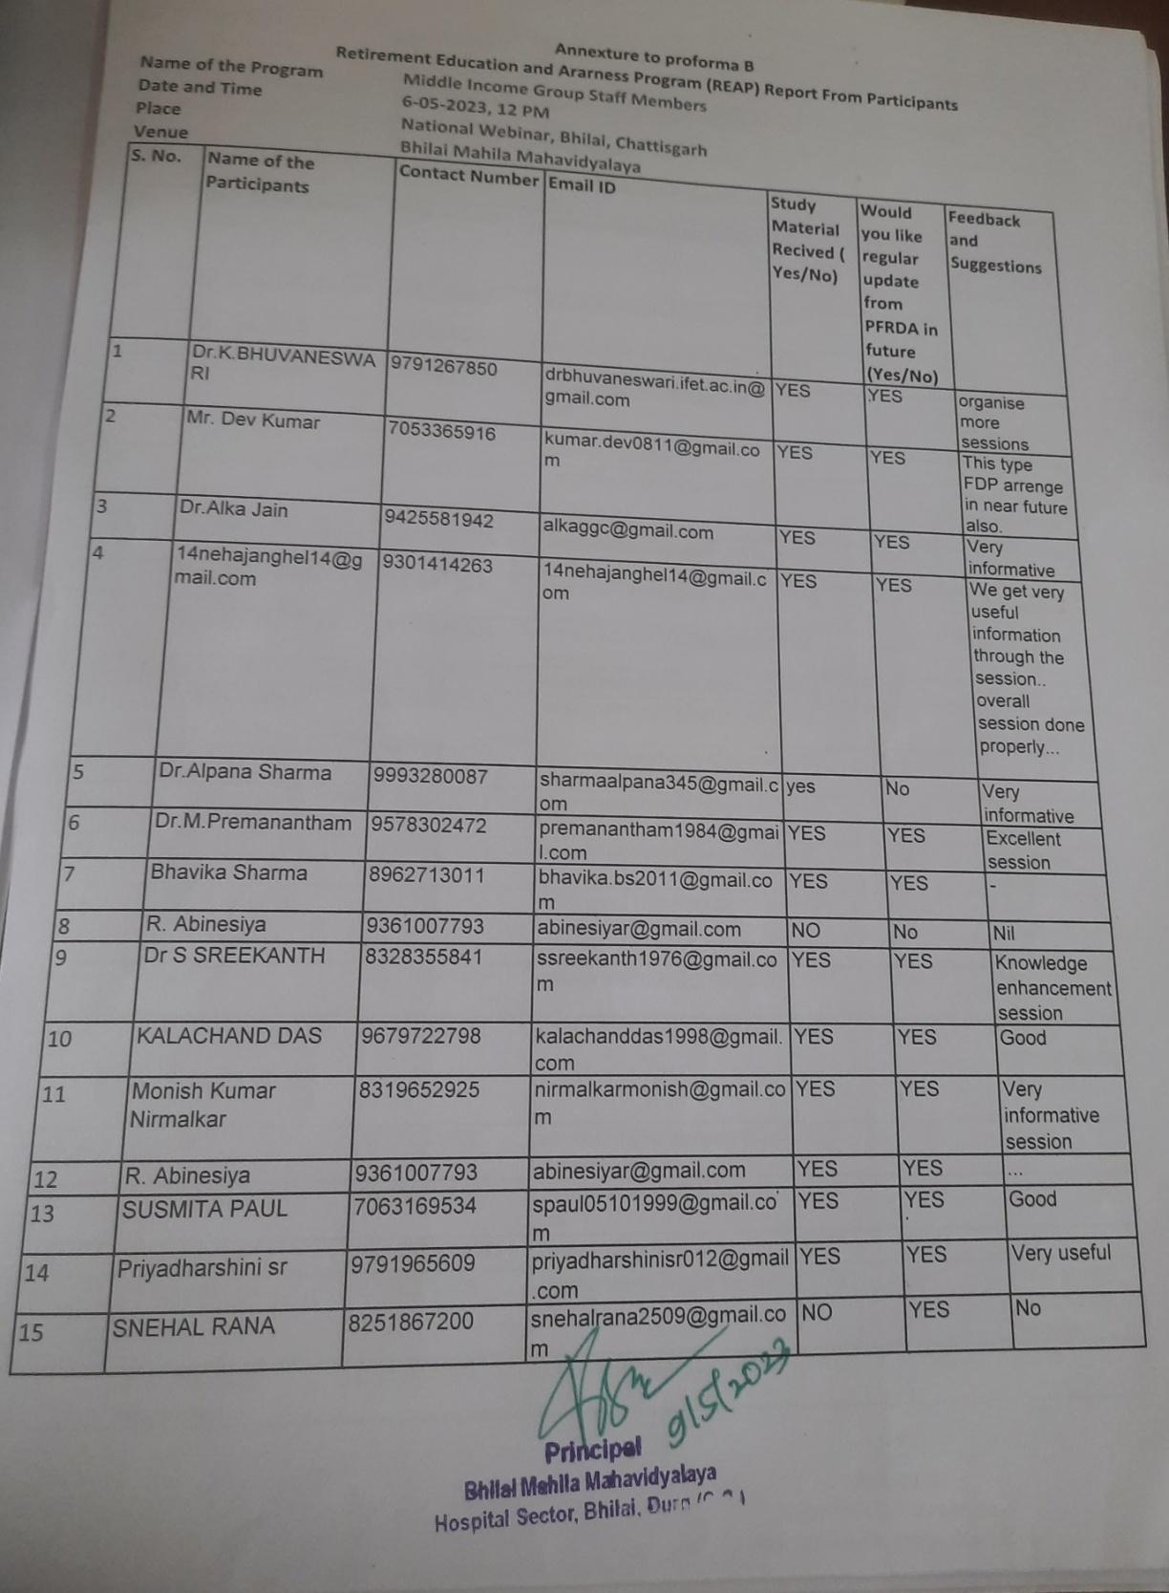

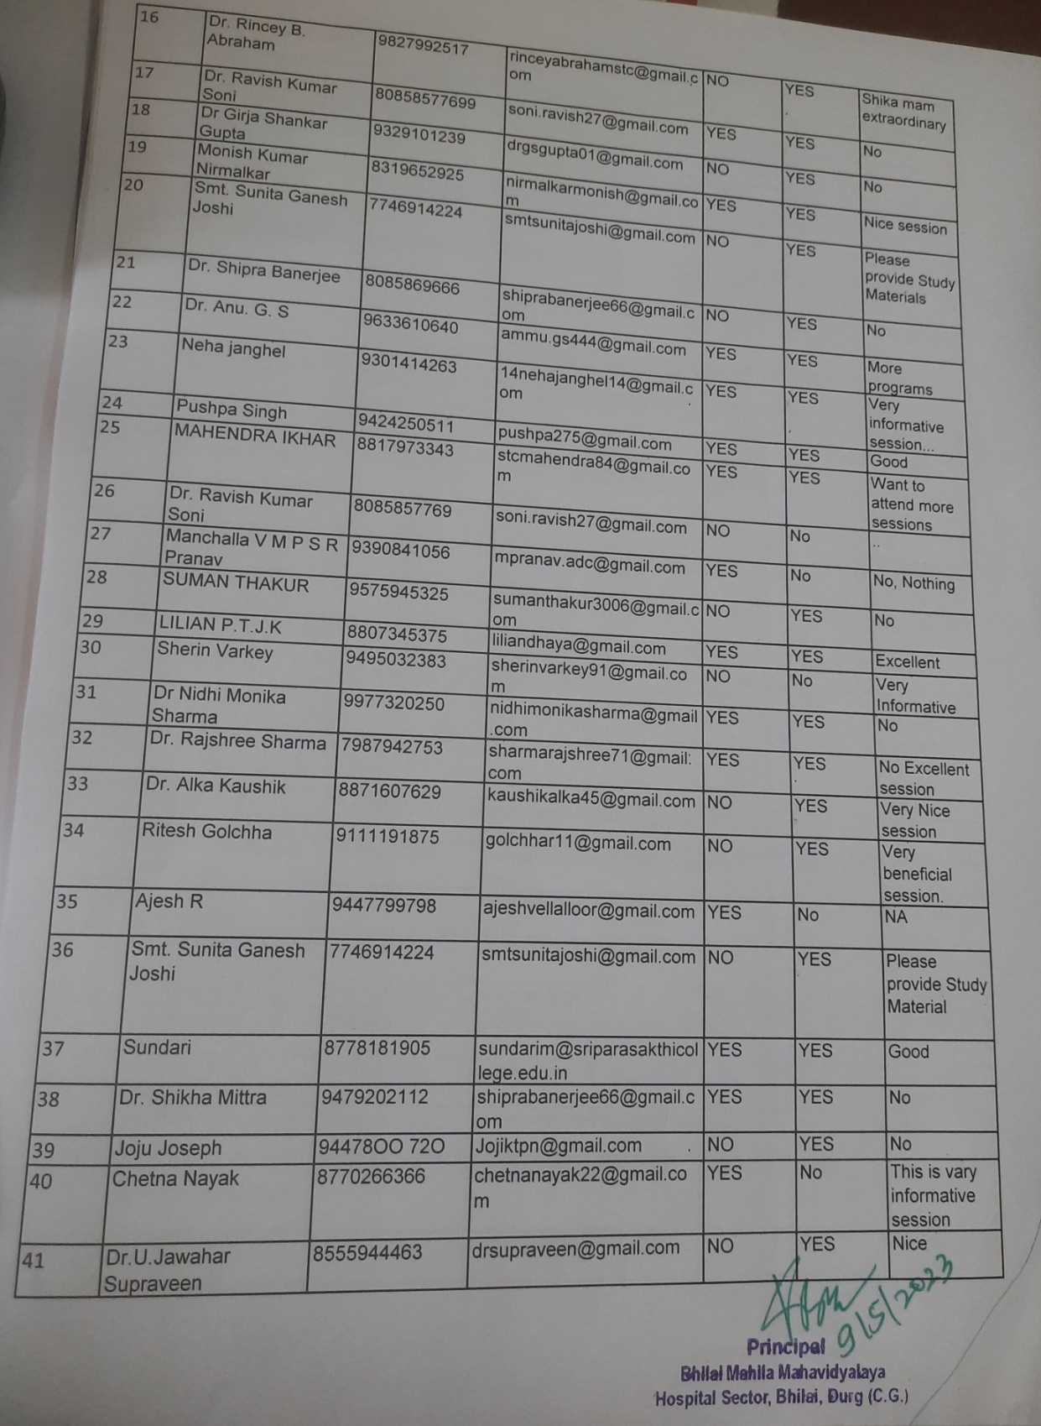

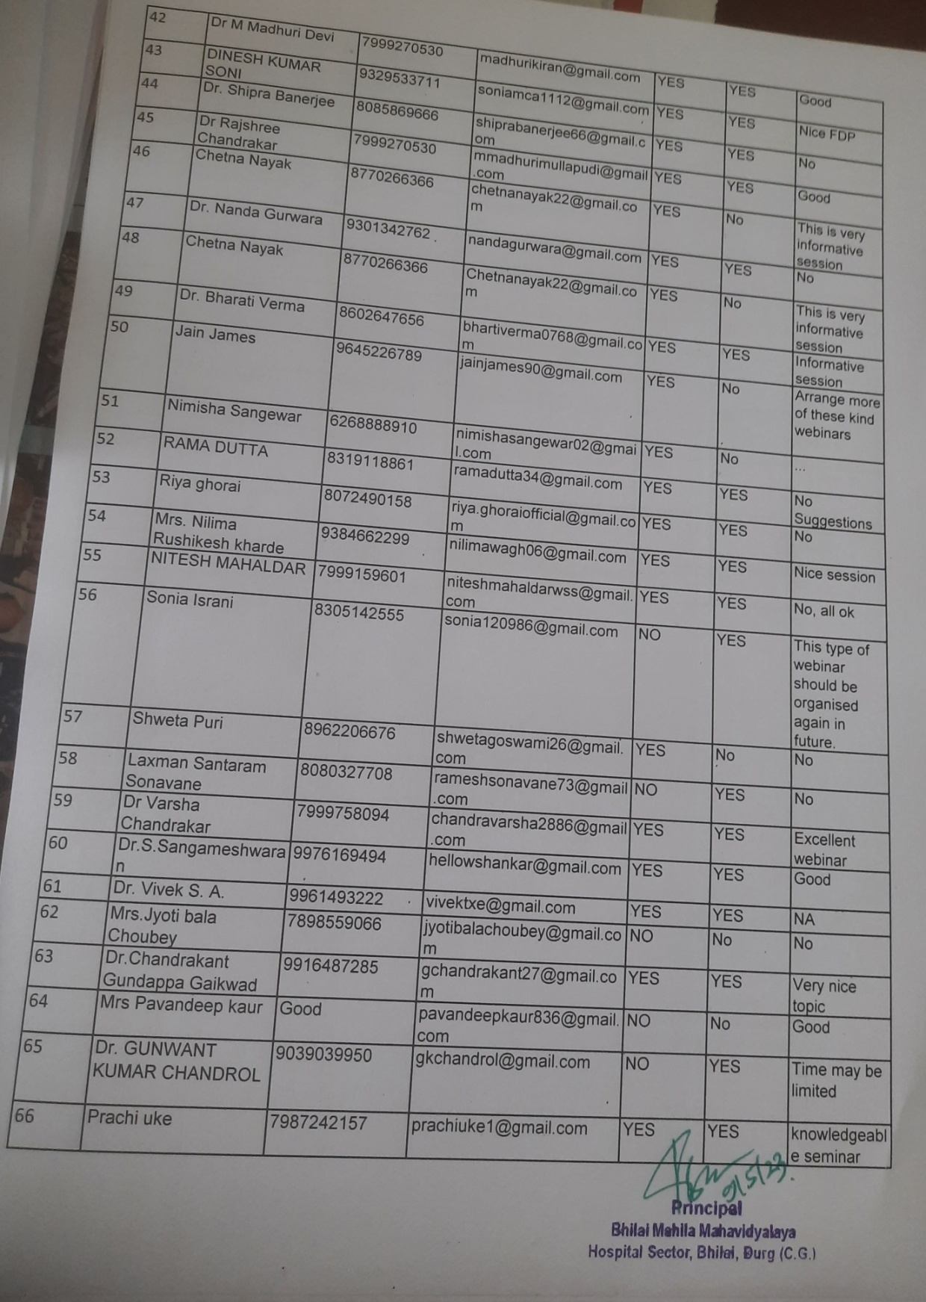

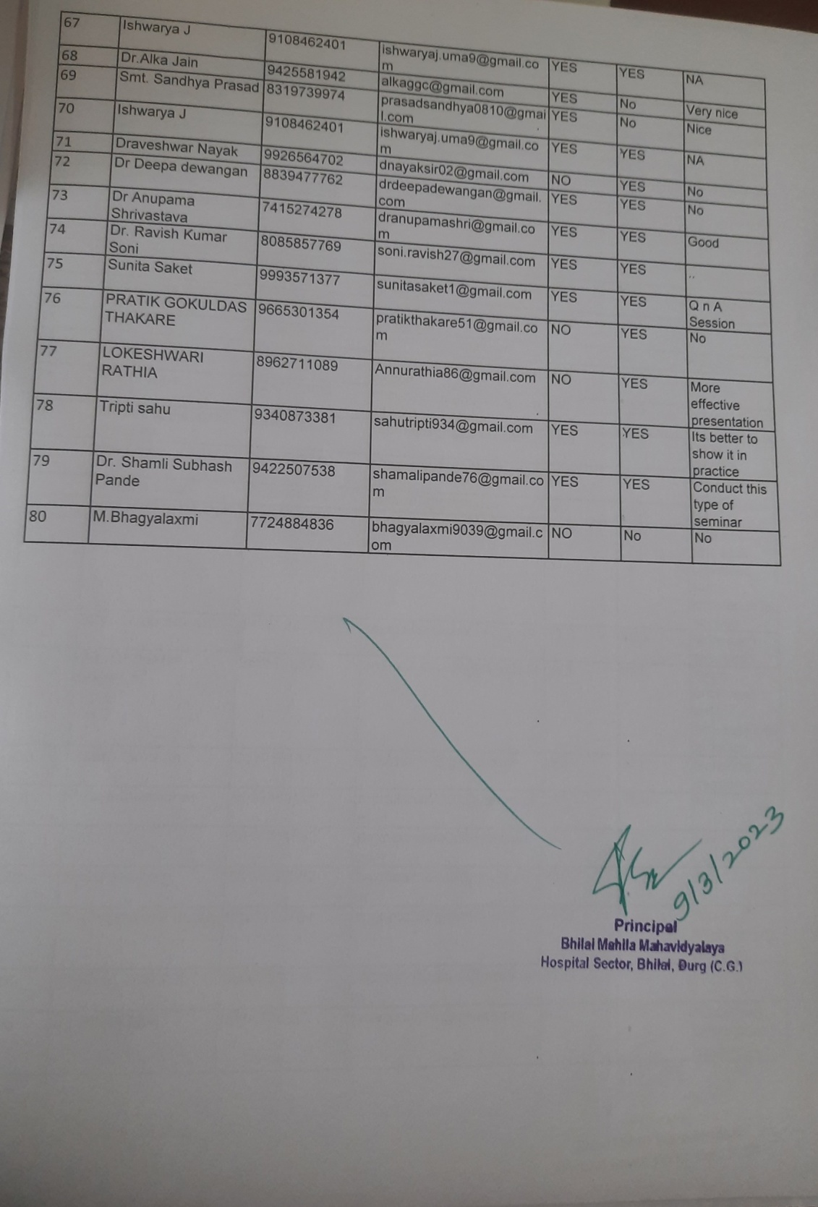

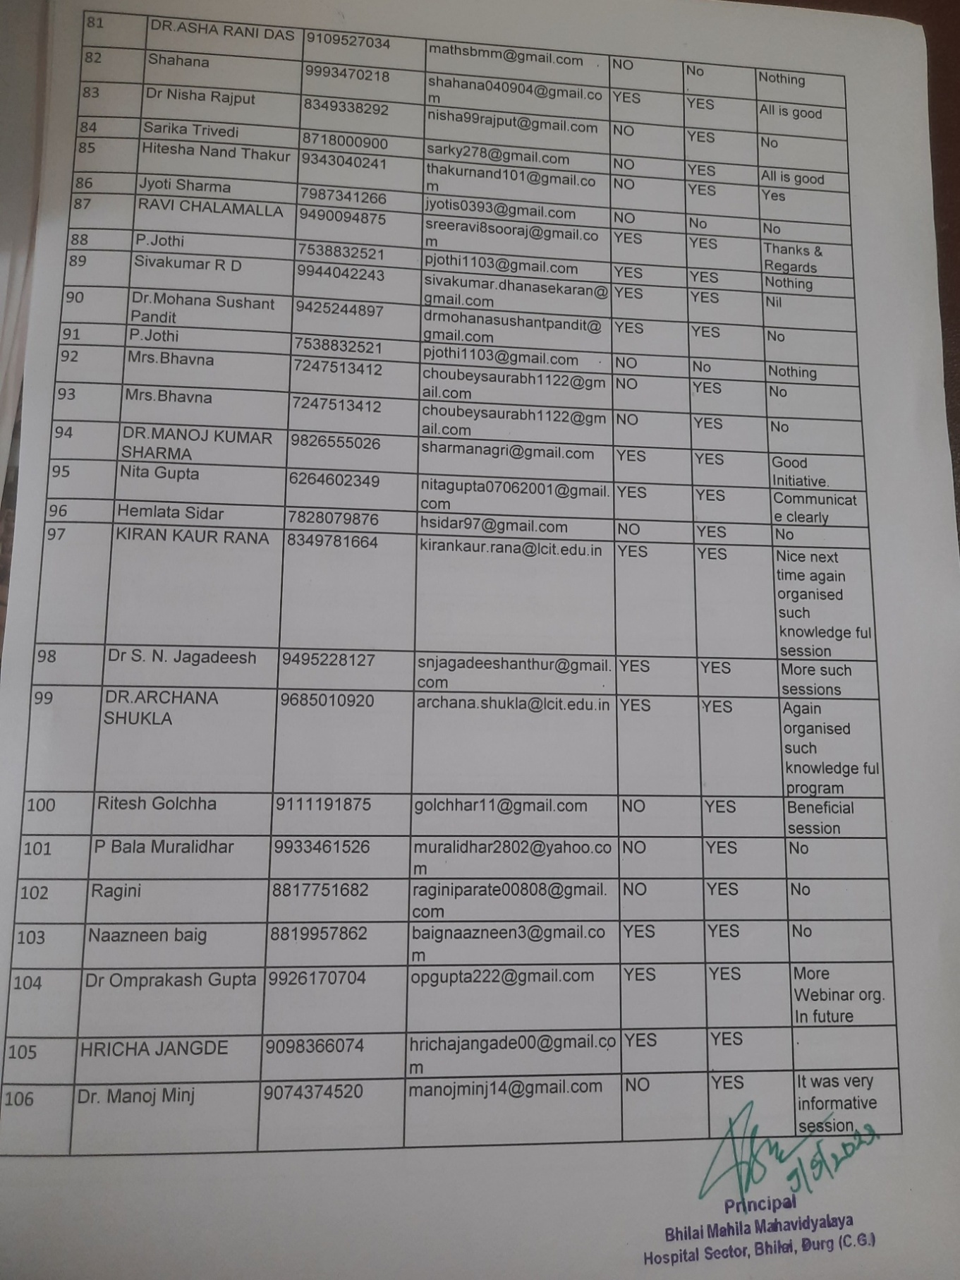

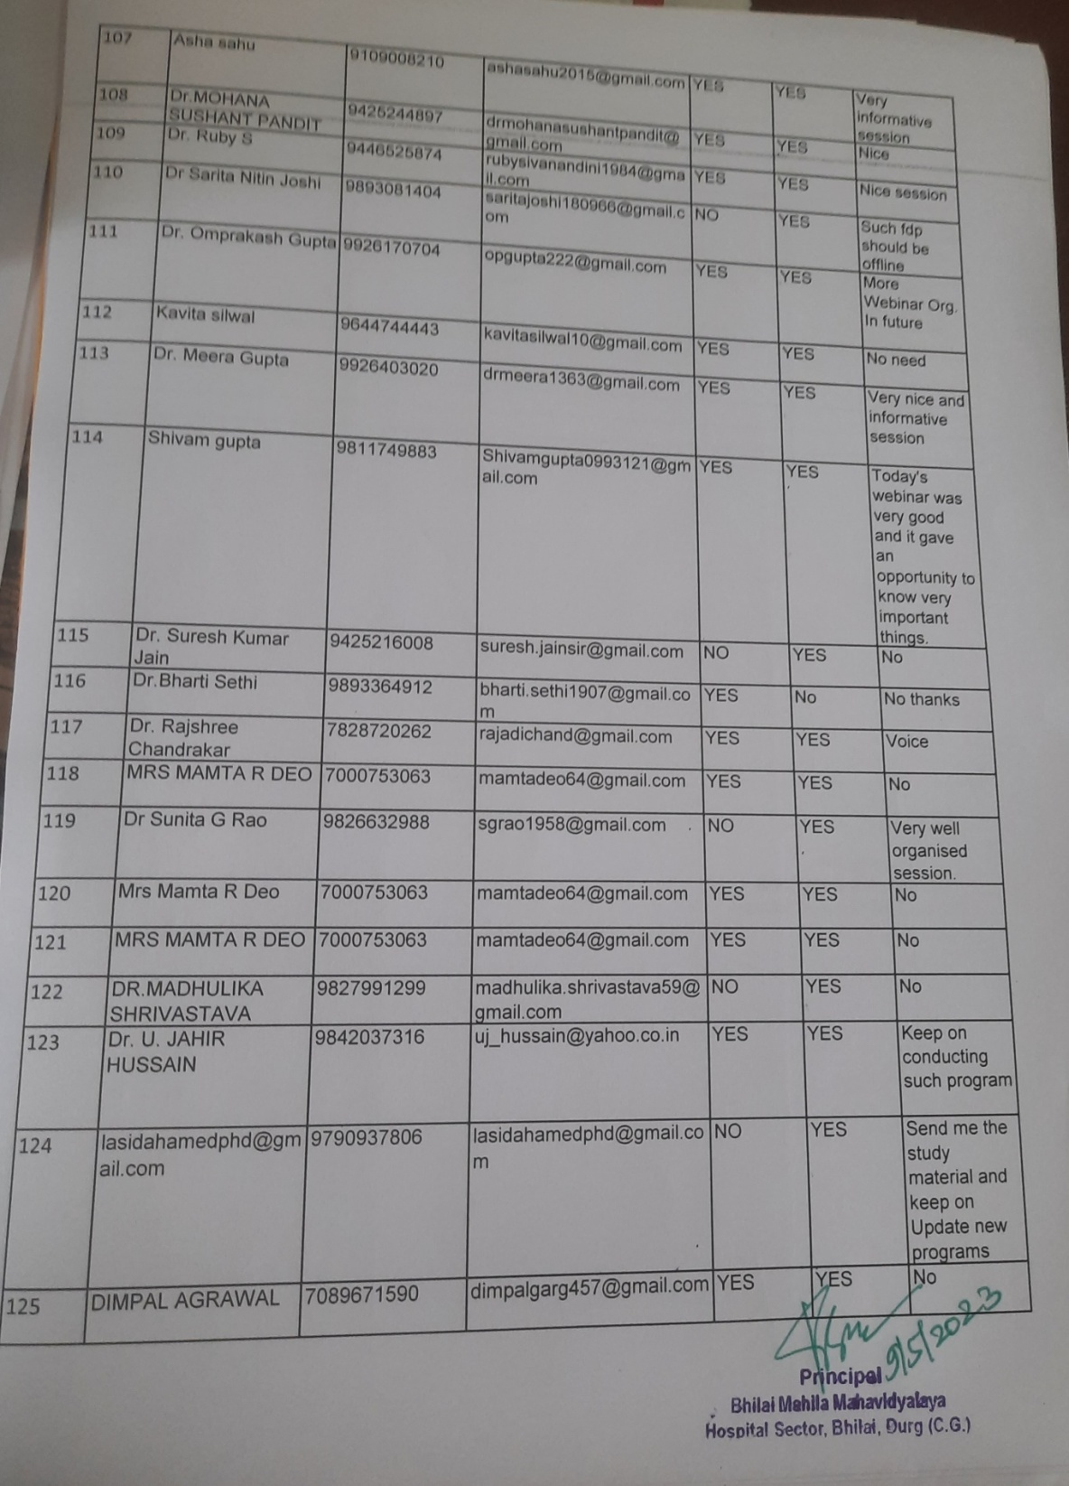

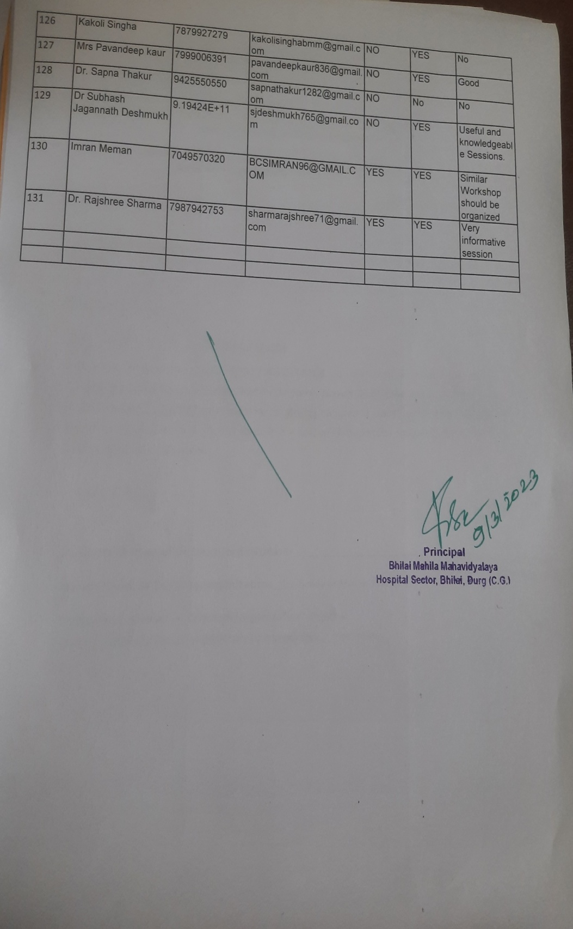

Entrepreneurship Awareness Programme:
Seminar on "Start-up India Policy” (under Youth-20 Summit) -Inspiration to the youth:

Attendance of Entrepreneurship Awareness Programme (Start-up India Policy):
