**3.4.2. *Number of awards and recognitions received for extension activities from government/ recognized bodies during the last year.***

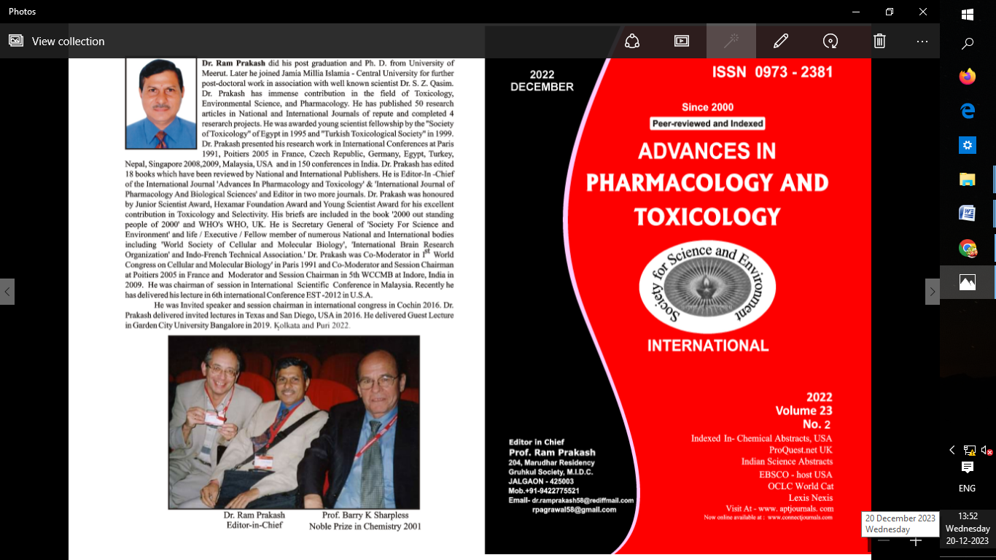

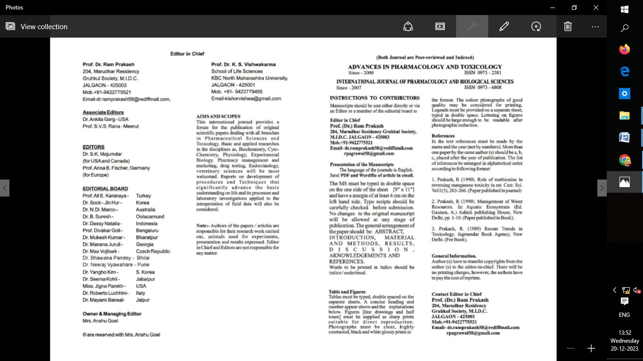

|  |
| --- |
| C:\Users\Admin\Desktop\ASSOCIATION 2021-22\SMM-removebg-preview.png |
| C:\Users\Admin\Downloads\seal-removebg-preview.png |

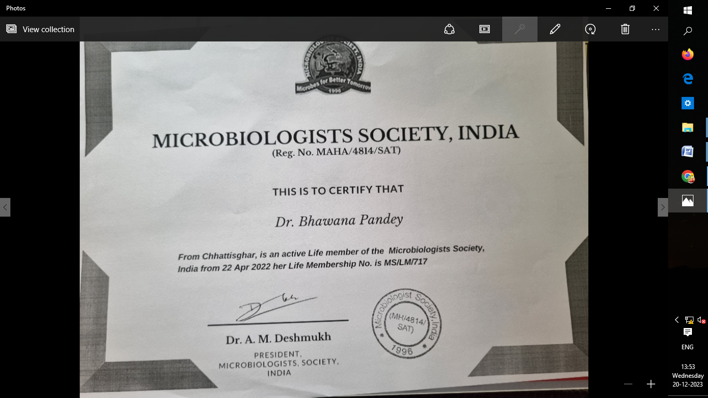

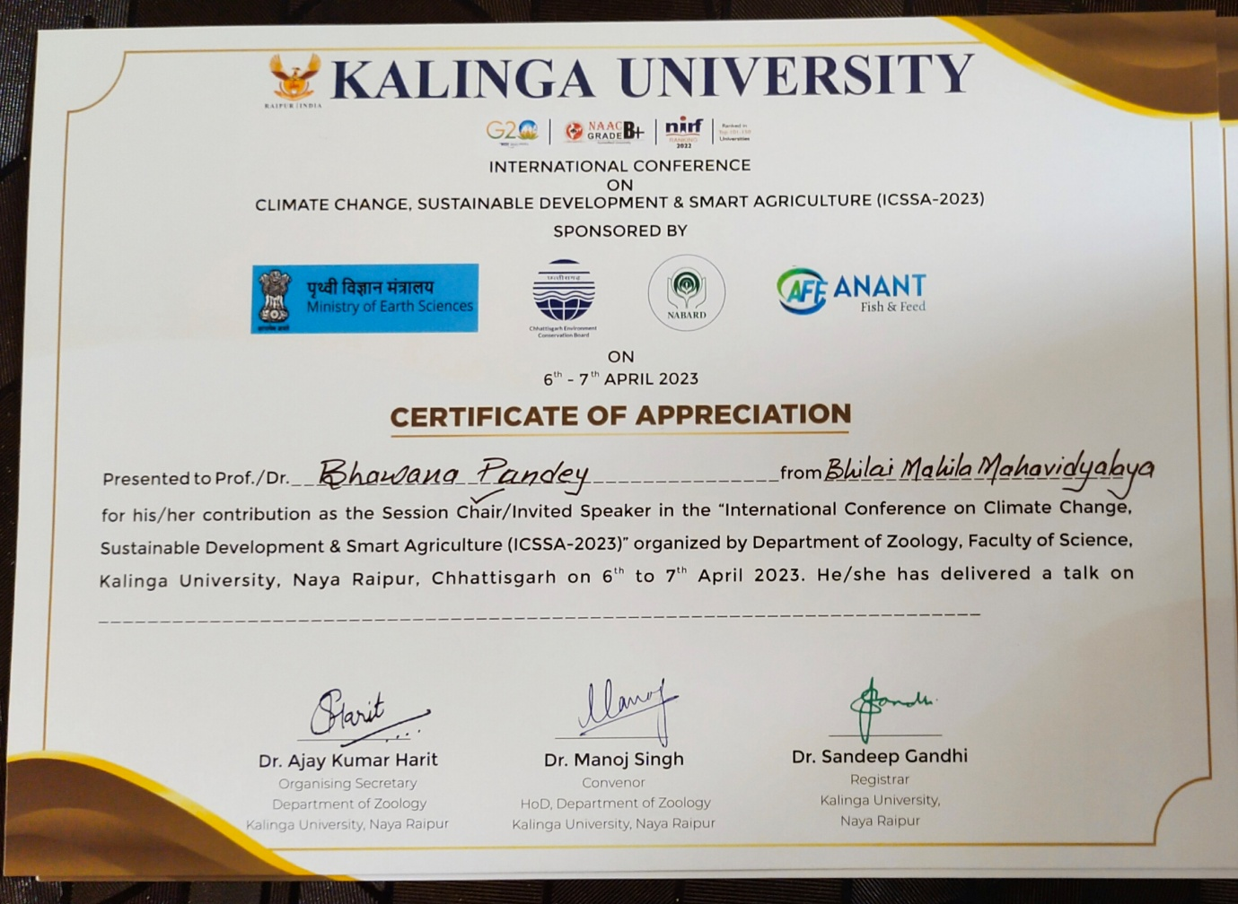

|  |
| --- |
| C:\Users\Admin\Desktop\ASSOCIATION 2021-22\SMM-removebg-preview.png |
| C:\Users\Admin\Downloads\seal-removebg-preview.png |

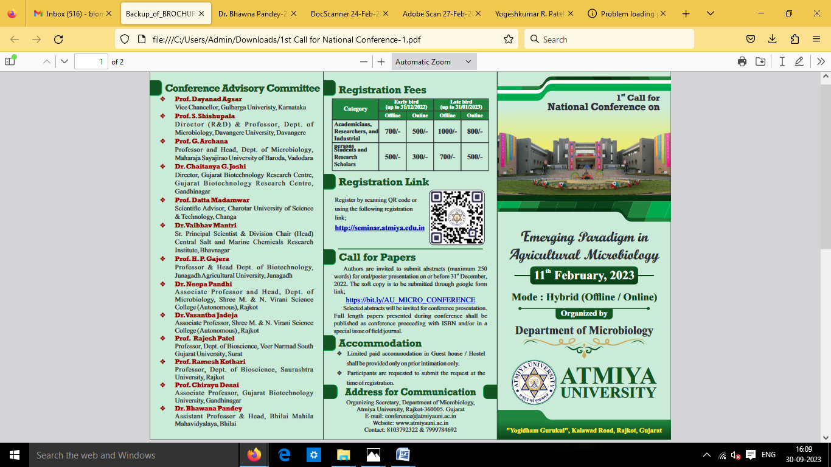

|  |
| --- |
| C:\Users\Admin\Desktop\ASSOCIATION 2021-22\SMM-removebg-preview.png |
| C:\Users\Admin\Downloads\seal-removebg-preview.png |

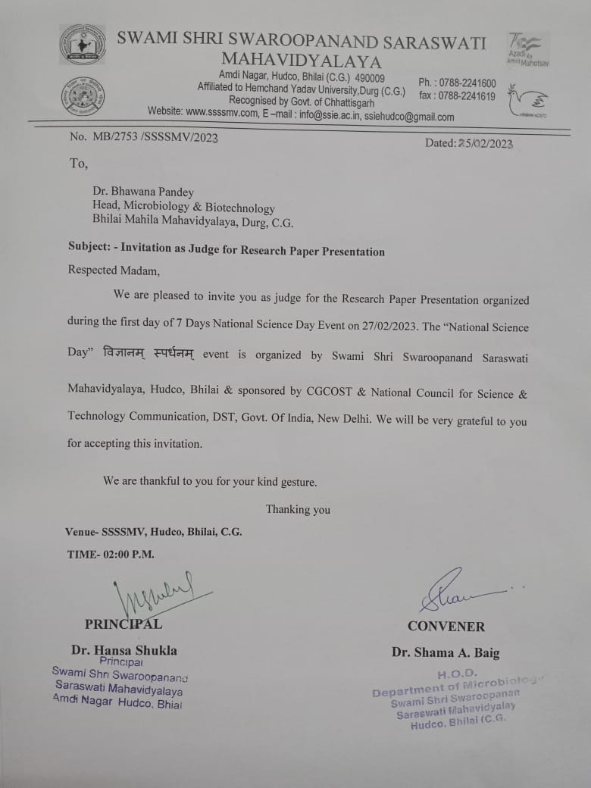

|  |
| --- |
| C:\Users\Admin\Desktop\ASSOCIATION 2021-22\SMM-removebg-preview.png |
| C:\Users\Admin\Downloads\seal-removebg-preview.png |

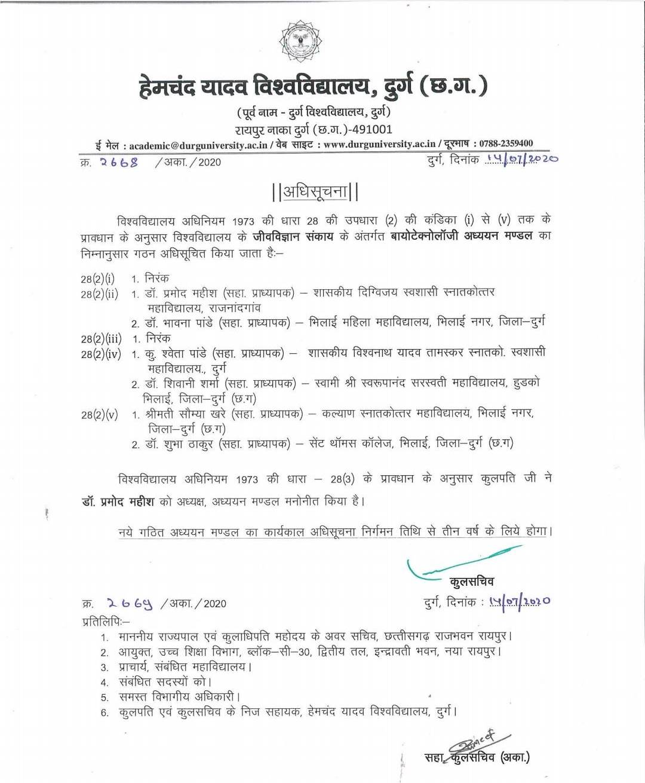

|  |
| --- |
| C:\Users\Admin\Desktop\ASSOCIATION 2021-22\SMM-removebg-preview.png |
| C:\Users\Admin\Downloads\seal-removebg-preview.png |

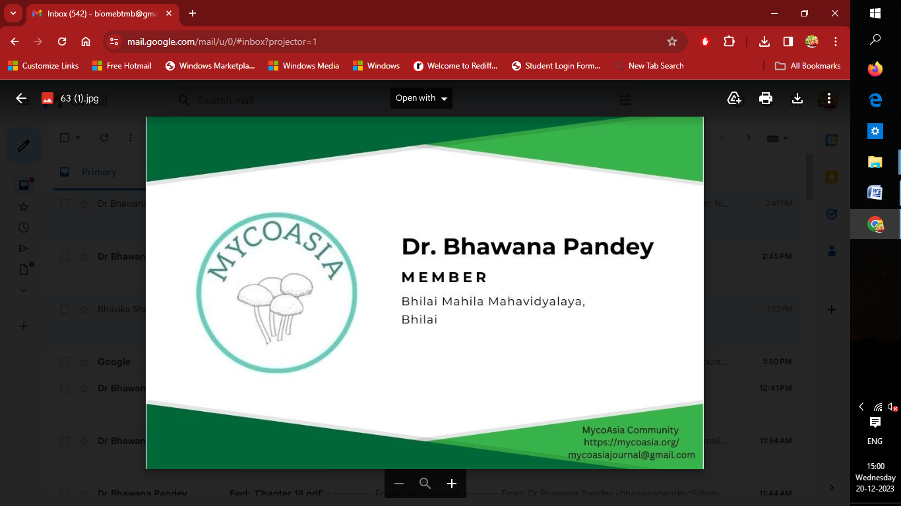

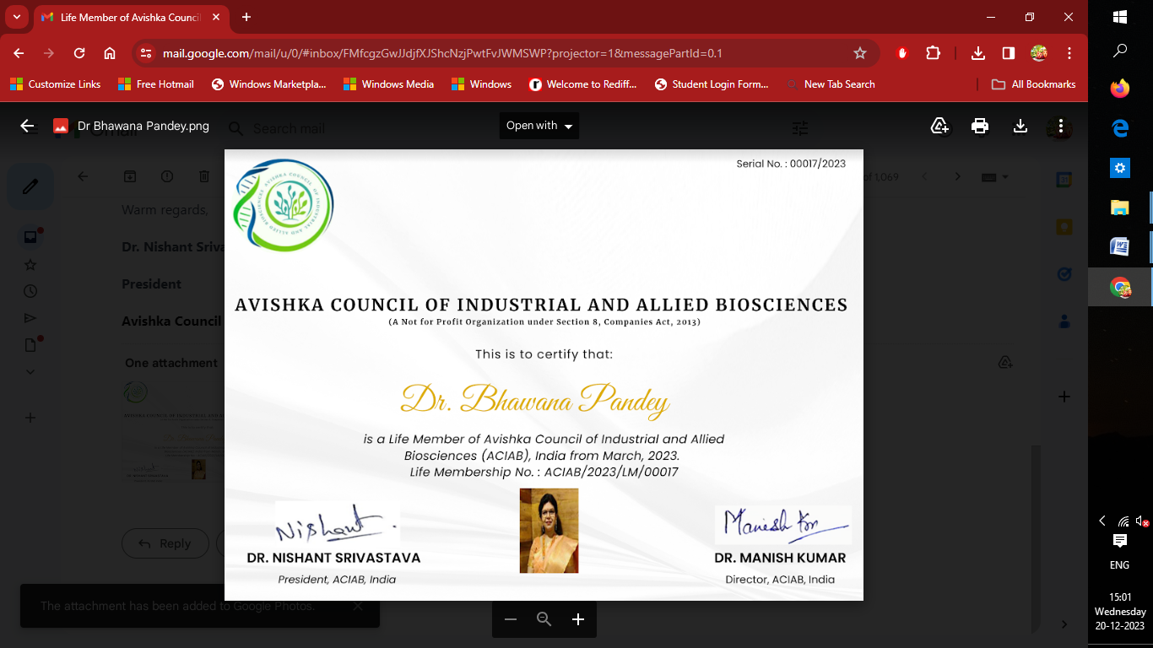

|  |
| --- |
| C:\Users\Admin\Desktop\ASSOCIATION 2021-22\SMM-removebg-preview.png |
| C:\Users\Admin\Downloads\seal-removebg-preview.png |

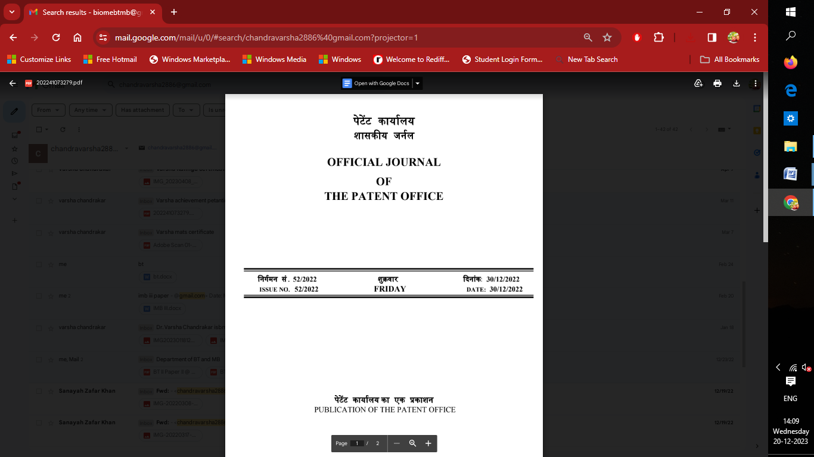

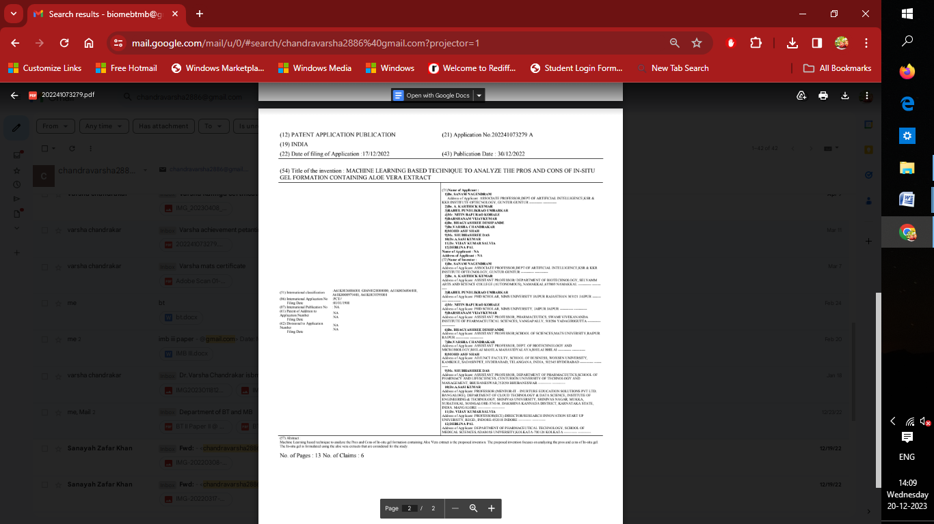

|  |
| --- |
| C:\Users\Admin\Desktop\ASSOCIATION 2021-22\SMM-removebg-preview.png |
| C:\Users\Admin\Downloads\seal-removebg-preview.png |

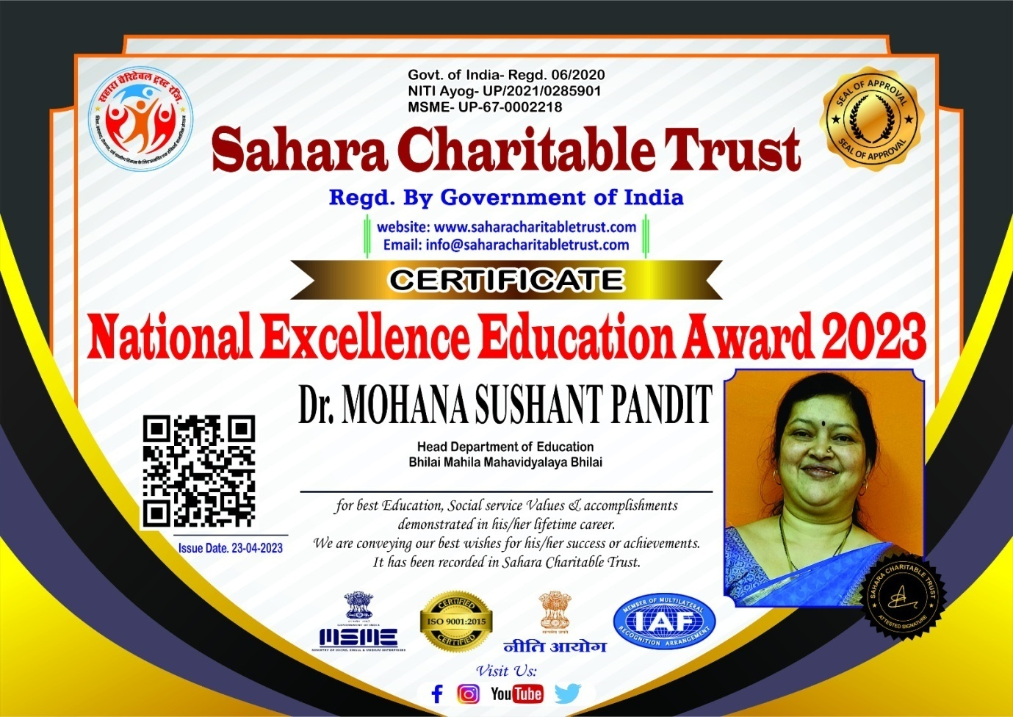

|  |
| --- |
| C:\Users\Admin\Desktop\ASSOCIATION 2021-22\SMM-removebg-preview.png |
| C:\Users\Admin\Downloads\seal-removebg-preview.png |

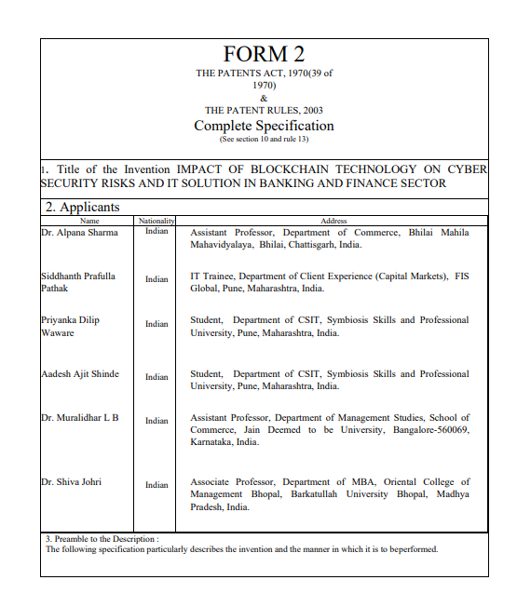

|  |
| --- |
| C:\Users\Admin\Desktop\ASSOCIATION 2021-22\SMM-removebg-preview.png |
| C:\Users\Admin\Downloads\seal-removebg-preview.png |