3.4.3.1
Number of extension and outreached programs conducted in collaboration with Industries, Community and Non Government Organization.
Name number of outreach programme - 01
Name : सुपोषण दिवस Suposhan Diwas Date : 23.09.2022
Name of Collaborating Agency :
Middle school village pisegaon through home science dept. & N.S.S. unit of, Bhilai Mahila Mahavidyalaya, Bhilai
Aim of the Program :
Awareness about nutrition and health among women and children

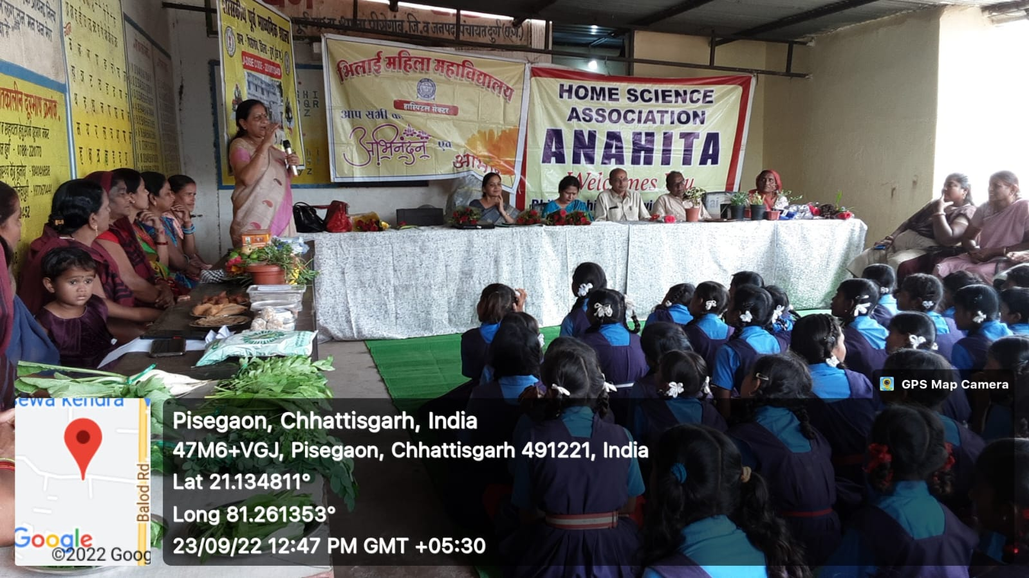
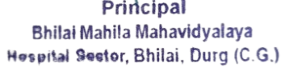

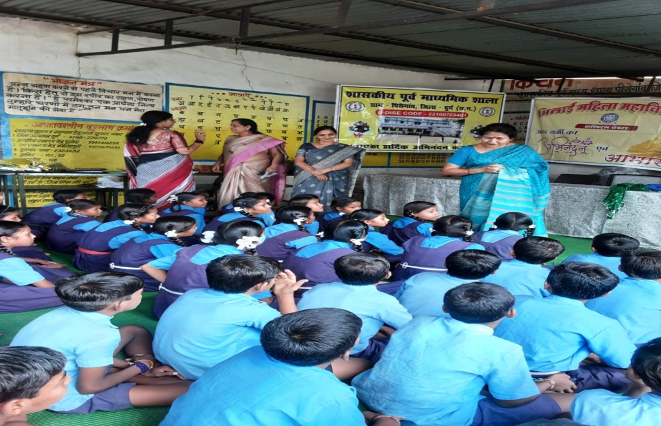

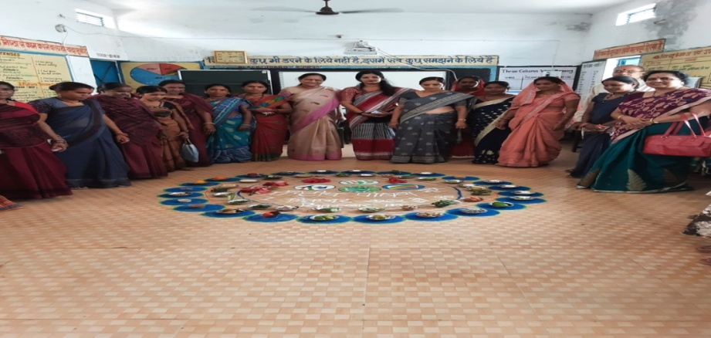

Name of Program in B.Ed Department | Photo
15 August 2022 | 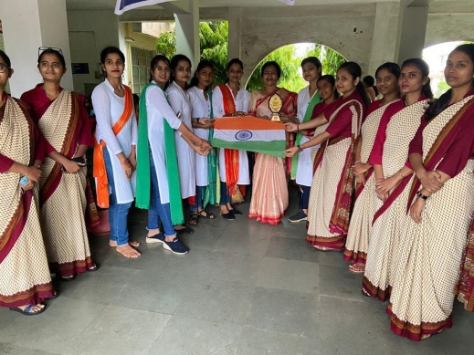
26January2023 | 