3.5.2. Number of functional MoUs with institutions of national, international importance, other universities, industries, corporate houses etc. during the last year (Only functional MoUs with ongoing activities to be considered)

      - Number of functional MoUs with Institutions of national, international importance, other universities, industries, corporate houses etc. year wise during the last year.

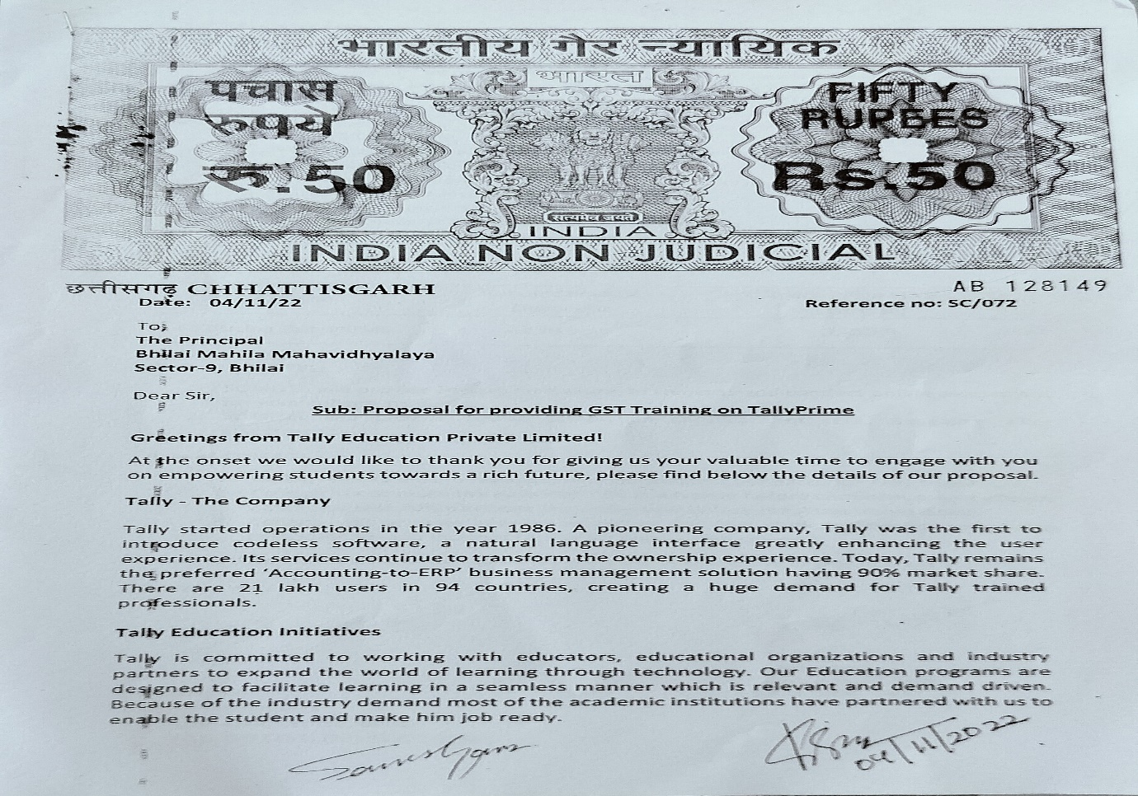

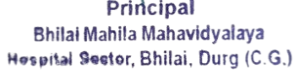

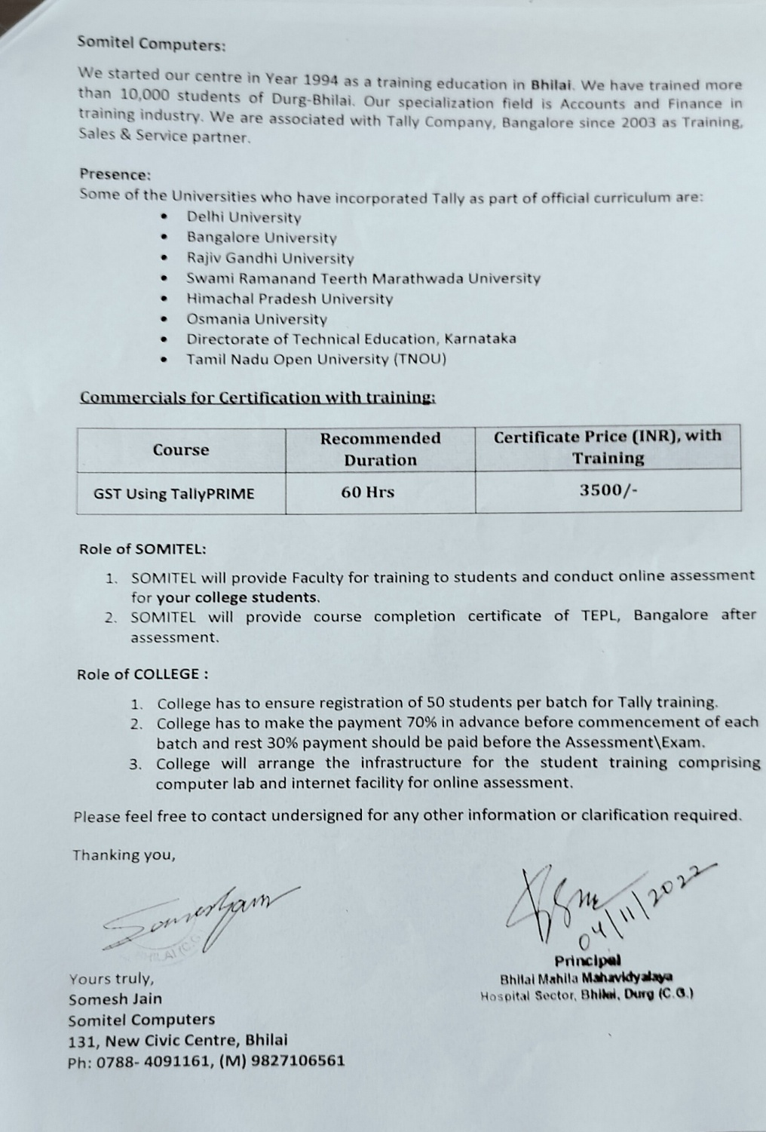

Attendance Sheets:

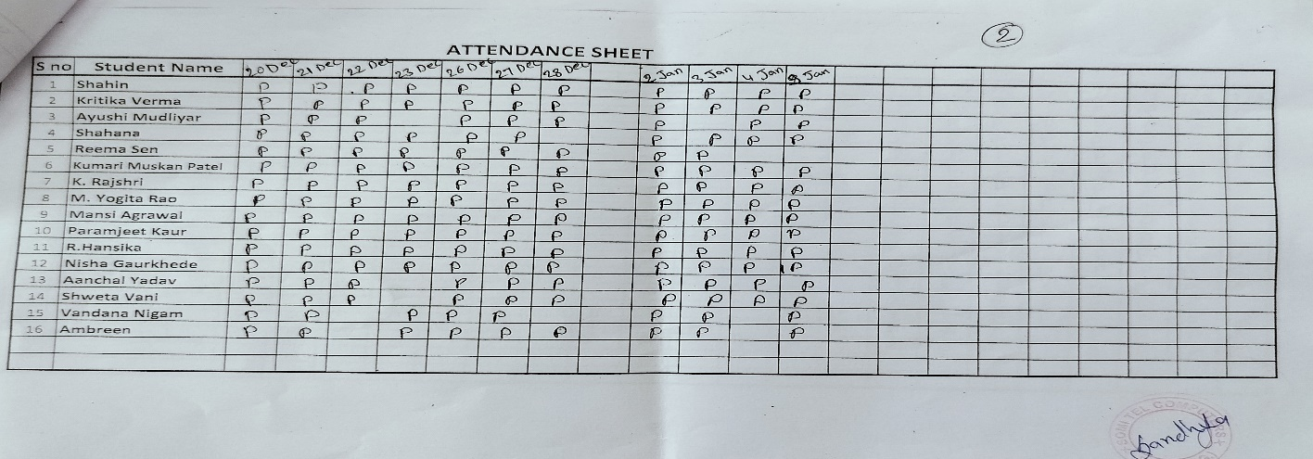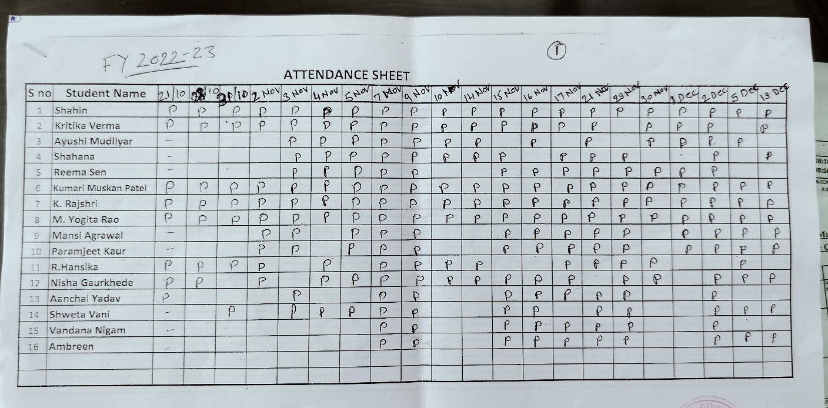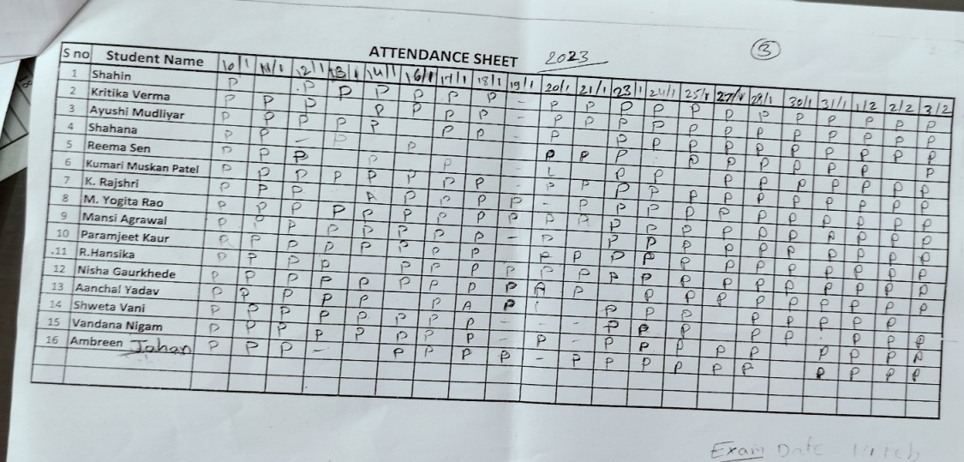

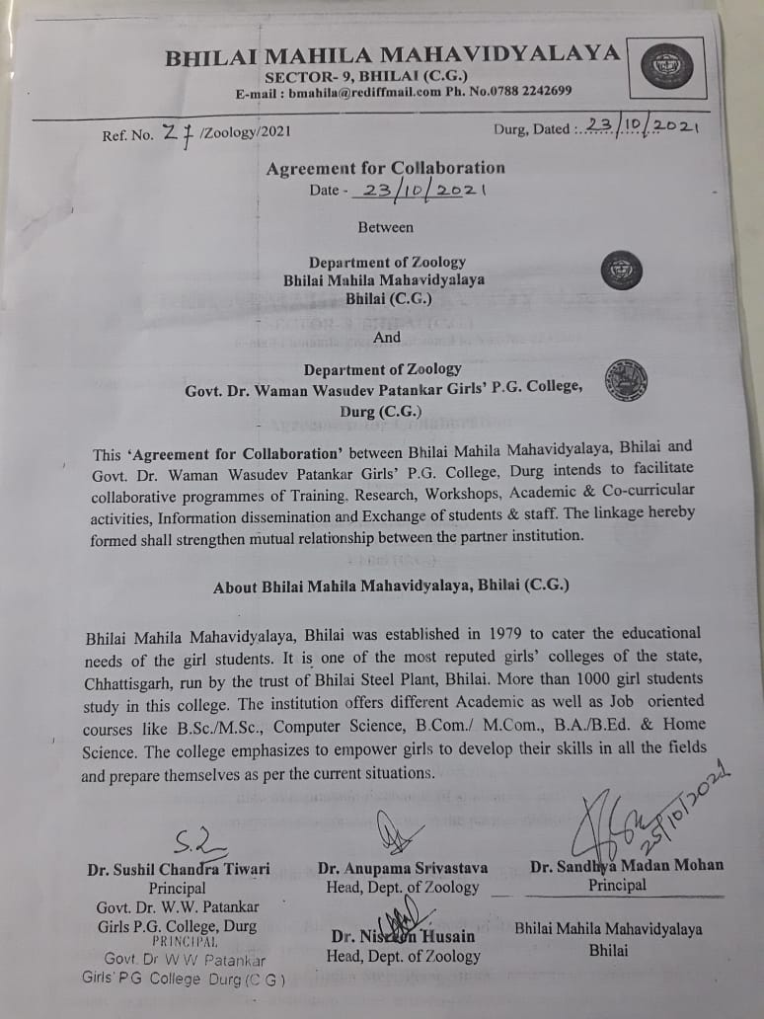

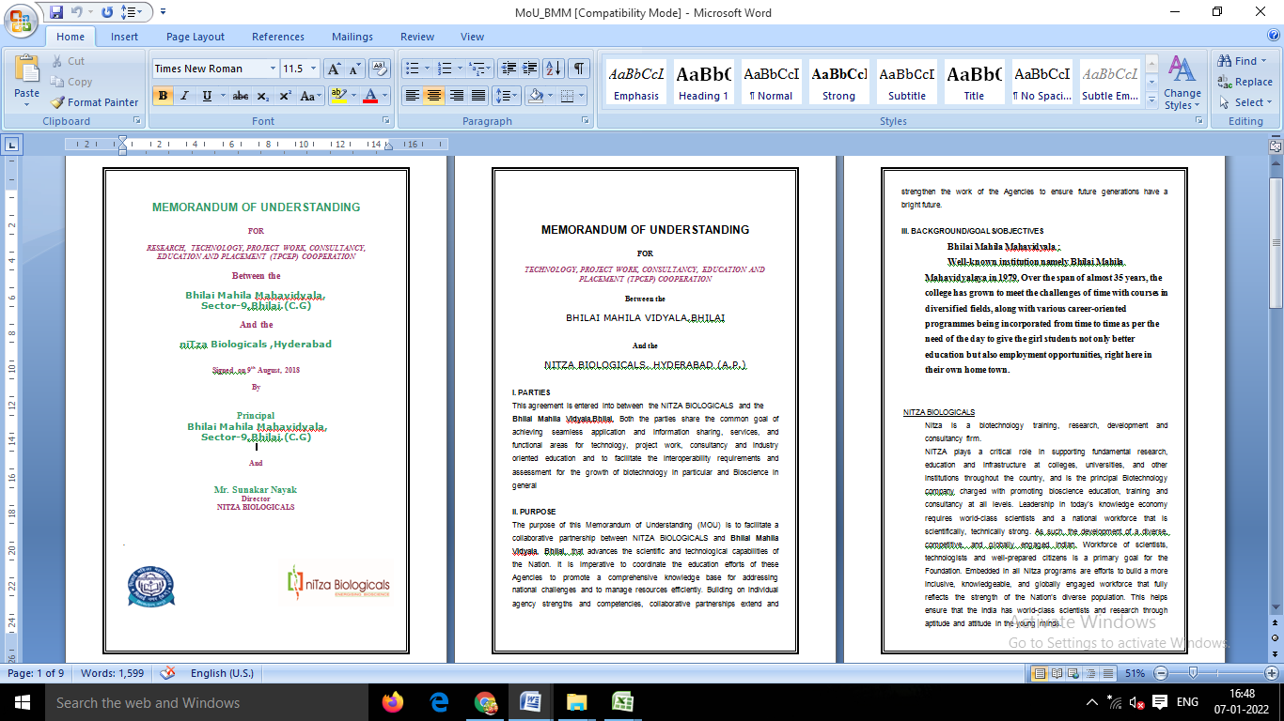

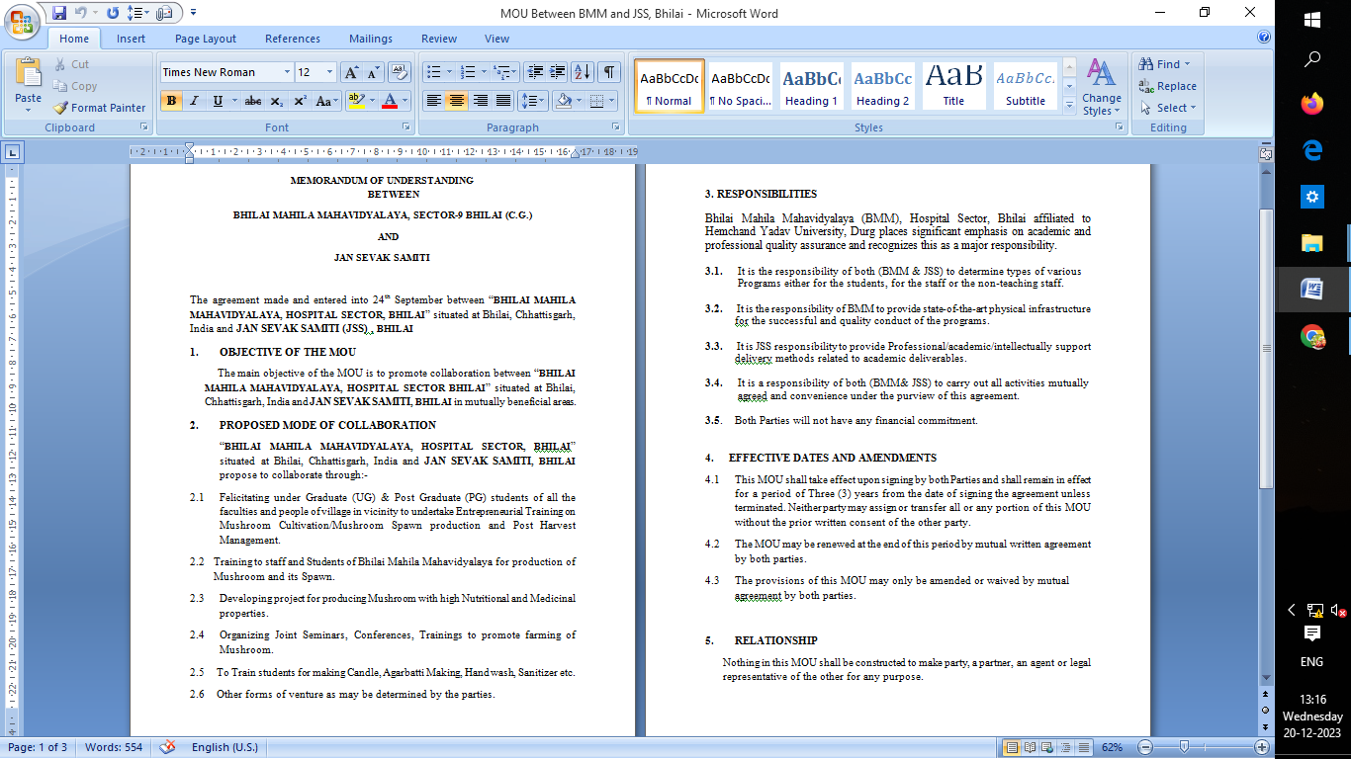

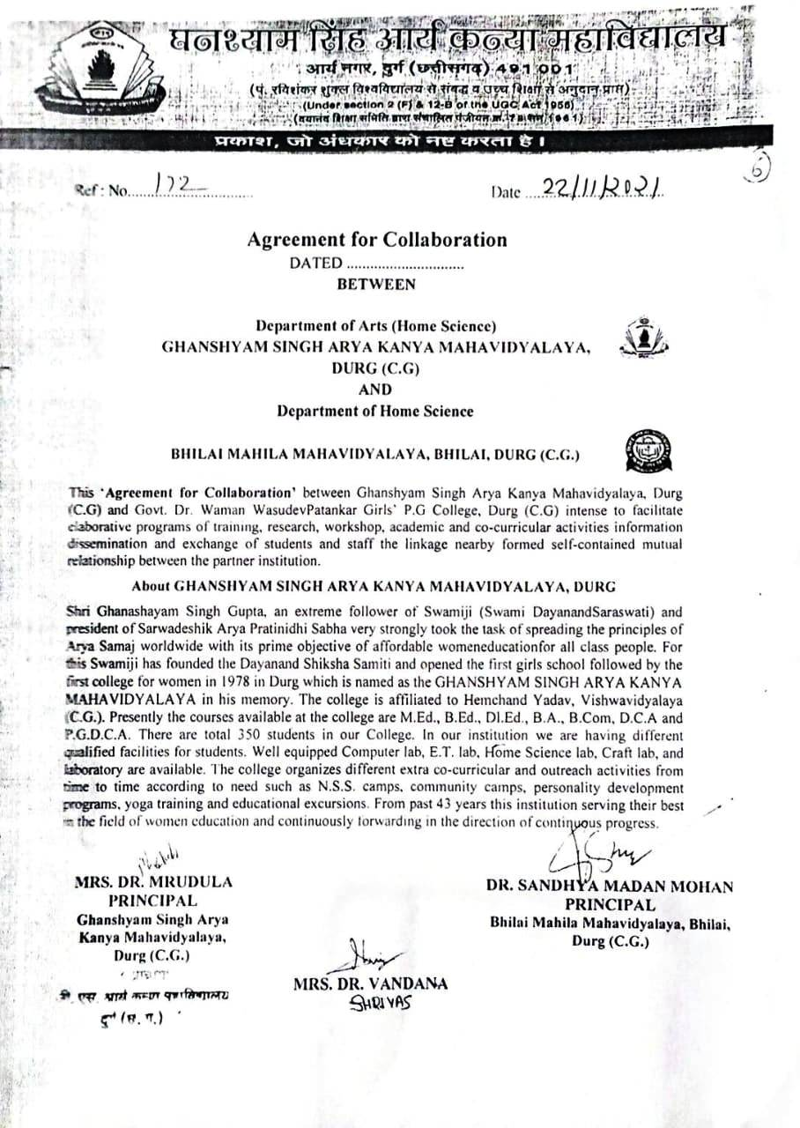

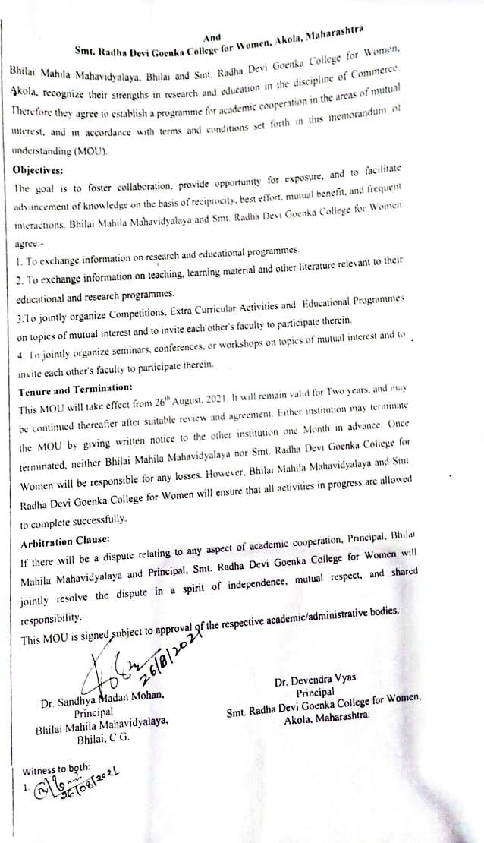

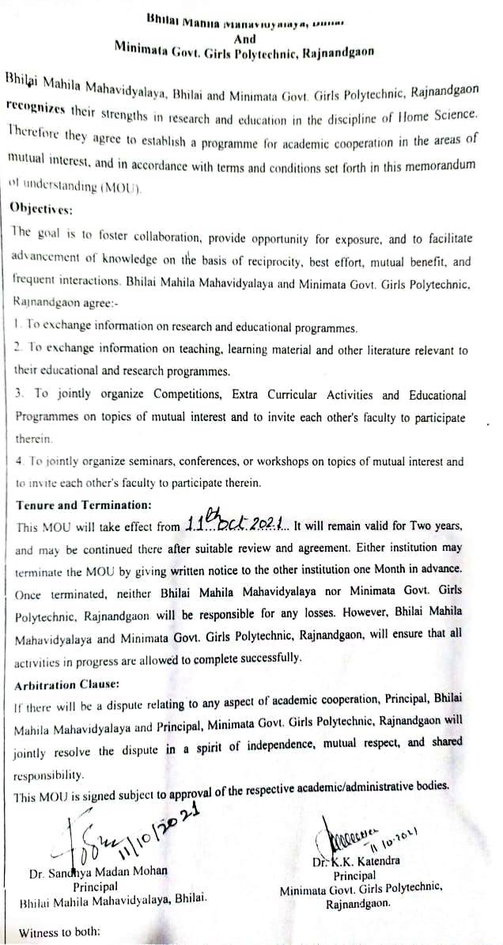

Report of the Program done under MOU:-
- Poster Completion : On the occasion of world hepatitis day a poster competition is organized on 28 July 2022 by dept. of Home Science, Bhilai Mahila Mahavidyalaya with MOUS Institutions i.e. Smt. Radha Devi Goenka College, Minimata Govt. Girls Polytechnic Rajnandgaon & St. Thomas College, Bhilai.
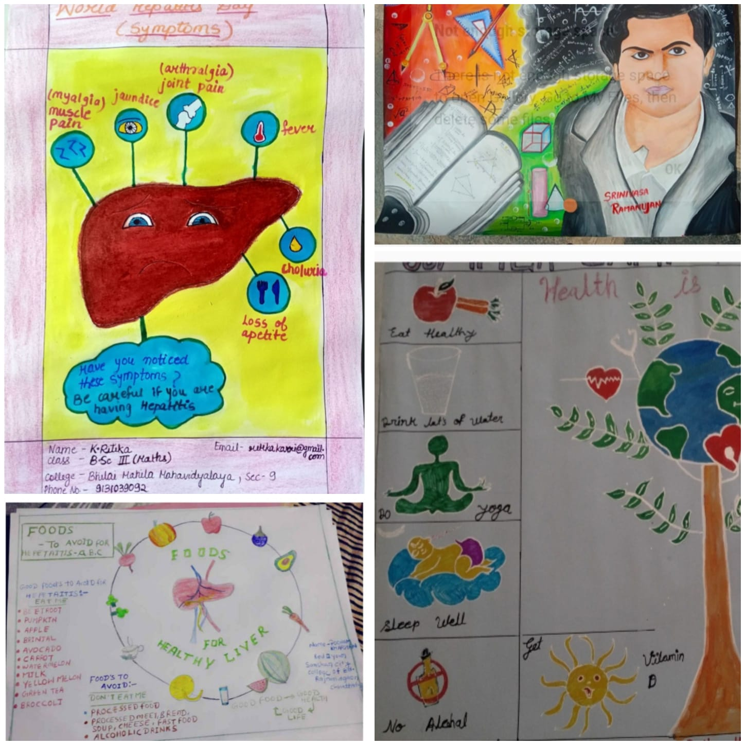

- Traditional Embroidery Competition : On the occasion of world embroidery online traditional embroidery competition was organized on 30.07.2022 by Dept of Home Science, Bhilai Mahila Mahavidyalaya with other MOUS Institutions i.e. Smt. Radha Devi Goenka College & Minimata Govt. Girls Polytechnic Rajnandgaon.

