5.1.3. Capacity building and skills enhancement initiatives taken by the institution include the following
Name of capability Enhancement program | Date of Implementation | No of student enrolled | Name of agencies/consultants involved with contact detail | photos
- Soft skills | 30-1-2022 | 73 | Guest Lecture By  Dr vishwajit panigrahi  On topic of Mahatma Gandhi | 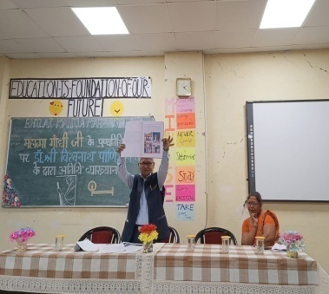 | 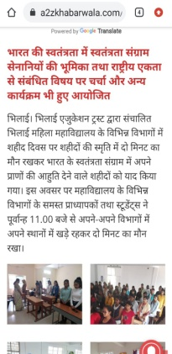
 |  |  |  | 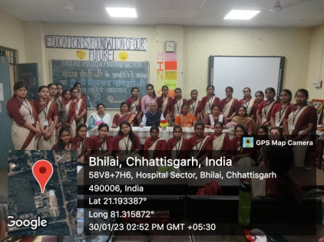 | 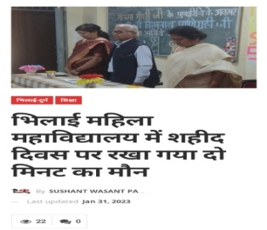
- Language and communication skills | 10-1-2023 | 16 | Hindi Poetry Competition  World Hindi Day | 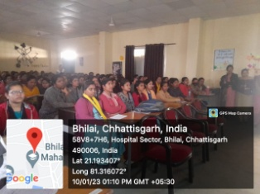 | 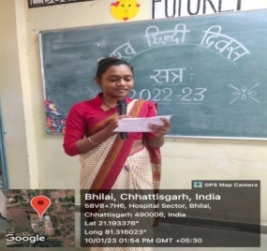
 | 16-9-2022 | 07 | Hindi Diwas(14-9-2022) Quiz Competition | 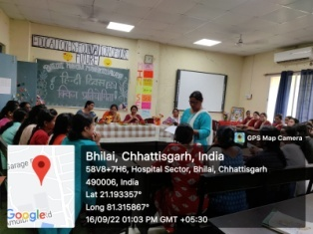 | 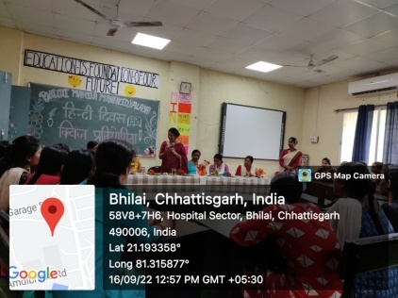
- Life skills Yoga, | 27-2-2023 | 63 | Yoga inuagration | 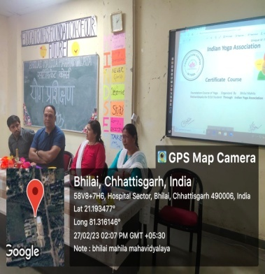 | 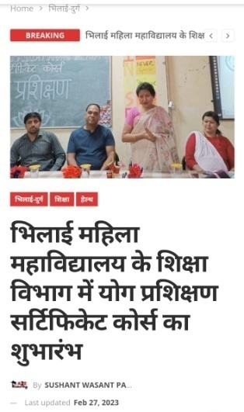
4.ICT/computing skills | 21-2-2023 | 80 | Basic Computer Knowledg | 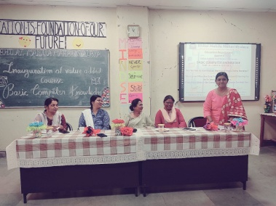 | 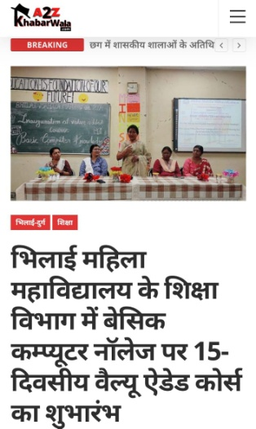
Soft skill development  Kalasangam  15 days art workshop | 12.09.2022 to 30.09.2022 | 45 | Pidilite  Mrs. Vinita Gupta  9826324525 | 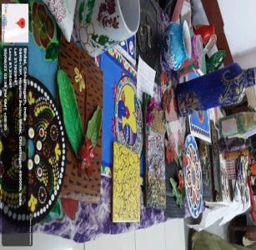
World Embroidery Day Celebration (Online)  Competition | 30.07.2022 | 51 |  | 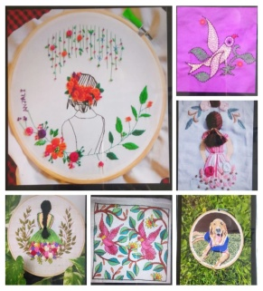
5.Physical fitness, health and hygiene  Life Skill  World Yoga Day | 21.06.2023 | Teachers : 05  Students : 12 |  | 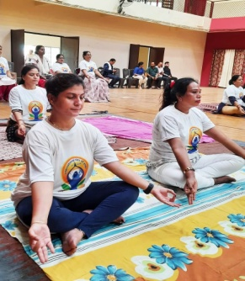
Nutrition Week/Month | 23.09.2023 | 90 | At Govt. School Pisegaon, Durg | 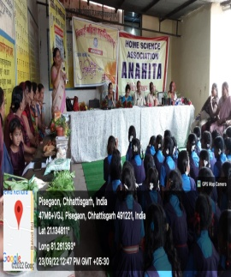
World Hepatitis Day  Poster making competition (online) | 28.09.2022 | 15 | - | 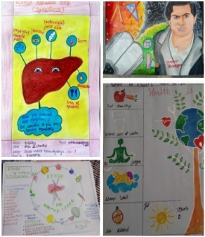
World Hindi Language Day, Room no. 109, Bhilai Mahila Mahavidyalaya:  -GK Competition  -Letter Writing | 10/01/2023 | 45  30 | Principal, BMM, Dr Sandhya Madan Mohan | 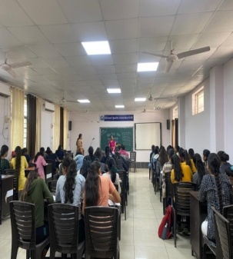
Hindi Diwas:  Poetry Recitation Competition | 14/09/2022 | 35 | Principal, BMM, Dr Sandhya Madan Mohan | 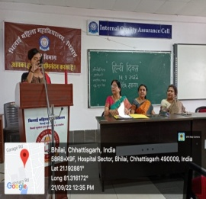
Fluenzy Spoken English: English Theater organized a one-day event, “Language Theatrics” on 24 January 2023. | 24/01/2023 | 57 | Principal, BMM, Dr Sandhya Madan Mohan | 