Bhilai Mahila Mahavidyalaya
Sports Activities 2022-23
S.  No | Year | No of Students Participated in International Level | No. of students participated in All India & East Zone Inter University Level | No of Students Participated in State level | No of Students Participated in Sector Level
1 | 2022-23 | - | 01 | 01 | 43

Achievements
S.No. | Name | Class | Achievement | Photos
1 | Anjali Pasi | BSC III | Won 3 Gold medal at Inter Collegiate Swimming Competition 2022-23 held at Shankaracharya Medical College, Junwani.  Events : 50 mtr. Breast Stroke, 100 mtr. Breast Stroke & 100 mtr Free Style | 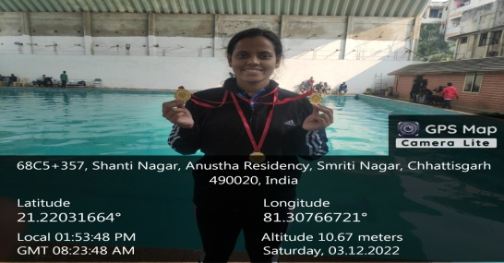
2 | Anjali Pasi | BSC III | Participated at All India Inter University Aquatics (Women) Tournament 2022-23 held at KISS University, Bhubneshwar. | 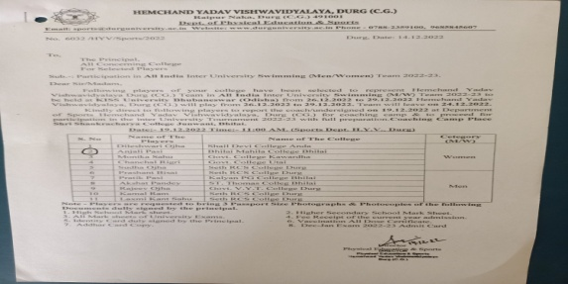  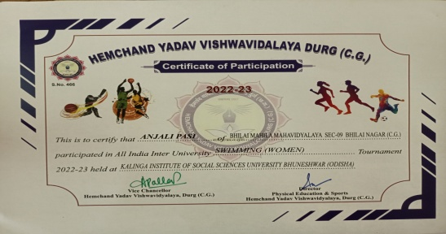
3 | Diksha Tandon | BSC III | Participated at State level Volleyball Tournament 2022-23 held at Pt. Ravishankar Shukla University ,Raipur | 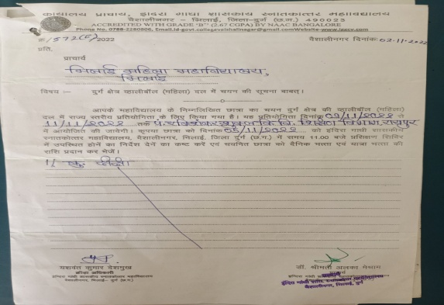

Sports Events Organized by College
S.no | Name of the Event | Date | Total no of Participation | Photo
1 | Inter Collegiate Badminton Competition for Women 2022-23 | 14/10/2022-15/10/2022 | Total Colleges participated-14 (No. of participants-45) | 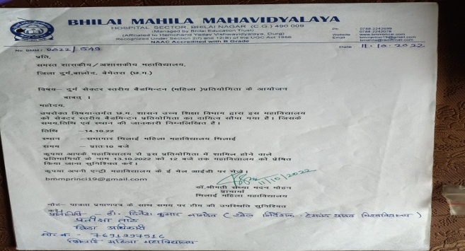  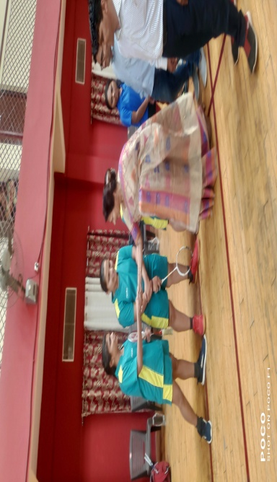
2 | Annual Sports Day 2022-23 | 17/01/2023 | 110 Participants of college | 