6.3.4 PROFESSIONAL DEVELOPMENT/ ADMINISTRATIVE TRAINING PROGRAMMES ATTENDED BY THE INSTITUTE BY TEACHING STAFF
S.No. | Name of teacher |  | Course | Duration |  | e-copy
1 |  | Dr.Amarpreet Kour Bhatia | UGC Sponsored “Interdisciplinary Refresher course on “E-Learning and E- Governance” by University of allahabad | March 28 to April 10, 2023 |  | 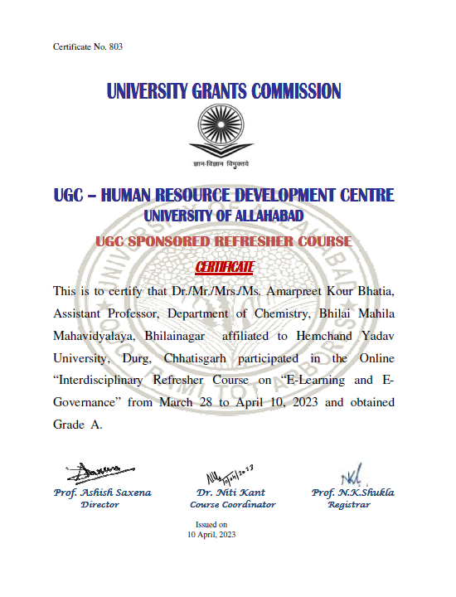
2 |  | Dr.Amarpreet Kour Bhatia | One week  e-Workshop on  “NeW IPR 2023” Innovative Technology Enabling Centre (InTEC), CSIR-IMMT, Bhubaneswar | June 12- 17, 2023 |  | 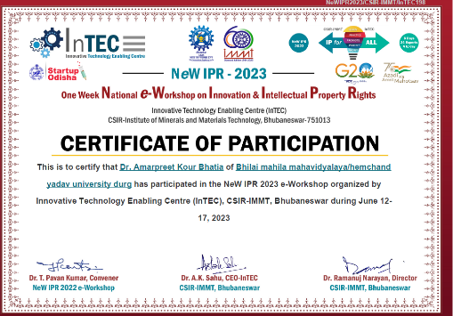
3 |  | Dr. Nishi Verma | Four week Orientation Programme,  Ramanujan College, University of Delhi | 22 March – 22 April 2023 |  | 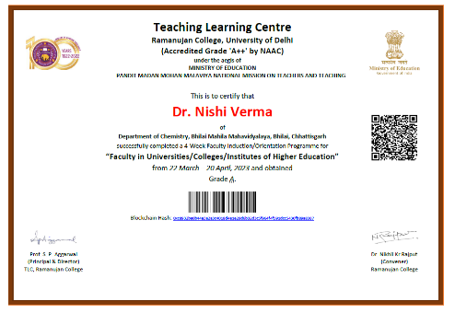
4 |  | Dr. Bhawana Pandey | International Short term Training Programme- VIII, “Energy and Environment Conservation” at Raj Rishi Govt. Autonomous College, Alwar, Rajasthan | 18th – 24 April 2023 |  | 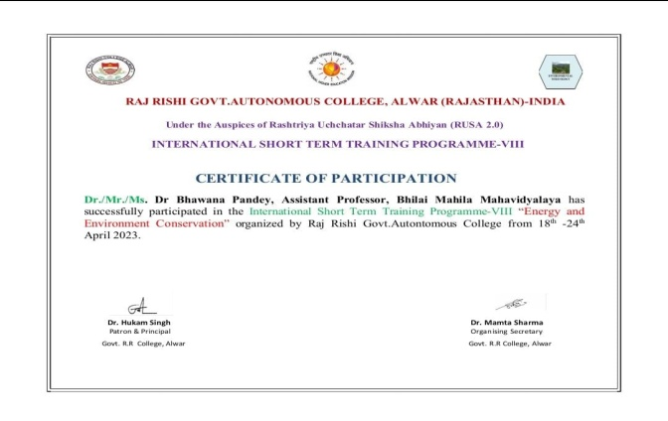
5 |  | Dr. Bhawana Pandey | International Short term Training Programme- IX, on Environment Pollution: A threat to Life below Water and World Environment day Celebration Week. at Raj Rishi Govt. Autonomous College, Alwar, Rajasthan | 5th –11 June 2023 |  | 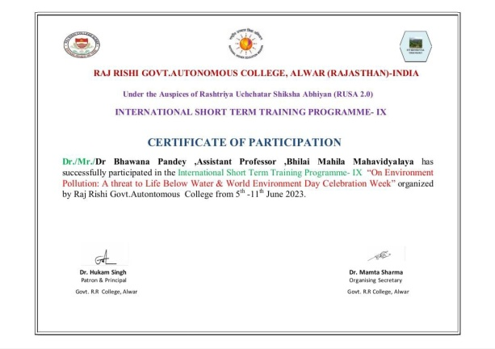
6 |  | Dr. Bhawana Pandey | Faculty Development Program  Quality Enhancement Inclusive Growth and Capacity Building Through Innovation and  Entrepreneurship in Higher Educational Institutions at Chaitanya Science & Arts College  Pamgarh, Dist – Janjgir-Champa (C.G.) | 13th -19th May 2023 |  | 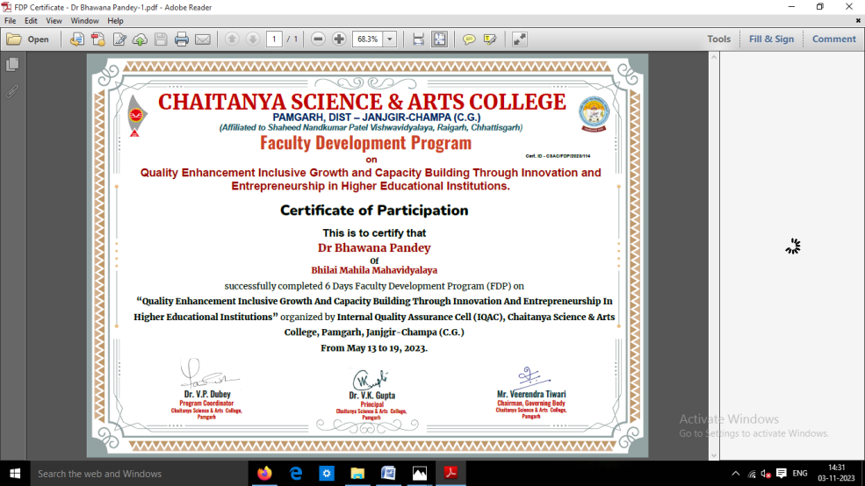
7 |  | Dr. Bhawana Pandey | National Faculty Development Programme  On ‘Research Methodology and Publication Ethics’ at Rajiv Gandhi Govt. Post Graduate College, Ambikapur, C.G. | 20th -25th March 2023 |  | 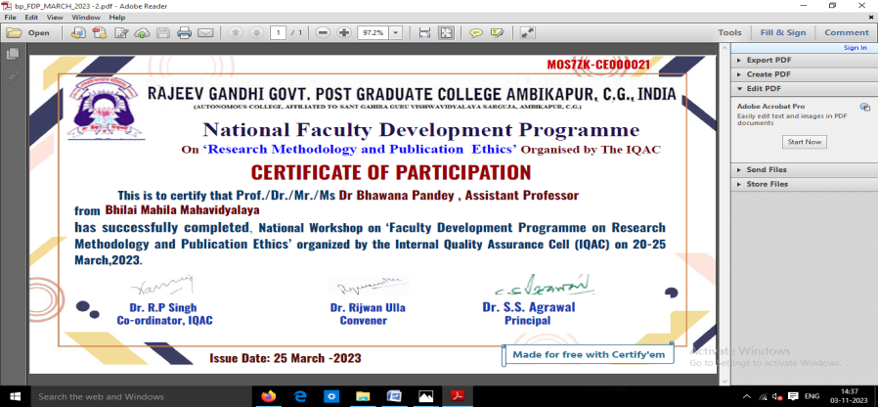
8 |  | Sabiha Naz | Refresher Course in Life Science from Devi Ahilya Vishwavidyalaya, Indore | 14th -27th March 2023 |  | 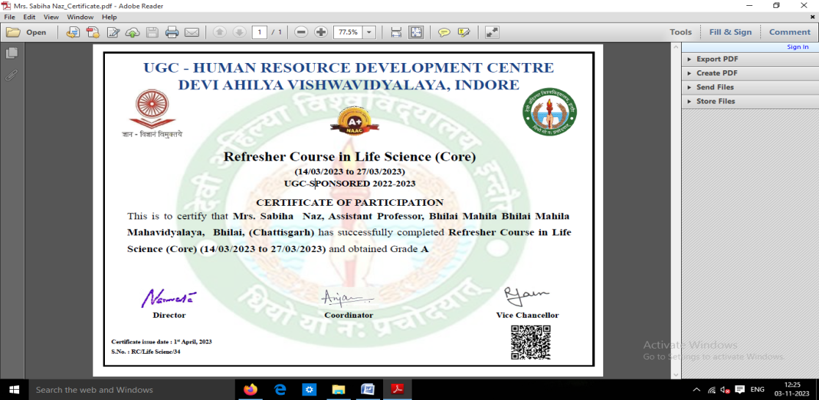
9 |  | Sabiha Naz | Value Added course on Mushroom Cultivation, Spawn Production and its Post Harvest Management | 20th Sep – 20th Oct 2022 |  | 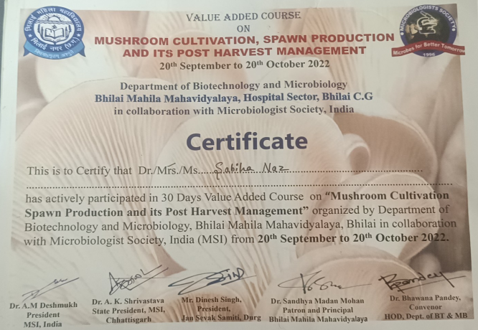
10 |  | Sabiha Naz | International Short term Training Programme- VIII, “Energy and Environment Conservation” at Raj Rishi Govt. Autonomous College, Alwar, Rajasthan | 18th – 24 April 2023 |  | 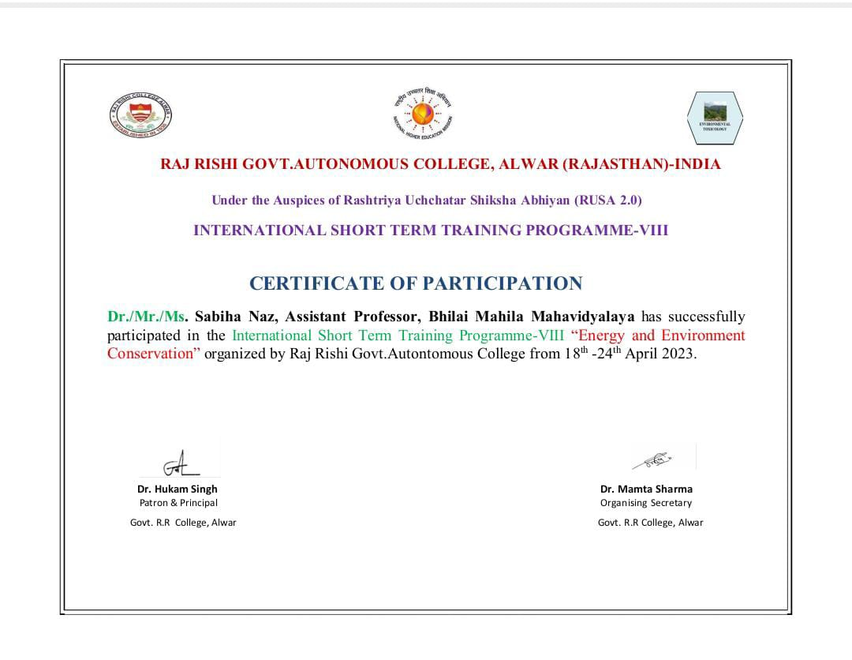
11 |  | Sabiha Naz | International Short term Training Programme- IX, on Environment Pollution: A threat to Life below Water and World Environment day Celebration Week. at Raj Rishi Govt. Autonomous College, Alwar, Rajasthan | 5th –11 June 2023 |  | 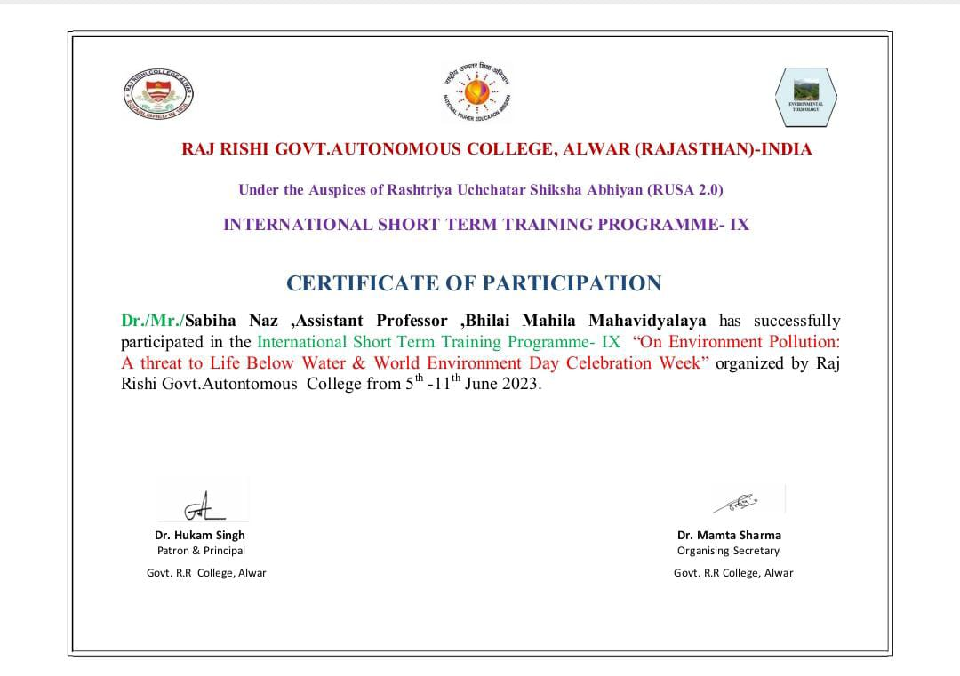
12 |  | Dr. Ranjana Sahu | International Short term Training Programme- VIII, “Energy and Environment Conservation” at Raj Rishi Govt. Autonomous College, Alwar, Rajasthan | 18th – 24 April 2023 |  | 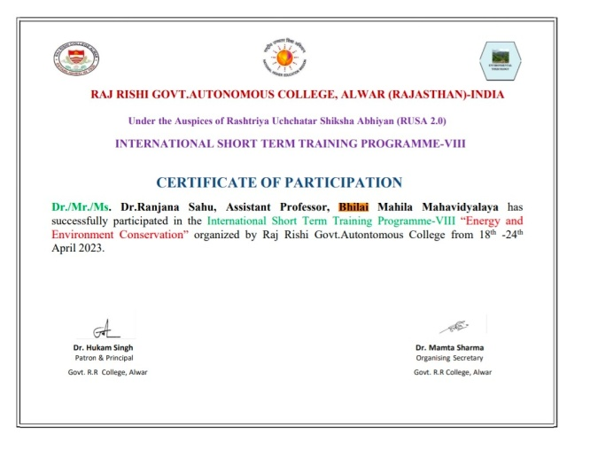
13 |  | Dr. Ranjana Sahu | Value Added course on Mushroom Cultivation, Spawn Production and its Post Harvest Management | 20th Sep – 20th Oct 2022 |  | 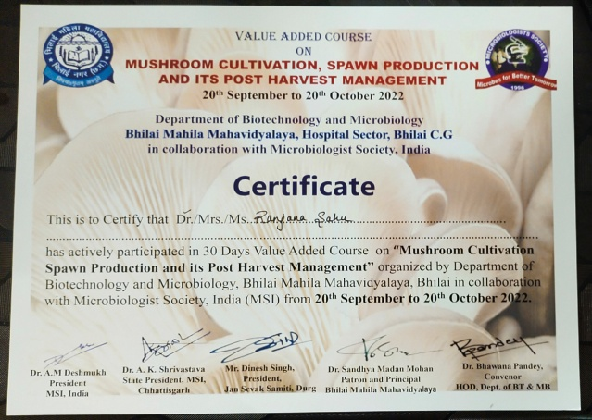
14 |  | Dr. Ranjana Sahu | UGC sponsored Faculty induction Programme at BHU, Varanasi | 24th Feb- 25th March 2023 |  | 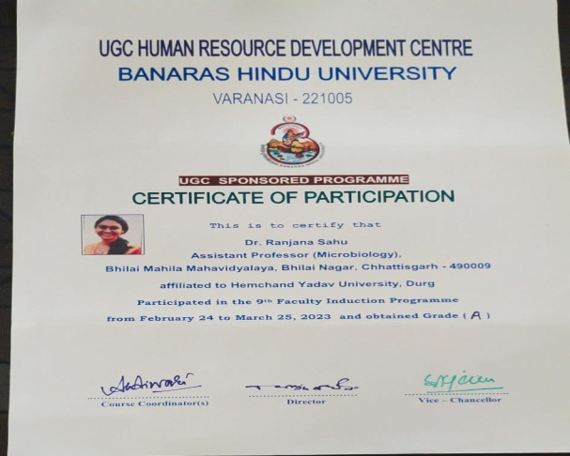
15 |  | Mrs. Divya Paikara | International Short term Training Programme- VIII, “Energy and Environment Conservation” at Raj Rishi Govt. Autonomous College, Alwar, Rajasthan | 18th – 24 April 2023 |  | 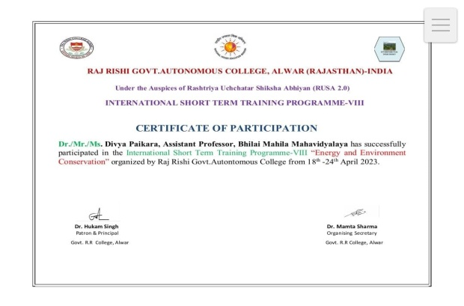
16 |  | Mrs. Divya Paikara | Value Added course on Mushroom Cultivation, Spawn Production and its Post Harvest Management | 20th Sep – 20th Oct 2022 |  | 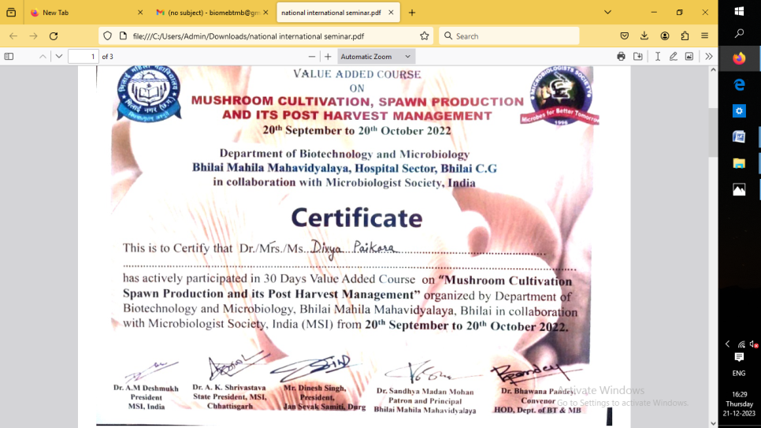
17 |  | Dr. Varsha Chandrakar | International Short term Training Programme- VIII, “Energy and Environment Conservation” at Raj Rishi Govt. Autonomous College, Alwar, Rajasthan | 18th – 24 April 2023 |  | 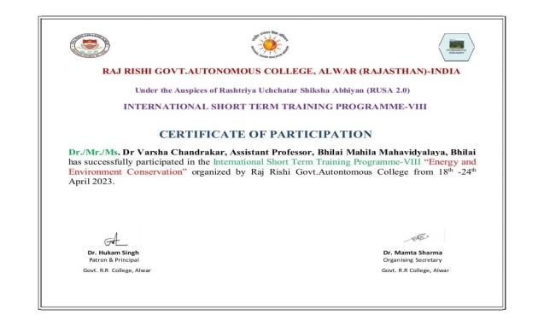
18 |  | Dr. Varsha Chandrakar | Value Added course on Mushroom Cultivation, Spawn Production and its Post Harvest Management | 20th Sep – 20th Oct 2022 |  | 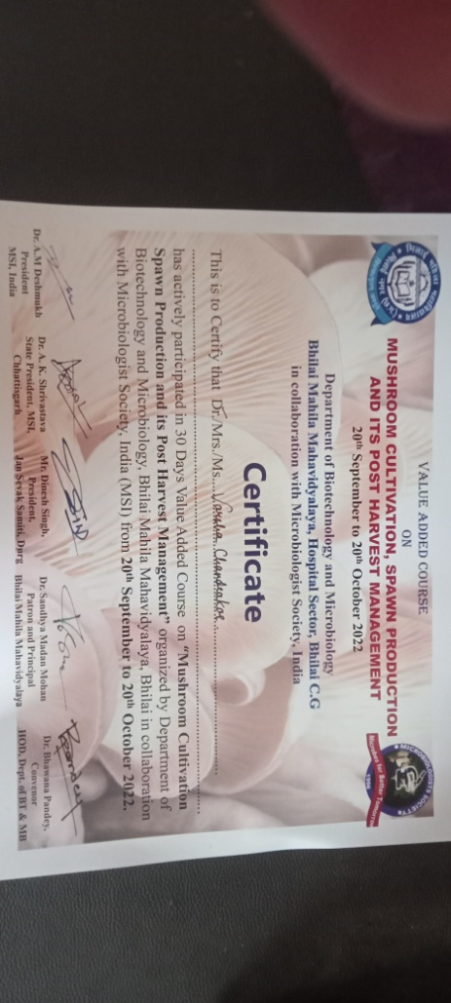
19 |  | Mrs. Bhavika Sharma | International Short term Training Programme- VIII, “Energy and Environment Conservation” at Raj Rishi Govt. Autonomous College, Alwar, Rajasthan | 18th – 24 April 2023 |  | 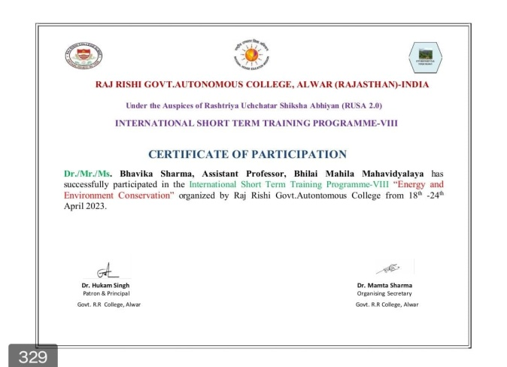
20 |  | Mrs. Bhavika Sharma | Value Added course on Mushroom Cultivation, Spawn Production and its Post Harvest Management | 20th Sep – 20th Oct 2022 |  | 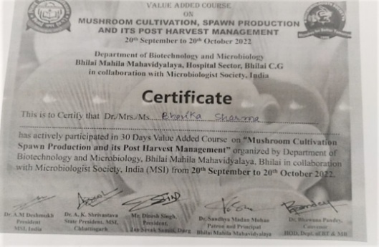
21 |  | Ms. Sadhana Gupta | International Short term Training Programme- VIII, “Energy and Environment Conservation” at Raj Rishi Govt. Autonomous College, Alwar, Rajasthan | 18th – 24 April 2023 |  | 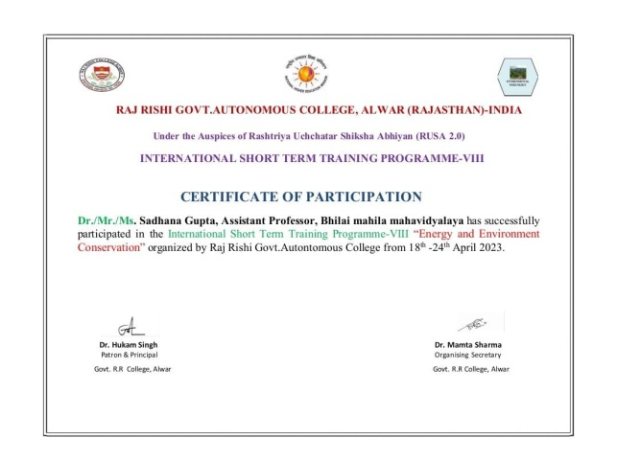
22  23  24  25 |  | Dr.MohanaSushantPandit | FDP | 5days |  | 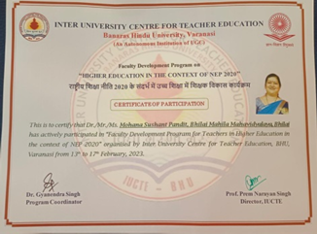
 |  |  | FDP | 5 Days |  | 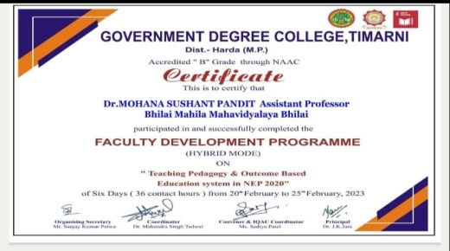
 |  |  | FDP | 15 Days |  | 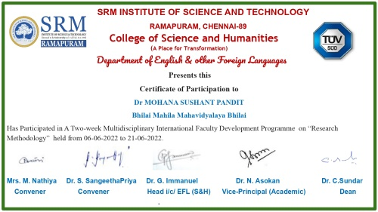
 |  |  |  |  |  | 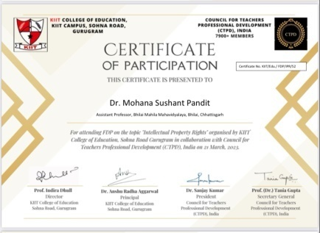
26 |  | Dr..Hemlata Sidar | FDP | 5 Days |  | 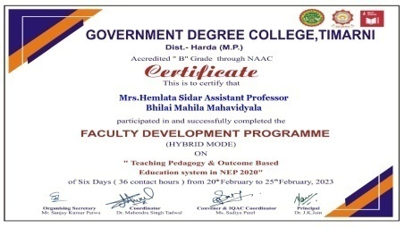
27 |  |  |  |  |  | 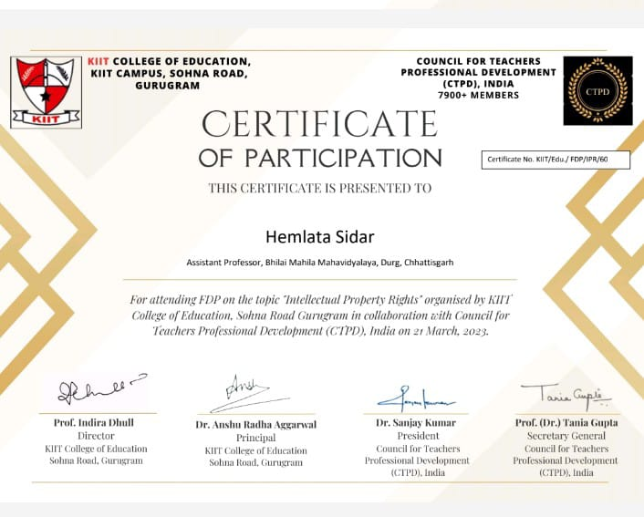
28 |  | Mrs Bhavna Chauhan | FDP |  |  | 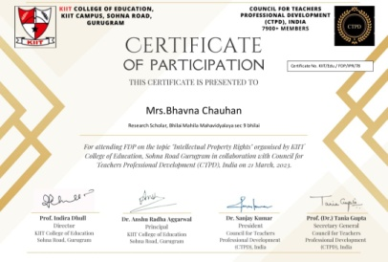
29 |  | Mrs.Naazneen Baig | FDP | 20.02.23 to 25.02.23 |  | 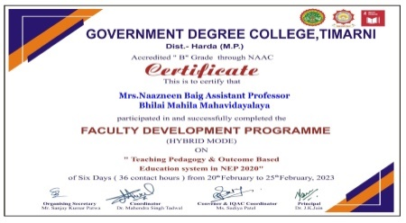
30  31 |  | Mrs. AshaSahu | FDP | 20.02.23 to 25.02.23 |  | 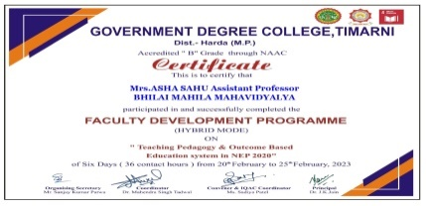
 |  |  | FDP |  |  | 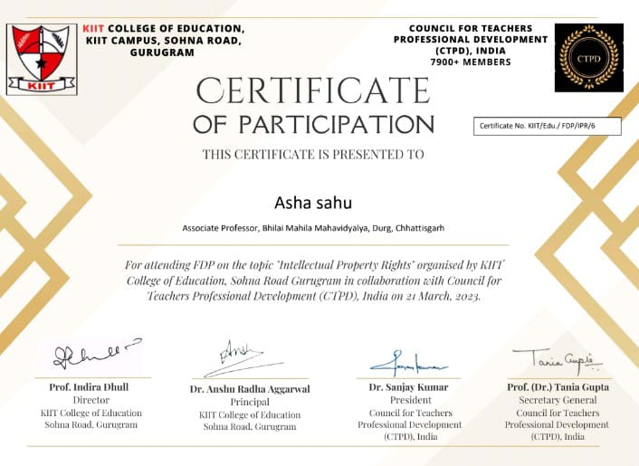
32 |  | Mrs.Kakoli Singha | FDP | 20.02.23 to 25.02.23 |  | 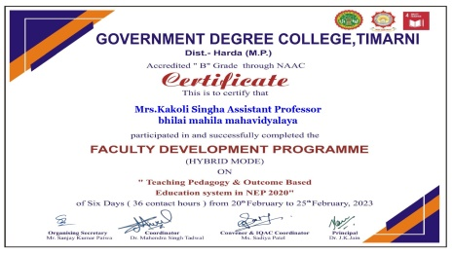
33 |  | Mrs.Satyam Mishra | FDP | 20.02.23 to 25.02.23 |  | 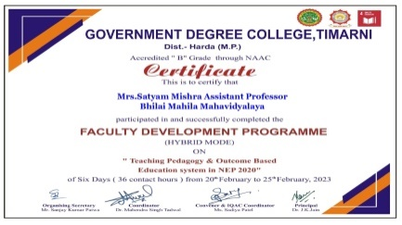
34 |  |  |  |  |  | 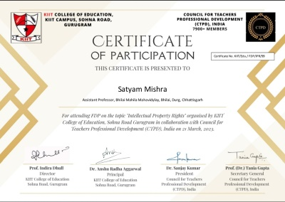
35 |  | Mrs Shweta Puri | FDP | 20.02.23 to 25.02.23 |  | 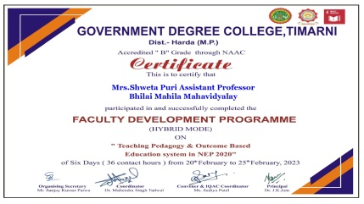
36 |  | Dr.Mohana Sushant Pandit | Interdisciplinary Refresher course on Teaching Research and Assessment, Human Resource development University of Allahabad |  | Connections and tensions among approaches to common issues, texts and phenomena |  | 01.02.23 to 14.02.23 | 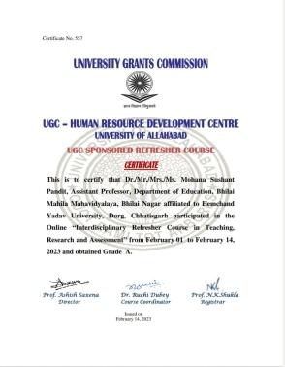
37 |  |  | Certificate course - Yug Purush Swami Vivekanand Hemchand Yadav University, Durg |  | Learning should be driven by curiosity and passion, rather than by fear and compulsion |  | 12.01.23 to 29.01.23 | 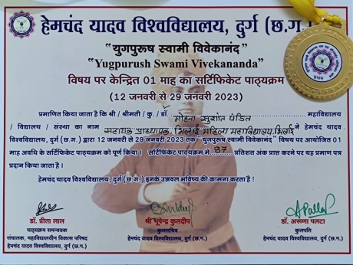
38 |  |  | IP Awareness Training Program under National intellectual property awareness mission |  | To inculcate the spirit of creativity and innovation to students of higher education and inspire the students of college/ university to innovate and protect their creation |  | 29.07.22 | 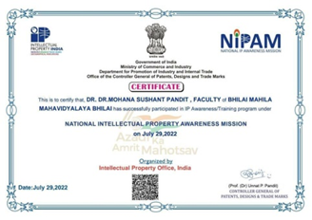
39 |  |  | National Seminar- Financial Awareness for Women |  |  |  | 03.05.23 to 04.05.23 | 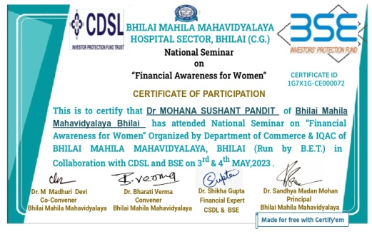
40 |  |  | Workshop - Qualitative Research Design and Data analysis, Deptt. Of Education |  | Focus on the thoughts,  Feelings, reasons motivations and values of a participant,to understand why people act in the way they do. |  | 20.03.23 to 24.03.23 | 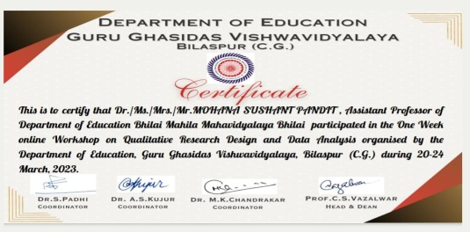
41 |  | Dr. Hemlata Sidar | Certificate Course –Focus on the thoughts of “Mahatma Gandhi” organized by Hemchand Yadav University |  | Non-violence teaches us that conflicts and injustices can be addressed peacefully |  | 02.10.22 to 31.10.2022 | 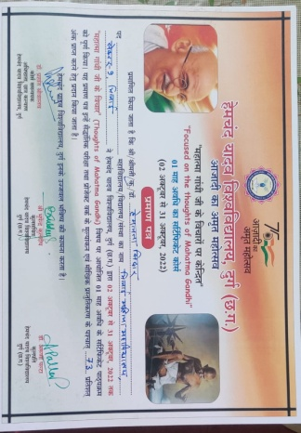
42 |  | Mrs.Naazneen Baig | Certificate Course –Focus on the thoughts of “Mahatma Gandhi” organized by Hemchand Yadav University |  | Pursuing truth teaches us to examie our beliefs,thoughts,and actions with honesty and sincerity. |  | 02.10.22 to 31.10.2022 | 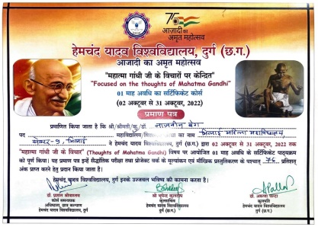
43 |  | Mrs. Asha Sahu | Focus on the thoughts of “Mahatma Gandhi” organized by Hemchand Yadav University |  | Non-violence is the greatest force at the disposal of man kind |  | 02.10.22 to 31.10.2022 | 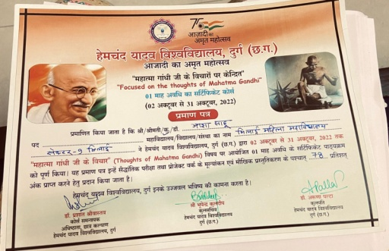
44 |  |  | Workshop - Qualitative Research Design and Data analysis, Deptt. Of Education |  |  |  | 20.03.23 to 24.03.23 | 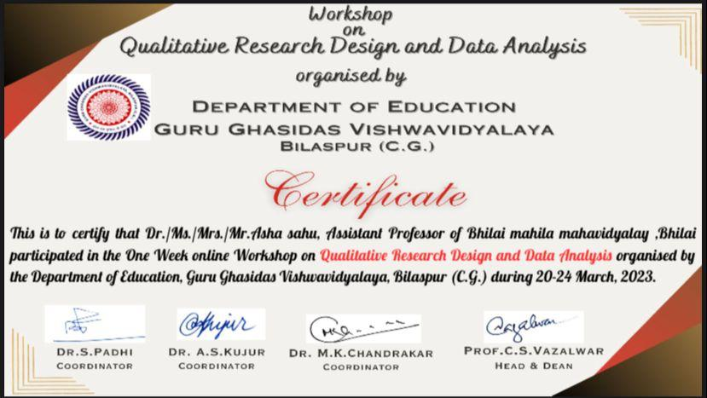
45 |  | Mrs.Kakoli Singha | Focus on the thoughts of “Mahatma Gandhi” organized by Hemchand Yadav University |  | Truth and honesty is a lesson and an eye for an eye only ends up making the whole world blind |  | 02.10.22 to 31.10.2022 | 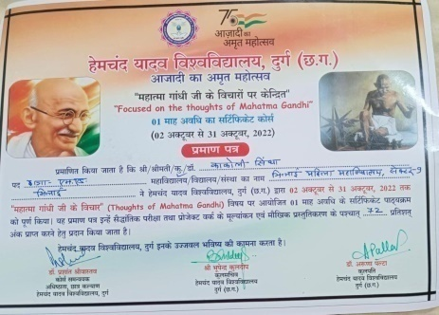
46 |  | Mrs Satyam Mishra | Certificate course - Yug Purush Swami Vivekanand Hemchand Yadav University, Durg |  | The great secret of true success, true happiness is this the man or woman who ask for no return, the perfectly unselfish person is the most successful |  |  | 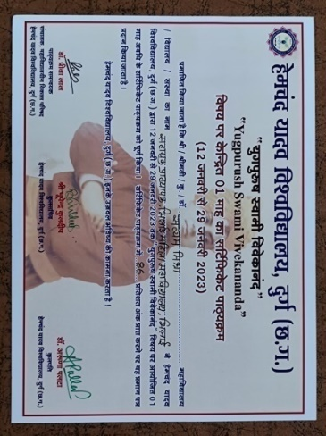
47 |  | Shweta Puri | Refresher Course on ICT(MDC) Organized By UGC HRDC Devi AhilyaVishwavidalaya, Indore |  |  |  | 27.10.2022 to 09.11.2022 | 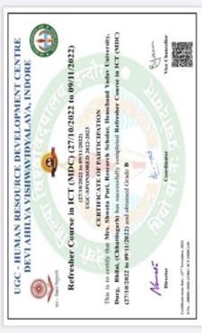
48 |  | Dr.Anupama Shrivastava | Rajrishi Govt. Autonomous college Alwar (Rajasthan) |  | International short term Training Programme Energy and environmental conservation |  | 18th to 24th April 2023 | 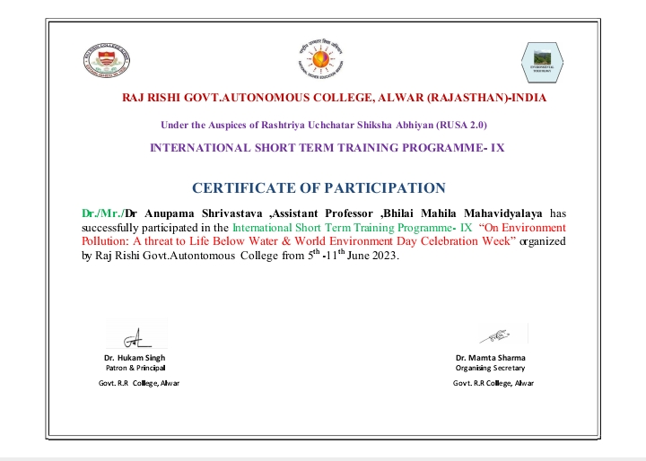
49 |  | Dr. Nishtha Vaidya | Teaching Learning Center, Ramanujan College, University of Delhi |  | FDP - Week faculty Induction Programme for faculty of University and colleges |  | 23 April-22 may, 2023 | 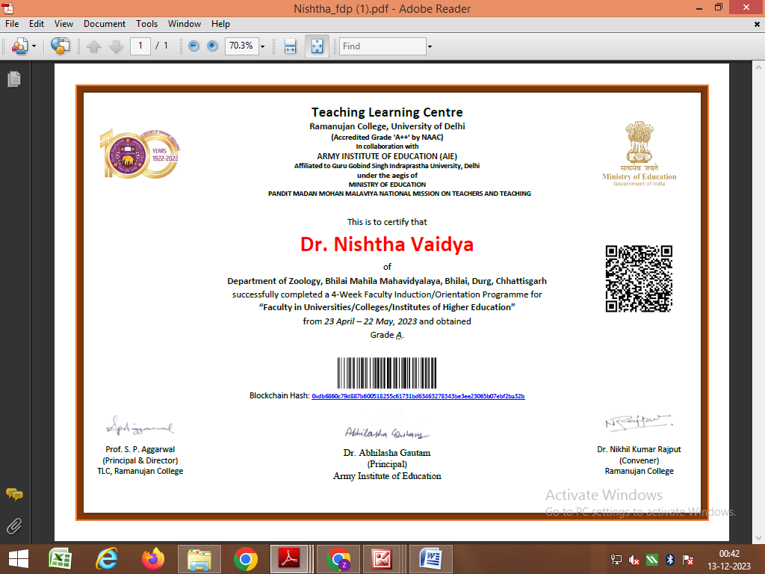
50. |  | Dr. Nishtha Vaidya | Indira Gandhi Open University New Delhi |  | UGC Approved Short Term Professional Development Program Implementation of NEP 2020 for University and College Teachers |  | 12 to 20 June, 2023 | 