6.5.3. Guest lecture
S.No. | Institute & Dept. | Date | Topic covered |  |  | Speaker |  | Geotagged pic
1 | Govt. W.W. Patankar  Girls PG college, Durg | 10.04.23 | Protein sorting and targeting of proteins to organelles |  |  | Dr. Pratiksha Pandey
2 | Govt NPG college of Science, Raipur | 16.02.23-  17.02.23 |  |  |  | Dr. Pratiksha Pandey
3 | Navyug Arts & Commerce College, Jabalpur (M.P.) India  (International Seminar) | 22.05.2023-  23.05.2023 | Research Ethics |  |  | Dr. Pratiksha Pandey
4 | Navyug Arts & Commerce College, Jabalpur (M.P.) India  (International Seminar) | 22.05.2023-  23.05.2023 | Research methology in Social Sciences |  |  | Dr. Deepti Chauhan
5 | school of life and allied scienes, ITM Univesity, Raipu. | September 16th 2022 | “World ozone day” |  |  | Dr. Amarpreet Kour Bhatia |  | 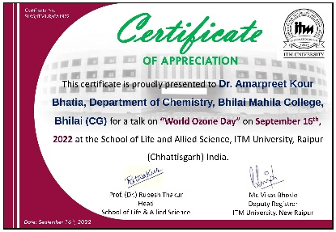
6 | Dr. Bhawana Pandey |  |  | Sai Mahavidyalaya on the topic of IPR | 08/09/22 |  | 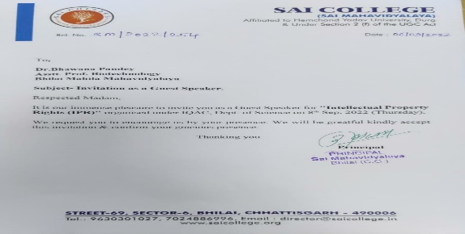
7 | Dr. Bhawana Pandey |  |  | Govt. Digvijay College , Rajnandgaon, (C.G.) on the topic of Subject expert in Minor research project | 24/11/22 |  | 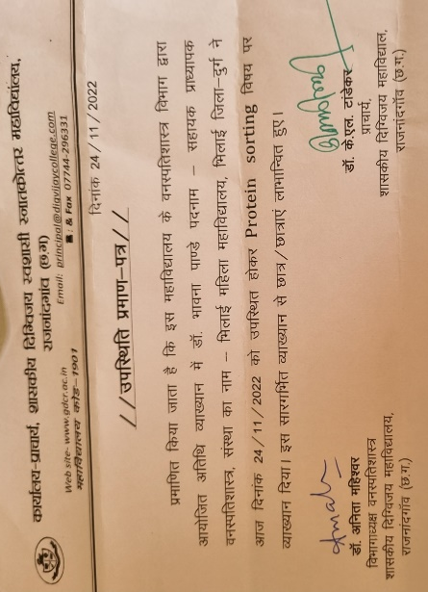
8 | Dr. Bhawana Pandey |  |  | National Conference of Environment, Pharmacology and Biological Sciences, Jalgaon, Maharashtra on the topic of Role of Nanomaterials for the Cure of malignancy | 19/01/23 |  | 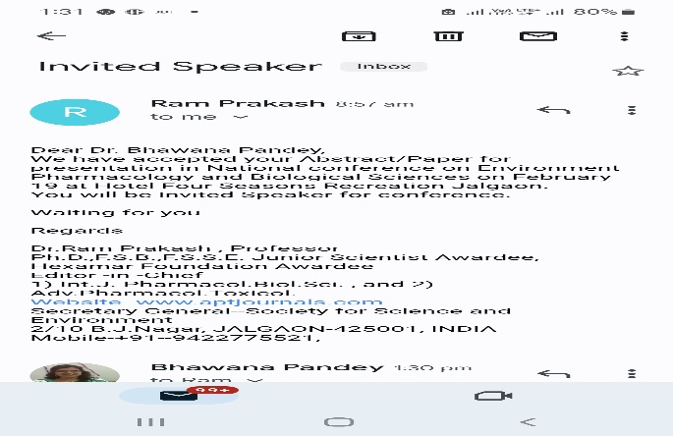
9 | Dr. Bhawana Pandey |  |  | International Conference on Climate Change, sustainable development and Smart Agriculture at Kalinga University, Raipur on the topic of Importance of Aquatic Flora in Sustainable Development | 6/2/23 |  | 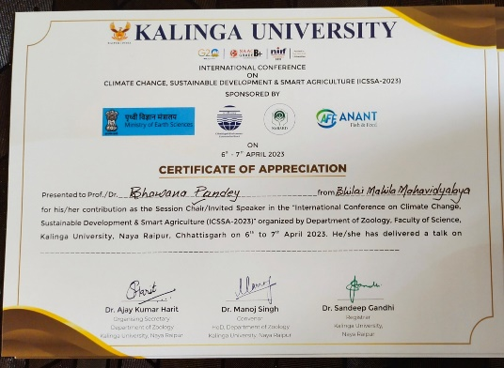
10 | Dr. Bhawana Pandey |  |  | National Seminar on Emerging Trends of Multidisciplinary research in Science, Technology and Innovation on the topic of Rhizobium as Biofertilizer | 27/02/23 |  | 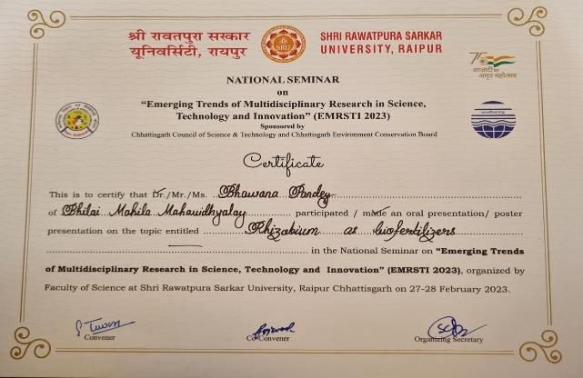
11 | Dr. Bhawana Pandey |  |  | Swami Swaroopanand Sarasawati Mahavidyalaya, Hudco, Bhilai on the topic of Fermenter | 22/3/23 |  | 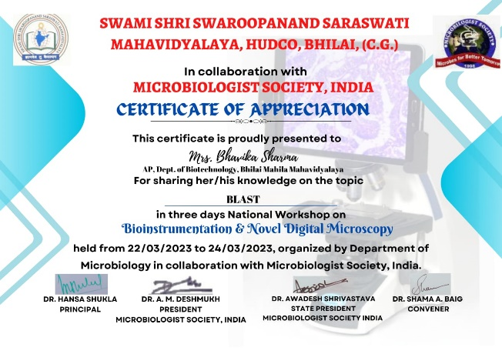
12 | Sabiha Naz |  |  | Guest Lecture on Govt. Digvijay College, Rajnandgaon on the topic of Recombinant DNA Technology | 7/1/2023 |  | 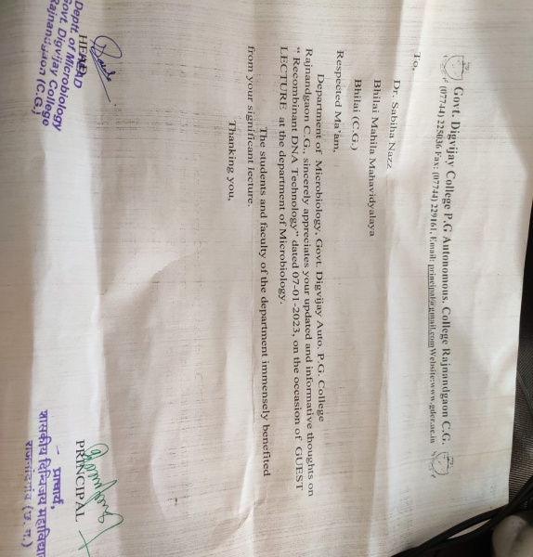
13 | Dr. Ranjana Sahu |  |  | Govt. VYTPG. Autonomous College, Durg on the topic of Awareness of Trends in Technology: Immunodiagnostics, Nanotechnology and Bioinformatics of Microbiology | 9/1/2023- 13/1/2023
14 | Dr. Ranjana Sahu |  |  | Guest Lecture on Govt. Digvijay College, Rajnandgaon on the topic of SCP Mushroom | 20/2/2023
15 | Mrs. Bhavika Sharma |  |  | Swami Swaroopanand Sarasawati Mahavidyalaya, Hudco, Bhilai on the topic of BLAST | 22/3/23 |  | 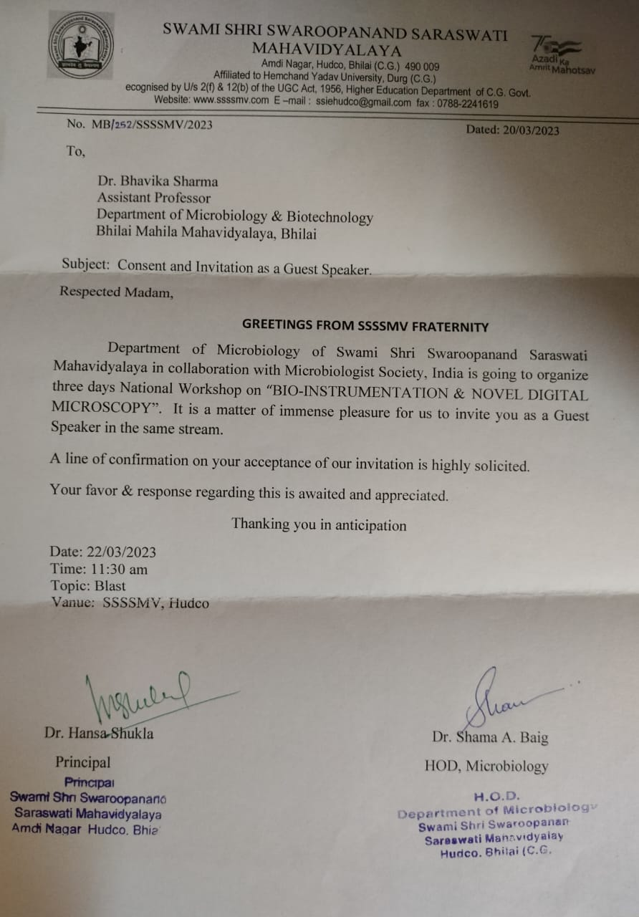
16 | Dr. Mohana Sushant Pandit |  |  | DAV College, Durg  Education | 08.02.2023 |  | 