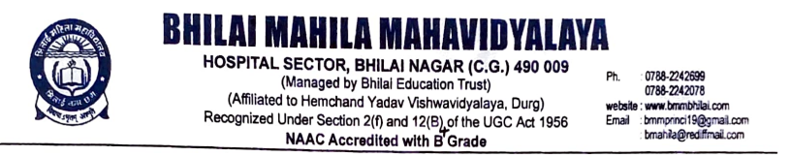

Criterion -7

7.1. Institutional Values and social responsibilities

7.1.1. Measures initiated by the Institution for the promotion of gender equity during the year 2022-23

Reports of the Programmes

Title of the Programme: Teachers Day celebration
Date: 05.09.2022 Number of participants: 100

Programme Report

Bhilai Mahila Mahavidyalaya in association with IQAC has organized Teachers Day celebration on 05.09.2022. “If there were no Teachers, all other Professions would not exist” The quote exactly mentioned the importance of teachers in life. Like every year, this year also the Teaching Staffs were invited to celebrate their day. The students expressed their gratitude and appreciation for the teachers. The celebration took place after the classes and it has started with the cake cutting ceremony by the teachers. The introductory speech was delivered by the Principal Dr. Sandhya Madhan Mohan and her words overwhelmed all of the staff and the students. All of us enjoyed the celebration and spent some memorable time with our loving teachers in the busy schedule.

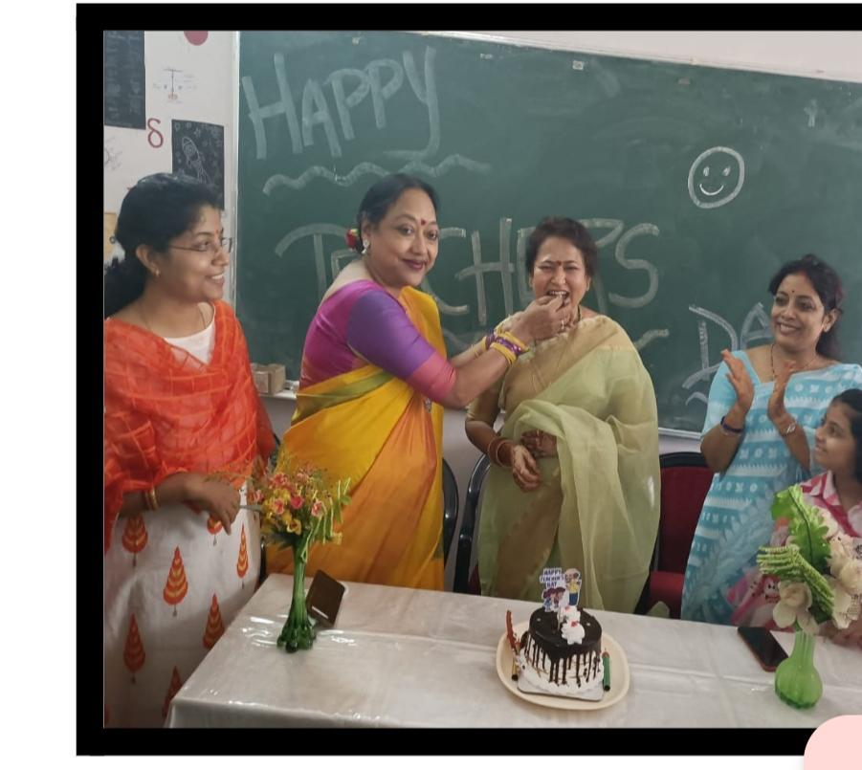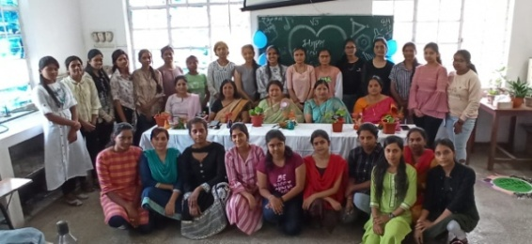
Teachers Day celebration

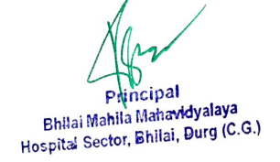

Title of the Programme: Lecture on Woman Nutrition

Date: 28.09.2022 Number of participants: 52

Programme Report

The NSS unit & Women Cell of Bhilai Mahila Mahavidyalaya in association with IQAC has organized Guest Lecture on Woman Nutrition on 28.09.2022. Dr Anupama Shrivastava HOD Zoology and NSS officer of this college gave Lecture on Woman Nutrition and which type food taken by pragnent woman. The event turned got to be a great success and made the day for many students and staff realizing the importance of Woman Nutrition. The participants were very happy to participate in the event and the program received wonderful response.

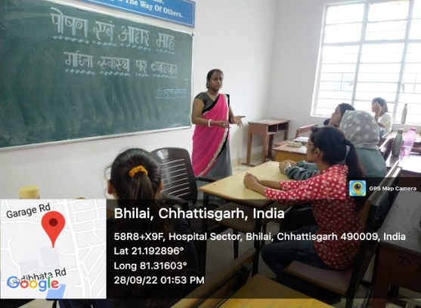
Lecture on Woman Nutrition

Title of the Programme: Role play on gender equity sensitization
Date: 02.12.2022 Number of participants: 26

Programme Report

The Department of Home Science & Women Cell of Bhilai Mahila Mahavidyalaya in association with IQAC has organized Role play on Gender Equity Sensitization on “Beta Beti Ek Saman” on 02/12/2022. As a step towards Women Empowerment, this event has created awareness on gender- based discrimination, inequalities faced by the Girl Child wherein it was conveyed that Son and Daughter are equal. We as members of society, should ensure that we provide equal opportunities to boys and girls in every field. The event turned got to be a great success and made the day for many students and staff realizing the importance if the girl child and the need to celebrate it. The participants were very happy to participate in the event and the program received wonderful response

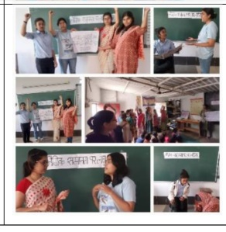
Role play on gender equity sensitization

Title of the Programme: Guest Lecture on Personality Development & Entrepreneurship

Date: 05.12.2022 Number of participants: 36

Programme Report

The Department of Zoology & Women Cell of Bhilai Mahila Mahavidyalaya in association with IQAC has organized Guest Lecture on Personality Development & Entrepreneurship on 05.12.2022. Dr. Sanjay Thiske from Govt. Digvijay College, Rajnandgaon has delivered on a Lecture on personality development and Ms. Renuka Thakur from Govt. Kunj bihari Choubey College, Lal Bahadur Nagar, Rajnandgaon has delivered a Lecture on entrepreneurship. The event turned got to be a great success and made the day for many students and staff realizing the importance of Personality Development & Entrepreneurship. The participants were very happy to participate in the event and the program received wonderful response.

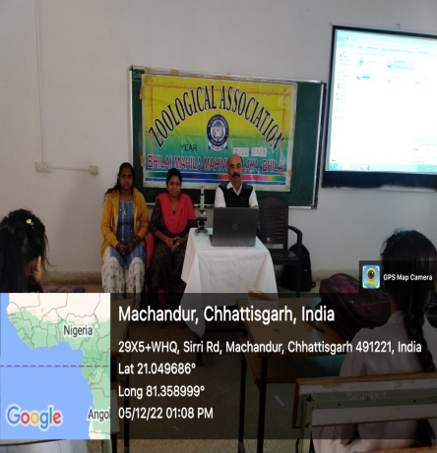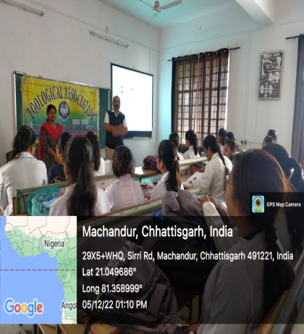
Guest Lecture on Personality Development

Title of the Programme: Sports Day Celebrations
Date: 17.01.23 Number of participants: 253

Programme Report

Bhilai Mahila Mahavidyalaya in association with IQAC has organized Annual sports day celebration on 17.01.2023. The event took place in the spacious playground of the College. The chief guest of the event was Dr. Aruna Palta, Vice Chancellor of Hemchand Yadav University, Durg. The event began with the students and followed by teaching and non-teaching staff participating in a great amalgamation of track and field events and some interesting yet fun races. Our Principal Dr. Sandhya Madhan Mohan rewarded the winners with medals and certificates and congratulated them for their victory. The event continuously laid the emphasis of sports in a student’s life and physical and mental development. It was a day filled with sportsmanship, enthusiasm and memories to cherish

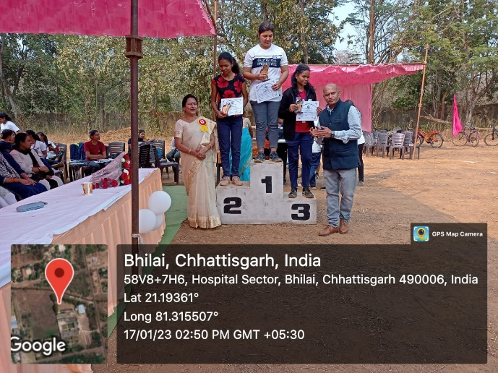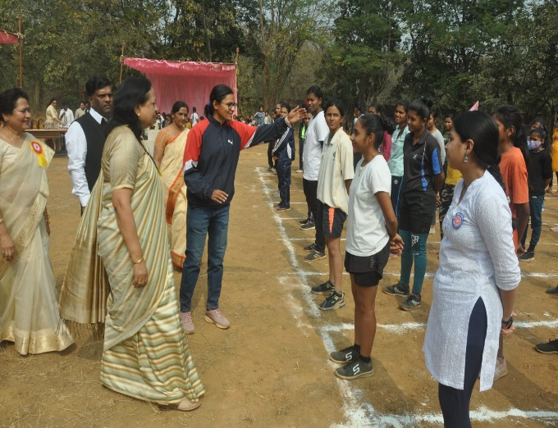
Sports Day Celebrations

Title of the Programme: - National Girl Child Day

Date: 24.01.2023 Number of participants: 36

Programme Report

Department of Education & women Cell of Bhilai Mahila Mahavidyalaya in association with IQAC has organized National Girl Child Day on 24.01.2023. The national girl child day is celebrated in India on 24th January every year. It was introduced by the ministry of women and child development in the year 2008 to create the awareness of gender-based discrimination, inequality of girl child and to save girl child. With respect to this celebration, Speech Competition on topic “Save Girl Child” was organised. The event turned got to be a great success and made the day for many students and staff realizing the importance if the girl child and the need to celebrate it. The participants were very happy to participate in the event and the program received wonderful response

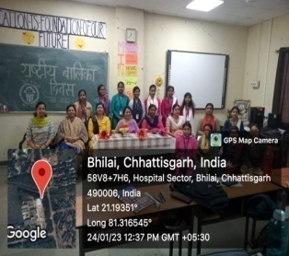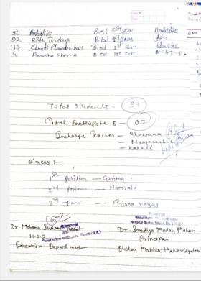
National Girl Child Day

