Criterion -7

Institutional Values and Social Responsibilities

7.1.1. Institution shows gender sensitivity in providing facilities

7.1.1. Institution shows gender sensitivity in providing facilities such as:

Specific facilities provided for women in terms of:
a. Safety and security - yes
b. Counseling - Yes
c. Common Rooms - Yes

- Safety and security

Facilities | Evidence
24X7 Guard room | 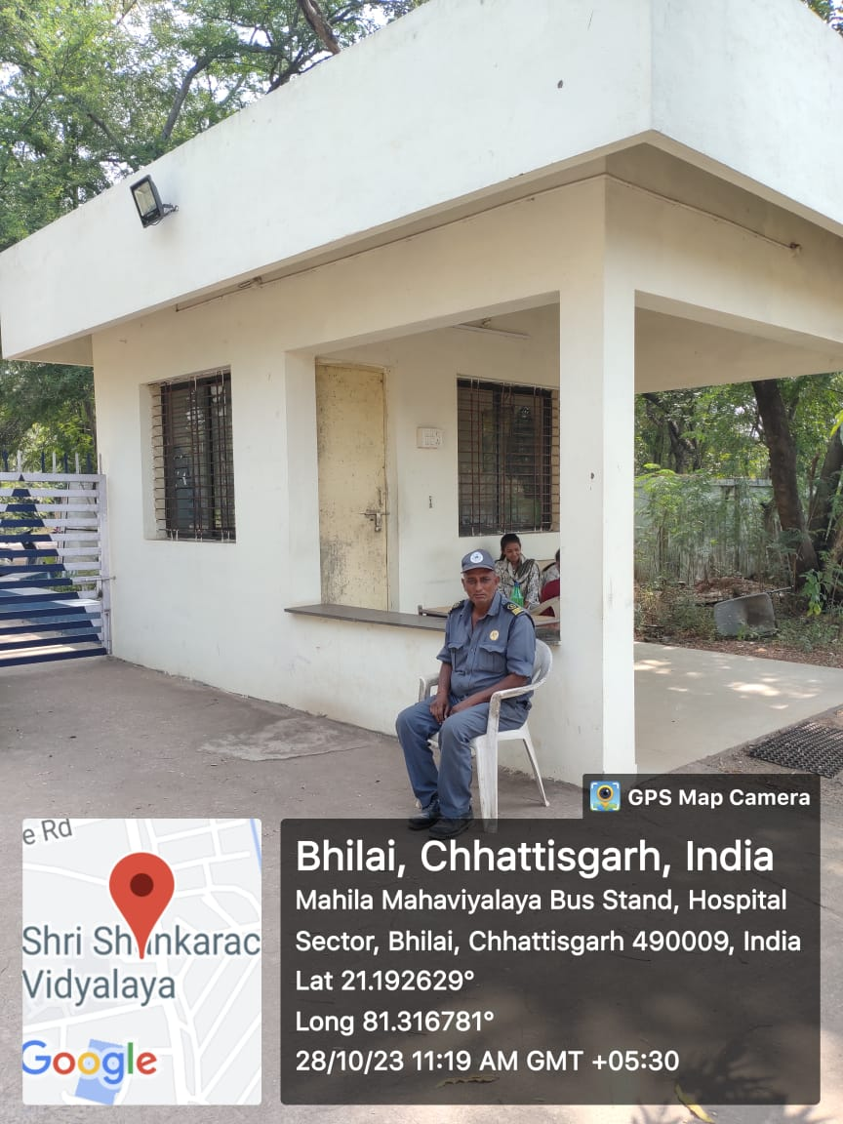
Compound Wall | 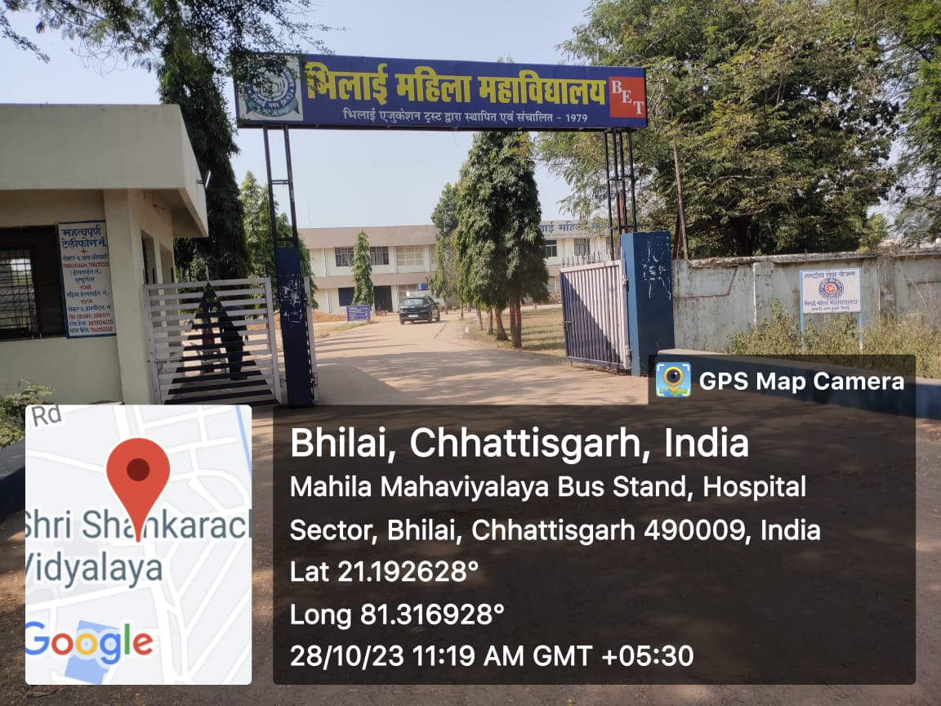
Vehicle Parking | 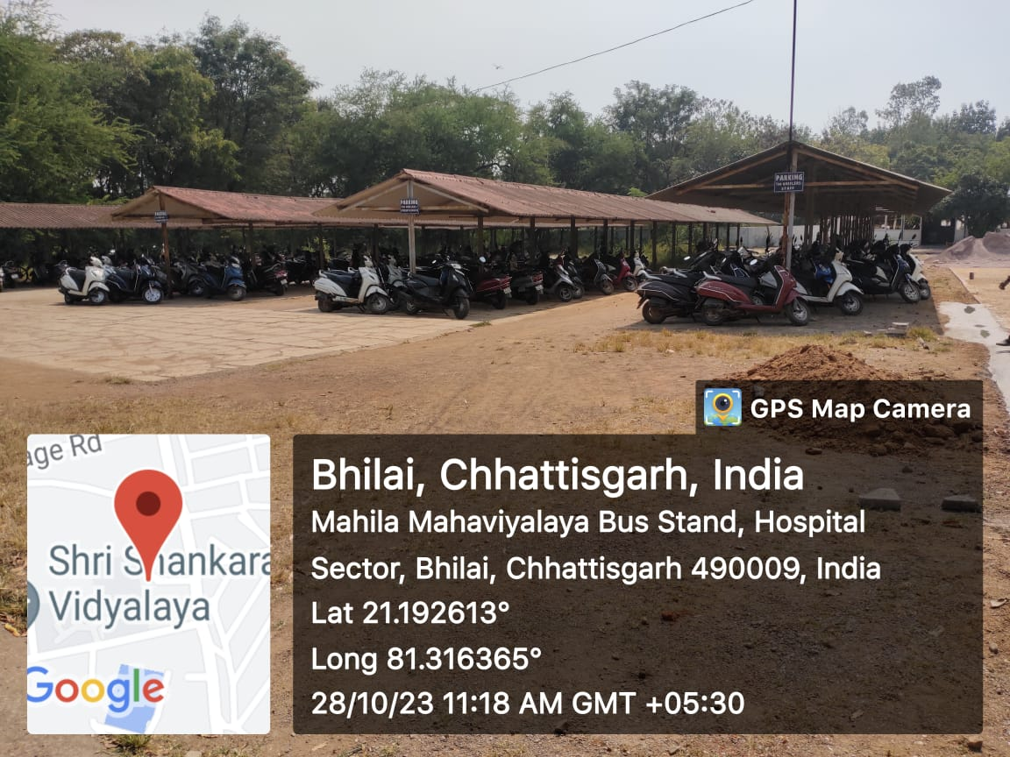
Stationery shop inside the campus | 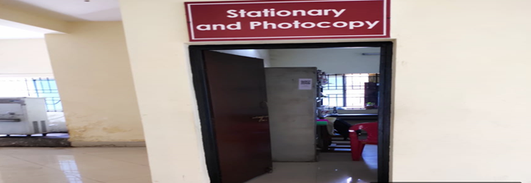  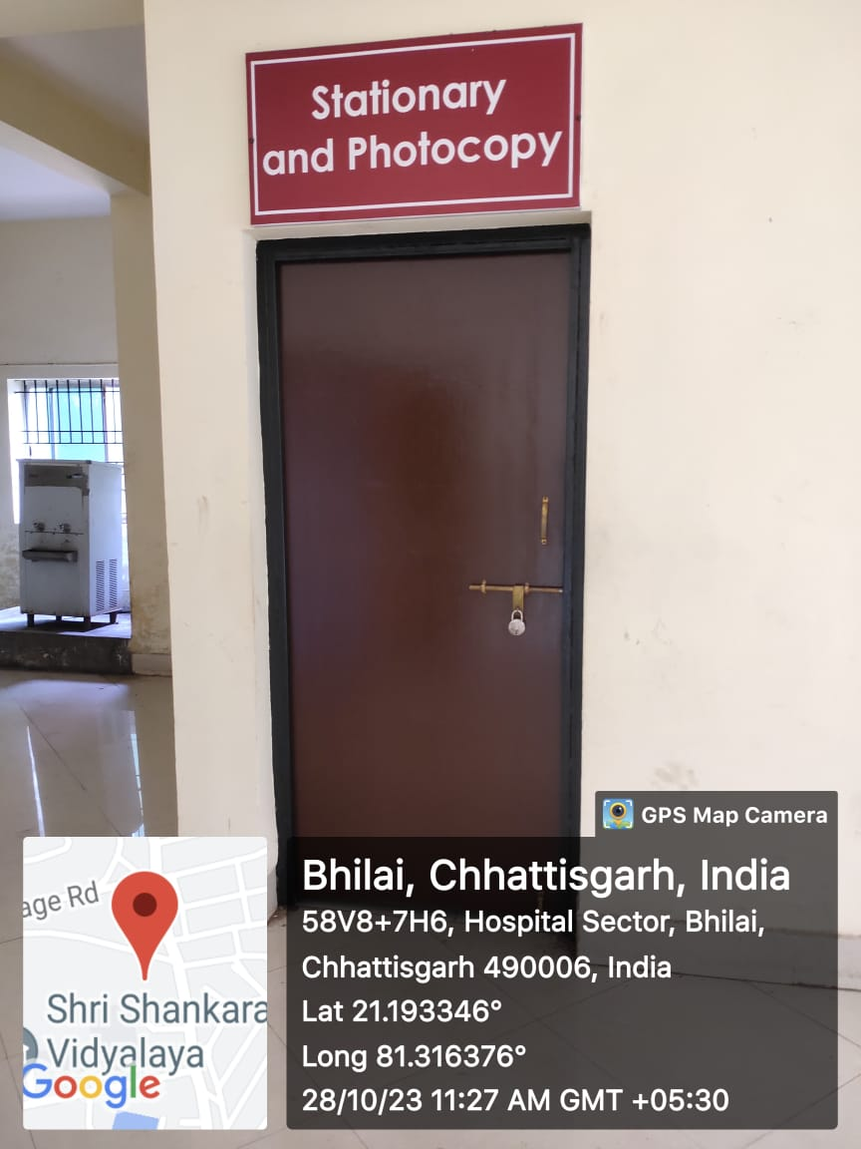
BMM canteen | 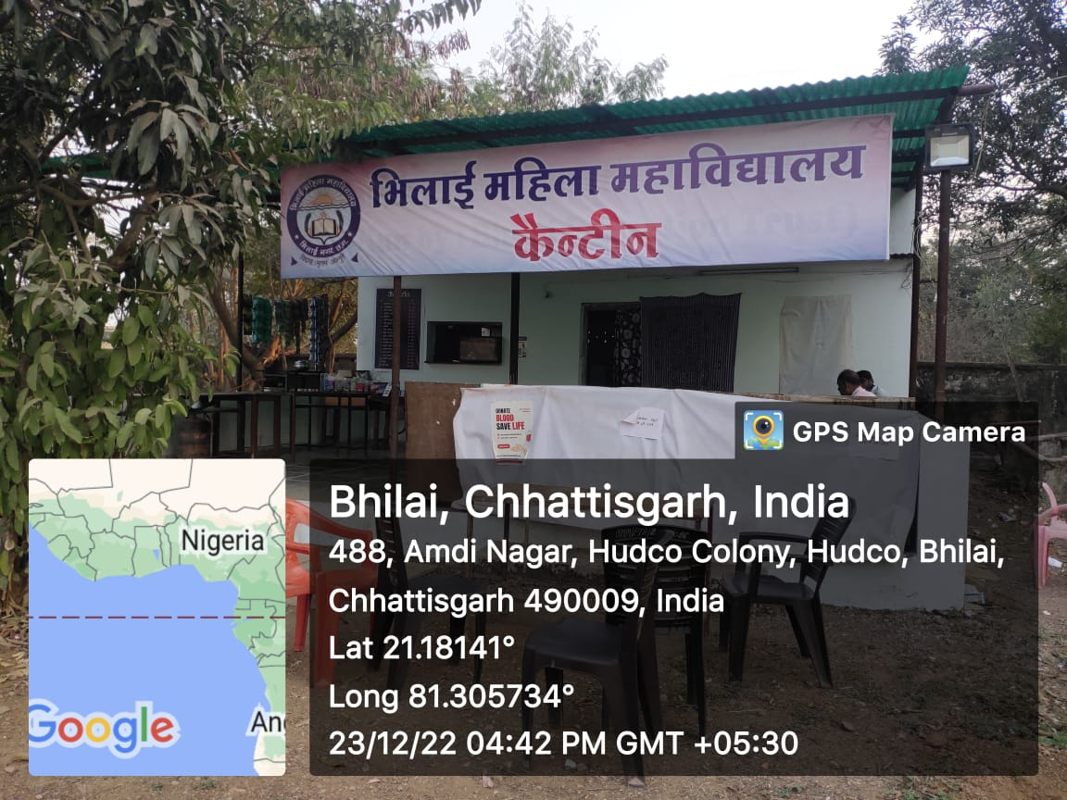
BMM hostel | 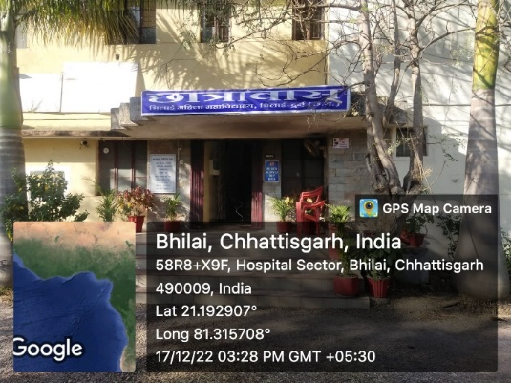
Water cooler | 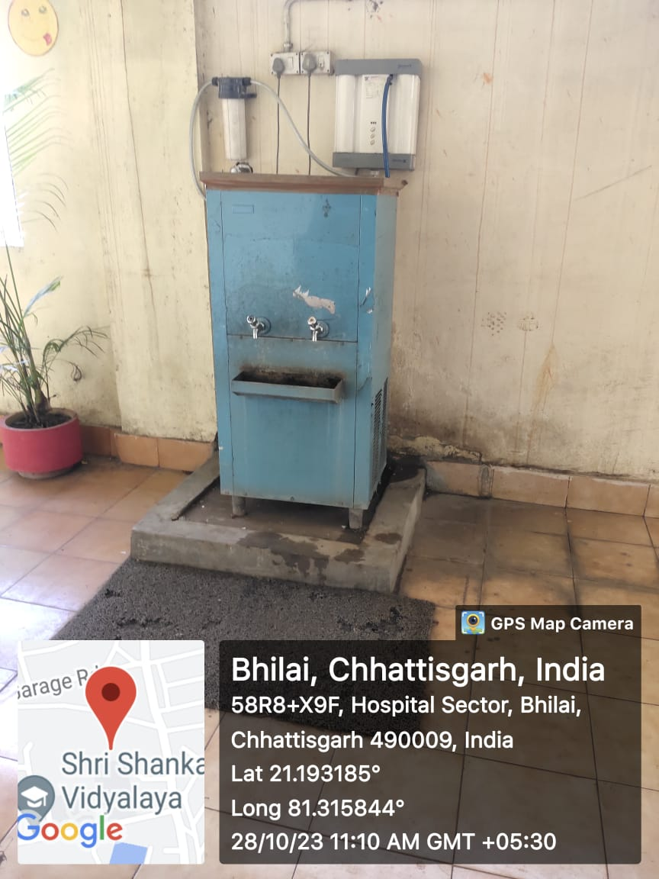
Complaint Box & Suggestion box | 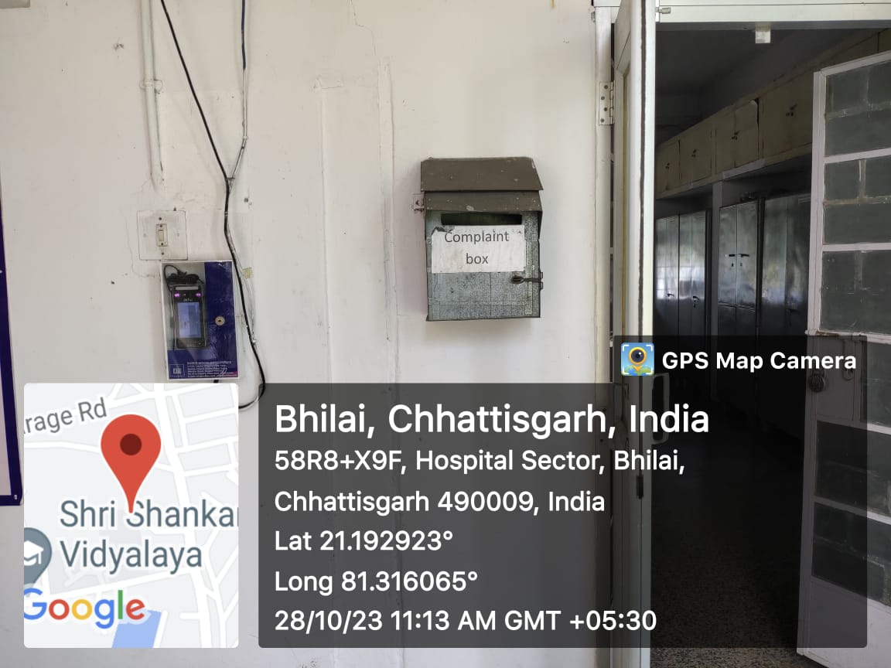  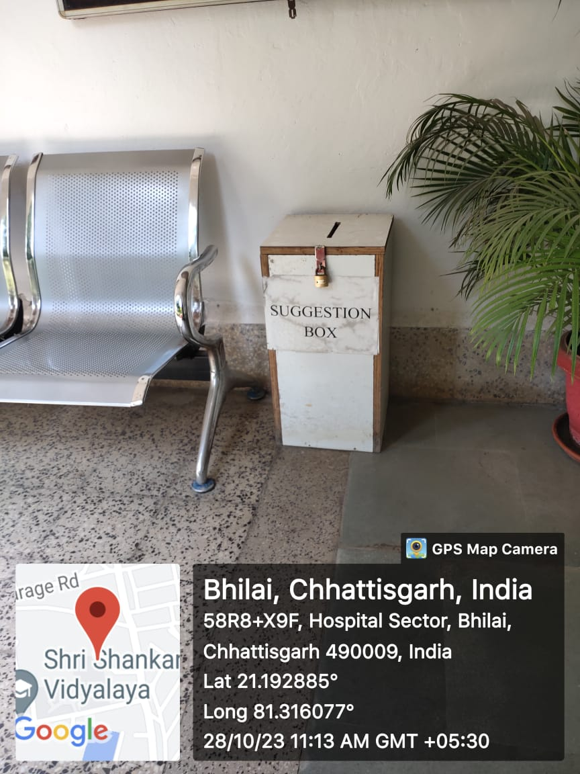
Generator | 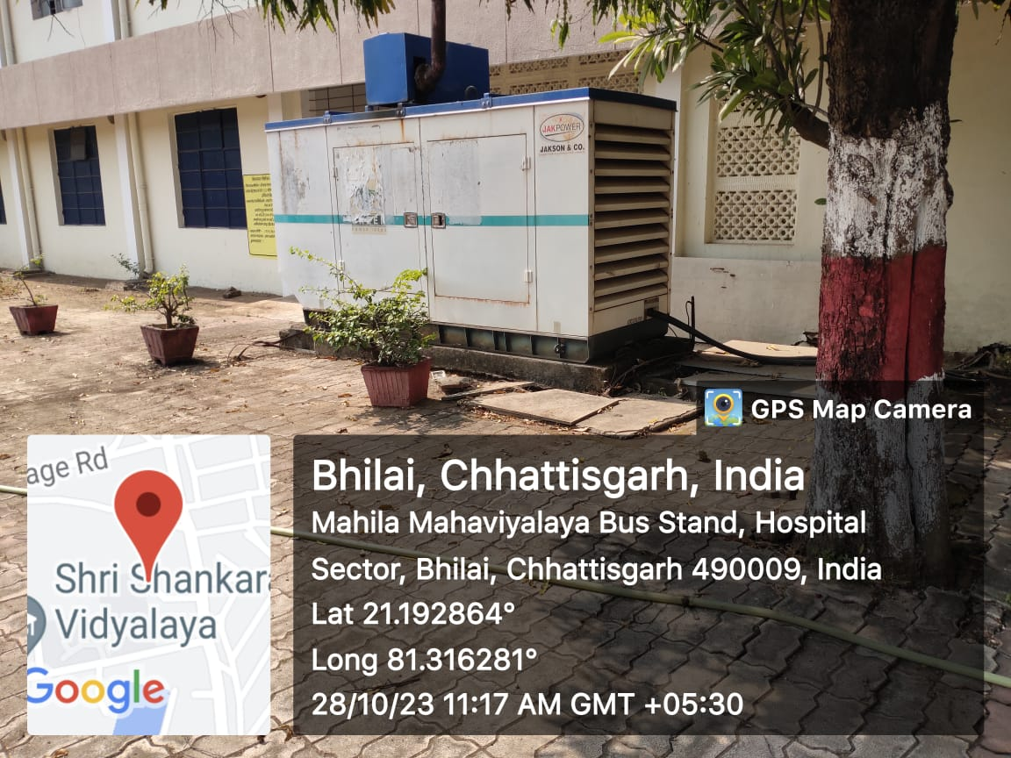
Fire Extinguisher | 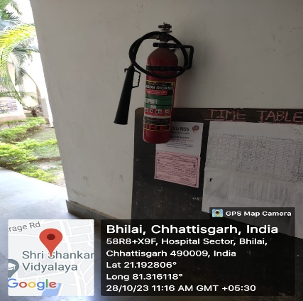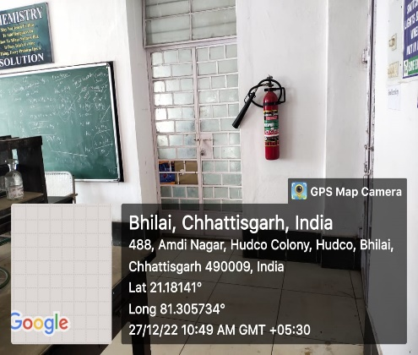  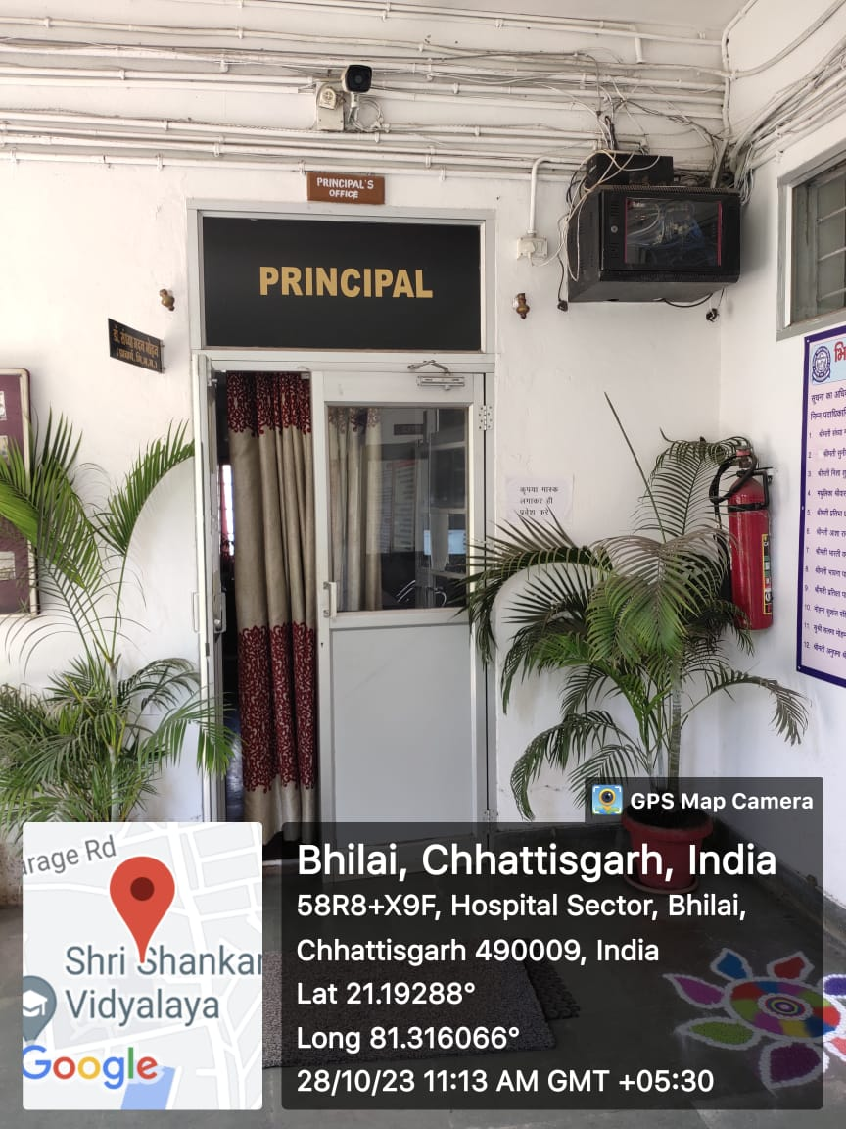
24X7 Wi-Fi Connection | 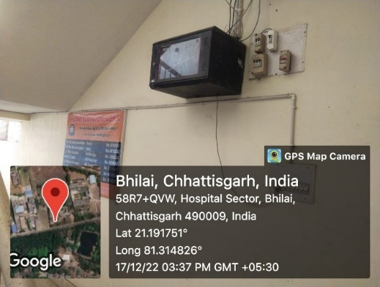
Auditorium cum multipurpose hall | 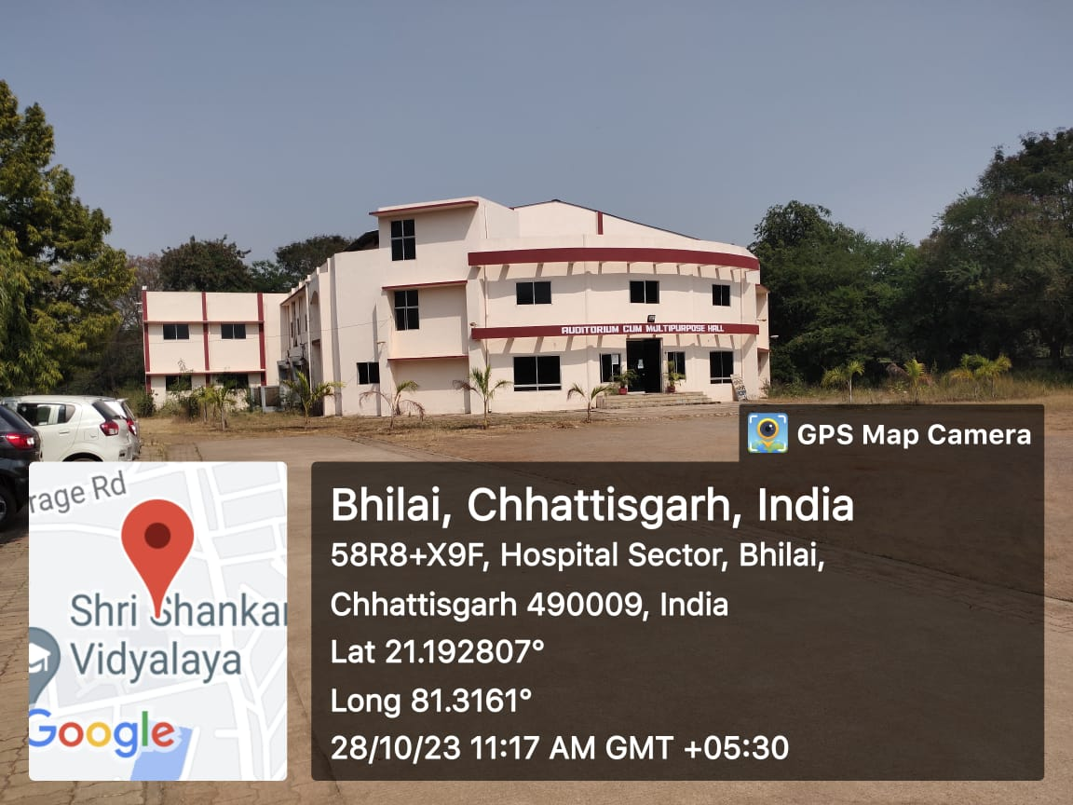
Dry cleaning Machine | 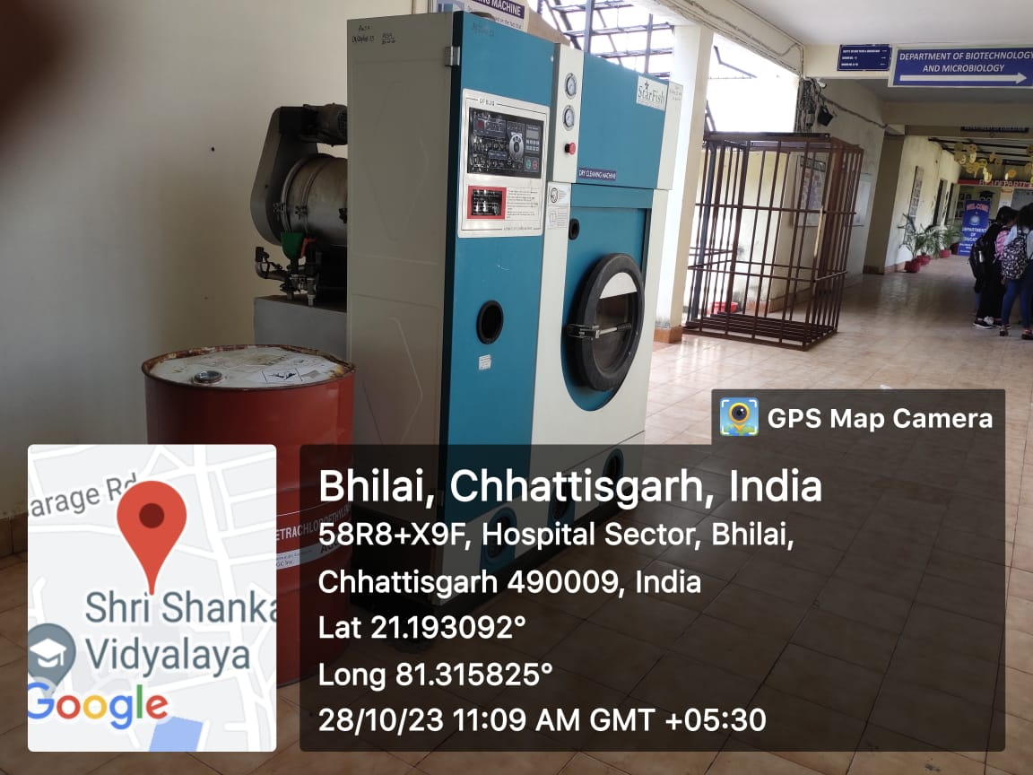
CCTV Camera | 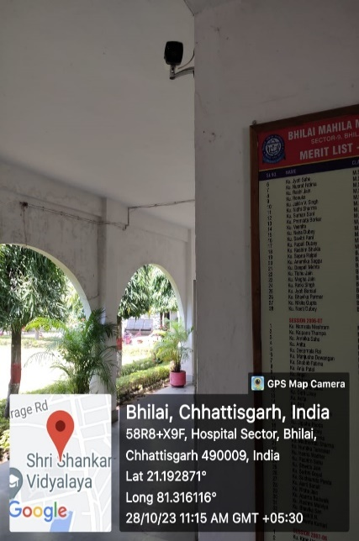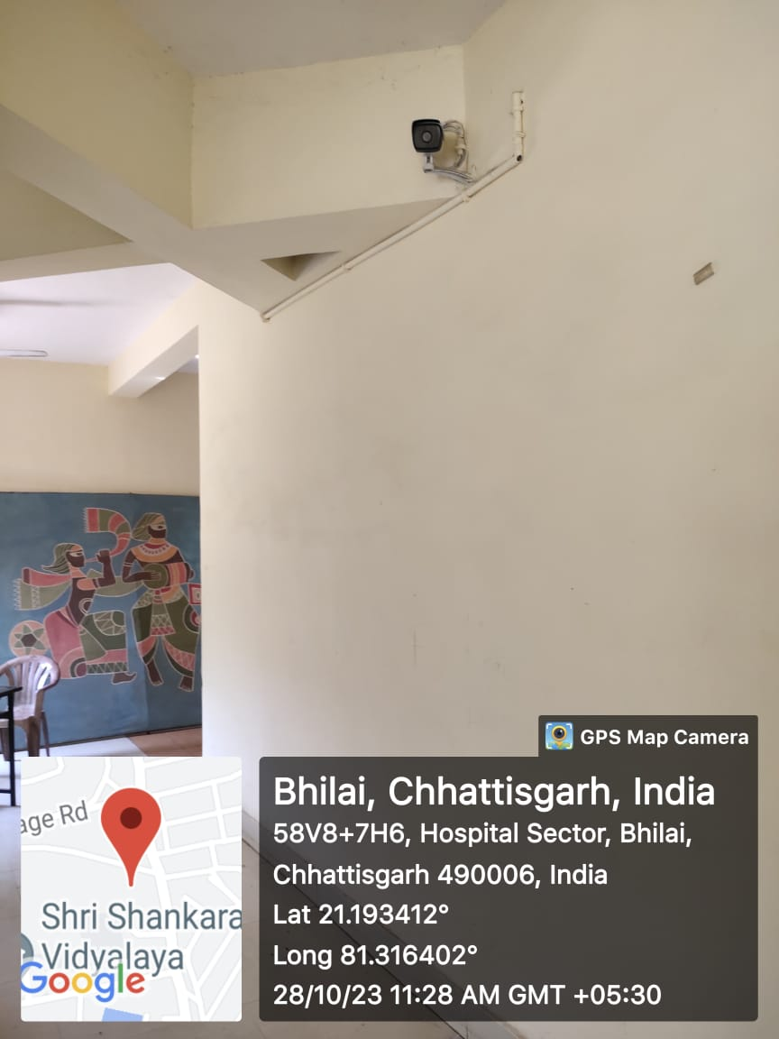
Sanitizer Unit | 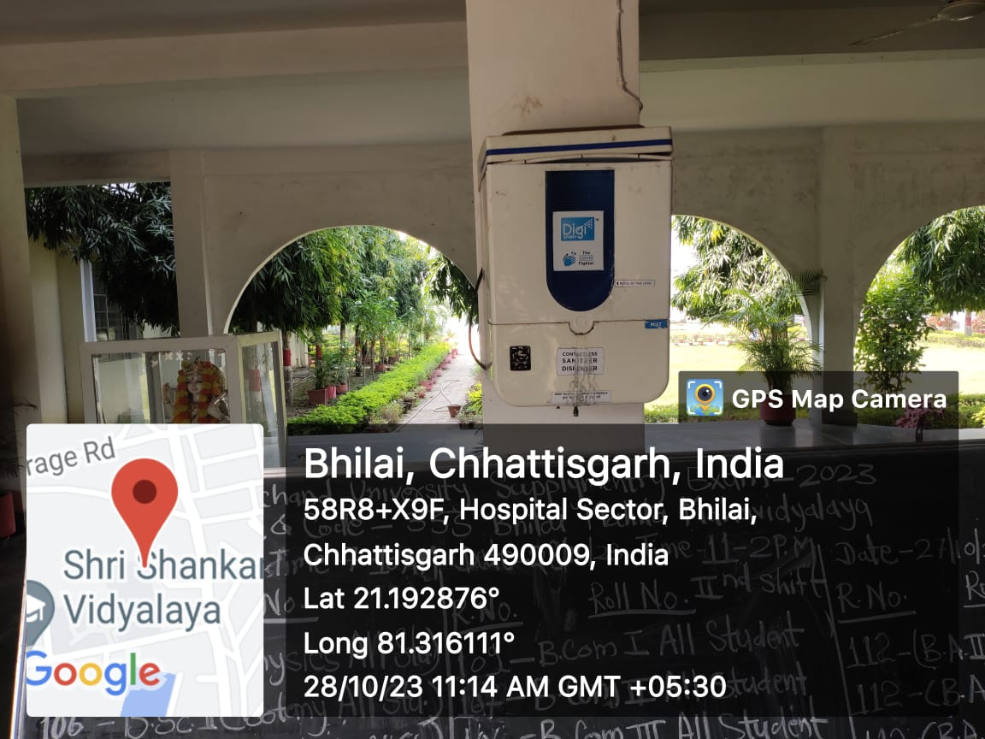
Sportz ground  Badminton court | 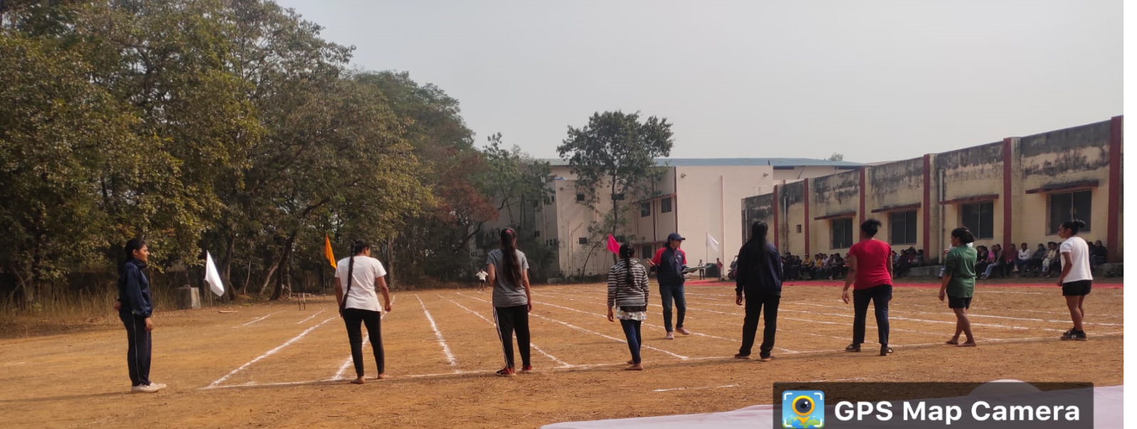  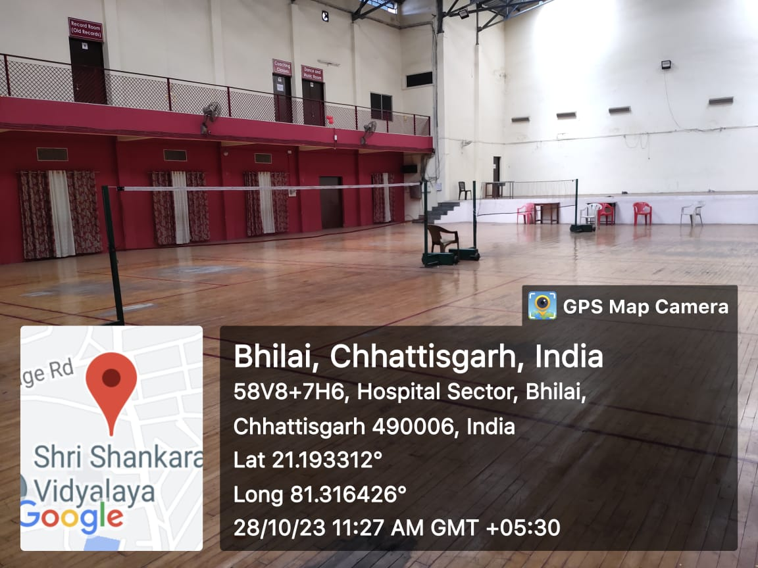
Vending Machine in Hostel and college campus | 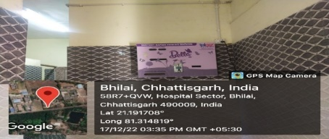
Gym Facility | 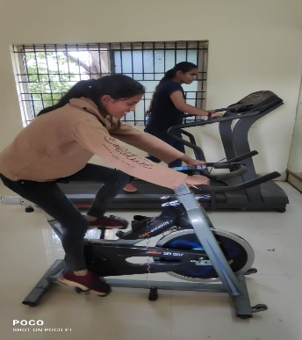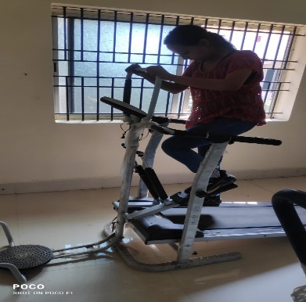
First Aid room/Rest room | 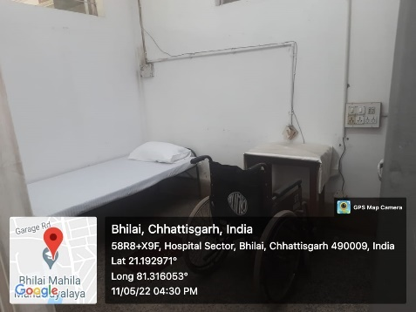

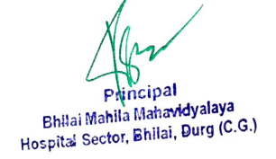

- Counselling
The institution has a dedicated Counselling Centre and good mentoring system for the students to take care of their academic, emotional, social and cognitive development. Personal Counselling is provided to the students at different levels. Career counseling for career opportunities in specific fields are also organized as such counseling has helped students to overcome their own fears and anxieties and achieve their best in both curricular and extra-curricular activities.
COUNSELING UNDER NMHP

No of student counselled | Nature of counseling | Evidence
8 | - Conflicts related to career  - Socio- emotional  - Anxiety stress  - Vocational and emotional counseling  - Personal problem related to adjustment  - Health issues and academic problems  - Depression  - Socio psychological problem related to career | 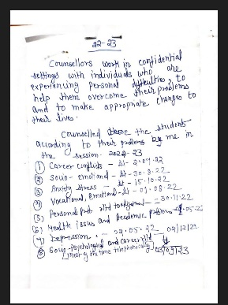  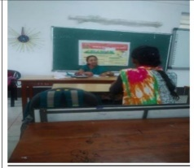

Common Room
Common room with good facilities for students available in various Floor. Washrooms are provided with sanitary napkin vending and incinerator unit for the safe and hygienic disposal of sanitary napkins

