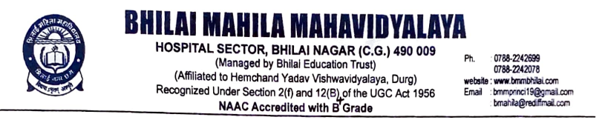

Criterion -7
7.1. Institutional Values and Social responsibilities
Human Values and Professional Ethics

7.1.10. The Institution has a prescribed code of conduct for students, teachers, administrators and other staff and conducts periodic programmes in this regard.

Reports of the Programmes

Title of the Programme: Children’s Day
Date: 14.11.2022 Number of participants: 48
Programme Report
Children’s day in India is celebrated every year on 14th of November to increase the awareness of people towards the rights, care and education of children. Bhiali Mahila Mahavidyalaya organised Essay Competition on the occasion of Children’s Day. Students from various department took part actively in this event.
V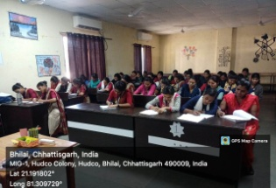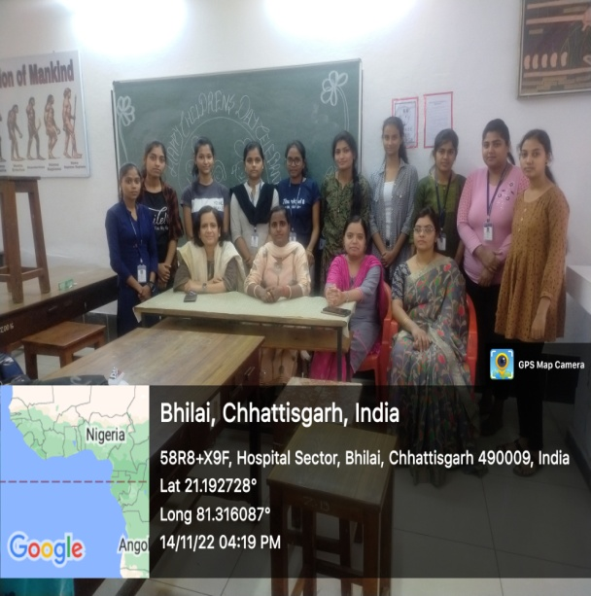

Children’s Day

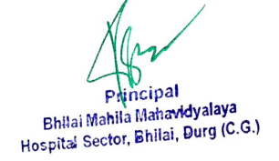
Title of the Programme: Teacher’s Day Celebration
Date: 05.09.2022 Number of participants: 100
Programme Report
Bhilai Mahila Mahavidyalaya in association with IQAC has organized Teachers Day celebration on 05.09.2022. “If there were no Teachers, all other Professions would not exist” The quote exactly mentioned the importance of teachers in life. Like every year, this year also the Teaching Staffs were invited to celebrate their day. The students expressed their gratitude and appreciation for the teachers. The celebration took place after the classes and it has started with the cake cutting ceremony by the teachers. The introductory speech was delivered by the Principal Dr. Sandhya Madhan Mohan and her words overwhelmed all of the staff and the students. All of us enjoyed the celebration and spent some memorable time with our loving teachers in the busy schedule.
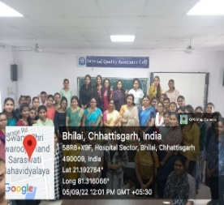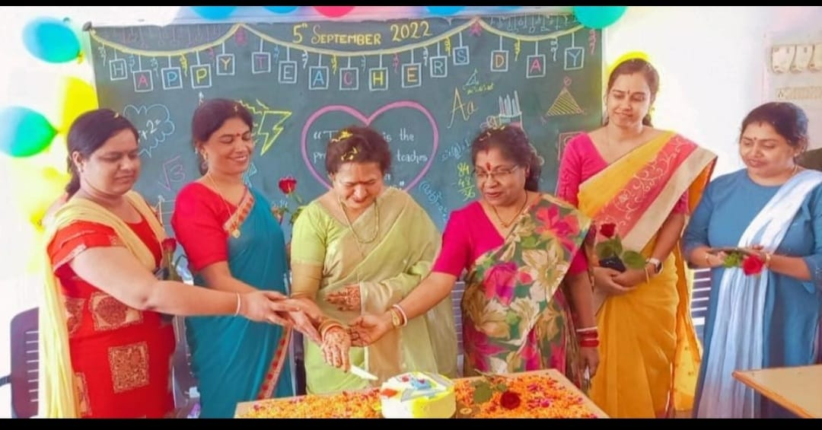
Teacher’s Day Celebration

Title of the Programme: World Population Day
Date: 11.07.2022 Number of participants: 86
Programme Report
Bhilai Mahila Mahavidyalaya organised programme on World population day 11.07.2022. The aim of this event was to highlight the growing problem that come with a growing global population and aims to increase people’s awareness on various population issues such as the importance of family planning, gender equality, poverty, maternal health and human rights. On this occasion, poster making and slogan writing competitions were conducted. Students from various department took part actively in this event.
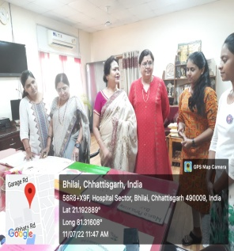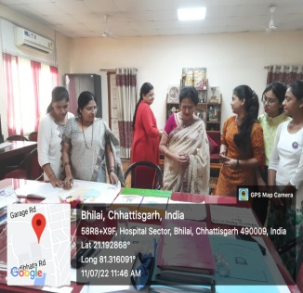
World Population Day

Title of the Programme: International Yoga Day Celebration
Date: 21.06.2022 Number of participants: 79
Programme Report
On 21st June 2022, Bhilai Mahila Mahavidyalaya in association with Hemchand Yadav University, Durg celebrated 8th International Yoga Day. It was attended by many prominent Professors, Directors and Students from different institute of the University with great enthusiasm. Warm up exercises were taken and all the students practiced & performed sitting and standing asanas, importance of these were explained simultaneously. The celebration concluded with the speech of our Hon’ble Vice-Chancellor Prof. Dr.Aruna Palta. She encouraged students to practice regular yoga to remain fit and improve concentration. All Faculties, Staff and students were taught the importance of Yoga in their life & how to maintain the harmony between body and mind.
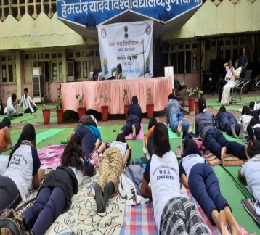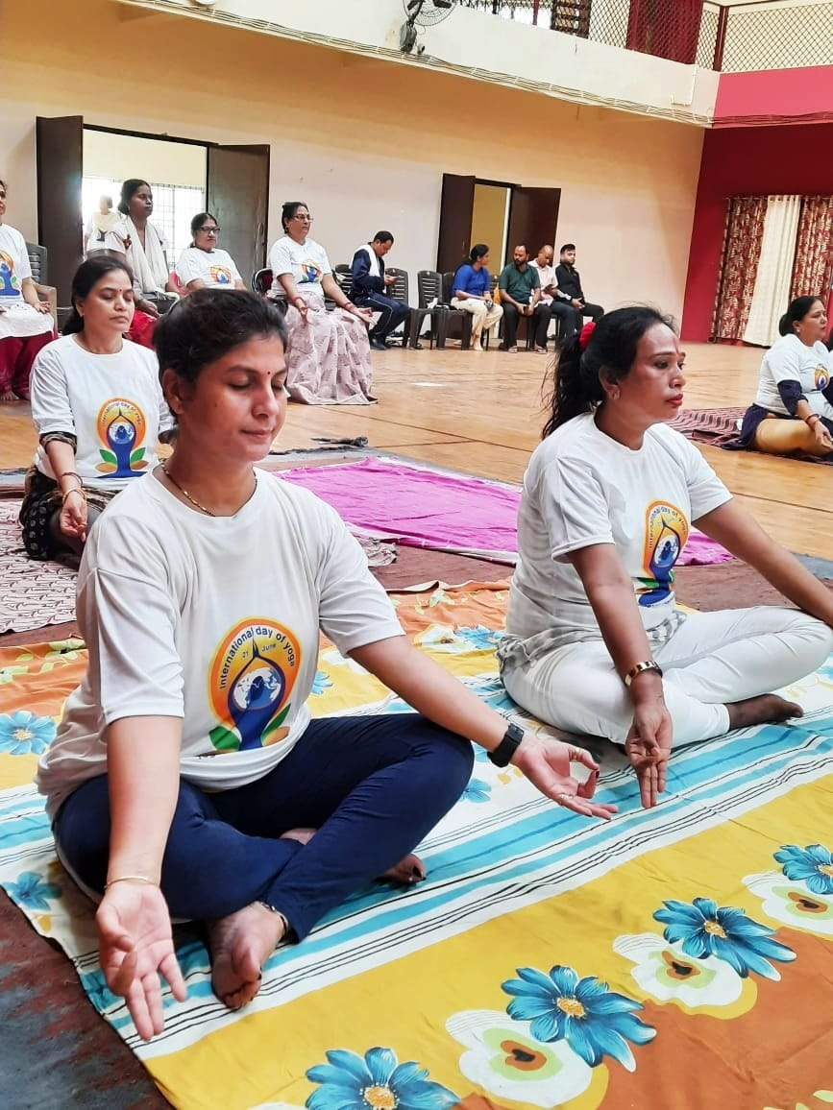
International Yoga Day Celebration

Title of the Programme: National Unity Day
Date: 31.10.2022 Number of participants: 68
Programme Report
India is a secular country with diversified cultures and the significances in their own kind. As an endeavor to solidify the bond of oneness and unification, the country celebrated the Birth Anniversary of Sardar Vallabhai Patel on 31st October as Rashtriya Ekta Diwas (National Unity Day). In line with the celebrations countrywide, Department of Education in Bhilai Mahila Mahavidyalaya in association with IQAC has been created Human Chain for being unity in college premises in order to extend their heartfelt appreciation about the life and the involvement of the great leader, Sardar Patel, in the veritable contribution during the freedom struggle and to lay a foundation of a unified country fused with oneness. The idea was to infuse in the young future generation with values integrated with the knowledge and adoration about the country’s rich heritage.
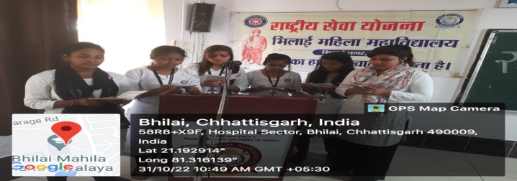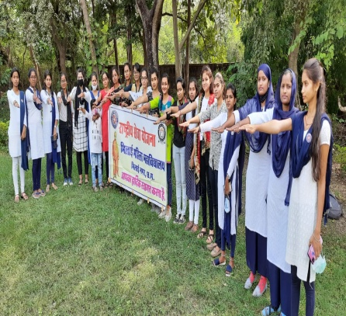
National Unity Day

