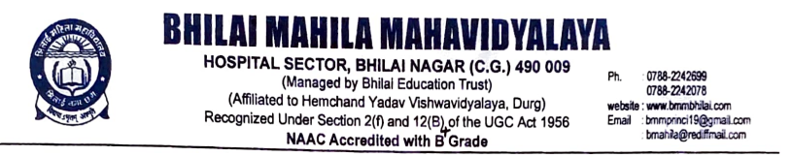

Criterion -7

Institutional Values and Social Responsibilities

Human Values and Professional Ethics

7.1.11. Institution celebrates / organizes national and international commemorative days, events and festivals

Title of the Programme: Environment Conservation Day

Date: 27.07.2022 Number of participants: 48

Programme Report

Bhilai Mahila Mahavidyalaya had organized Environment Conservation Day to develop the importance of Environment Conservation among the students. NSS members, Teaching staff and students from various departments had actively participated in this programme. Poster competition was organized under the guidance of IQAC.

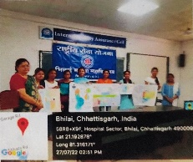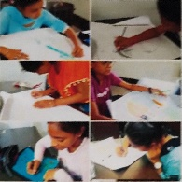

Environment Conservation Day

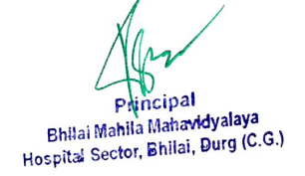

Title of the Programme: Har Ghar Tiranga

Date: 29.07.2022 Number of participants: 48

Programme Report

Bhilai Mahila Mahavidyalaya had organized Har Ghar Tiranga programme to evoke a sense of patriotism in the heart of every student. NSS members, Teaching staff and students from various departments had actively participated in this programme. Slogan, Poster competition and Cycle rally was organised under the guidance of IQAC.

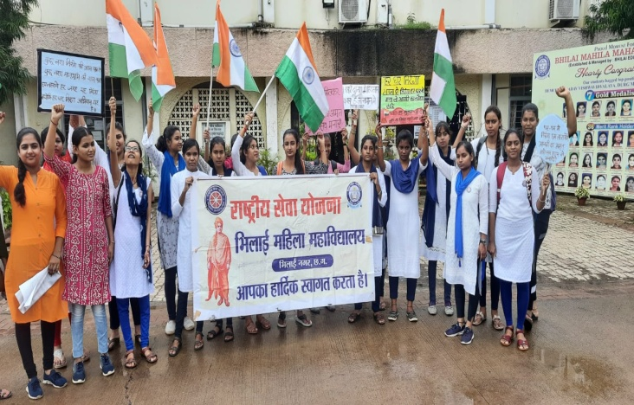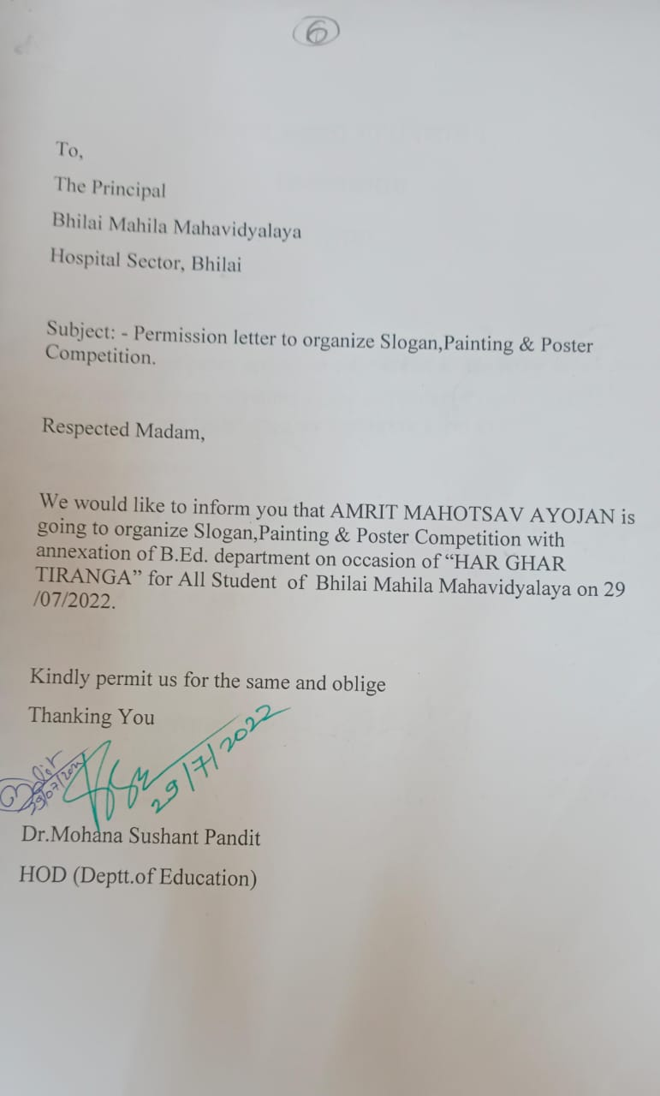

Har Ghar Tiranga programme

Title of the Programme: Azadi ka Amrit Mahotsav

Date: 13-08-2022
Number of participants: 76

Programme Report

In this programme, the NSS Officers Dr. Anupama Shrivastava and Dr. Rajshree Sharma, and NSS Volunteers held a rally for creating awareness on Azadi ka Amrit Mahotsav at civic centre, Bhilai. At the end of rally the volunteers did a street show on the topic har ghar tiranga in the presence of Managing Trustee Mr. Vijay Gupta, Dr. Sunita G Rao, and Student Union in Charge Dr. Nish Shukla.

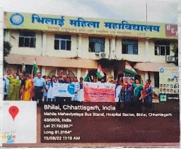
Azadi ka Amrit Mohotsav

Title of the Programme: Independence Day Celebration

Date: 15.08.2022 Number of participants: 156

Programme Report
On August 15, 2022, Bhilai Mahila Mahavidyalaya celebrated India’s 76th Independence Day, where students, faculty, and staff members paid tribute to the nation and freedom fighters of India. It is a remarkable day when we honor and respect all our freedom fighters who fought for India’s freedom. The celebrations started with flag hoisting by The Principal and followed by the National Anthem. The principal delivered an inspiring speech and the program continued with cultural programs. The program concluded with a vote of thanks, and sweets were distributed to all the students and staff members.
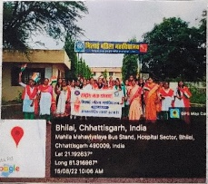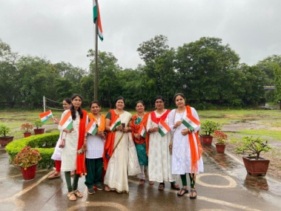

Independence Day

Title of the Programme: National Service Scheme Foundation Day

Date: 24.09.2022 Number of participants: 136

Programme Report

NSS unit of Bhilai Mahila Mahavidyalaya has organized National Service Scheme Foundation Day on 24.09.2022. On this event, Principal Dr Sandhya Madan Mohan, NSS officer Dr Rajshree Sharma and Dr Anupama Shrivastava distributed B and C certificate to NSS students. NSS volunteers were played different games and took part in cultural activity.

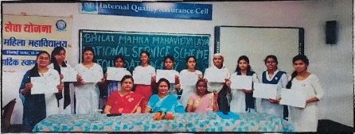
National Service Scheme Foundation Day

Title of the Programme: Gandhi Jayanti Celebration

Date: 02.10.2022 Number of participants: 56

Programme Report

NSS cell of Bhilai Mahila Maha Vidyalaya has celebrated Mahatma Gandhi Jayanthi in our college campus on 02nd October, 2022. All the HODs, faculty, non- teaching staff and students have participated. Students of our institution enthusiastically took part story telling competition in the Gandhi Jayanthi event celebrations. This day is also celebrated as International Peace Day all across the world. Students also sang a song based on the truth and non-violence message of Bapu.

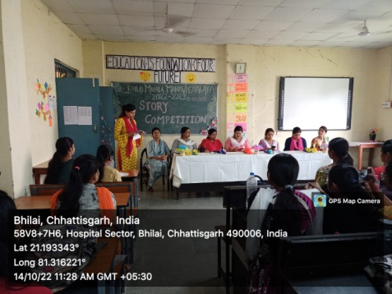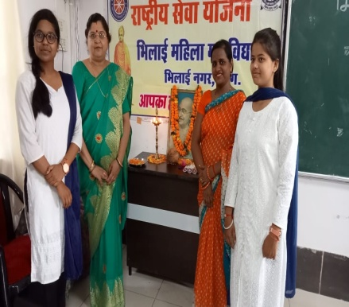
Gandhi Jayanti Celebration

Title of the Programme: Swachhata Programme

Date: 01.09.2022-15.09.2022 Number of participants: 83

Programme Report

As part of the campaign for Swachh Bharat-Swachhta Pakhwada, various activities were conducted in our college to create awareness among the students regarding Cleanliness and the ongoing cleanliness drive “Swachh Bharat” started by our respected Prime Minister, Shri Narendra Modi. Swachhta Shapath was taken on the very first day of the Pakhwada, where all the students of NSS, Principal, Vice Principal and the staff of the college participated. A rally was organized by the students of NSS to create awareness about “Cleanliness and Hygiene”. and also done pond cleaning.
.
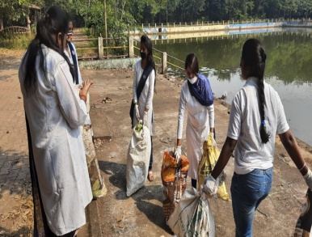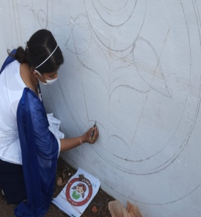
Swachhata Programme

Title of the Programme: Dr. APJ Abdul Kalam Jayanti

Date: 15.10.2022 Number of participants: 43

Programme Report

Department of Education in Bhilai Mahila Mahavidyalaya in association with IQAC has been organized one day celebration of Dr. APJ Abdul kalam's 91th birth anniversary on 15th October 2022. This day is also celebrated as world student’s day, because Dr. APJ Abdul kalam spent his whole life in welfare of students. The aim of this event was to develop Scientific sprit among students by conducting Essay competition. Various students were actively participated in this event.

.
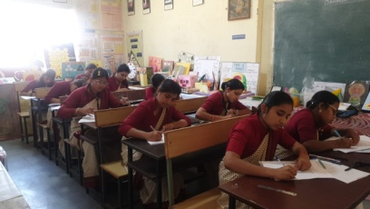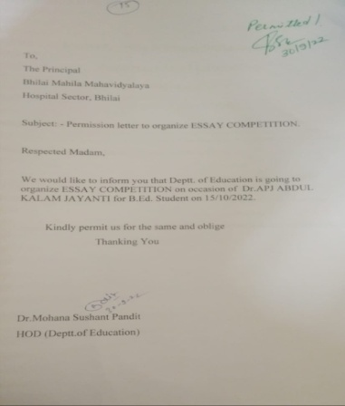
Dr. APJ Abdul Kalam Jayanti

Title of the Programme: Vallabh bhai Patel Jayanti

Date: 31.10.2022 Number of participants: 23

Programme Report

India is a secular country with diversified cultures and the significances in their own kind. As an endeavor to solidify the bond of oneness and unification, the country celebrated the Birth Anniversary of Sardar Vallabhai Patel on 31st October as Rashtriya Ekta Diwas (National Unity Day). In line with the celebrations countrywide, Department of Education in Bhilai Mahila Mahavidyalaya in association with IQAC has been created Human Chain for being unity in College premises in order to extend their heartfelt appreciation about the life and the involvement of the great leader, Sardar Patel , in the veritable contribution during the freedom struggle and to lay a foundation of a unified country fused with oneness. The idea was to infuse in the young future generation with values integrated with the knowledge and adoration about the country’s rich heritage.
.
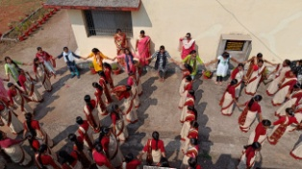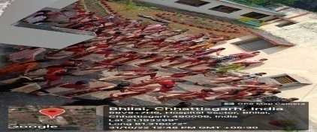
Human Chain on Vallabh bhai Patel Jayanti

Title of the Programme: VIvekanand Jayanti

Date: 12.01.2023 Number of participants: 148

Programme Report

Swami Vivekananda was born as Narendranath Dutta on 12th January 1863. He was a key figure in the introduction of the Indian philosophies of Vedanta and Yoga to the western world and was credited with raising interfaith awareness. He was a chief disciple of 19th century saint Ramakrishna and founder of Ramakrishna Math and Ramakrishna mission. The Birth Anniversary of Swami Vivekananda is celebrated all over the country giving a message to the youth the way of life and ideals that will make India a better country in future. On this occasion, Teaching staff and NSS volunteers of our institute visited Sneha Sampada and played with mentally retarded children and distributed fruits and snacks for them.

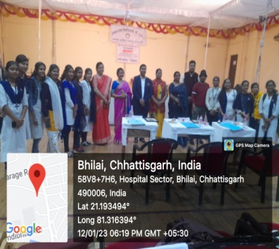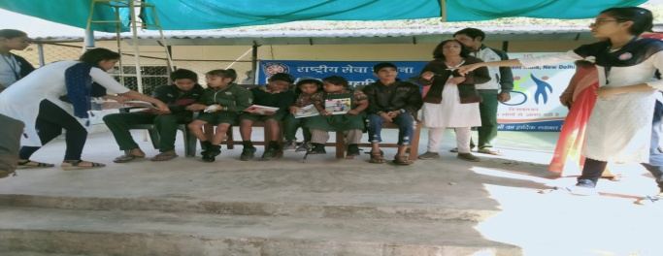
Vivekanand Jayanti

