Criterion -7

7.1. Institutional Values and Social responsibilities
7.1.2 -Environmental Consciousness and Sustainability

7.1.2. Environmental Consciousness and Sustainability
The Institution has facilities for alternate sources of energy and energy conservation measures
Solar energy:  Bhilai Mahila Vidyalaya is a non-technical college, there is a significant energy conservation and environmental activity both by faculty and students. The environmental awareness initiatives are substantial. Electromech Devices Mfg. Co. Raipur has installed a Grid Connected Solar Power Plant of Tata Solar having capacity of 50 KWp and handed over to Bhilai Education Trust on 29th March, 2018. This may lead to the prosperous future in context of Green Campus having energy conservation activities & use of renewable energy and thus sustainable environment and community development. | 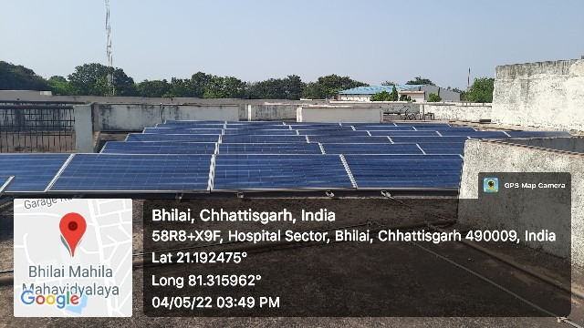
Use of LED bulbs/ power efficient equipment | 