Criterion -7

7.1. Institutional Values and Social responsibilities

7.1.7. The Institution has disabled-friendly, barrier free environment

Ramp | 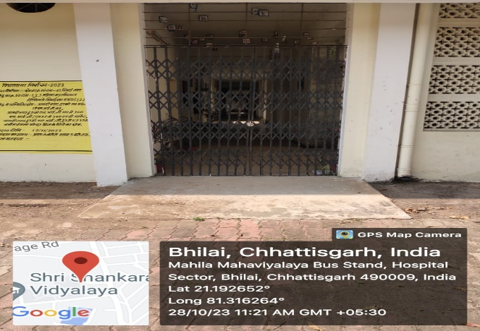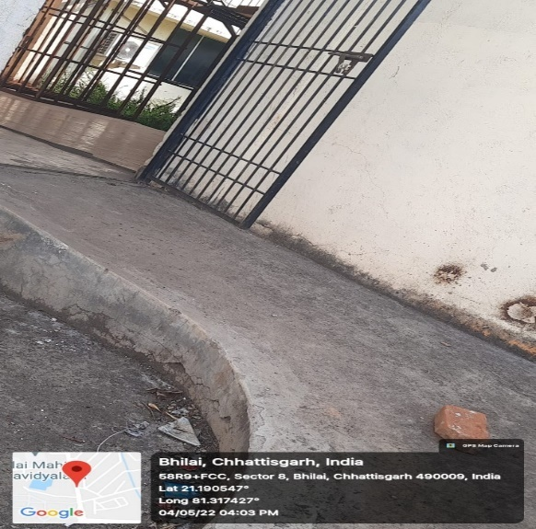
Rest room | 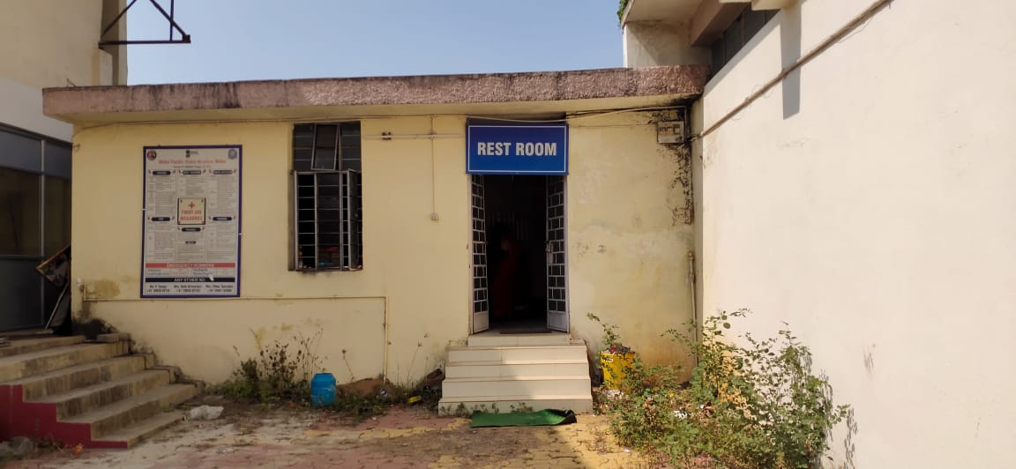
Wheel chair | 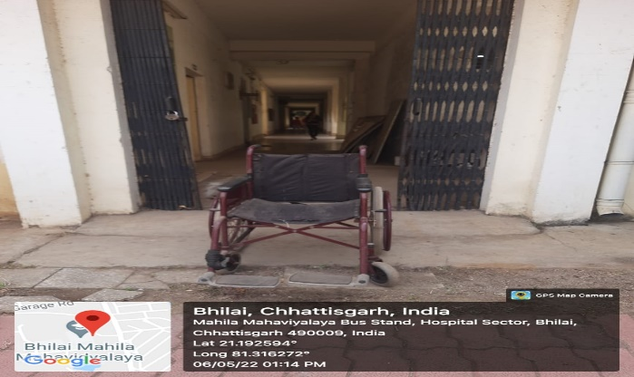
7.1.7. The Institution has disabled-friendly, barrier free environment

. 