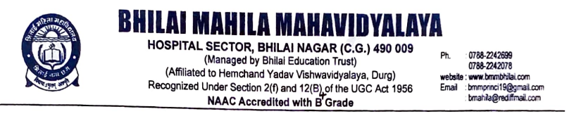

Criterion -7
7.1. Institutional Values and Social Responsibilities
7.1.8. Inclusion and Situatedness

7.1.8. Institutional efforts/initiatives in providing an inclusive environment i.e., tolerance and harmony towards cultural, regional, linguistic, communal socioeconomic and other diversities

Reports of the Programmes

Title of the Programme: International Yoga Day Celebration
Date: 21.06.2022 Number of participants: 79
Programme Report
On 21st June 2022, Bhilai Mahila Mahavidyalaya in association with Hemchand Yadav University, Durg celebrated 8th International Yoga Day. It was attended by many prominent Professors, Directors and Students from different institute of the University with great enthusiasm. Warm up exercises were taken and all the students practiced & performed sitting and standing asanas, importance of these were explained simultaneously. The celebration concluded with the speech of our Hon’ble Vice-Chancellor Prof. Dr.Aruna Palta. She encouraged students to practice regular yoga to remain fit and improve concentration. All Faculties, Staff and students were taught the importance of Yoga in their life & how to maintain the harmony between body and mind.
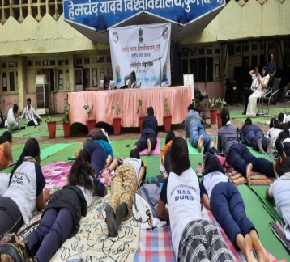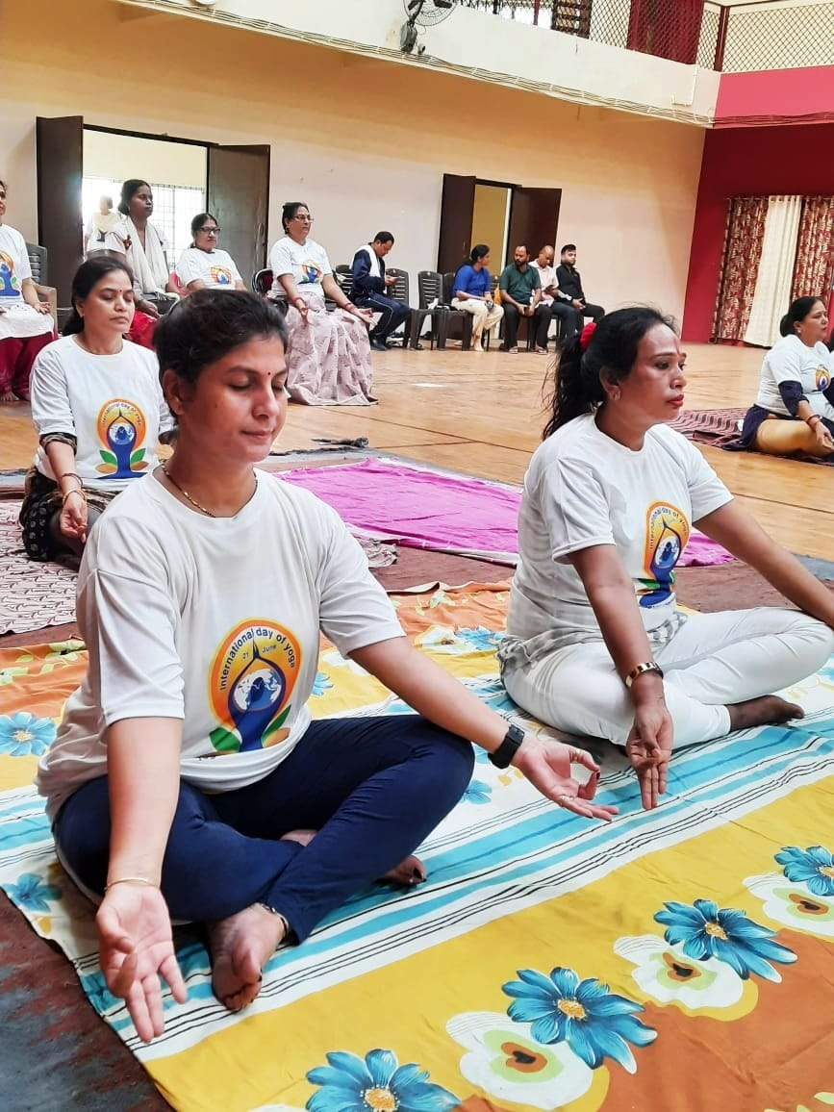
International Yoga Day Celebration

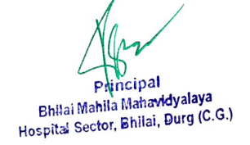
Title of the Programme: Basant Panchami Celebration
Date: 26.01.2023 Number of participants: 137
Programme Report
Bhilai Mahila Mahavidyalaya had celebrated the festival of Basant Panchami. To celebrate the festival, faculty and students gathered to pay homage to the goddess of knowledge and wisdom, Saraswati, with a traditional Aarti and Bhajan ceremony. The institute came together to celebrate India’s cultural heritage and making the day a truly memorable one.
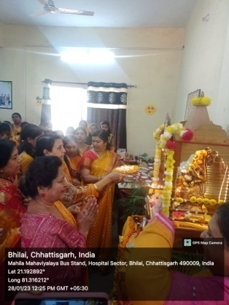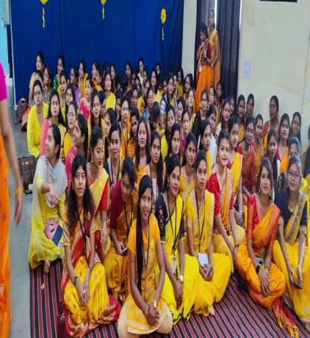
Basant Panchami Celebration

Title of the Programme: Shri Vishwakarma Pooja
Date: 17.09.2022 Number of participants: 85
Programme Report
Vishwakarma Puja was organized by the Department of Computer Science in Bhilai Mahila Mahavidyalaya in association with IQAC on 17th September 2022. On this occasion, Vishwakarma baba was worshipped by the Principal. Computers, instruments and equipment which are the asset of knowledge in all departments were also worshipped. After completion of puja, prasad was distributed to all staff members and students. In this event, all faculty members and students were actively participated.

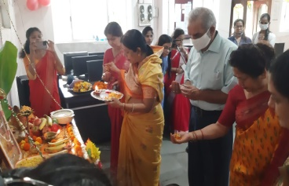
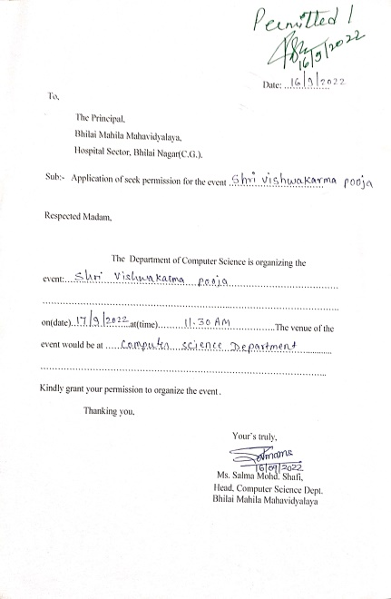

Shri Vishwakarma Pooja

Title of the Programme: Republic Day celebration
Date: 26.01.2023 Number of participants: 212
Programme Report
The 74th Republic Day celebration at Bhilai Mahila Mahavidyalaya was a memorable event that highlighted the institute patriotic spirit and cultural diversity. The celebration started with flag hoisting by the Principal, followed by mesmerizing performances by students including dances, singing, and instrumental music. The “Vande Mataram” song filled the air with a sense of national pride and unity. All faculty and students actively participated in the celebration, reinforcing the idea of unity in diversity and the importance of the day. The institute came together to celebrate India’s constitutional values and rich cultural heritage, making the day a truly memorable one.
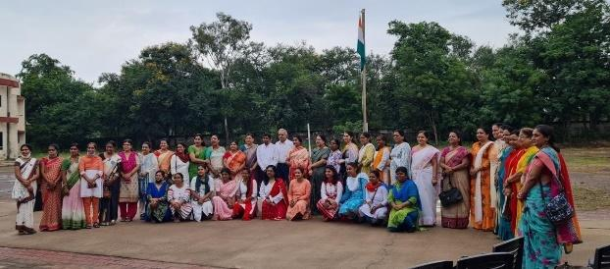
Republic Day

Title of the Programme: -Teej Milan
Date: 29.08.2022 Number of participants: All students & Staff Members
Programme Report
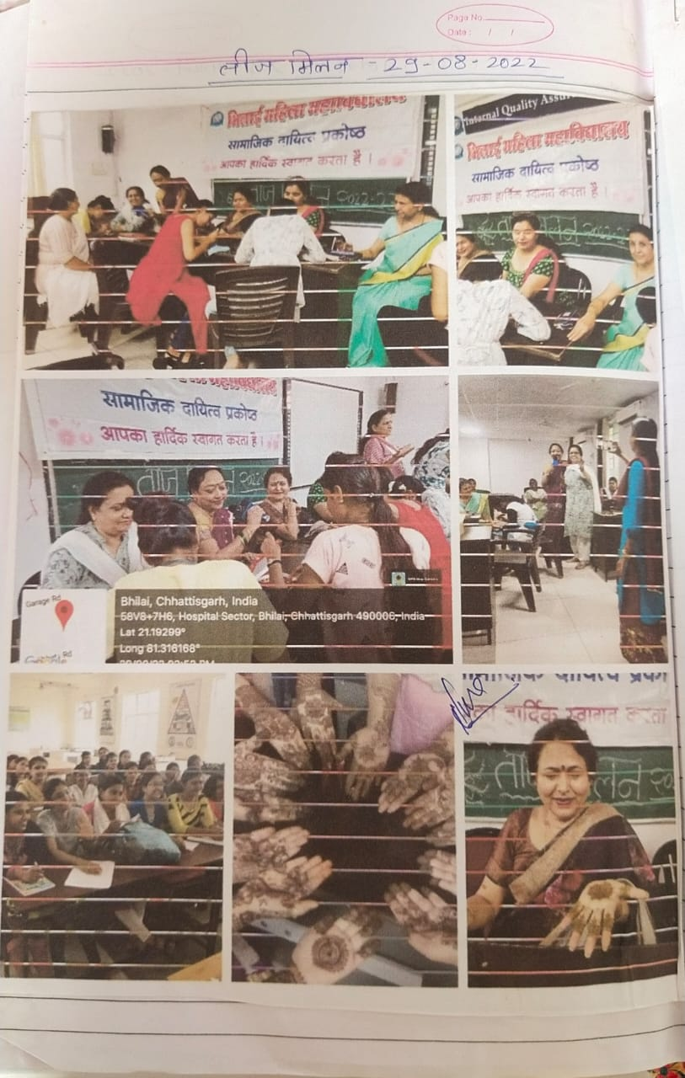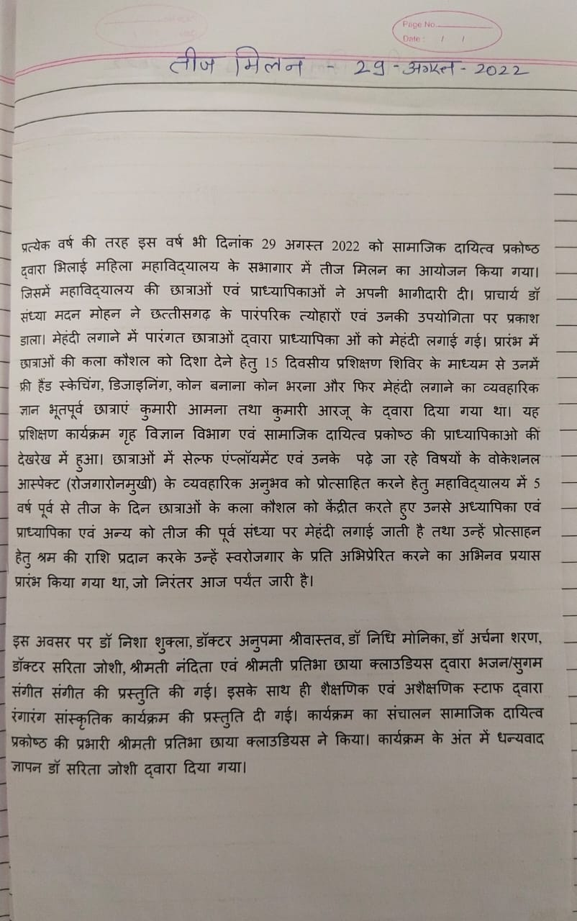
TEEJ MILAN

Title of the Programme: - Celebration of Ganesh Chaturthi
Date: 31-08-2022 Number of participants: All students & Staff Members
Programme Report
Bhilai Mahila Mahavidyalaya had organized Ganesh Chaturthi Celebration to preserve Indian cultures and tradition on 31.08.2022.

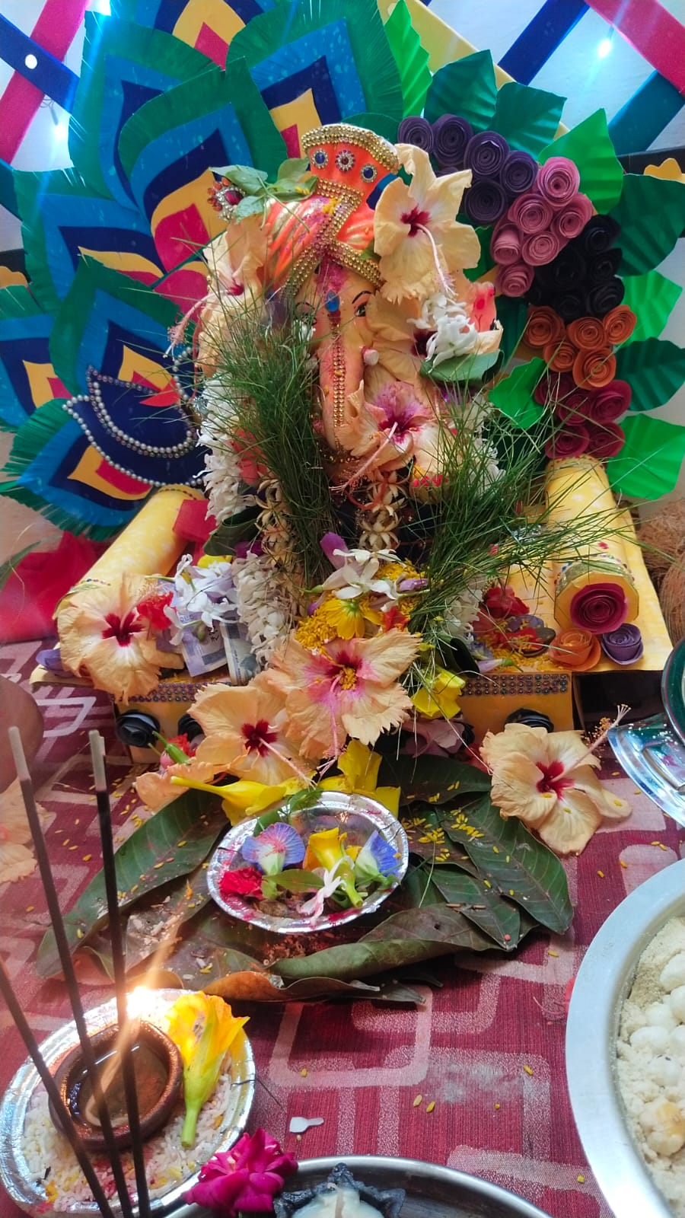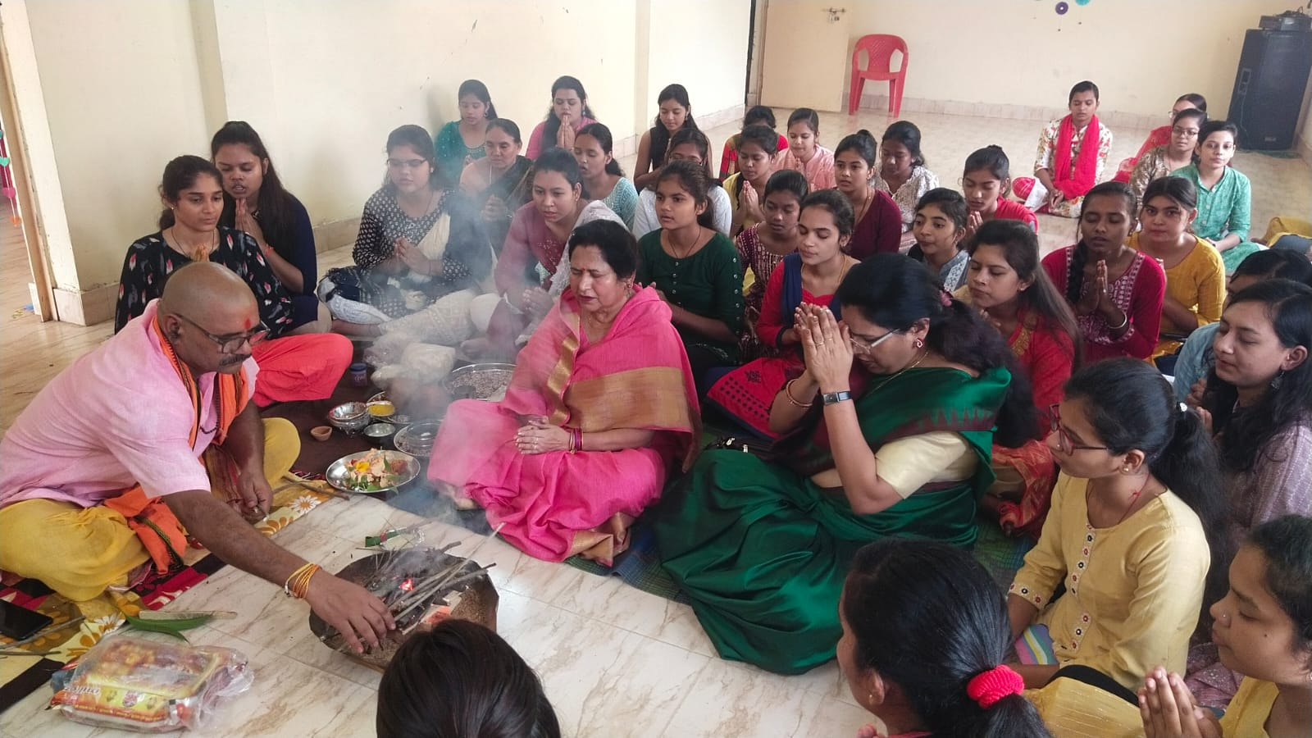
- Celebration of Ganesh Chaturthi

Title of the Programme: - National nutrition month celebration
Date: 20.09.2022 Number of participants: 110
Programme Report
NSS Members of Bhilai Mahila Mahavidyalaya in association with IQAC has organized National nutrition month celebration at adopted village “pisegaon.The main objective of this celebration was to create awareness about the importance of nutrition among gram sabha school children and women.
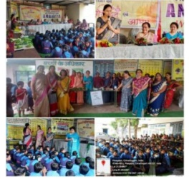
National nutrition month celebration

Title of the Programme: - Celebration of Garba festival Date: 01.10.2022 Number of participants: All students & Staff Members
Programme Report
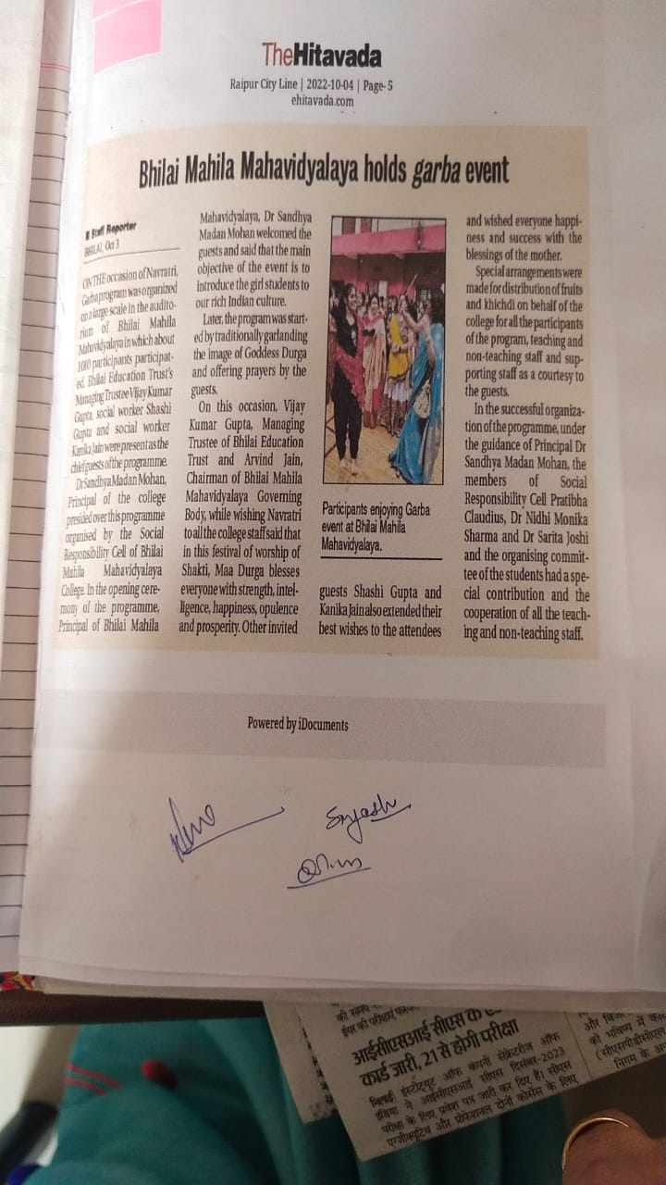
Garba Festival

Title of the Programme: - Swachhata Programme
Date: 13-10-2022 Number of participants: 23

Programme Report
NSS Members of Bhilai Mahila Mahavidyalaya in association with IQAC had organized Swachhata Programme on 13.10.2022. In this, Students of NSS volunteered to clean Manokameshwer mandir Parisar, near by our college.

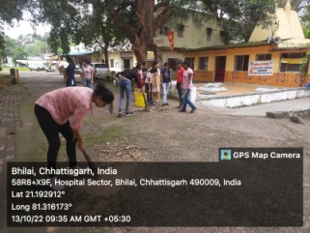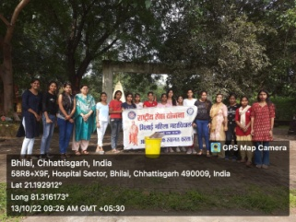
Swachhata Programme

Title of the Programme: - Holi Milan
Date: 07.03.2023 Number of participants: All students & Staff Members
Programme Report
The festival of Colours is not about getting rid of the waste and negative energies from our lives and homes but much more. Holi is also celebrated as a pledge day when one takes account of their shortcomings and accepts your flaws and mistakes and promises oneself not to repeat them and overcome them. Bhilai Mahila Mahavidyalaya has organized “Holi Celebration” on 07th March, 2023. The event was organized by the cultural committee under the guidance of IQAC. More than 250 students along with faculty members took part in this event.
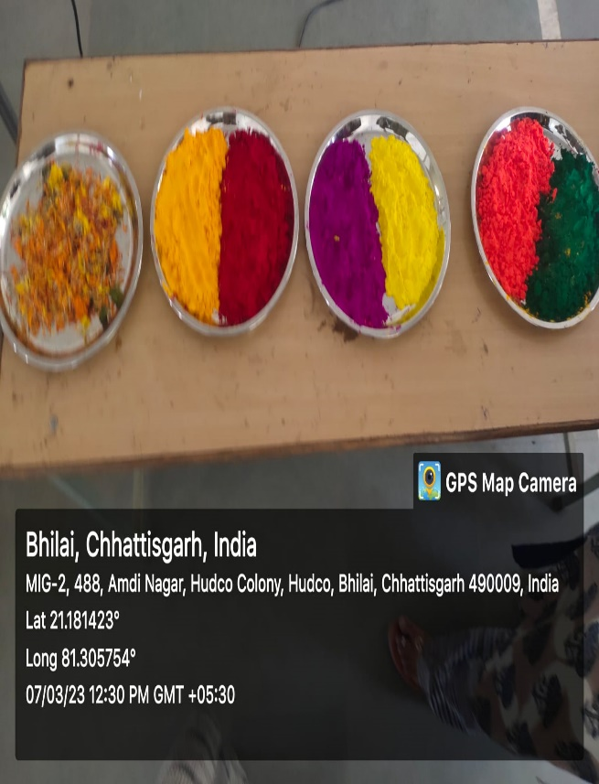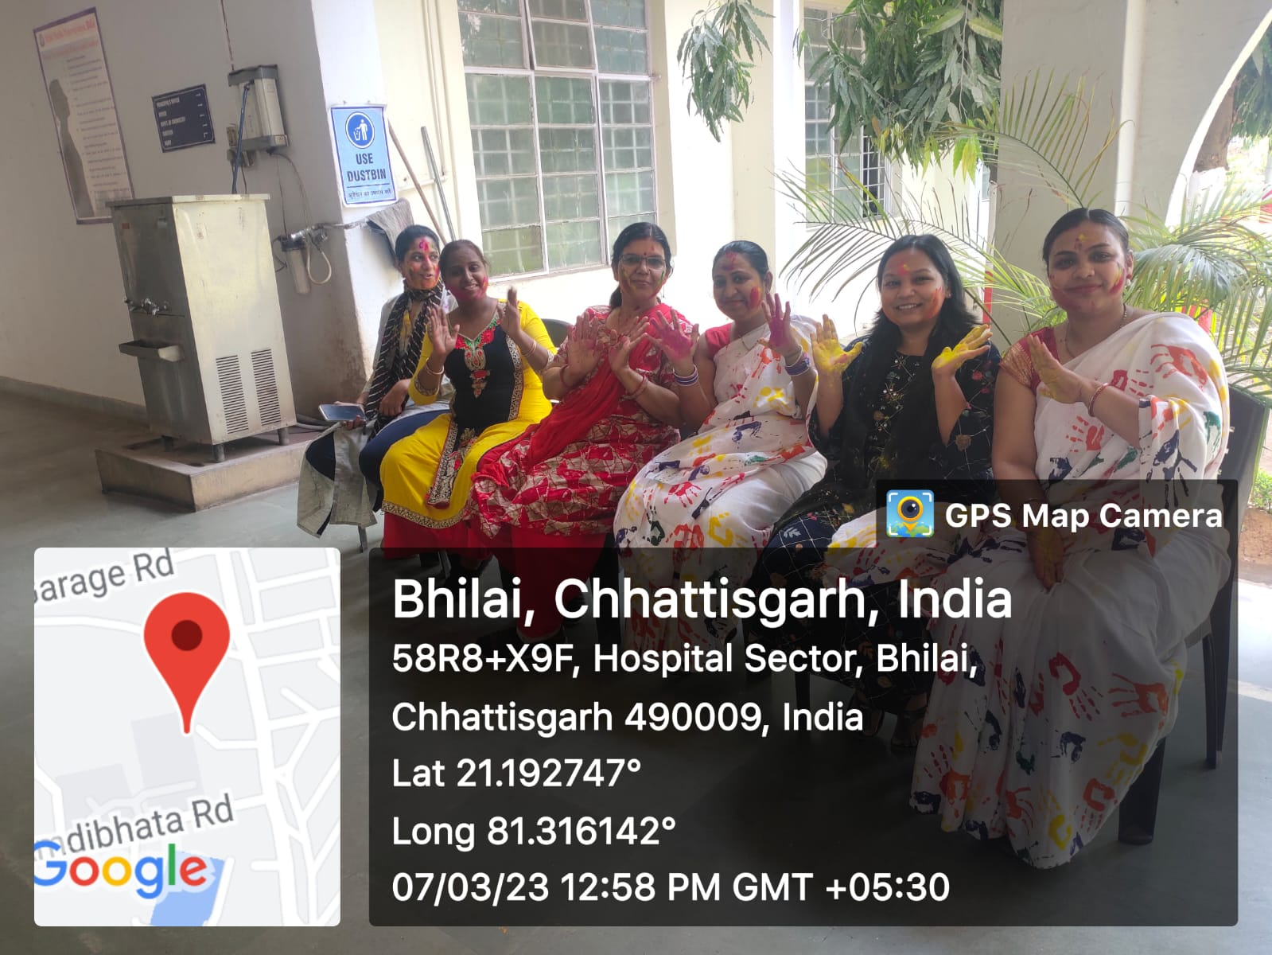
Holi Milan

