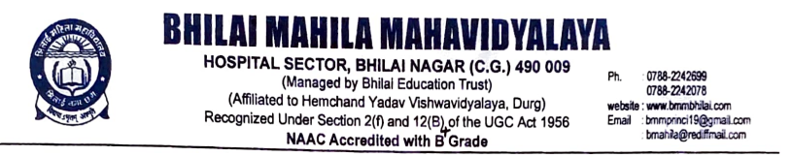

Criterion -7

7.1. Institutional Values and Social Responsibilities

Human Values and Professional Ethics

7.1.9. Sensitization of students and employees of the Institution to the constitutional obligations: values, rights, duties and responsibilities of citizens

Title of the Programme: Environment Conservation Day

Date: 27.07.2022 Number of participants: 48

Programme Report

Bhilai Mahila Mahavidyalaya had organized Environment Conservation Day to develop the importance of Environment Conservation among the students. NSS members, Teaching staff and students from various departments had actively participated in this programme. Poster competition was organized under the guidance of IQAC.

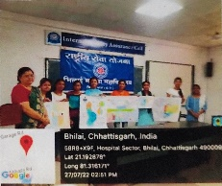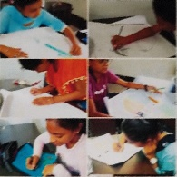

Environment Conservation Day

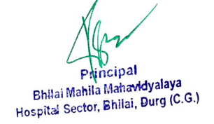

Title of the Programme: Swachhata Programme

Date: 01.09.2022-15.09.2022 Number of participants: 83

Programme Report

As part of the campaign for Swachh Bharat-Swachhta Pakhwada, various activities were conducted in our college to create awareness among the students regarding Cleanliness and the ongoing cleanliness drive “Swachh Bharat” started by our respected Prime Minister, Shri Narendra Modi. Swachhta Shapath was taken on the very first day of the Pakhwada, where all the students of NSS, Principal, Vice Principal and the staff of the college participated. A rally was organized by the students of NSS to create awareness about “Cleanliness and Hygiene”. and also done pond cleaning.
.
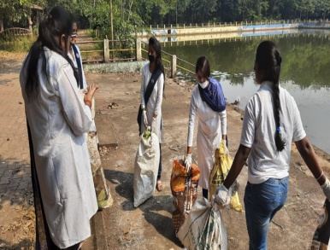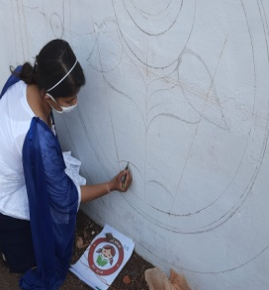
Swachhata Programme

Title of the Programme: Role of Media in Empowerment of Democracy

Date: 23.11.2022 Number of participants:56
Programme Report
Bhilai Mahila Mahavidyalaya had organized Speech competition on 23.11.2022 on “ Role of Media in Empowerment of Democracy “The aim of this event was to create awareness on Indian Constitution and Democracy. Students from various departments of this college actively participated in this competition.

.
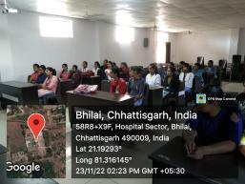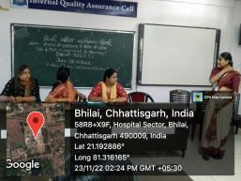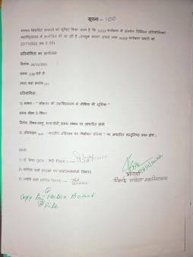

Role of Media in Empowerment of Democracy

Title of the Programme: Indian Constitution and Election Process
.
Date: 23.11.2022 Number of participants: 86

Programme Report

Bhilai Mahila Mahavidyalaya had organized Online Quiz competition on Indian Constitution and Election Process. The aim of this event was to create awareness on Indian Constitution and Election Process. Students from various departments of this college actively participated in this competition.
.
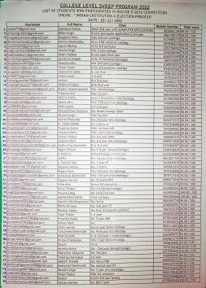
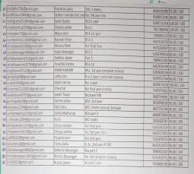
Indian Constitution and Election Process

Title of the Programme: National Voter’s Day
Date: 25.01.2023 Number of participants: 48

Programme Report
The National Voters’ Day has been celebrated on January 25 every year since 2011, all across the country to mark the foundation day of Election Commission of India, i.e. 25th January 1950. Theme for this year’s NVD is ‘Making Elections Inclusive, Accessible and Participative’. The main purpose of the NVD celebration is to encourage, facilitate and maximize enrolment, especially for the new voters. On the occasion of National Voter’s Day, Teaching staff and students of Bhilai Mahila Mahavidyalaya took an oath to create electoral awareness and encourage them to participate in the electoral process.

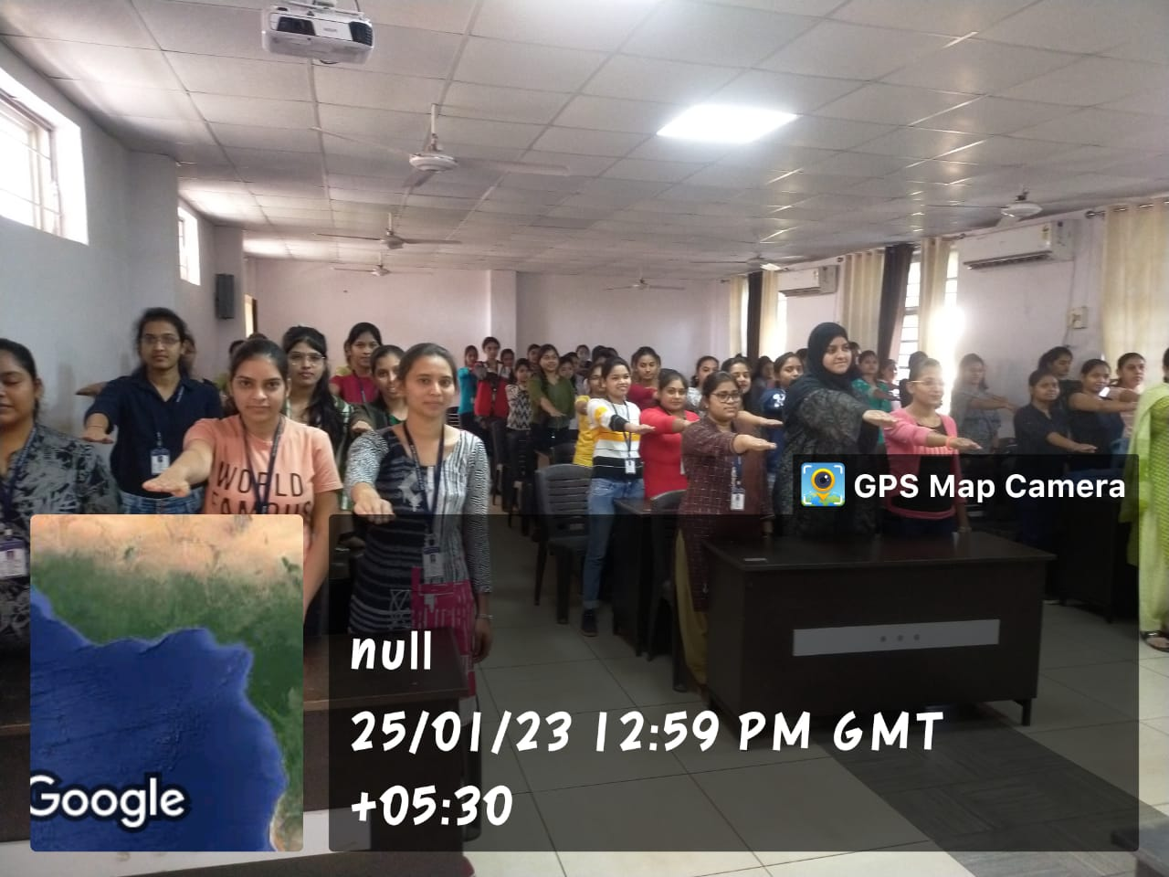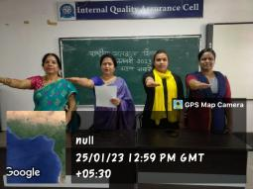
National Voter’s Day

Title of the Programme: Blood Donation Camp
Date: 10.12.2022 Number of participants: 178

Programme Report

A Blood donation camp was organized by our institute in collaboration with Red Cross Society, NSS unit and volunteers from a local club. In which more than 100 units of blood was donated by both students and the staff members of our college. It is a way of gesture in bringing a ray of hope to contribute to the serious problems of acutes shortage of blood. Our college has been religiously organizing blood donation camps every year and students and the faculty members come forward voluntarily to donate blood. While addressing to people at the camp our NSS volunteers brought awareness in them about shortage of blood and why we must donate blood every year, to help the persons requiring blood. After the completion of the blood donation, the Principal thanked and appreciated everyone present in the camp. The day ended with the National Anthem and a heartfelt vote of thanks given by the Principal.

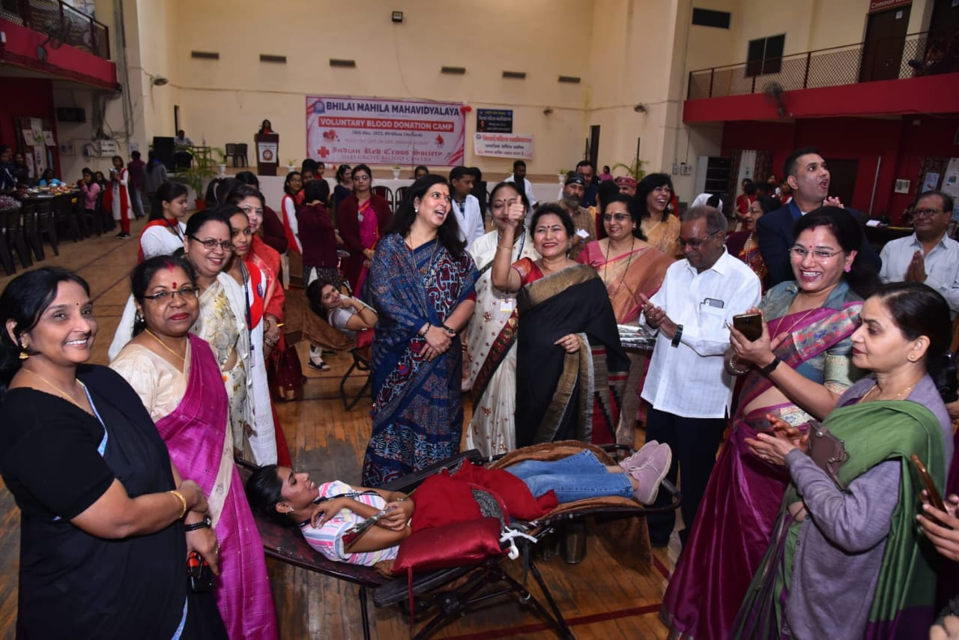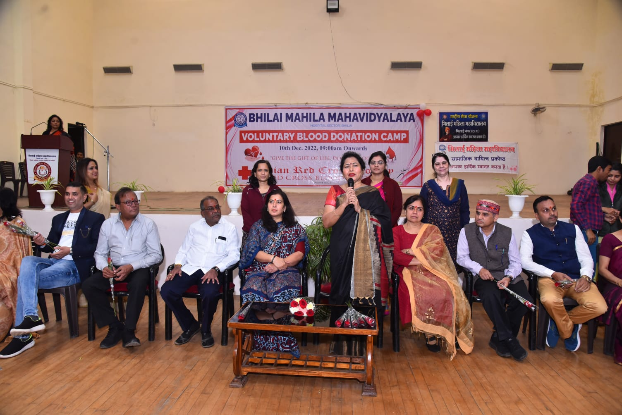
Blood Donation Camp

Title of the Programme: - Awareness on Education Date: 28.11.2022 Number of participants: 23
Programme Report
NSS Members of Bhilai Mahila Mahavidyalaya in association with IQAC had organized the programme on Awareness on Education on 28.11.2022 at Udiya basti Anganwadi Sector-10. During this programme NSS Volunteers initiated Awareness on Education through demonstration with use of pictorial charts and posters. They also Distributed the pamphlets to semi-literate women in Anganwadi.

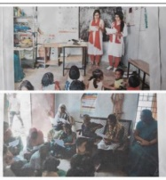
Awareness on Education

