- MADHAVA MATHEMATICS COMPETITION 2023

Offline Madhava Mathematics Competition organized by Department of Mathematics S.P. College, Pune & Homi Bhabha Centre of Science Education TIFR, Mumbai on 29/01/2023. Our mathematics department of Bhilai Mahila Mahavidyalaya was center for this exam. In this competition our 45 under Graduate Students were appeared in this examination.
Participated students will get certificate of participation and successful students will get benefit of scholarship for further Higher Education.

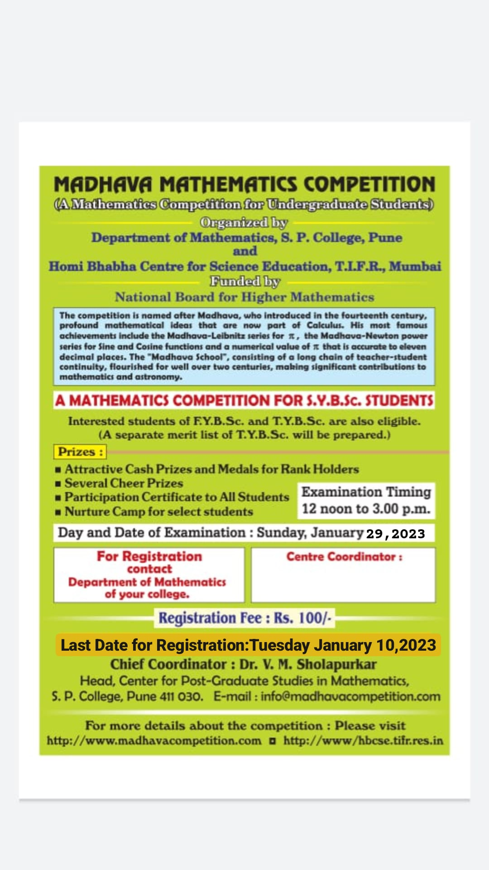
The following are the list of participant with their section
S.NO. | NAME OF STUDENT | FATHERS NAME | CLASS (F.Y./S.Y./T.Y. B.SC )
 | BHAVANA YADAV | MR. RAVI LAL YADAV | B.SC. F.Y.
 | HEMA SAHU | MR. TAHAT SAHU | B.SC. F.Y.
 | KAJAL SAHU | MR. SHASHT BHUSHAN SAHU | B.SC. F.Y.
 | LALITA PANDEY | MR. RAKESH KUMAR PANDEY | B.SC. F.Y.
 | PRANJALI SAHU | MR. SANTOSH SAHU | B.SC. F.Y.
 | PRIYANKA DESHMUKH | MR. GIRDHAR LAL DESHMUKH | B.SC. F.Y.
 | POOJA DESHMUKH | MR. PAWAN DESHMUKH | B.SC. F.Y.
 | REENA SAHU | MR. MILAN RAM SAHU | B.SC. F.Y.
 | NEHA YADAV | MR. MANOJ KUMAR YADAV | B.SC. F.Y.
 | TOSHIKA SAHU | MR. SANTOSH KUMAR SAHU | B.SC. F.Y.
 | DIKSHA TANDON | MR. LOKENDRA KUMAR TANDON | B.SC. F.Y.
 | NIDHI VERMA | MR. CHANDRAPRAKASH SAHU | B.SC. F.Y.
 | SHRISHTI SAHU | MR. LIKESH SAHU | B.SC. F.Y.
 | VANSHIKA SATI | MR. MOHAN CHANDRA SATI | B.SC. F.Y.
 | DEEKSHA | MR. TEJRAM | B.SC. F.Y.
 | KANCHAN VERMA | MR. BADRI PRASAD VERMA | B.SC. F.Y.
 | SAKSHI SAHU | MR. RAMANAND SAHU | B.SC. F.Y.
 | PRABHA NAGRAJ | MR. SENAJIT NAGRAJ | B.SC. F.Y.
 | YAMINEE SAHU | MR. SANTOSH SAHU | B.SC. F.Y.
 | CHITRALEKHA SAHU | MR. NIRANJAN SAHU | B.SC. F.Y.
 | GARIMA THAKUR | MR. TAKKAR SHING THAKUR | B.SC. F.Y.
 | PRACHI TAMRAKAR | MR. AYODHYA PRASAD TAMRAKAR | B.SC. F.Y.
 | MEGHA SAHU | MR. SHATRUHAN LAL SAHU | B.SC. F.Y.
 | ISHA YADAV | MR. RADHESHYAM YADAV | B.SC. F.Y.
 | HIMANGANI VERMA | CHANDRABHAN SINGH VERMA | B.SC. S.Y.
 | POONAM | KISUN RAM | B.SC. S.Y.
 | SHIWANI VISHWAKARMA | GAURI SHANKAR VISHWAKARMA | B.SC. S.Y.
 | ANANYA SINHA | KHUBCHAND SINHA | B.SC. S.Y.
 | CHANCHAL YADAV | DEV KUMAR YADAV | B.SC. S.Y.
 | LATIKA JAIN | DULESHWAR RAM JAIN | B.SC. S.Y.
 | NIKITA SAHU | BHARAT LAL SAHU | B.SC. S.Y.
 | SNEHA PARIHAR | SANJAY SINGH PARIHAR | B.SC. S.Y.
 | SWARNA PRAJAPATI | HARIDEV | B.SC. S.Y.
 | ARADHNA | GHANARAM SINHA | B.SC. S.Y.
 | PREETY DHRUW | BHAGVAN SINGH DHRUW | B.SC. S.Y.
 | VARSHA SARKAR | BISWAJEET SARKAR | B.SC. S.Y.
 | MOHINEE BOE | ANADI BOE | B.SC. S.Y.
 | ADITI THAKUR | B.P. THAKUR | B.SC. S.Y.
 | NIKITA SHRIWAS | RAKESH ROSHAN SHRIWAS | B.SC. S.Y.
 | DEVIKA DESHMUKH | PUSHKAR DESHMUKH | B.SC. S.Y.
 | GUNJITA DEWANGAN | ROHIT DEWANGAN | B.SC. S.Y.
 | HARSHITA | AJAY KUMAR SAHU | B.SC. S.Y.
 | TRISHU SAHU | NOHAR SINGH SAHU | B.SC. S.Y.
 | KHUSHI RAJPUT | DAMAN SINGH RAJPUT | B.SC. S.Y.
 | KHUSHBU RAJPUT | DAMAN SINGH RAJPUT | B.SC. S.Y.

