Format for Add-ons, Certificate course or Skill development course: -
S.No. | Topic &Dept. | Learning outcome | Duration | e-copy
1 | Energy and environment conservation,  Raj Rishi Govt. Autonomous college, Alwar Rajasthan | Recycling of materials, lower energy costs for consumers, less pollution due to a reduction in use of fossil fuels, and less harm to animals and the environment. | 18.04.23-24.04.2023
Date | Programme Name | No. of Students | Topic and Department | Learning outcomes |  | Attachment
20/9/22-20/10/22 | Value Added Course on Mushroom Cultivation | 54 | Value Added Course on Mushroom Cultivation | • Skill Development: |  | 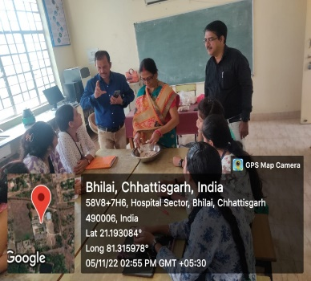
 |  |  | Department of BT and MB | • Entrepreneurship Opportunities: Nutritional Awareness:.
 |  |  |  | • Sustainability:.
 |  |  |  | • Income Generation: Value Addition
 |  |  |  | • Waste Reduction:
 |  |  |  | • Research and Innovation: Participants may be inspired to further research and innovate in the field of mushroom cultivation, exploring new techniques and varieties.
S.No. | Date | Guest Speaker and Address | No. of Students | Topic | Out come | Attachments
1 | 01-04-2023 | Guest Lecture by Dr. A.K. Shrivastava, Govt. D.T. College, Utai | 61 | Protein Localization”. | Enhanced Learning: | 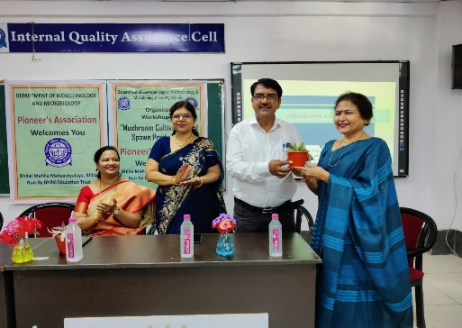
 |  |  |  |  | • Career Readiness:
 |  |  |  |  | • Critical Thinking: Students develop critical thinking skills by analyzing and evaluating the insights shared by guest speakers.
 |  |  |  |  | • Motivated Learning:
 |  |  |  |  | • Future Directions:
 |  |  |  |  | • Overall, guest lecturers play a vital role in enriching students' education, offering them the chance to learn from those who have practical experience in their fields of interest.
2 | 20-09-2022 | Dr. Pragya Kulkarni, Govt. VYTPG Science College, Durg. | 54 | Mushroom: A Miracle Food | Enhanced Learning: | 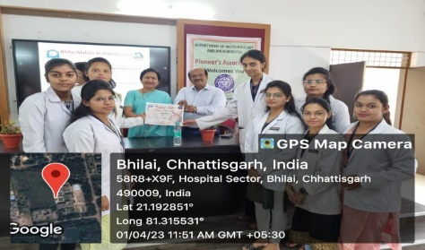
 |  |  |  |  | • Career Readiness:
 |  |  |  |  | • Critical Thinking: Students develop critical thinking skills by analyzing and evaluating the insights shared by guest speakers.
 |  |  |  |  | • Motivated Learning:
 |  |  |  |  | • Future Directions:
 |  |  |  |  | • Overall, guest lecturers play a vital role in enriching students' education, offering them the chance to learn from those who have practical experience in their fields of interest.
3 | 27-09-2022 | By Dr. Trilok Dev, Govt. Digvijay College, Rajnandgaon. | 50 | Edible and Non Edible Mushroom | Enhanced Learning: | 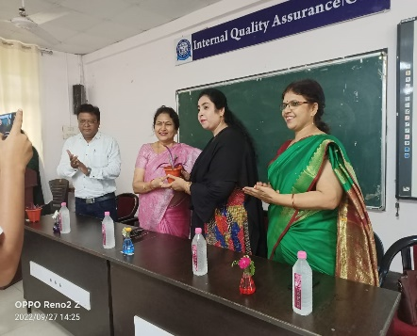
 |  |  |  |  | • Career Readiness:
 |  |  |  |  | • Critical Thinking: Students develop critical thinking skills by analyzing and evaluating the insights shared by guest speakers.
 |  |  |  |  | • Motivated Learning:
 |  |  |  |  | • Future Directions:
 |  |  |  |  | • Overall, guest lecturers play a vital role in enriching students' education, offering them the chance to learn from those who have practical experience in their fields of interest.
4 | 12-05-2023 | Guest Lecture by Dr. D. K. Shrivastava, Govt. ERR Science College, Bilaspur | 48 | “New Education Policy”. | Enhanced Learning: | 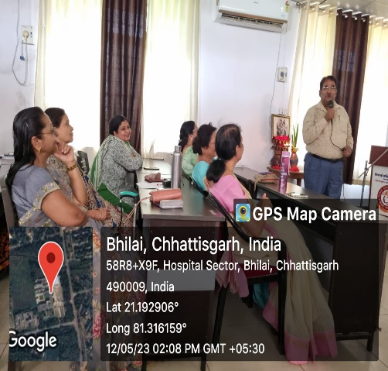
 |  |  |  |  | • Career Readiness:
 |  |  |  |  | • Critical Thinking: Students develop critical thinking skills by analyzing and evaluating the insights shared by guest speakers.
 |  |  |  |  | • Motivated Learning:
 |  |  |  |  | • Future Directions:
 |  |  |  |  | • Overall, guest lecturers play a vital role in enriching students' education, offering them the chance to learn from those who have practical experience in their fields of interest.

