CTET /CGTET Coaching
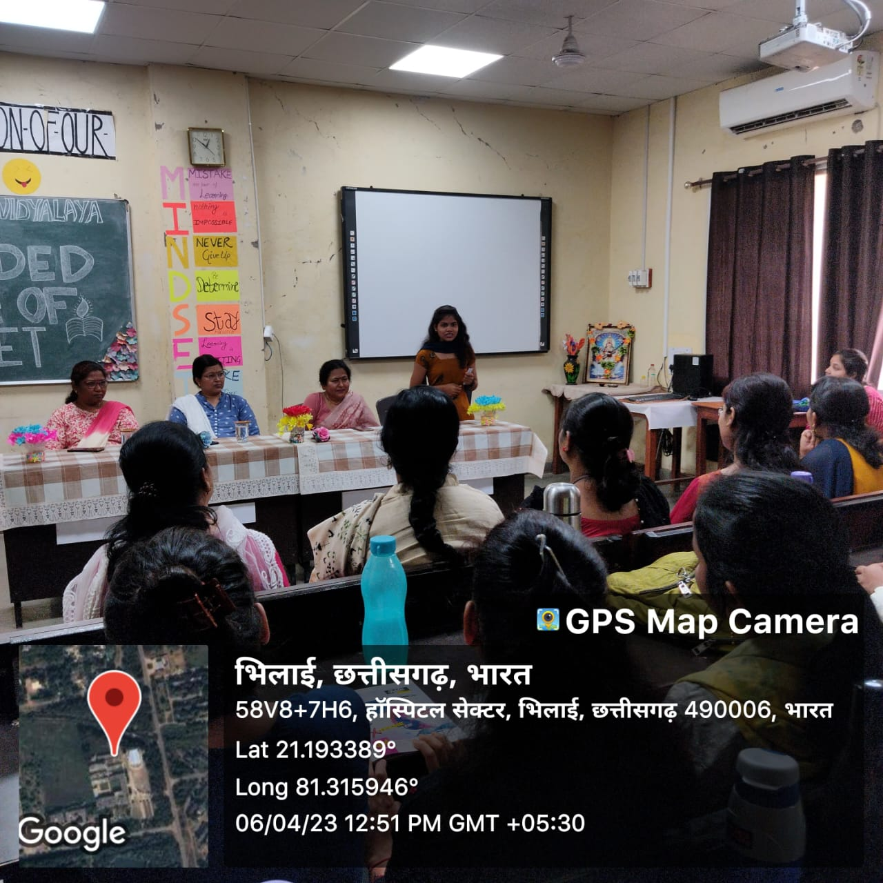
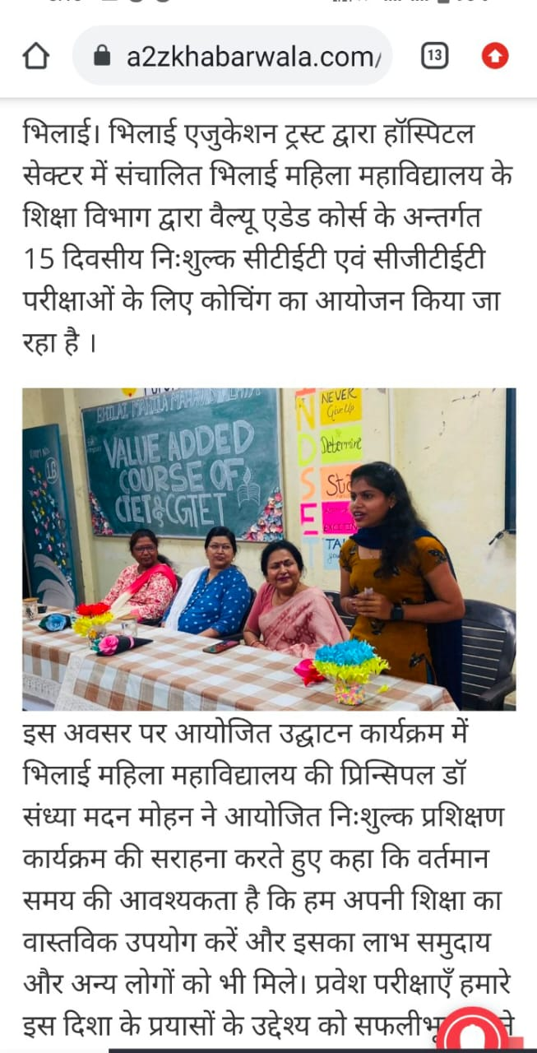
Bhoj Sinha
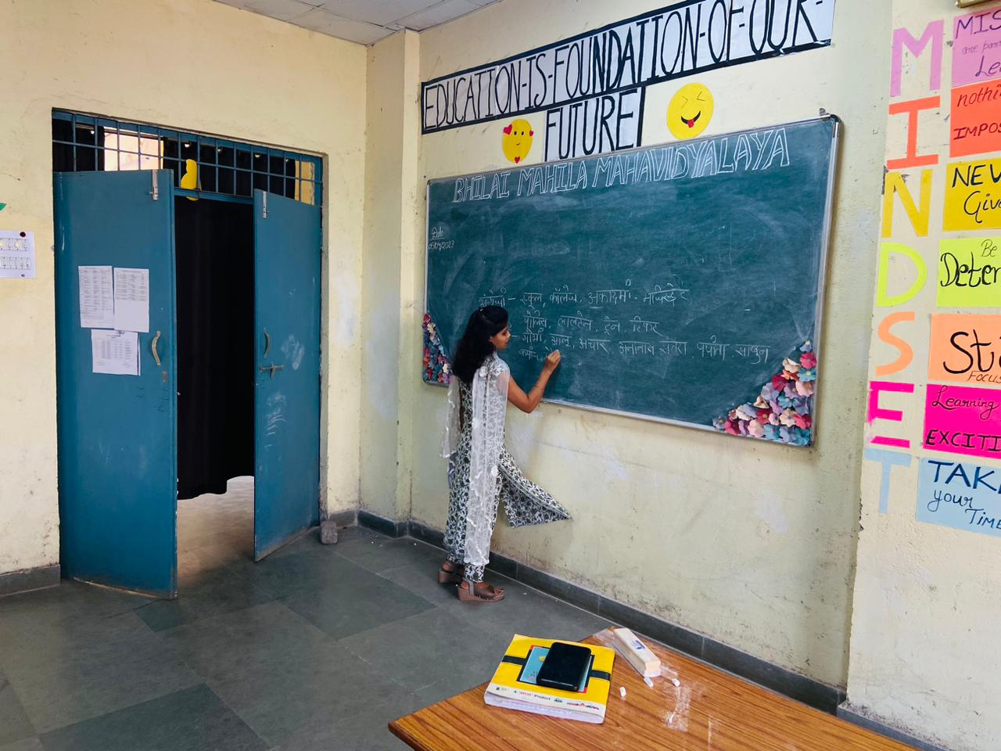
Gauri purnima

Guest lecture by Alumini’s: Anjali singh, Priya Agrawal, Anjali kashyap .Lecture on preparation of competitive exam.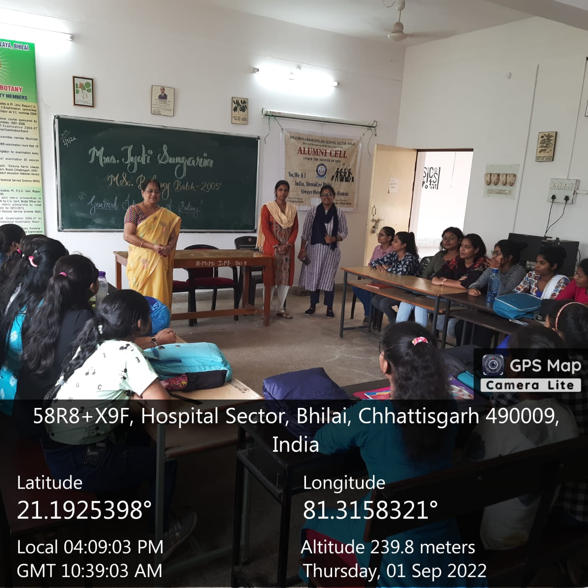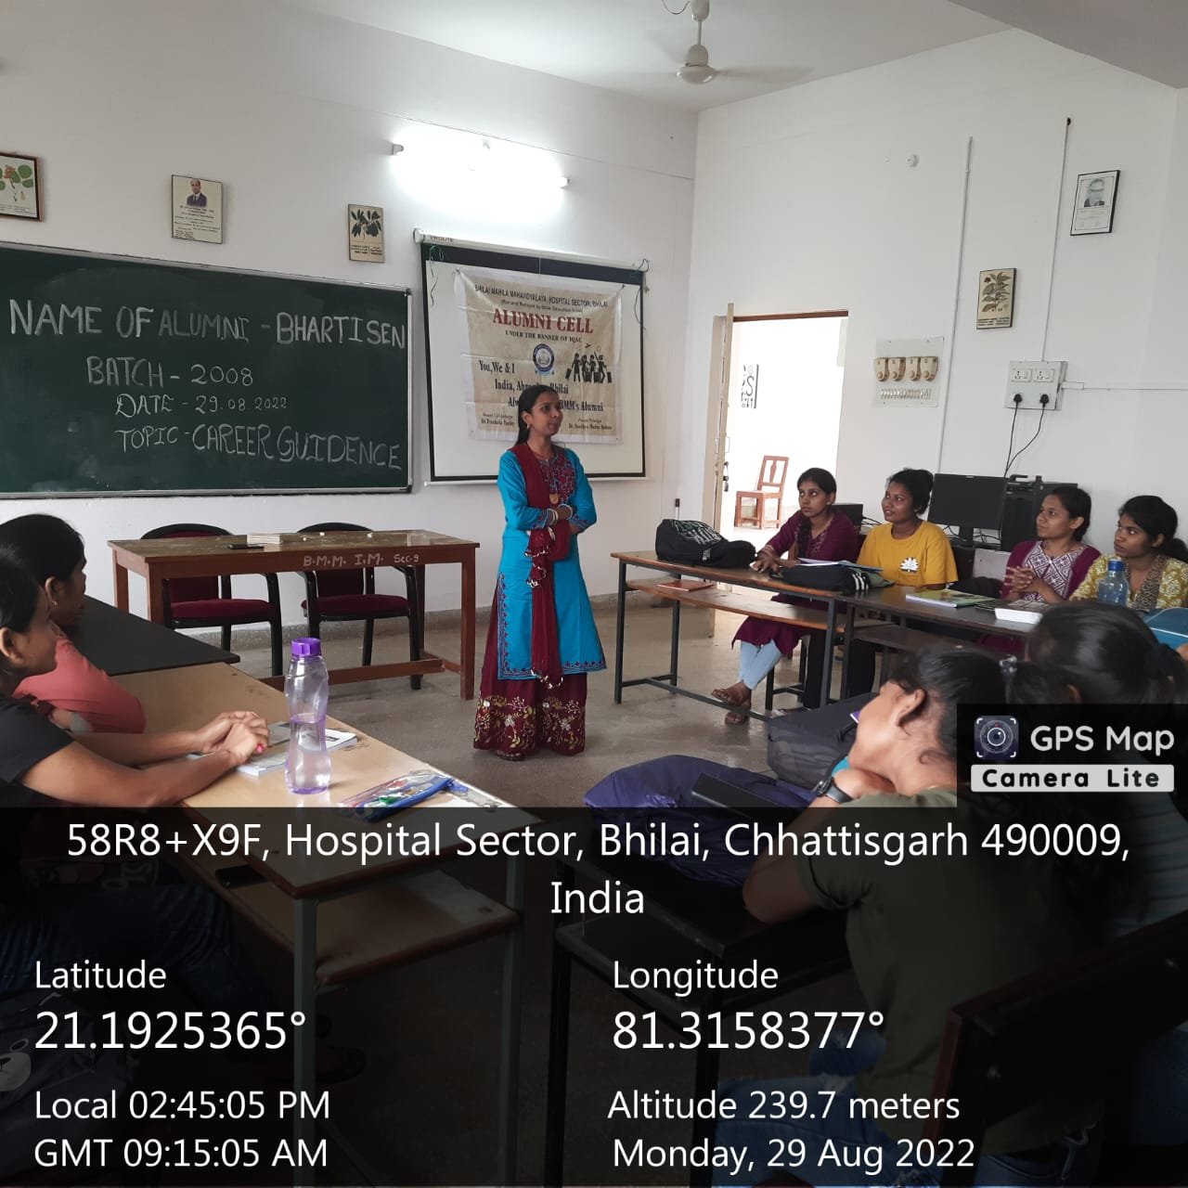

1) Inauguration of Zoological Society 2022-23

Date- 18th November
Time- 12 P.M.
Topic- Reproductive Behaviour
Lecture delivered by- Dr.Usha Sahu
Govt. V.Y.T.PG. Autonomous College,Durg
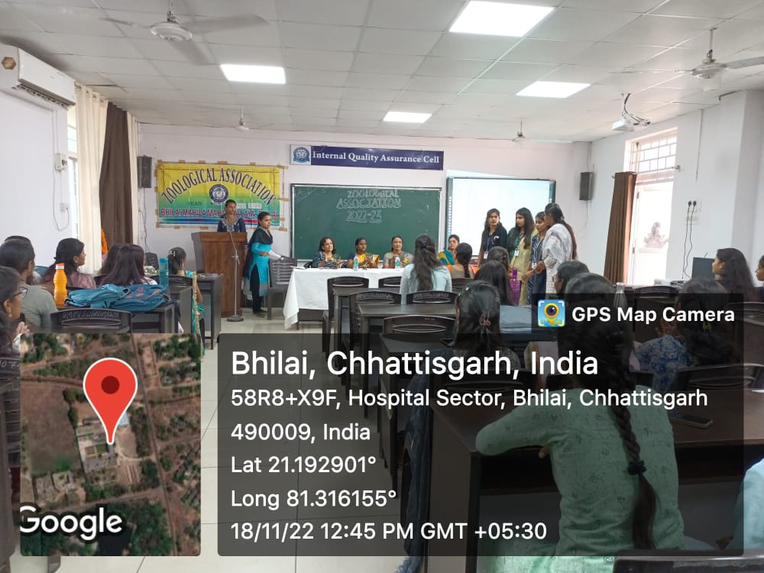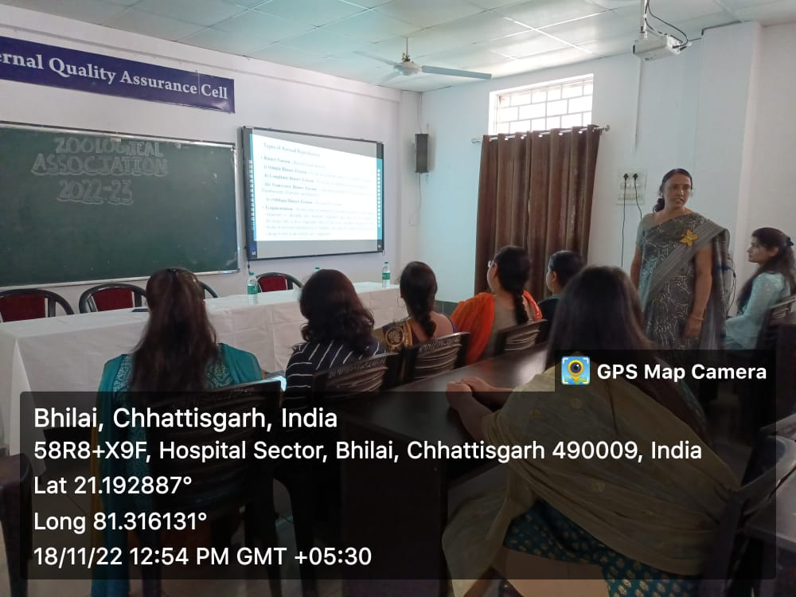

2) Guest Lecture-II

Date- 05th December
Time- 03 P.M.
Topic- Personality Development Programme
Lecture delivered by- Dr. Sanjay Thiske (Govt. Digvijay College Rajnandgaon)
Ms. Renuka Thakur( Govt. Kunj bihari Choubey College ,Lal Bahadur Nagar
Rajnandgaon)
