**MOU with SOMITEL Computers:**

**MOU:**

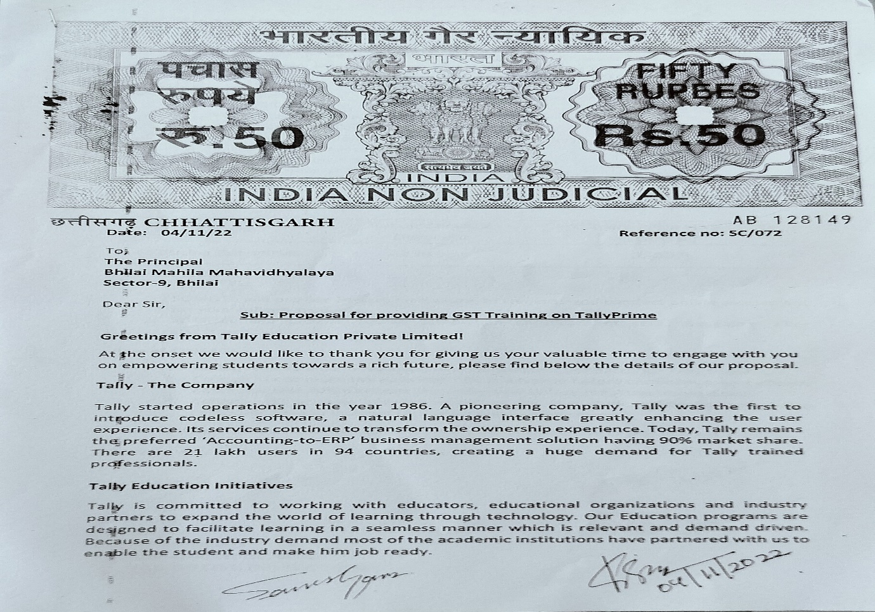

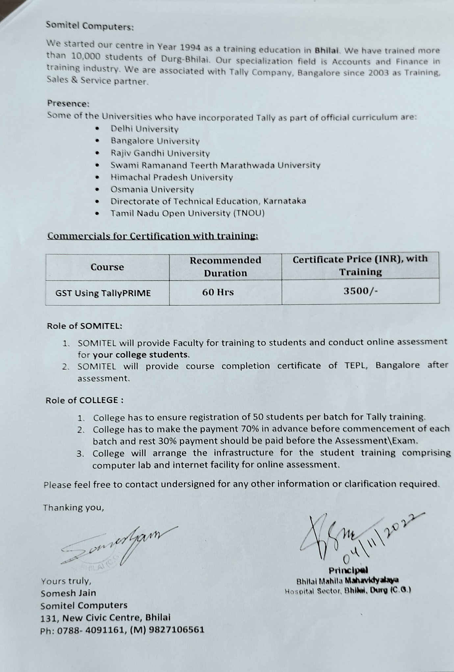

**Attendance Sheets:**

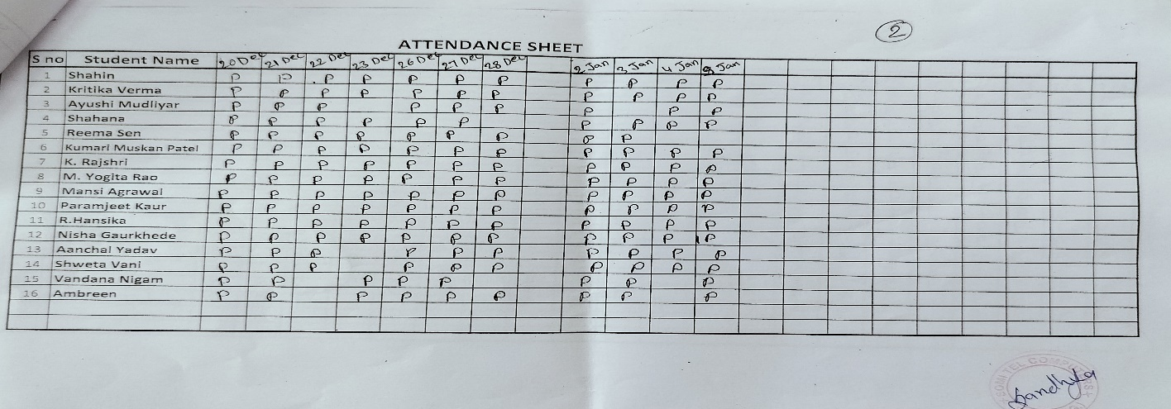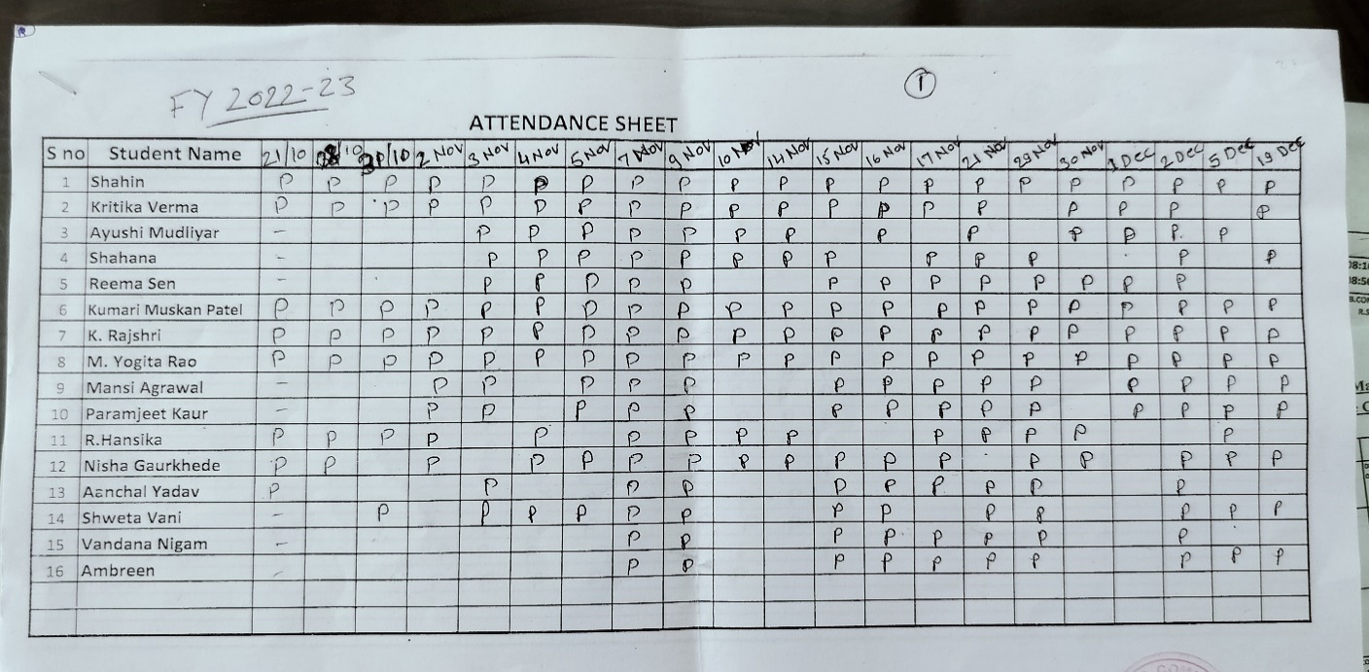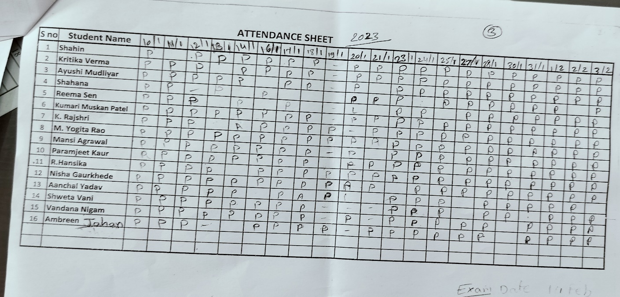

|  |  |  |  |  |
| --- | --- | --- | --- | --- |
| **SN** | **Department** | **Institute** | **Program** | **Attachment** |
| 1. | Department of Biotechnology and Microbiology | Nitza Hyderabad | Instrumentation Workshop |  |
| 2. | Department of Biotechnology and Microbiology | Jan Sevak Samiti | Mushroom Workshop |  |

**Minutes of Meeting**



