Objective- Value Added Course on Mushroom Cultivation

Date-20/09/2022-20/10/2022
Outcome-
A Mushroom Cultivation and Post Harvest Management Value Added Course can yield several outcomes:

•Skill Development: Participants can gain hands-on skills in cultivating different types of mushrooms, understanding their growth requirements, and managing the cultivation process effectively.

•Entrepreneurship Opportunities: The course can empower individuals to start their own mushroom cultivation businesses, tapping into the growing demand for these nutritious and versatile fungi.

•Nutritional Awareness: Learners can develop an understanding of the nutritional benefits of mushrooms and their inclusion in a balanced diet.

•Sustainability: Knowledge of mushroom cultivation can contribute to sustainable agricultural practices, as mushrooms can be grown using agricultural waste or by-products.

•Income Generation: Successful cultivation and management can provide an additional source of income for individuals or communities.

•Value Addition: Post-harvest management techniques, such as processing, packaging, and preservation, can enhance the shelf life and value of mushrooms.

•Waste Reduction: Learning how to efficiently manage mushroom waste and by-products can contribute to waste reduction and composting efforts.

•Research and Innovation: Participants may be inspired to further research and innovate in the field of mushroom cultivation, exploring new techniques and varieties.

•Local Food Systems: The course can support local food systems by encouraging the cultivation and consumption of locally produced mushrooms.

•Awareness of Environmental Impact: Understanding the environmental implications of mushroom cultivation can lead to more informed choices and sustainable practices.

Overall, this course can contribute to individual growth, community development, and sustainable agricultural practices while promoting the use of mushrooms as a valuable food source.

Permission Letter

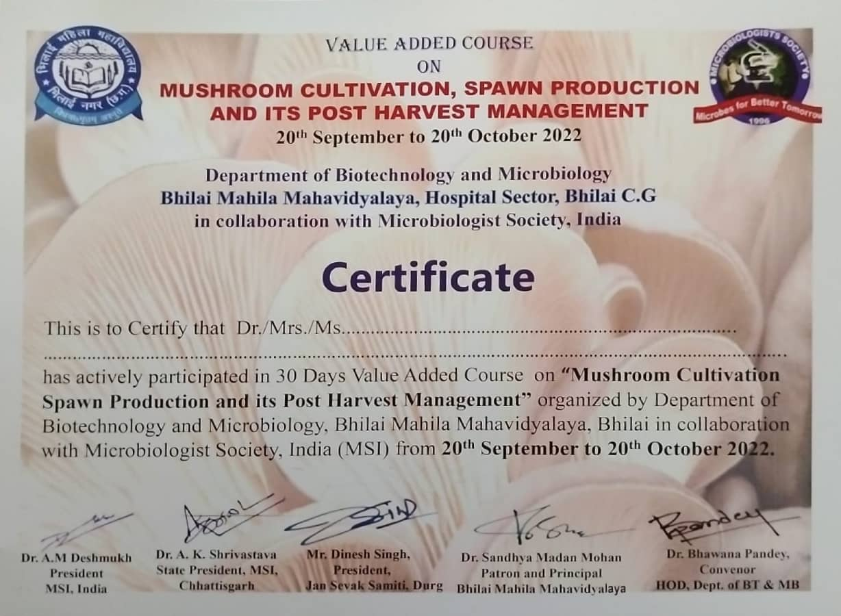
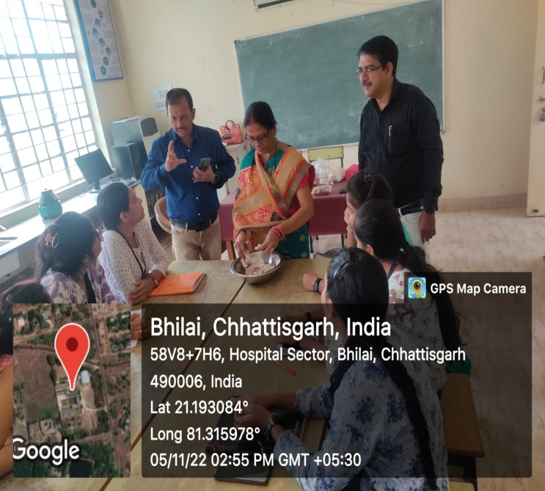
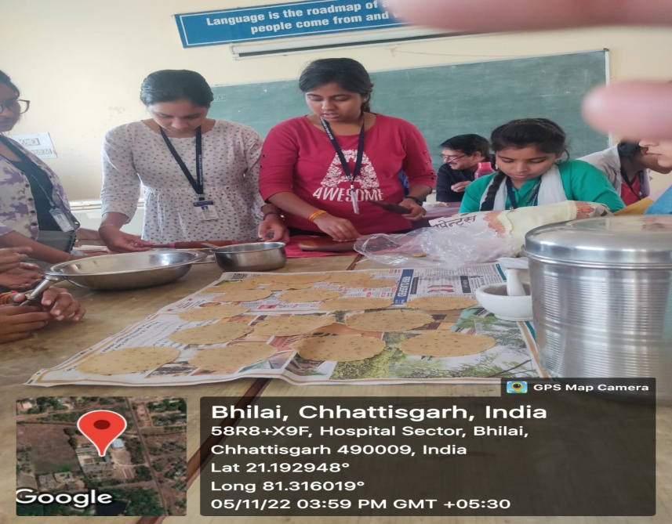
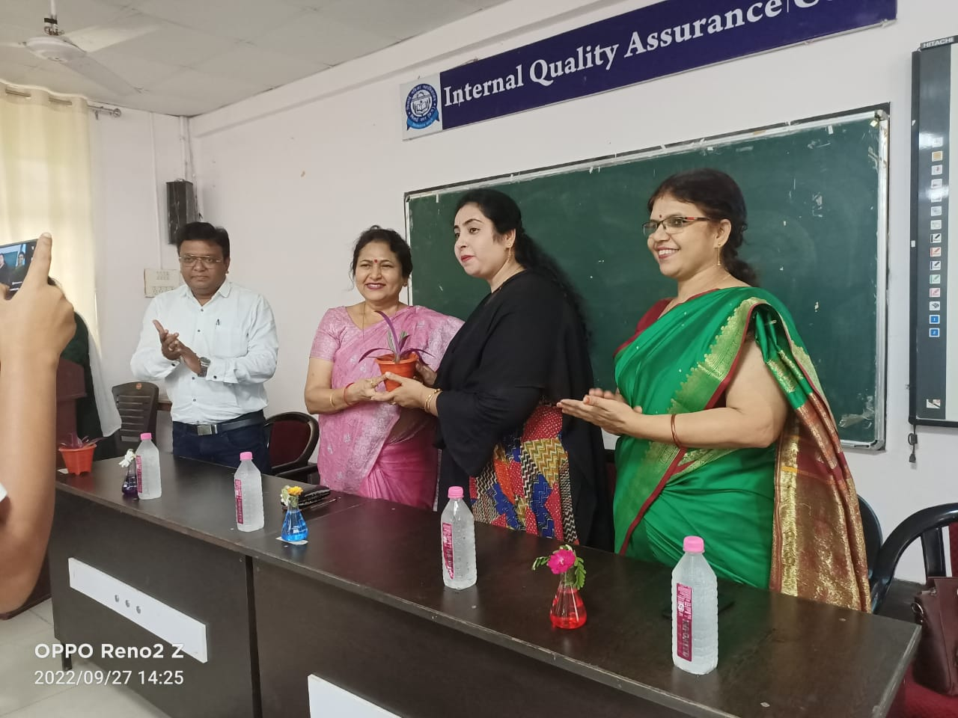
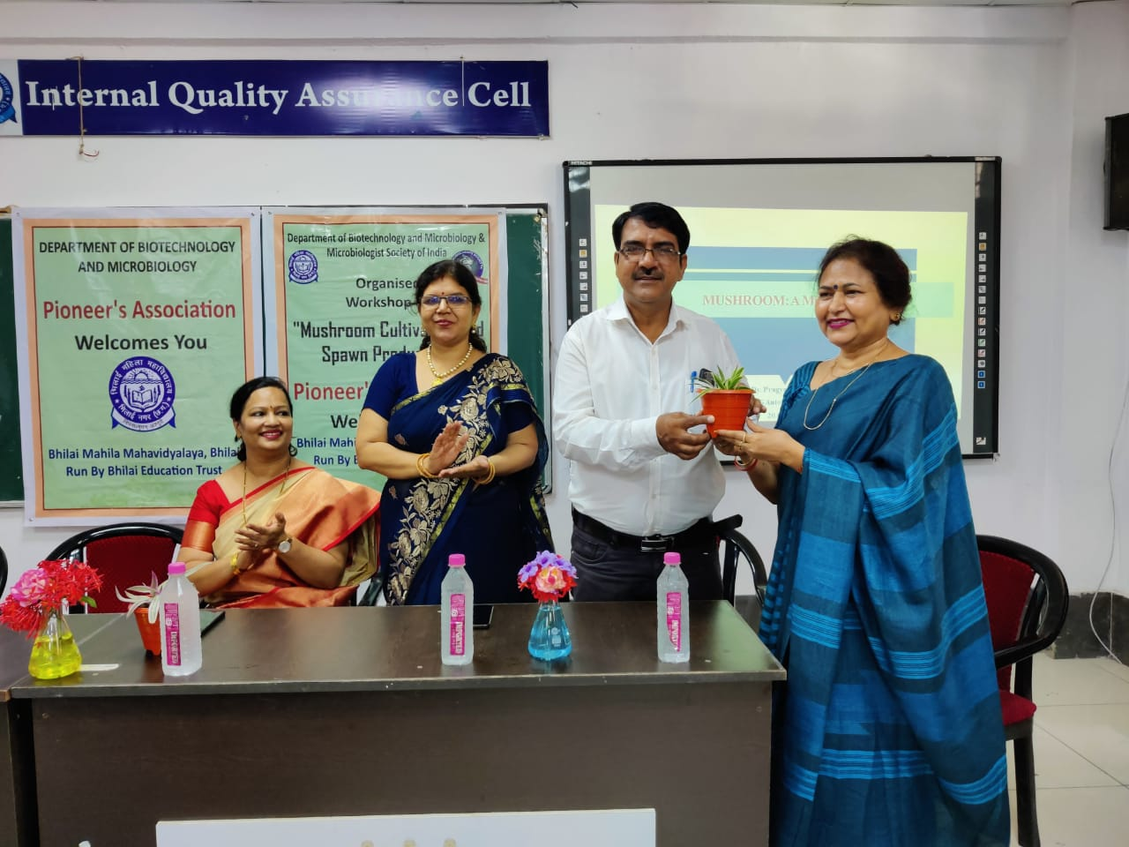
Objective- Value Added Course Production of Vermicompost.
Date-13/02/2023- 20/02/2023
Outcome- A Value Added Course on Vermicompost can lead to various outcomes:

- Sustainable Agriculture: Participants learn to produce nutrient-rich Vermicompost, contributing to sustainable and organic farming practices.

- Soil Health Improvement: The use of Vermicompost enhances soil structure, fertility, and water retention, leading to healthier and more productive soils.

- Waste Management: The course educates individuals about the effective recycling of organic waste, reducing the burden on landfills and promoting eco-friendly waste disposal.

- Nutrient-Rich Plants: Vermicompost supplies essential nutrients to plants, leading to healthier growth, improved yields, and better quality produce.

- Cost Savings: Farmers and gardeners can reduce costs by using Vermicompost as a natural fertilizer, thus decreasing the reliance on synthetic alternatives.

- Increased Crop Yield: Improved soil fertility and nutrient availability contribute to higher agricultural productivity.

- Environmental Awareness: Participants gain a better understanding of the importance of organic waste management and its positive impact on the environment.

- Entrepreneurship Opportunities: Graduates of the course can start their own Vermicompost production ventures, creating income-generating opportunities.

- Compost Quality Control: Participants learn about the right conditions for Vermicomposting, ensuring the production of high-quality compost.

- Public Health Benefits: Proper waste management and Vermicomposting can reduce the spread of diseases and pests associated with improper waste disposal.

- Educational Outreach: Graduates can become educators, promoting the benefits of Vermicomposting in schools, communities, and agricultural extension services.

- Research and Innovation: The course can inspire participants to explore innovative techniques and applications of Vermicompost in different fields.

- Contribution to Biodiversity: Vermicomposting contributes to the preservation of beneficial soil microorganisms and macro organisms, enhancing ecosystem health.

- Eco-conscious Mindset: Participants develop an eco-conscious mindset, understanding the importance of recycling and sustainability in daily life.

Overall, a Vermicompost Value Added Course equips individuals with the knowledge and skills to promote environmental responsibility, improve agricultural practices, and contribute positively to local communities.
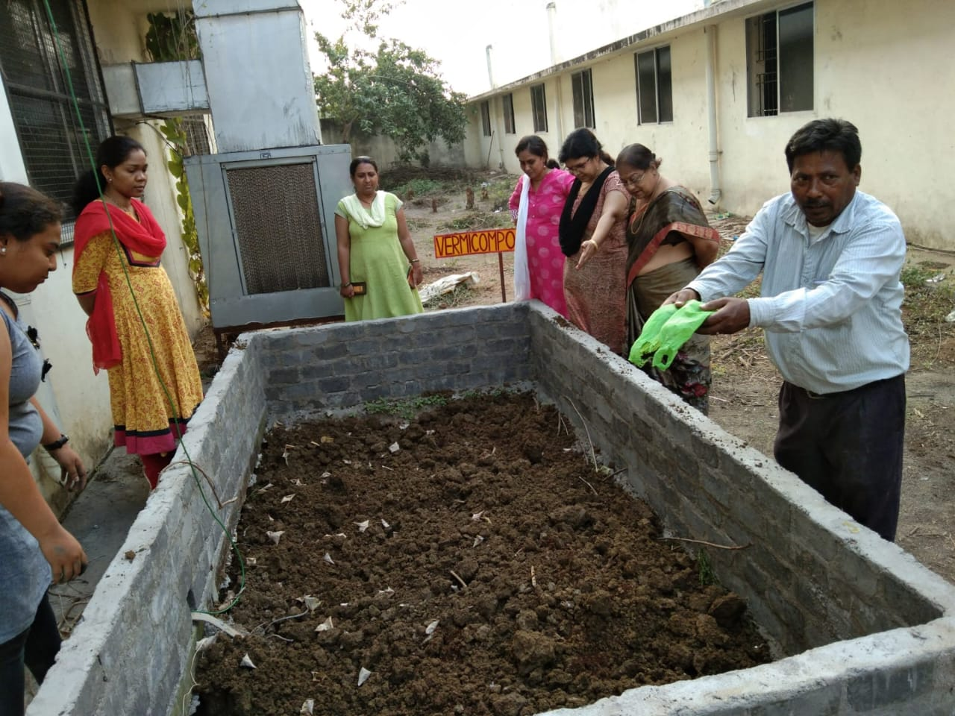
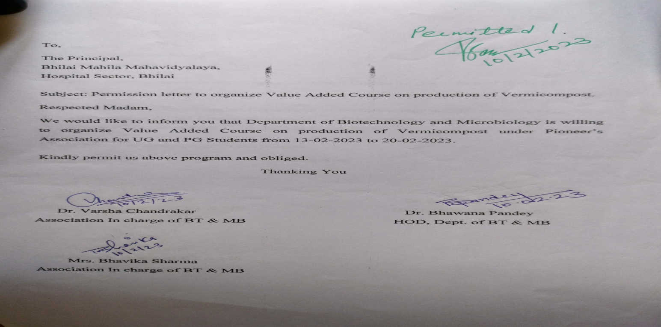

Objective- Value Added Course Production of Biofertilizer.

Date-15/03/2023- 15/04/2023
Outcome-
A Value Added Course on Biofertilizer Production through Rhizobium Bacteria can lead to the following outcomes:
- Enhanced Agricultural Productivity: Participants can learn to produce biofertilizers containing Rhizobium bacteria, which help fix atmospheric nitrogen in soil, enhancing plant growth and crop yield.

- Sustainable Agriculture Practices: Knowledge gained from the course can promote the use of biofertilizers as an eco-friendly alternative to chemical fertilizers, reducing environmental impact.

- Soil Health Improvement: Proper use of Rhizobium biofertilizers can improve soil fertility, structure, and nutrient content over time.

- Cost Savings for Farmers: Farmers can benefit from reduced fertilizer costs, as biofertilizers can supplement or replace chemical fertilizers.

- Nutrient-Rich Crops: Biofertilizers can lead to healthier crops with higher nutrient content, contributing to improved food quality.

- Promotion of Legume Cultivation: Rhizobium bacteria are particularly beneficial for leguminous crops, so the course can encourage the cultivation of these nitrogen-fixing plants.

- Knowledge Transfer: Participants can become sources of knowledge in their communities, promoting the adoption of biofertilizers and sustainable farming practices.

- Entrepreneurship Opportunities: The course can empower individuals to start small-scale biofertilizers production ventures, catering to local agricultural needs.

- Reduced Environmental Pollution: Biofertilizers reduce the risk of nutrient runoff and water pollution associated with excessive chemical fertilizer use.

- Research and Innovation: Learners may be inspired to further explore the potential of biofertilizers and contribute to research and innovation in the field.

- Participation in Agricultural Extension Services: Course participants can become valuable resources for agricultural extension services, educating farmers about the benefits of biofertilizers.

- Community Sustainability: Encouraging the use of biofertilizers contributes to the overall sustainability of farming communities and their ecosystems.

By imparting the skills and knowledge needed to produce and use Rhizobium-based biofertilizers, this value-added course can play a significant role in promoting sustainable agriculture and improving food security.

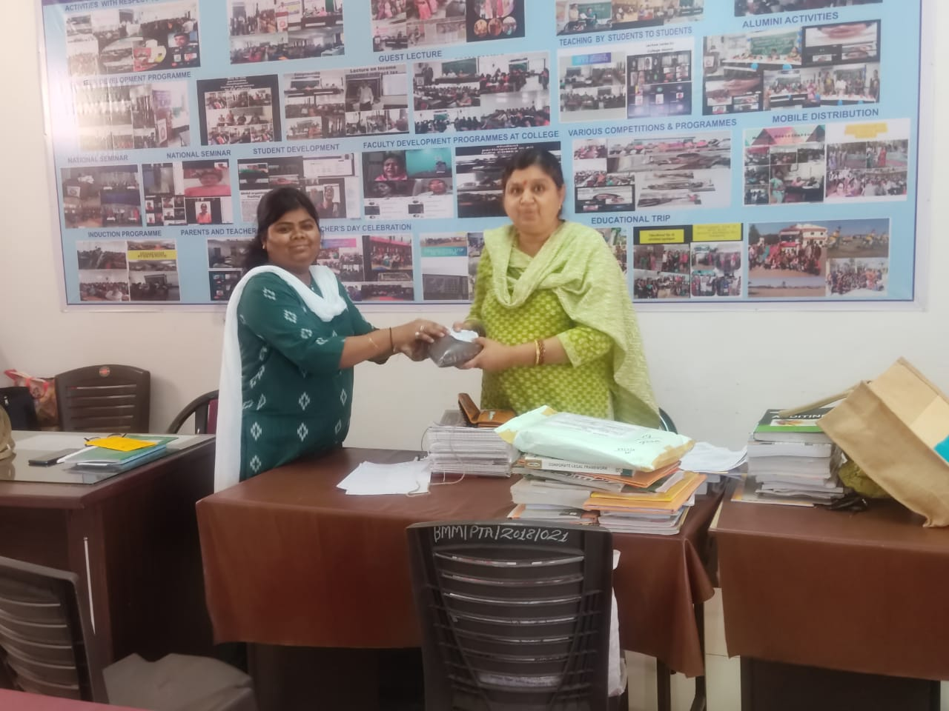
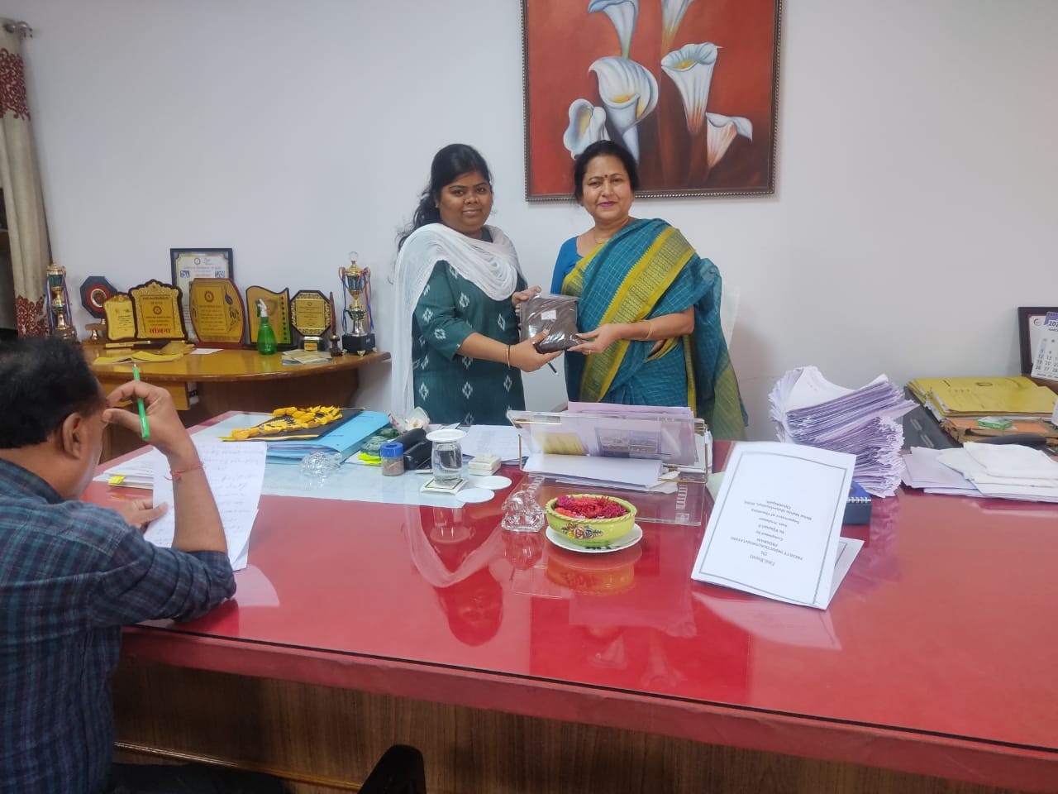
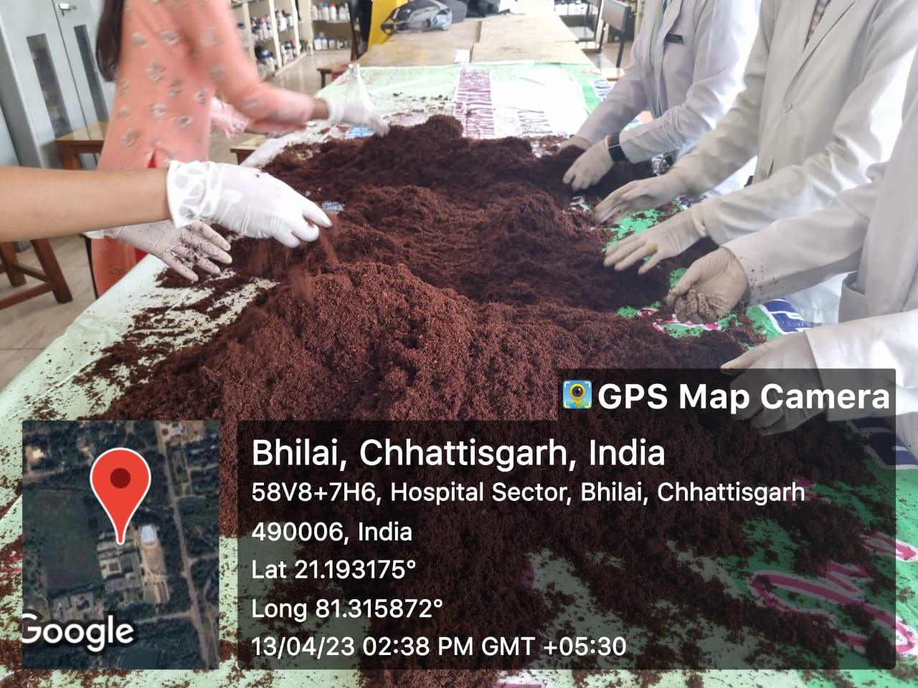
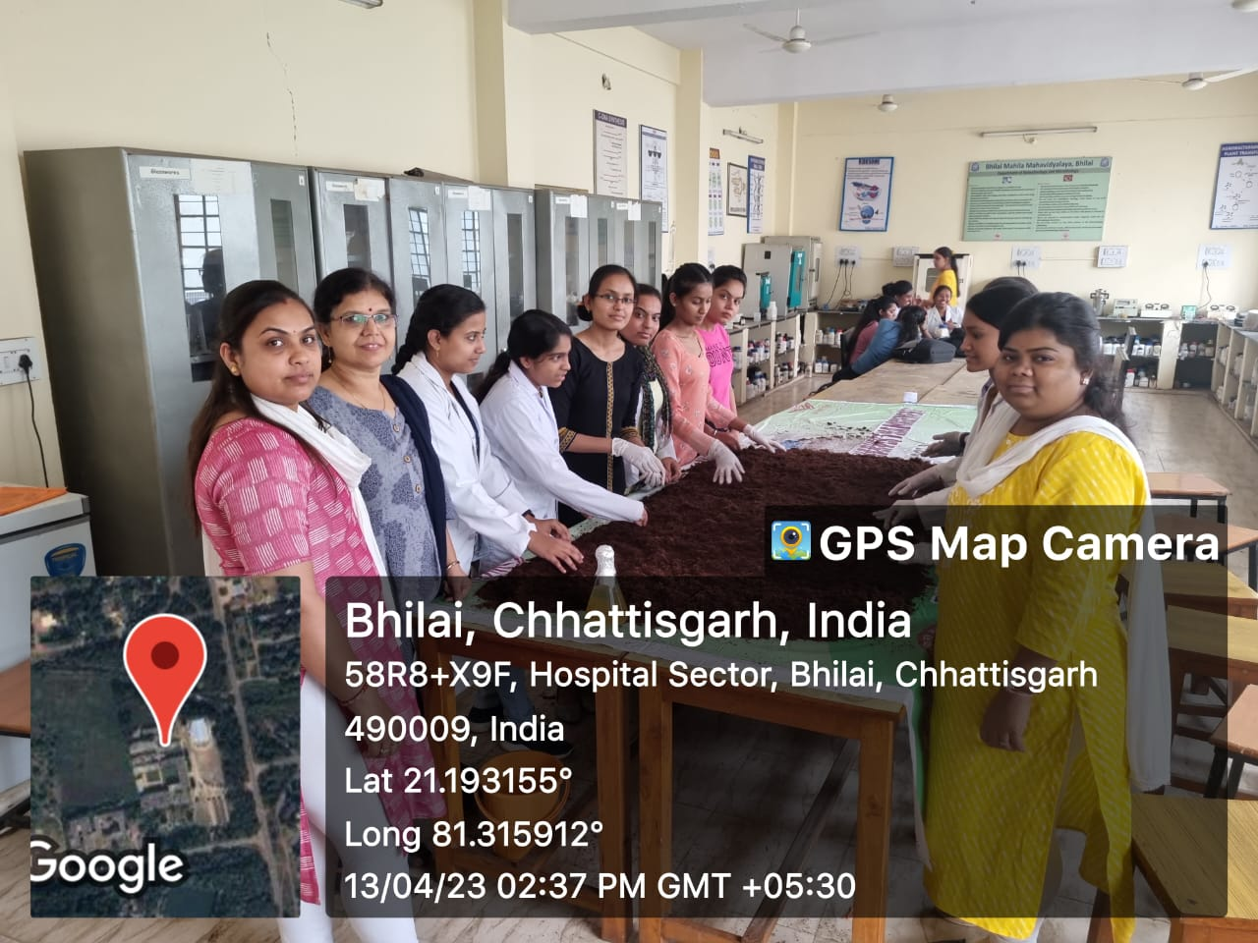
BIOFERTILIZER MAKING
SELLING OF BIOFERTILIZER
